**GAME IDEA 1: Shooting Range**

**Concept:**

‘*Shooting Range*’ is a First-Person Shooter that provides the enjoyment of a carnival game with the challenge of time and movement.

There are two objectives in the game:

1. Beat the par time on the level
2. Knock down all the targets on the way

**Gameplay:**

The player spawns in a room where they can choose one of two weapons. The door is always open and once they leave, the timer starts.

Each target is counted, and the player needs to move quickly and accurately to beat the time. Winning is achieved on beating the time. Special achievement if you beat it after killing all the targets.

* Each target left standing discounts time
* Special target that does not discount time

**Core Mechanics:**

* Guns are hitscan: bullet travel time is negligible
* Reloading and shooting scripts
* Movement is very fast, but accurate: you can stop quickly
* ‘WASD’ movement with jumping
* Hit detection on targets (humanoid targets)

**Minor Mechanics/Logic:**

* Doors that can be opened by shooting the button before you reach it (Adds a possibility of saving time)
* Script that keeps track of how many targets have been destroyed and how many are standing for final scoring
* On-screen timer accurate to Tenths
* Spawn door acts as trigger to initiate the timer
* Menu UI and level reset

**Out of scope mechanics:**

* Targets are sentries and shoot back
* Sliding to gain a little speed
* Aiming Down Sights
* More weapons
* Reloading and shooting animations

**Inspirations/similar works:**

* ‘*CoD: Modern Warfare*’ training level

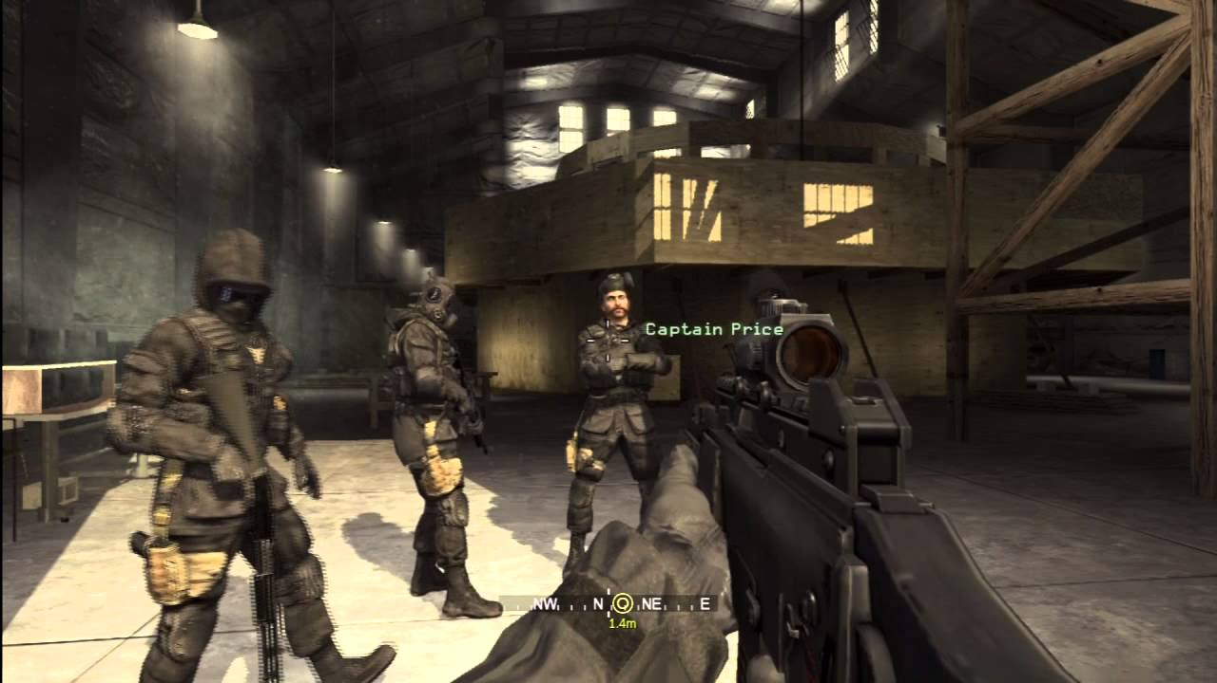

* ‘*Titanfall 2*’ Gauntlet mission

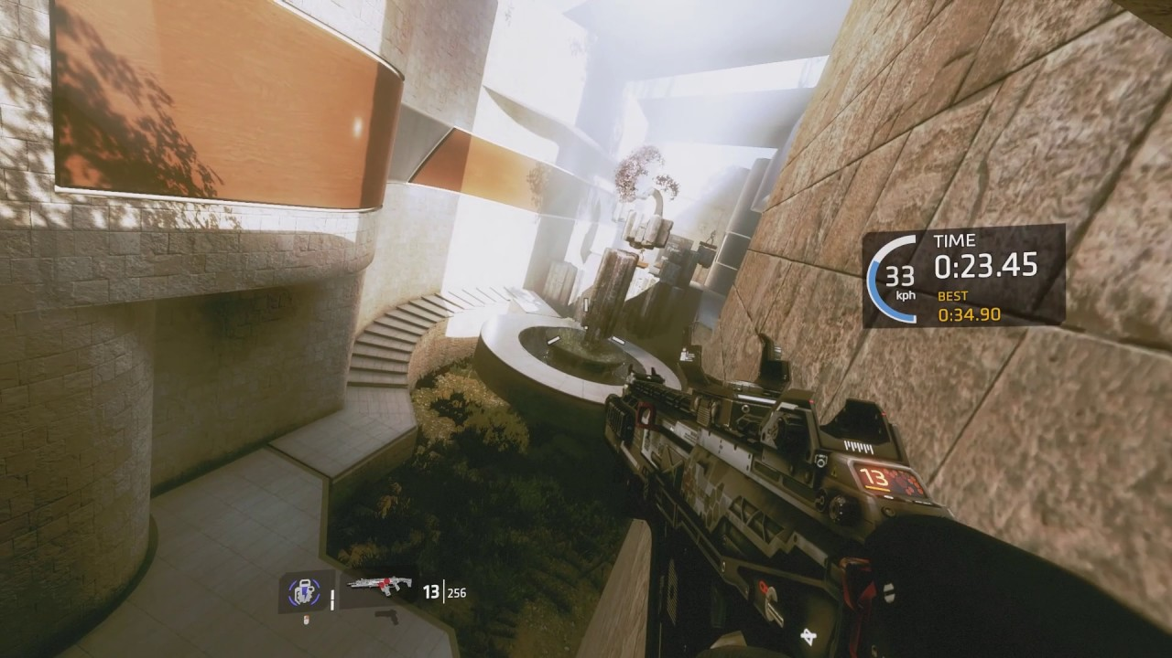

**Development challenges:**

* I don’t know how to make UI
* Still not comfortable with inter-script communication