Client: NBA Team Business Operations & Ticketing
Consultant: Jonah Jutzi
Project: NBA Attendance Analytics & Self-Updating Dashboard
Date: 12/10/2025

Executive summary:
NBA team business operations groups face a recurring challenge: turning large amounts of historical game data into clear, actionable guidance for pricing, promotions, and scheduling decisions. The goal of this proof-of-concept (POC) project was to design and implement a business intelligence solution that centralizes game-level attendance data in the cloud, allows staff to add new games through a simple form, and surfaces insights through an interactive dashboard and storyboard.
The implemented solution uses three main components. First, historical games and team information are stored in an Azure SQL database (db30) in a normalized structure with separate Games, TeamHistories, and FormInput tables. Second, a Microsoft Forms survey plus a Power Automate flow lets users enter a new game’s home team, away team, date, attendance, and winner; the flow writes those rows directly into the FormInput table while deriving a consistent WinnerTeamName. Third, Tableau connects to the database via Custom SQL, unions historical and form-based games into a single “Games+” data source, and presents the results through a reusable and updating dashboard and storyboard that can be filtered for any team.
For the client, this POC delivers several immediate benefits. Ticketing and pricing managers can quickly see which opponents drive above- or below-average attendance and adjust prices accordingly. Marketing analysts can identify matchups that need extra promotions, monitor the impact of campaigns, and understand the team’s value as a road draw in other arenas. Because the underlying database and automation are already in place, the solution can be extended in future work to incorporate ticket price, promotion, or customer-segment data without redesigning the architecture.

Use Cases:
User Type 1: Ticketing & Pricing Manager
- Set prices for an upcoming season’s schedule.
  - Select their team in the dashboard.
  - Review historical home attendance by opponent and season.
  - Identify high-demand opponents (large positive % change vs. average) to price at a premium.
  - Flag low-demand opponents for value pricing or added promotions.
- Monitor attendance for in-season course corrections.
  - After each game, form inputs allow for refreshing to include new games and adjust pricing
  - Check if any opponent is underperforming expectations.
  - Trigger targeted offers for upcoming games with projected weak attendance.

User Type 2: Marketing & Business Operations Analyst
- Identify promotional opportunities.
  - Use the “Average Home Game Attendance by Opponent” table to find teams consistently below the home average.
  - Design campaigns (rivalry nights, giveaways, partner promotions) tailored to those matchups.
- Assess the team’s value as a traveling draw.
  - View “Average Away Game Attendance” and opponent tables.
  - Spot arenas where the team significantly boosts attendance.
  - Share insights with league/partners to support national TV discussions.

Business Rules & Modeling Assumptions:
These rules guided the data model and calculations:
- Game identity & structure
  - Each row in the Games table represents one NBA regular-season game.
  - Each game has exactly one home team and one away team.
  - Each game has exactly one winner (ties are not allowed in the NBA).
- Team identity
  - Teams are uniquely identified by a TeamId (e.g., 1610612747).
  - Team names are stored in the TeamHistories and Games tables and used for form selection and dashboard labels.
- Season definition
  - An NBA season runs from October through April of the following year.
  - Season labels are stored/derived as text values like '03-04', '04-05', …, '24-25'.
  - All games outside this window (including preseason or playoffs) are excluded from this POC.
- Data scope
  - Only NBA vs. NBA regular-season games are included (both hometeamId and awayteamId in the NBA ID range).
  - Games with missing attendance are excluded from attendance analysis.
  - Games before the ’03-04 season are filtered out.
- Form input rules
  - The Microsoft Form only allows selection of valid NBA team names for home and away teams.
  - The form requires a valid date, non-negative attendance value, and one winner (home or away).
  - When a response is submitted, Power Automate converts “Home Team” or “Away Team” into the corresponding WinnerTeamName.
- Analytic rules
  - Home and away averages are computed at the game level using arithmetic mean of attendance.
  - % Change in Attendance is calculated relative to the selected team’s overall home average for that season or across seasons.
  - Season wins for a team are counted as the number of games where WinnerTeamName = selected team name within that season.

Entity Relationship Diagram:
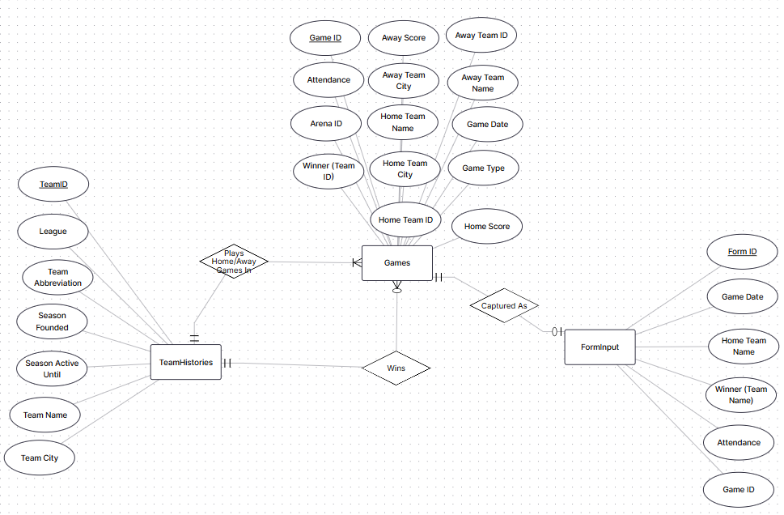

Relational Data Model/Schema:
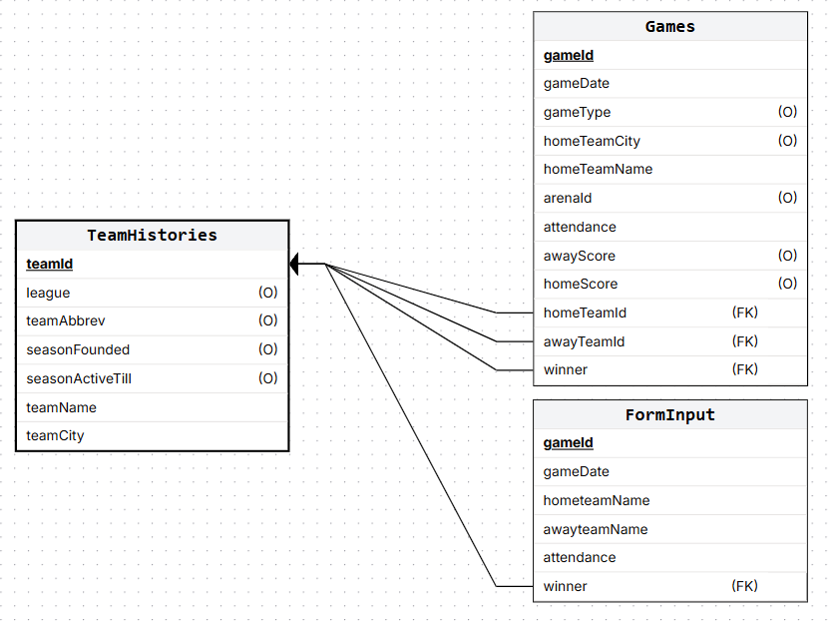
In Tableau, a Custom SQL unions Games and FormInput into a single logical “Games+” source. For historical rows, the winner is the teamId joined to TeamHistories; for form rows, the winner is the WinnerTeamName derived in Power Automate and later mapped to the same team dimension.

SQL Database
The physical database is implemented in Azure SQL (server: proj510dbserver.database.windows.net, database: db30).
- Tables: Games, TeamHistories, and FormInput
- Primary keys: Games.gameId, TeamHistories.teamId, and FormInput.formId.
Tableau connects to this database using a Custom SQL query that:
- Filters Games to regular-season NBA-vs-NBA games from October 20, 2003 onward.
- Left joins TeamHistories to translate numeric winner IDs into WinnerTeamName.
- Unions those rows with FormInput, where WinnerTeamName is already stored as text.

Input Form
NBA Attendance Input Form – Fill out form

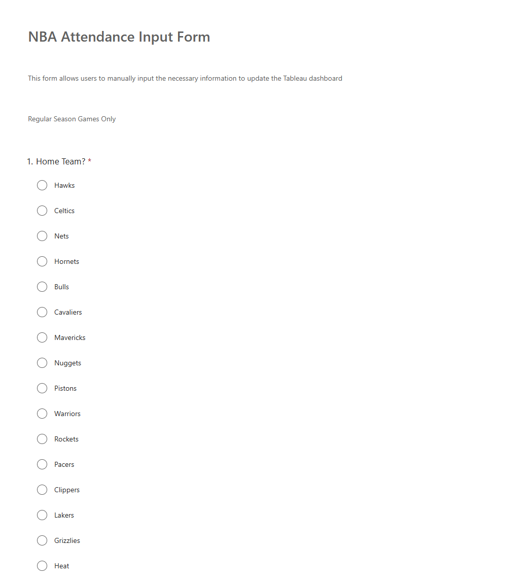
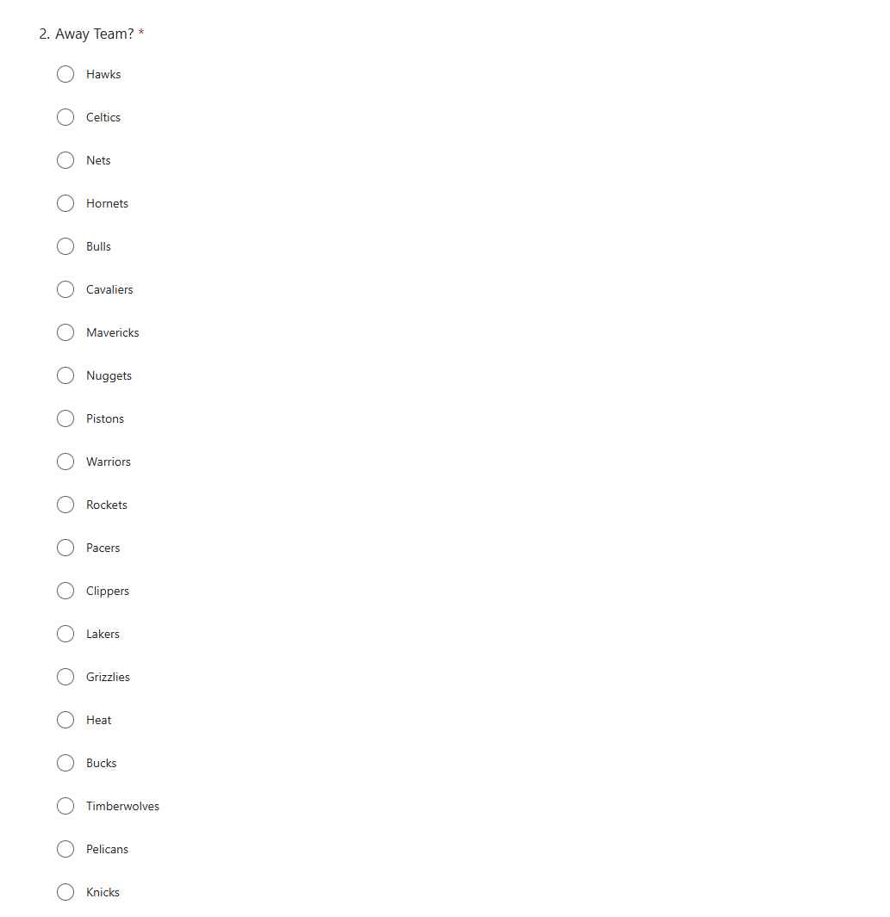
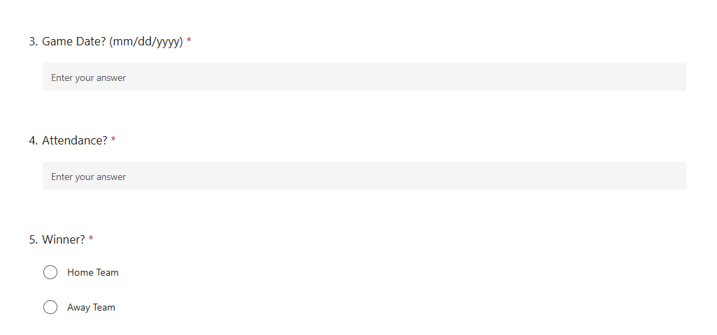
*The home team and away team fields contain values for each NBA team.

- Accessing the Form
  - Open the NBA Attendance Input Form LINK
  - For each newly completed game:
    - Select the Home Team and Away Team from the dropdowns.
    - Enter the Game Date (mm/dd/yyyy).
    - Enter Attendance (scanned or announced attendance).
    - Choose the Winner? (Home Team or Away Team).
    - Submit the form.
- Behind-the-Scenes Processing
  - The Power Automate flow runs automatically:
    - Reads the form response.
    - Derives the WinnerTeamName.
    - Inserts a new row into dbo.FormInput in the Azure SQL database.
- Refreshing the Dashboard
  - Open the Tableau packaged workbook
  - Ensure you can log into the Azure SQL database (db30) with the provided connection credentials.
  - Click Data → Refresh All Extracts (or Refresh if using live connection).
  - New games from FormInput are now unioned with the historical Games data and visible in:
    - Season-level attendance lines,
    - Home/away opponent tables,
    - Season wins tiles (if the game falls into a defined regular season).
- Basic Testing Checklist
  - Enter a test game (ex: a unique future date) via the form.
  - Refresh Tableau and confirm:
    - The game appears in the correct season.
    - Attendance updates any relevant averages.
    - Season wins increase if the selected team is the winner.
  - Delete or mark the test game as needed in SQL after verification.
- Using Team Selector Parameter
  - The Team Selector Parameter allows for users to view different teams and their respective attendance. Simply click the drop-down menu and select the appropriate team.

