12/10/2025
Jonah Jutzi

I certify that I have completed this assignment within the Academic Integrity guidelines presented in the UW General Catalog. Further, I certify that I do not have any knowledge of any other individual(s) violating these guidelines.

Executive Summary:
This project analyzes NBA regular-season attendance from October 2003 through April 2025 in order to help team business operations staff make smarter pricing and marketing decisions. Using game-level data loaded into an Azure SQL database and visualized in Tableau, I built a league-wide storyboard and a team-specific dashboard that reveal how attendance varies by season, opponent, and team performance. New games can be added via a Microsoft Forms survey, which flows into the same database through Power Automate so that the dashboard remains up to date without manual data entry.
League-wide, attendance has been relatively stable over the last two decades, with a sharp temporary collapse during the 2020–21 COVID season that should be treated as an outlier rather than a trend. At the team level, stronger seasons in the win–loss column generally correspond to higher home crowds, but opponent identity also matters: some visiting teams reliably lift attendance above a club’s typical home average, while others consistently underperform. The final dashboard combines these patterns so that a ticketing or marketing manager can quickly tier opponents for premium vs. value pricing, identify matchups that need extra promotional support, and monitor how new games compare with historical expectations as soon as they are entered through the form.

Background:
NBA teams face a recurring question every season: how much should we charge for each game, and which matchups deserve premium pricing or extra marketing support? Ticket demand is influenced by many factors, including team performance, star players, rivalries, day of week, and arena capacity—but most front offices still rely heavily on experience and simple averages when planning prices and promotions.
For this project, I focused on attendance as a proxy for demand. The underlying dataset includes regular-season games from October 2003 through April 2025, with fields such as game date, home and away teams, attendance, and game result. I connected these data to a personal Azure SQL database, cleaned and filtered them to NBA-vs-NBA regular season games, and then built a Tableau dashboard that can be used by any team’s business operations staff.
The core business question is:
Given a specific NBA team, how does attendance change by opponent and season, and how can those patterns support more informed pricing and marketing decisions?

Purposes and Questions (Dashboard):
The dashboard is designed to answer a focused set of practical questions for any given team (selected via a Team Selector parameter):
- Season-level demand:
  - How has average home and away game attendance for the selected team changed over seasons?
- Opponent impact at home:
  - For this team’s home games, which visiting opponents generate the largest positive or negative percentage change in attendance relative to the team’s typical home crowd?
- Opponent impact on the road:
  - When this team plays away, how do different host arenas respond? Which opposing teams see higher-than-usual attendance when this team visits?
- Connection to on-court success:
  - How many games does the selected team win each season, and how might changes in record align with attendance trends?
- Recent matchups and new games:
  - The MSFT Form supports new data entry, allowing for the dashboard tool to be updated after every game.
Together, these questions support ticketing, pricing, and marketing decisions such as setting higher prices for consistently high-demand opponents, identifying low-attendance games that may need promotions, and monitoring how demand shifts when team performance changes.

Purposes and Questions (Storyboard):
The storyboard is designed to walk a business user through the investigation in a logical sequence, starting from the “big picture” and gradually narrowing down to actionable, team-specific questions.
- NBA Attendance Histogram (league-wide)
The first slide shows average attendance by season across all regular-season games. This view answers: Is demand for the NBA growing, shrinking, or stable over time? Users immediately see that attendance is fairly stable with a dramatic dip in 2020-21, confirming that this season should be treated as an outlier rather than a trend shift.
- Attendance by Team (selecting a team)
The second slide introduces a Team Selector and plots average attendance over seasons for the chosen team. This answers: How does the selected team’s attendance trend compare to the league average? For example, when selecting the Trail Blazers, we see a stretch of strong home crowds during competitive years and a decline in more recent seasons.
- Attendance and Team Performance
The third slide overlays two lines: average attendance and total wins by season, both filtered by the selected team. This view asks: How tightly is attendance linked with on-court success? Seasons with more wins generally show stronger attendance, but not perfectly, highlighting that performance is important but not the only driver of demand.
- Average Home Attendance (league ranking)
The next slide ranks teams by average home attendance. This answers: Where does each team sit relative to the rest of the league? It also highlights consistently high-demand franchises that are likely to benefit from strong brands and larger markets.
- Attendance Matrix (opponent combinations)
The matrix slide shows average attendance for every home–away team pair, using a heatmap. This view addresses: Which specific matchups are the biggest draws or the weakest draws? It reveals, for instance, that games involving certain marquee teams almost always appear in green (higher attendance) cells regardless of venue.
- Change in Home Attendance per Team (selecting home team)
This slide filters down to one home team and lists visiting opponents alongside the percentage change in attendance relative to that team’s typical home crowd. This answers: Which opponents generate the largest positive or negative attendance lift when hosted? These are natural candidates for premium pricing or targeted promotions.
- Change in Away Attendance per Team (selecting away team)
Similarly, this slide treats the selected team as the away team and shows how host arenas respond when that team visits. The question is: How much of a “road draw” is the selected team? This is useful for league-level scheduling and for understanding brand strength outside the home market.
- Dashboard
The final storyboard slide is the integrated dashboard. It combines time-series trends, opponent tables, and season wins for the selected team. This is where a decision-maker can revisit specific opponents or new games entered through the form and see how those games fit into the broader historical context.
Together, the storyboard maps a clear path from exploratory understanding to diagnostic and prescriptive questions.

Methods and Data Source:
- Original game-level data (Games, Teams, Team Histories, etc.) were provided as CSV files covering all NBA games from 1971 to present.
- I imported these files into an Azure SQL database (db30) using Azure Data Studio and created a cleaned Games view via Custom SQL.
- To keep the analysis focused, I filtered to:
  - Regular-season games only (gameType = 'Regular Season'),
  - Dates on or after 2003-10-20
    - I chose this date as the start date for my analysis because the oldest current player in the NBA, Lebron James, was a rookie in the ’03-04 season.
  - Games where both home and away team IDs fell within the NBA range (to remove exhibitions vs. international or G-League teams).
Season Definition
- Because NBA seasons span two calendar years, I created a Season Label field in Tableau that groups games from October–April into single seasons. This allows meaningful comparison of attendance by season rather than by calendar year.

Form Input and Automation
- I built a Microsoft Forms questionnaire that lets a user enter:
  - Home team
  - Away team
  - Game date
  - Attendance
  - Winner (home or away).
- A Power Automate flow triggers when a response is submitted, transforms the winner into the actual team’s name, and inserts a new row into a FormInput table in the same SQL database.
- In Tableau, I use Custom SQL to union the historical Games data with the FormInput table so freshly entered games appear automatically in the dashboard once the data source is refreshed.
Visualization and Calculations
- All visualizations are built in Tableau Desktop using:
  - Line charts for season-level average home and away attendance.
  - Tables ranked by opponent, showing average attendance, team-specific home average, and percent change vs. that baseline.
  - A “Season Wins” heatmap based on counting games where the selected team is the winner, grouped by season label provides additional context to the attendance graphs and tables.
- Key calculated fields include:
  - Home Avg: the team’s average home attendance across all opponents.
  - % Change in Attendance: (Average attendance vs. given opponent – Home Avg) / Home Avg.
  - WinnerTeamName: derived from either the team IDs (for historical data) or the form’s winner field (for new games).
  - Season Wins: count of games per season where WinnerTeamName = Team Selector.

Results and Recommendations:
League-wide demand
The opening histogram shows that NBA regular-season attendance is generally stable over time. The one dramatic exception is the 2020–21 season, when COVID-19 restrictions forced arenas to operate at limited or zero capacity. This confirms that long-term pricing and planning should be based on “normal” seasons, treating 2019–20 and especially 2020–21 as special cases rather than signals of structural decline.
Team performance and attendance
For individual teams, the storyboard shows that better on-court performance usually coincides with stronger home attendance, but not perfectly. Some seasons with similar win totals have noticeably different attendance, suggesting that brand strength, star players, and local market conditions also play meaningful roles. For decision makers, this means that performance should be considered a key variable rather than the sole driver.
Opponent-driven demand differences
The league-wide home-attendance ranking table and the opponent matrix highlight large, systematic differences across matchups. Certain teams—often large-market or historically successful franchises—tend to draw above-average crowds in almost every building, while others underperform relative to a given home team’s baseline. For any selected team, the “Change in Home Attendance per Team” view isolates which visiting opponents generate the largest positive or negative percentage change in attendance relative to that team’s overall home average.
Home vs. away perspectives
The complementary “Change in Away Attendance per Team” view flips the lens, showing how arenas respond when the selected team visits. Some clubs act as strong draws (ex. Lakers) boosting attendance in multiple markets; others have a more neutral or even negative effect (ex. Hornets). This information can inform league scheduling, national TV selections, and joint marketing campaigns with other teams or partners when a strong road draw is in town.

Recommendations:
- Create opponent tiers for pricing. For each team, group opponents into at least three tiers based on percentage change in attendance vs. the home average (e.g., +5% or more, within ±3%, –5% or worse). Apply higher base prices and fewer discounts to Tier A opponents, standard pricing to Tier B, and value pricing plus promotions to Tier C.
- Incorporate performance context, not just opponent. Use the Season Wins tiles jointly with attendance trends when setting prices for a new season. After strong seasons, lean more on dynamic pricing and premium tiers; after weak seasons, keep prices conservative except for the very high-demand opponents.
- Plan promotions around structurally weak matchups. For opponents that consistently sit at the bottom of the %-change lists across seasons, treat those games as promotion opportunities on the schedule.
- Extend the model when richer data become available. If ticket price, promotion, or customer-segment data can be added to the database, the same architecture (Azure SQL + FormInput + Tableau) can support more advanced revenue management analyses.

Limitations:
Several limitations and threats to validity should be noted:
- Unobserved factors: Attendance is affected by variables not captured in the dataset, such as weather, competing local events, transportation issues, and specific promotional nights.
- Day-of-week effects: Weekend games generally draw better than weekday games. Because this analysis does not explicitly control for day of week, some differences in attendance may be due to scheduling rather than opponent.
- COVID-19 seasons: The ‘20–21 season (and, to a lesser degree, ‘19–20) is an outlier because of pandemic-related capacity restrictions. Even though these seasons are visible in the dashboard, they should be interpreted with caution and not used as a baseline for pricing decisions.
- Pricing data unavailable: I do not have historical ticket price data. As a result, recommendations about pricing are relative, based on which games draw more or fewer fans rather than tied to specific price elasticities or revenue optimization models.
- Attendance vs. true demand: Attendance is used as a proxy for demand or tickets purchased because that is what was available in the dataset. Attendance reflects tickets scanned, not necessarily tickets sold, and does not capture secondary-market behavior or no-shows.
- Star players and injuries: Star players have a significant impact on demand, especially when visiting. This analysis does not incorporate player availability or injuries, so some low-attendance games against high-profile opponents may simply reflect nights when key players rested.
Despite these limitations, the dashboard still provides valuable, actionable insight into relative demand across opponents and seasons and can serve as a foundation for more sophisticated revenue management analyses if richer data (pricing, promotions, etc.) become available.

URL Link for a dashboard
Screen Shot of a dashboard

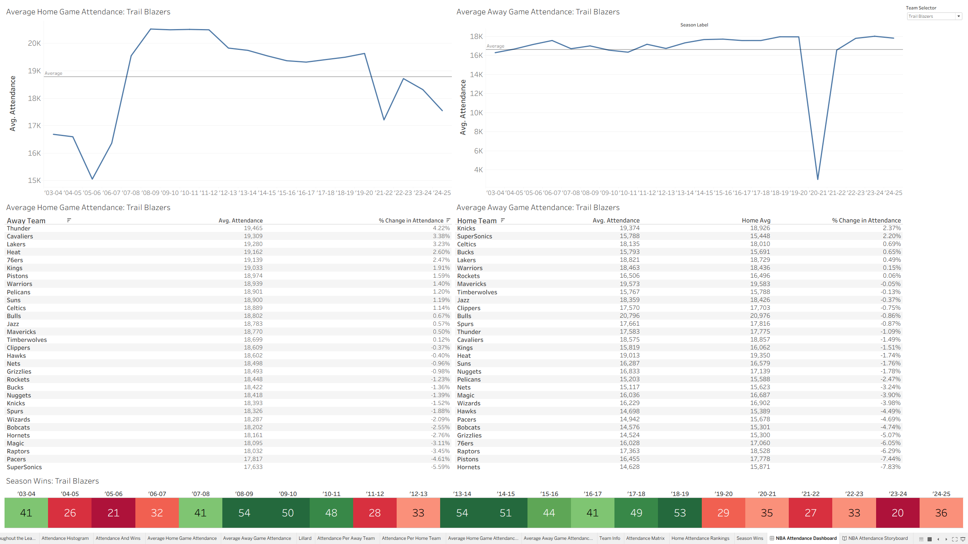
URL Link for a storyboard
Screen shots of story board visualizations

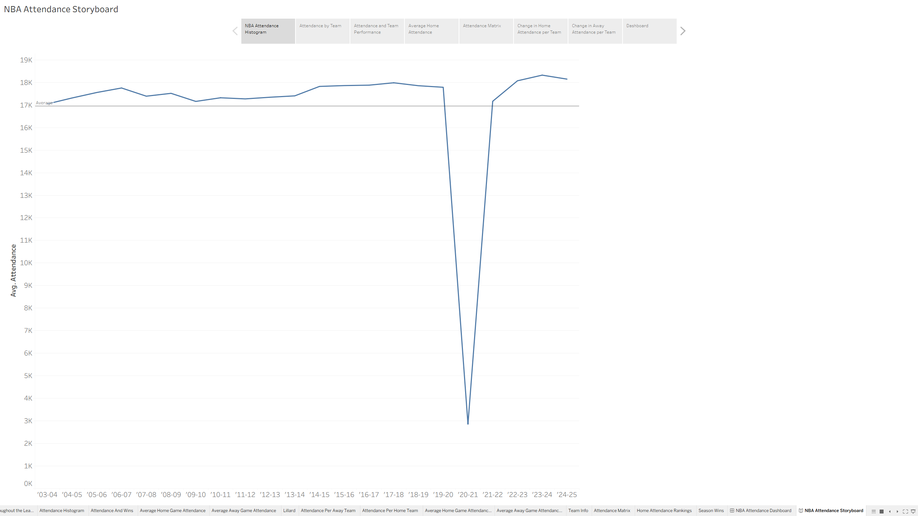
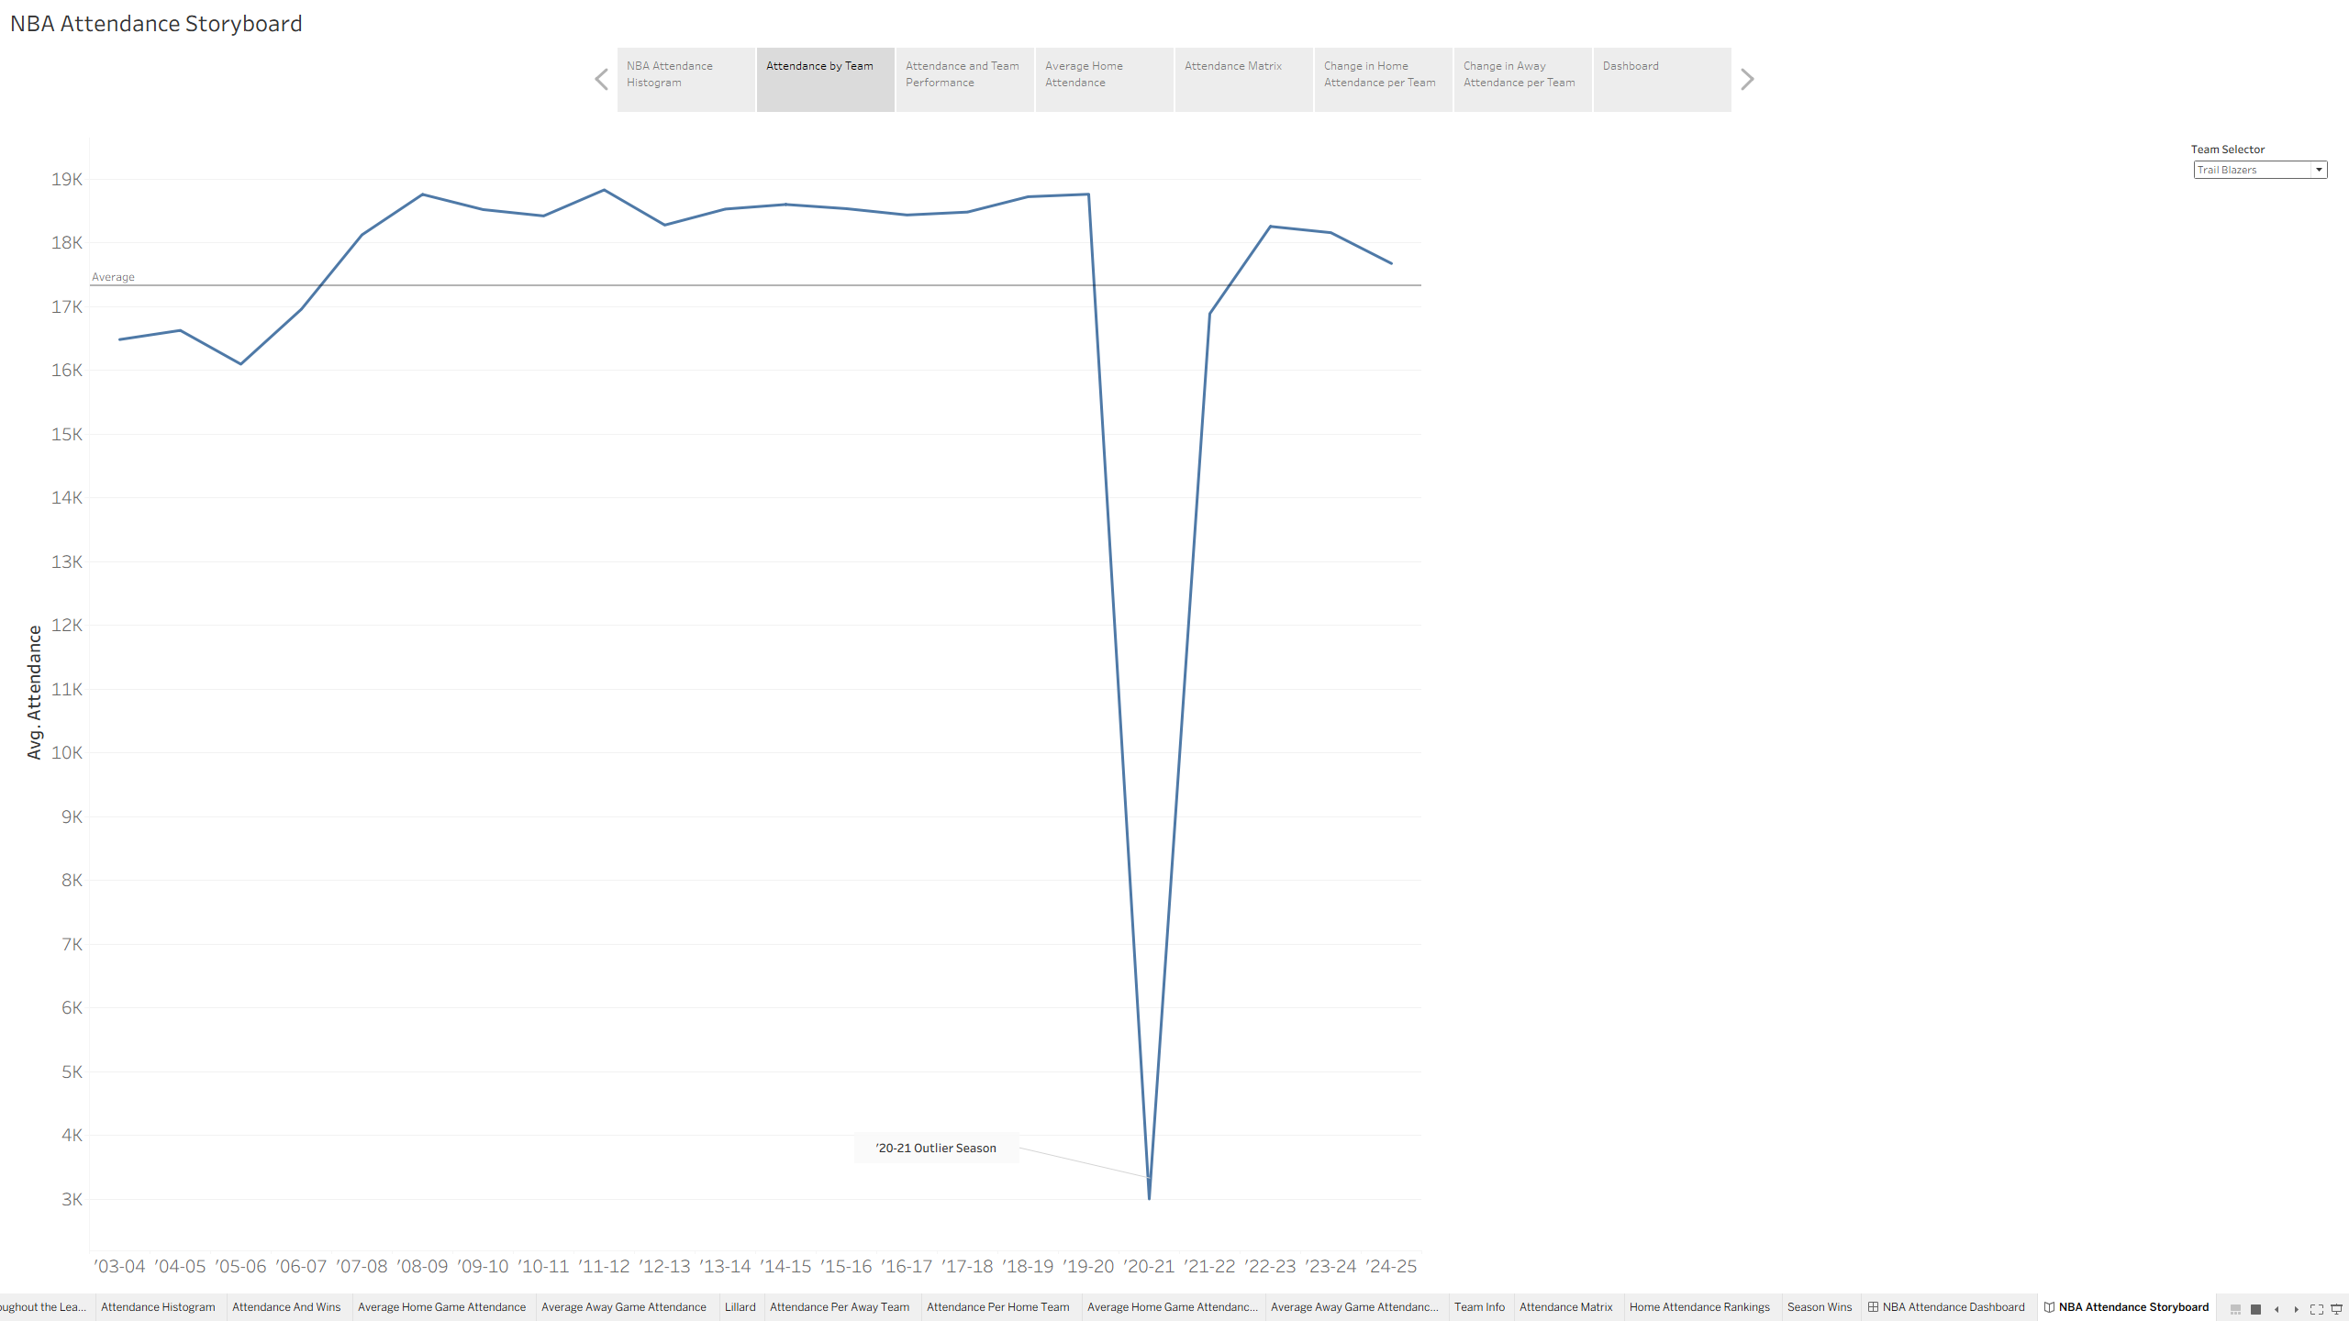
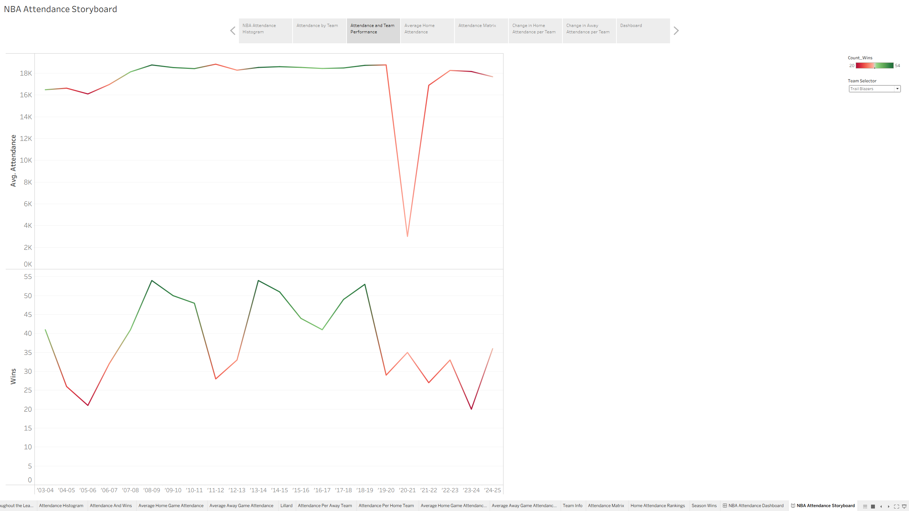
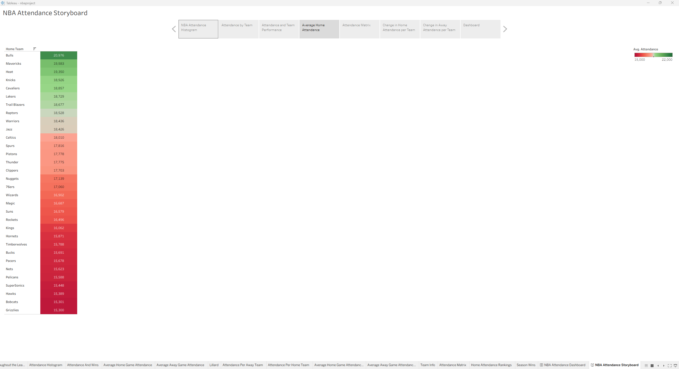
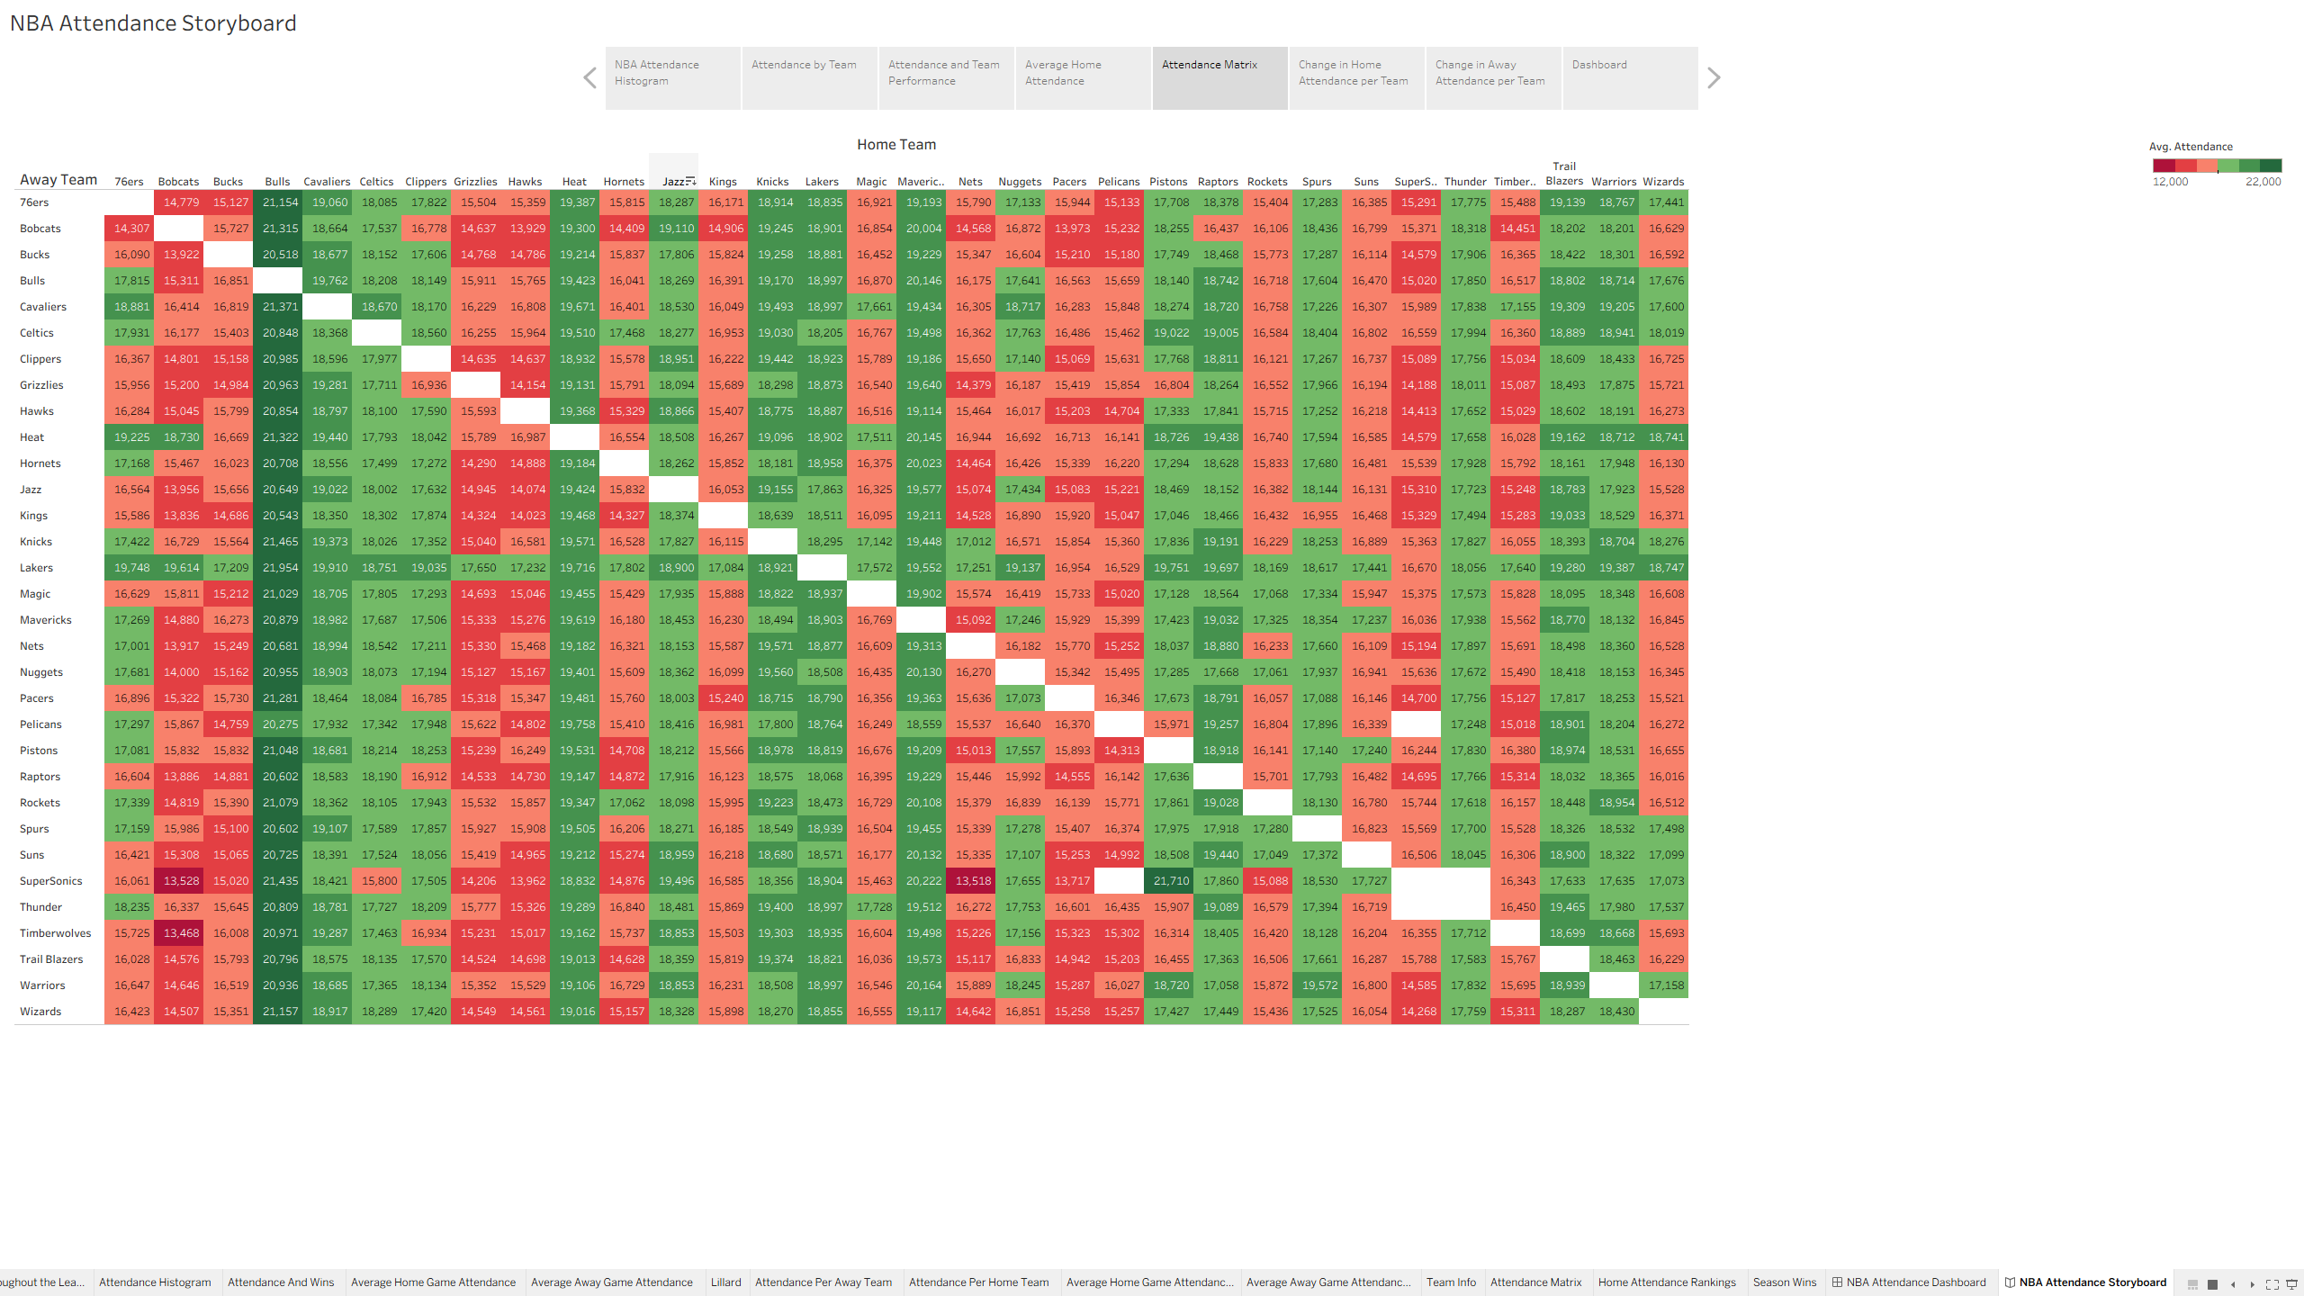
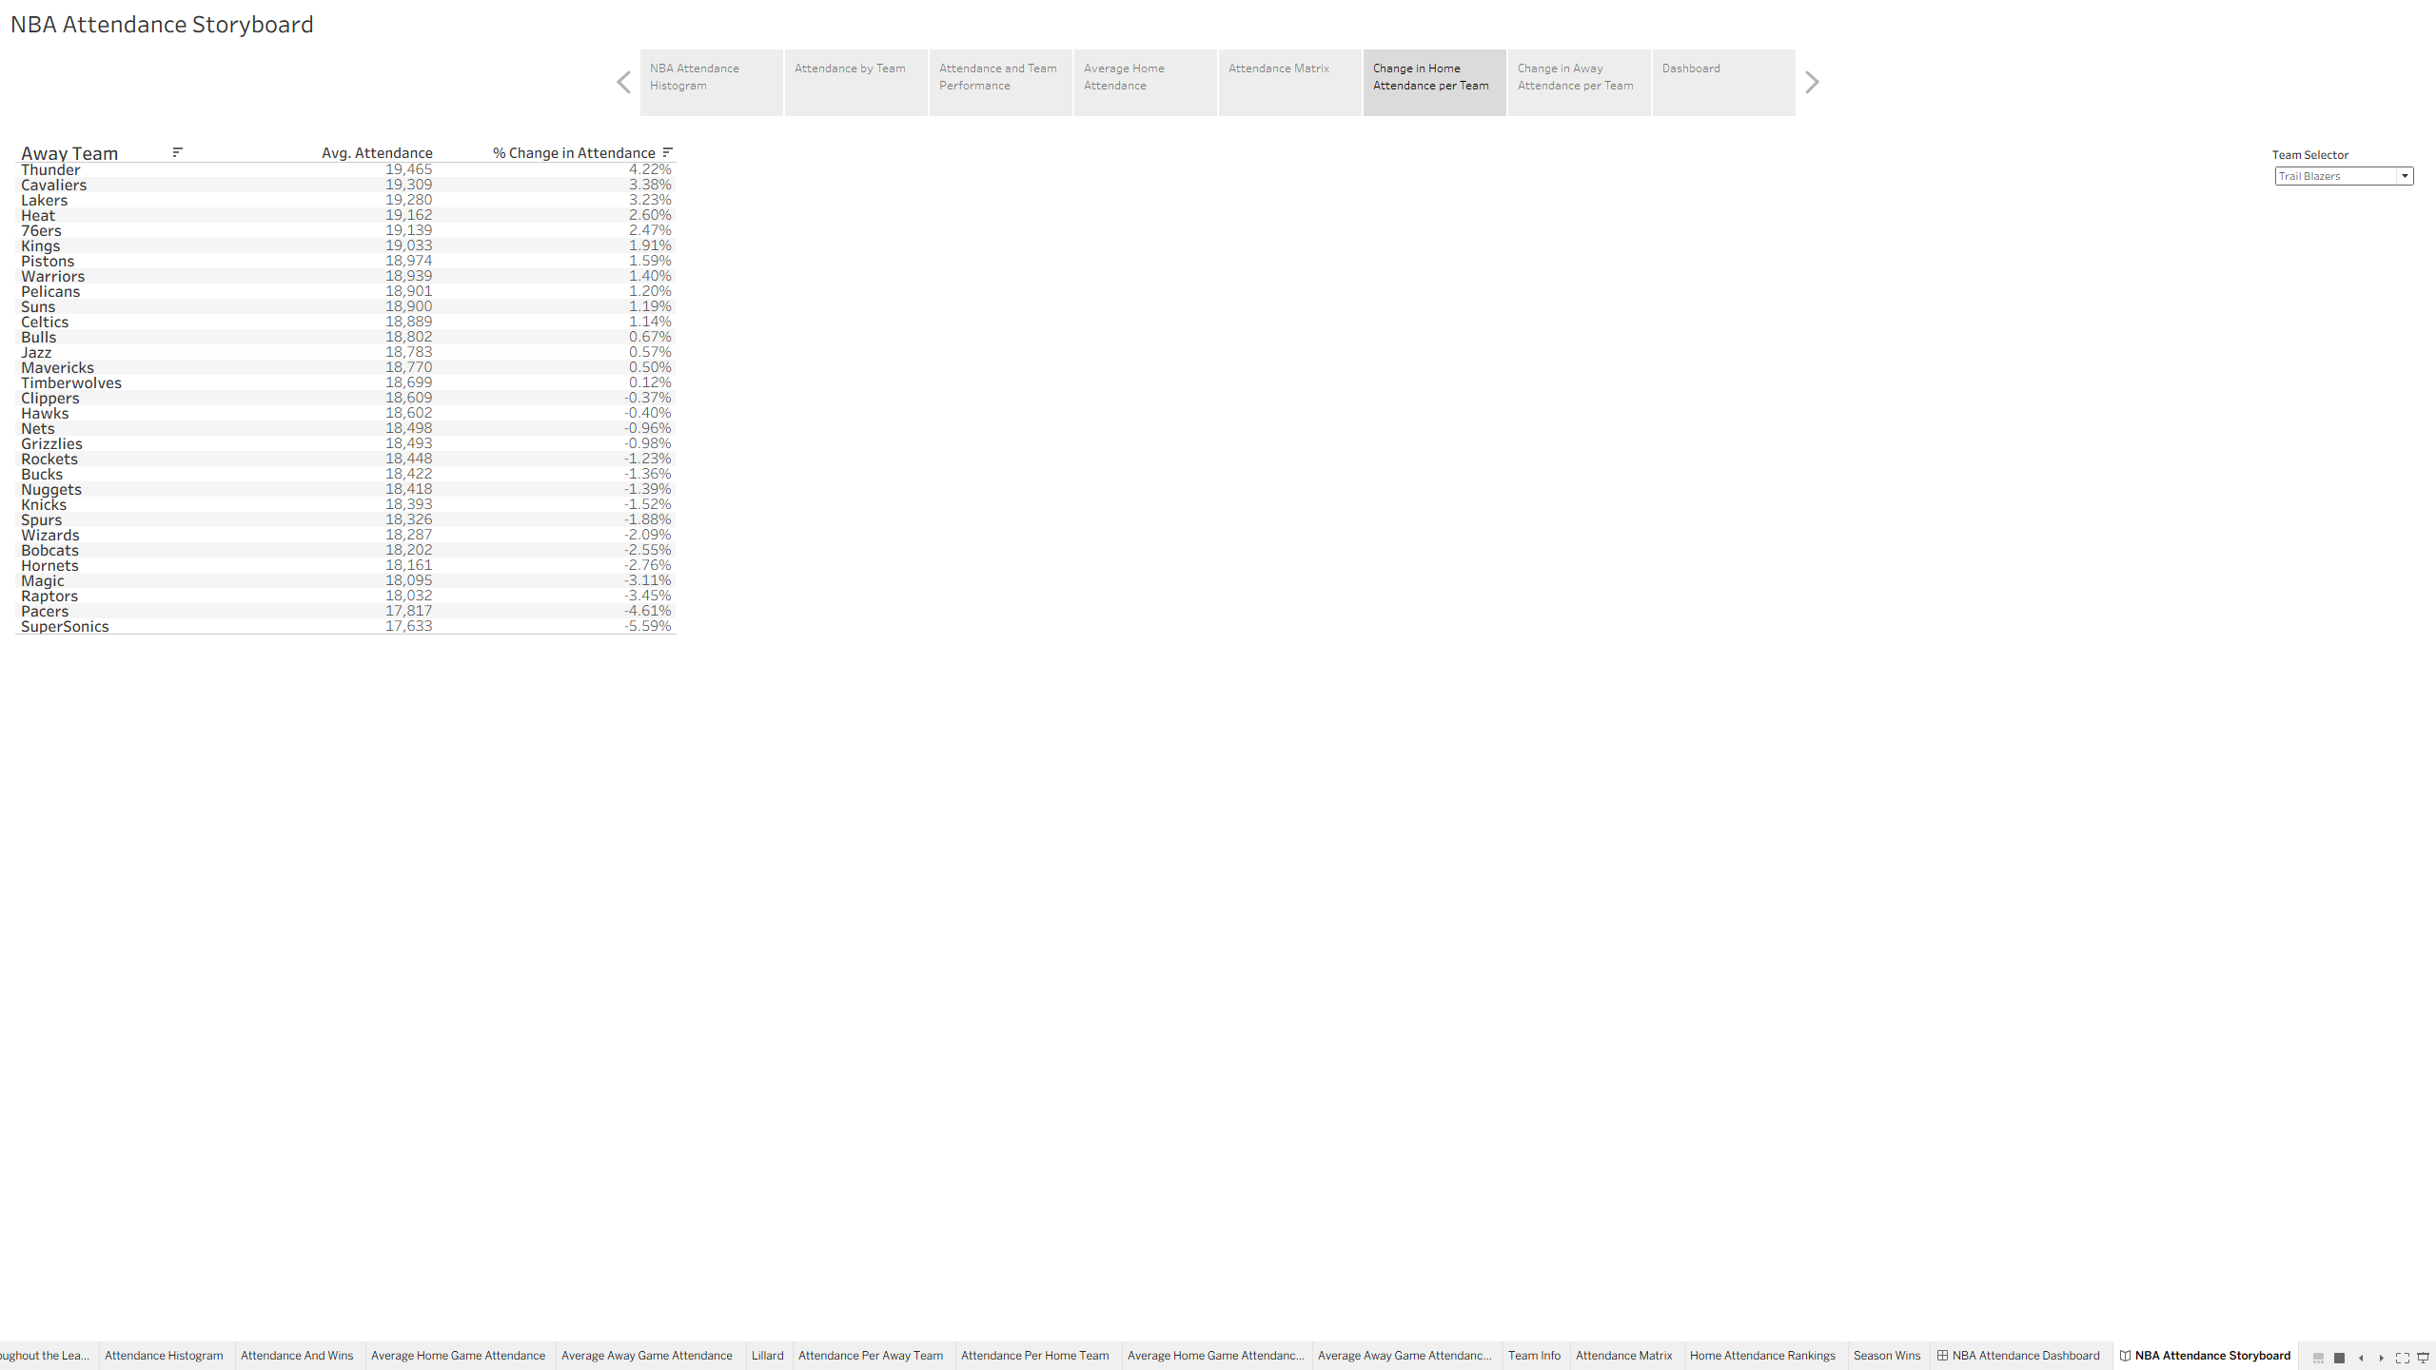
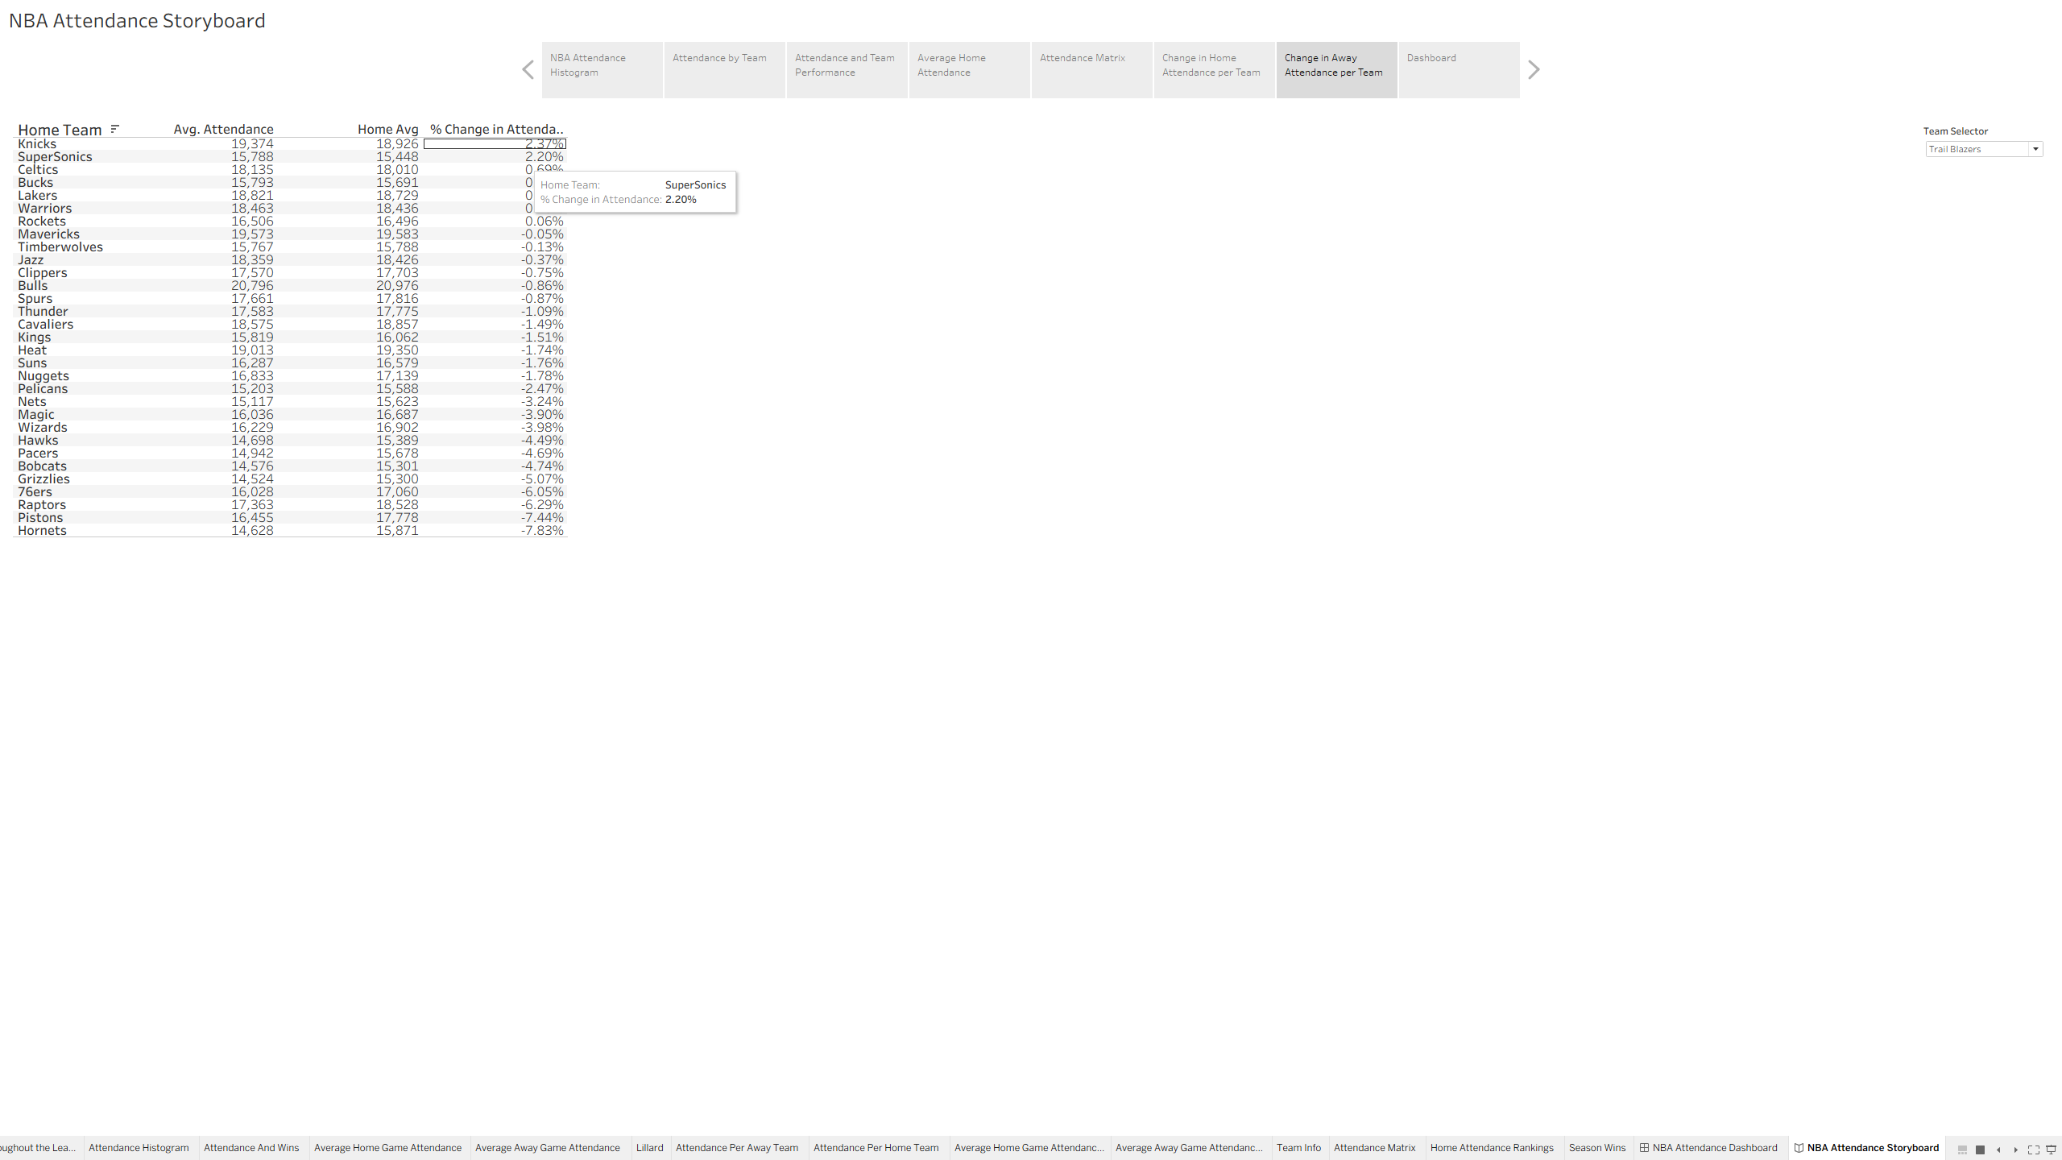
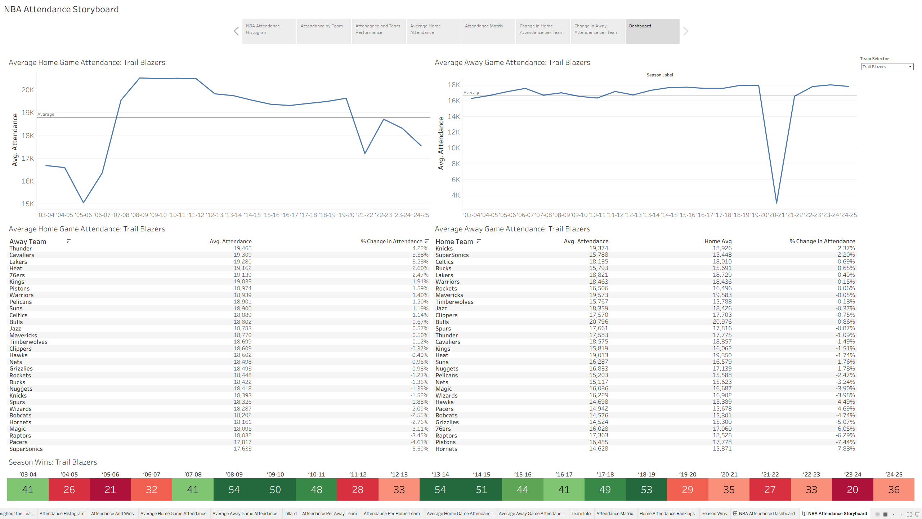
Intended Size for Dashboard and Storyboard:
