**Rule #1: Avoid “white” carbohydrates**

Avoid any carbohydrate that is — or can be — white. The following foods are thus prohibited, except for within 1.5 hours of finishing a resistance-training workout of at least 20 minutes in length: bread, rice, cereal, potatoes, pasta, and fried food with breading. If you avoid eating anything white, you’ll be safe.

**Rule #2: Eat the same few meals over and over again**

The most successful dieters, regardless of whether their goal is muscle gain or fat loss, eat the same few meals over and over again. Mix and match, constructing each meal with one from each of the three following groups:

**Proteins:**  
Egg whites with one whole egg for flavor  
Chicken breast or thigh  
Grass-fed organic beef  
Pork

**Legumes:**  
Lentils  
Black beans  
Pinto beans

**Vegetables:**  
Spinach  
Asparagus  
Peas  
Mixed vegetables

Eat as much as you like of the above food items. Just remember: keep it simple. Pick three or four meals and repeat them. Almost all restaurants can give you a salad or vegetables in place of french fries or potatoes. Surprisingly, I have found Mexican food, swapping out rice for vegetables, to be one of the cuisines most conducive to the “slow carb” diet.

10am – breakfast  
1pm – lunch  
5pm – smaller second lunch  
10pm – dinner

**Rule #3: Don’t drink calories**

Drink massive quantities of water and as much unsweetened iced tea, tea, diet sodas, coffee (without white cream), or other no-calorie/low-calorie beverages as you like. Do not drink milk, normal soft drinks, or fruit juice. I’m a wine fanatic and have at least one glass of wine each evening, which I believe actually aids sports recovery and fat-loss. Recent research into resveratrol supports this.

**Rule #4: Take one day off per week**

I recommend Saturdays as your “Dieters Gone Wild” day. I am allowed to eat whatever I want on Saturdays, and I go out of my way to eat ice cream, Snickers, Take 5, and all of my other vices in excess. I make myself a little sick and don’t want to look at any of it for the rest of the week. Paradoxically, dramatically spiking caloric intake in this way once per week increases fat loss by ensuring that your metabolic rate (thyroid function, etc.) doesn’t downregulate from extended caloric restriction. That’s right: eating pure crap can help you lose fat. Welcome to Utopia.

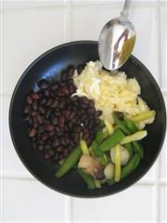Scrambled [Eggology pourable egg whites](http://www.eggology.com/) with one whole egg, black beans, and microwaved mixed vegetables  
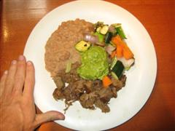Grass-fed organic beef, pinto beans, mixed vegetables, and extra guacamole (Mexican restaurant)  
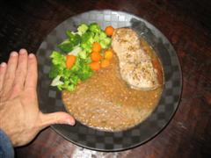Grass-fed organic beef (from Trader Joe’s), lentils, and mixed vegetables  
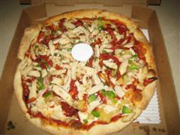Post-workout pizza with extra chicken, cilantro, pineapple, garlic, sundried tomotoes, bell peppers, and red onions