Jonah R. Smith

PSID: 1569818

04/23/2019

MECE 5397: Assignment 8AA

1. A hard drive has the following properties:

Rotational Speed = 10,000 rpm

Average Seek Time = 4ms

Average Sectors per Track = 800 = Sectors per Rotation

Bytes/Sector = 1024 = 1 KB

**Determine the total access time to read 32 KB of data from one surface of a hard drive:**

Time to Read = (Seek Time) + [Bytes]/[(Sectors per Rotation)*(Rotations per Second) * (Bytes/Sector)]

$$Time=4×{10}^{-3}s+\left[32 KB\right]/\left[\left(800 Sectors/Rotation\right)*\left(10,000/60 Rotations/s\right) *\left(1 KB/Sector\right) \right]$$

**Time = 4.24 ms**

**2. Compare 70% cache hit rate with 31% cache miss rate**

I’ll assume the same cache hit time and miss penalty used in the Memory Hierarchy lecture notes:

Cache hit time = 1 cycle

Miss Penalty = 100 cycle

Then the average access time can be found by: Cycles = Cache Hit Time + (Miss Chance) * Miss Penalty

70% Hit Rate: Cycles = Cache Hit Time + 0.3*Miss Penalty

31% Miss Rate: Cycles = Cache Hit Time + 0.31*Miss Penalty

This can give us the relationship of how much slower the 31% miss penalty is than the 70% hit rate:

(Cycles for 31% Miss Rate) - (Cycles for 70% Hit Rate) = 0.01*Miss Penalty

In our example, if the miss penalty is 100 cycles, that means we take 1 extra cycle for the 31% Miss Rate than if we had a 70% Hit Rate. Numerically, this would solve to:

70% Hit Rate: Takes 31 cycles

31% Miss Rate: Takes 32 cycles

That is, having a 70% hit rate vs. a 31% miss rate, using our assumed values for cache hi time and miss penalty, would have a 3.125% decrease in required cycles.

**3. Fortran programming language uses column major ordering to store arrays. If I have a large 2D array in Fortran with individual dimensions of array exceeding the cache memory size, what would be the cache miss rate when traversing along a column and when traversing along a row (assume single cache memory level)?**

Again, we’re assuming a 1 cycle hit rate and 100 cycle miss penalty.

Well idk, I’ll do this problem later, and hopefully not submit it with this text still in here.

**4. Optimize the following piece of code:**

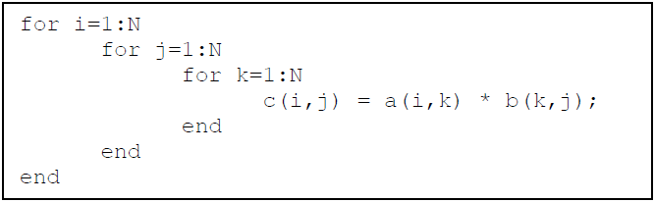

I shall assume that we are using MATLAB, since the indices start at 1 and not 0 for these arrays.

Notice that c(i,j) gets overwritten for every i,j by the value at k=N in the original code.

**Optimized Code:**

for j=1:N

for i=1:N

c(i,j) = a(i,N) * b(N,j);

end

end

**5. Copy over some mountain script, compile it, and show the output to prove that I did it.**

I downloaded Cygwin (since that’s how I emulate Linux at work) with packages for GCC and Git. Very easy installation and friendly interface for downloading packages, but there are a lot of packages so the students would have to know what they’re looking for before they start downloading stuff. I’ll get around to playing with Git at the command line level later; for now, I’m sticking with the app they’ve made. Below are the standard outputs of the mountain.exe file after being compiled and run.

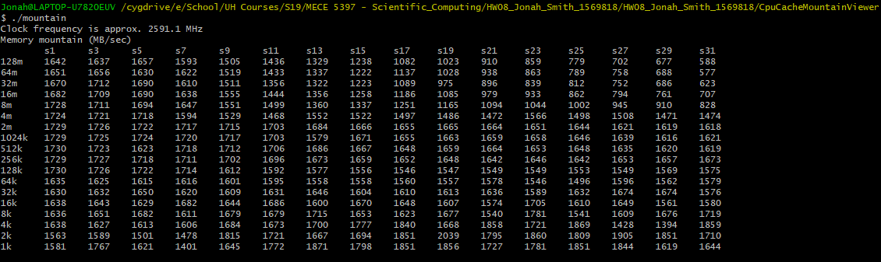

**6. Write you own matrix multiplication code and recreate the graph from the “Core i7 Matrix Multiply**

**Performance” slide.**