Using ADI, the max relative error for any given node between two timesteps was as small as 2.634e-16, with a mesh 64x64 nodes in size. The elapsed time in this figure is inaccurate due to the run being restarted using the save and load features of the script, with a real runtime closer to 3 hours.



This run used a value of DTIMEI = 1e-4, which was much smaller than the script needed in an attempt to reach true convergence to steady state (which is likely impossible even after an infinite amount of time simply due to floating point errors at this level of precision).

Another run using DTIMEI = 5e-3 (while still using a 64x64 mesh) shows that a relative error about 5x larger can be converged to in only 45 seconds instead of 3 hours. From here forward.

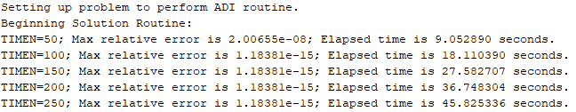

After reaching this conclusion, I wanted to see what the effects of using a very large timestep would be. By setting DTIMEI = 50, the following results were received.

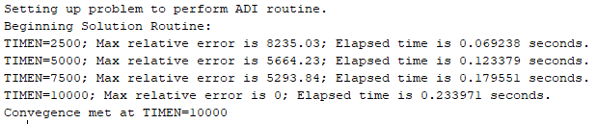

However, this was just a false positive. The array for u was completely filled with NaN’s, except at the Dirichlet boundary conditions. This confirmed that having too large of a timestep would result in unbounded behavior. Additional testing showed that even using DTIMEI = 0.1 would result in this same behavior in which NaN’s would be produced, but using a value of DTIMEI = 0.01 worked using the 64x64 sized grid.

