Dependency

Data Preprocessing

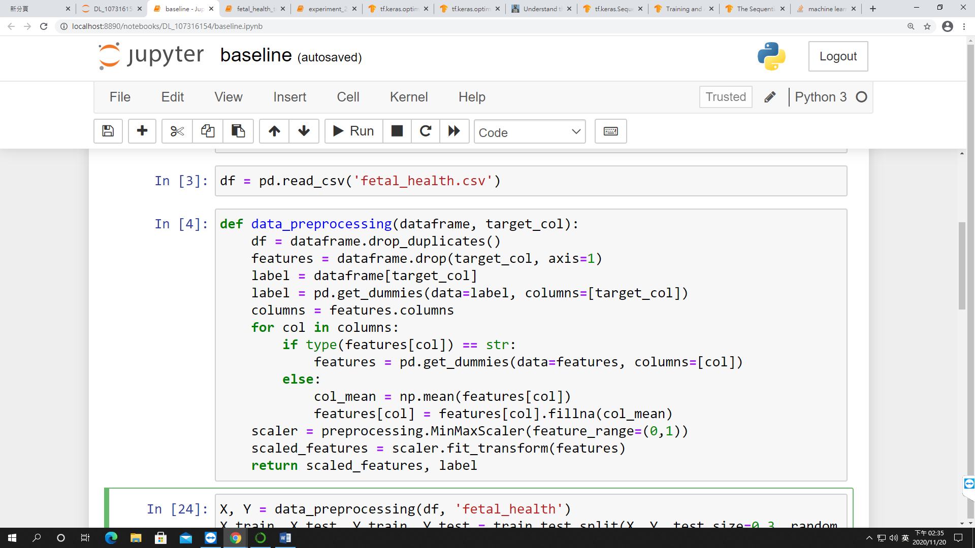

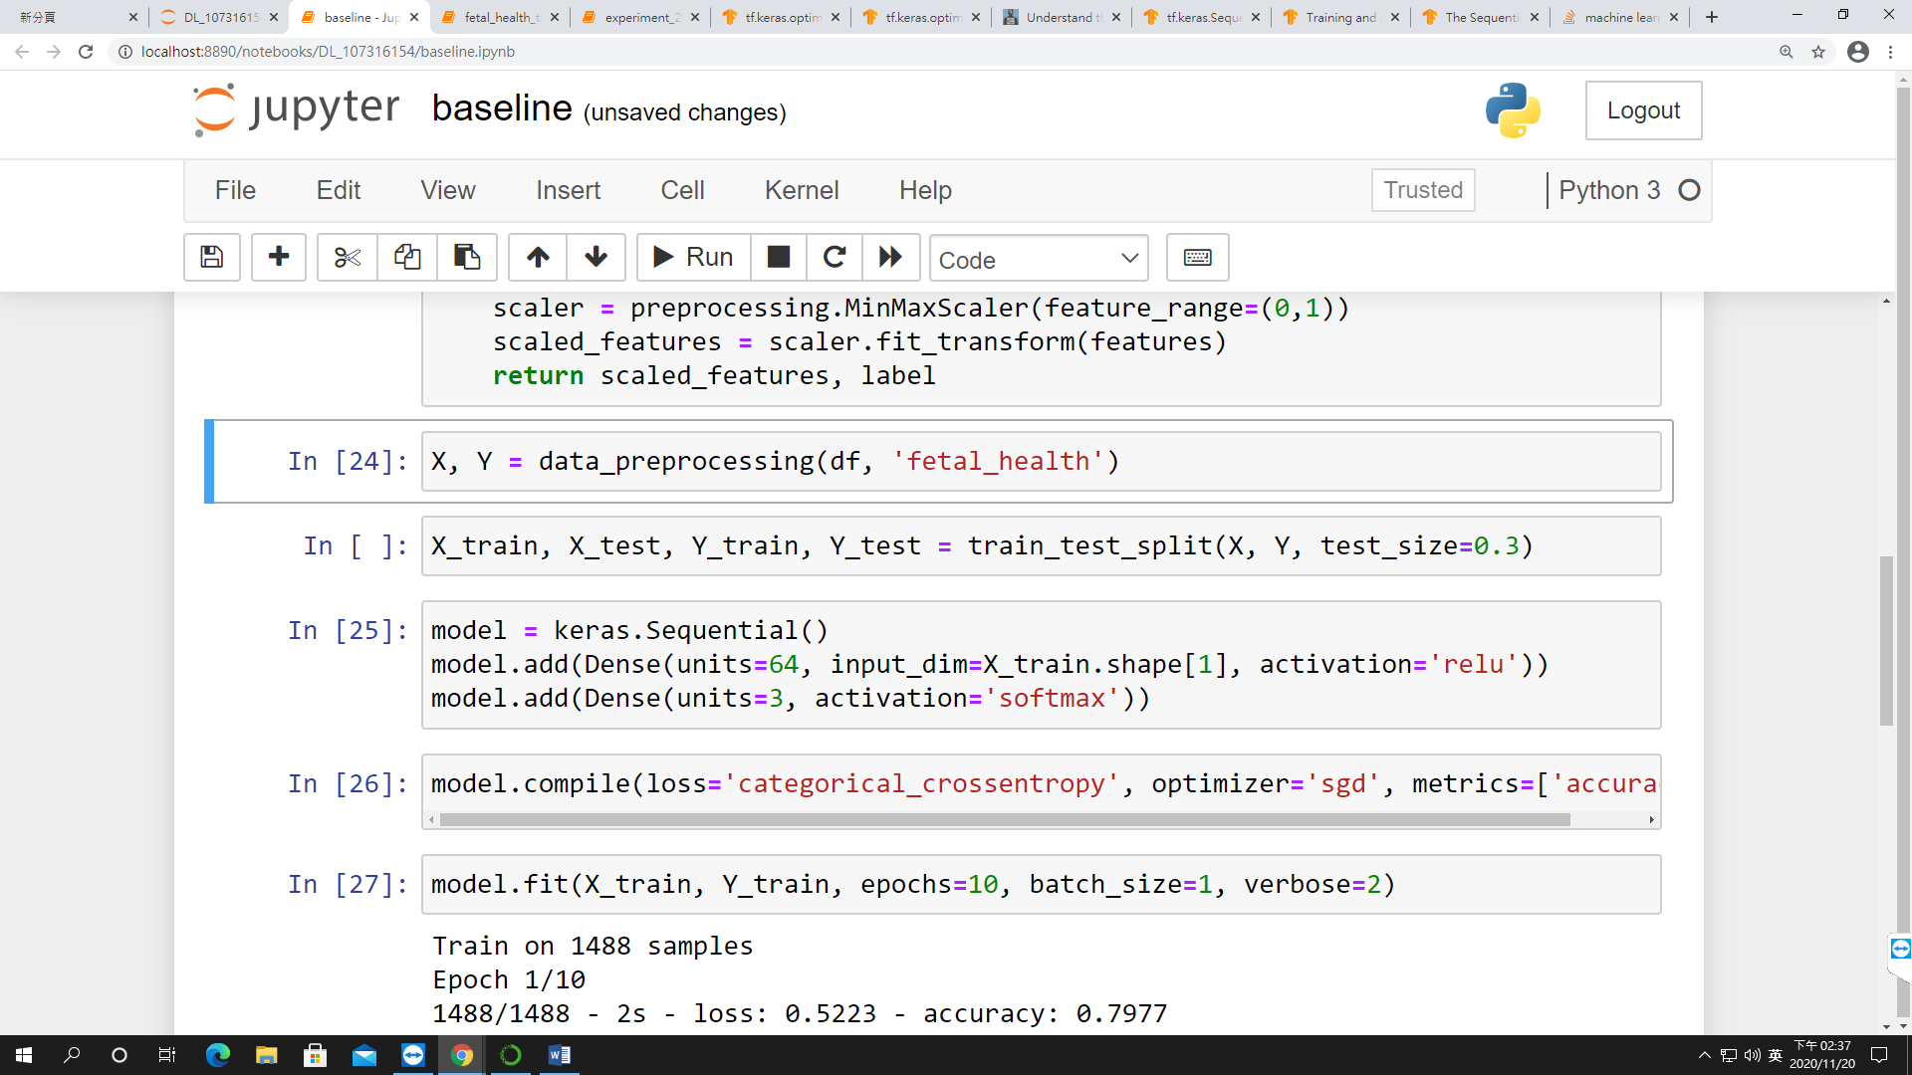

Baseline

Model Design

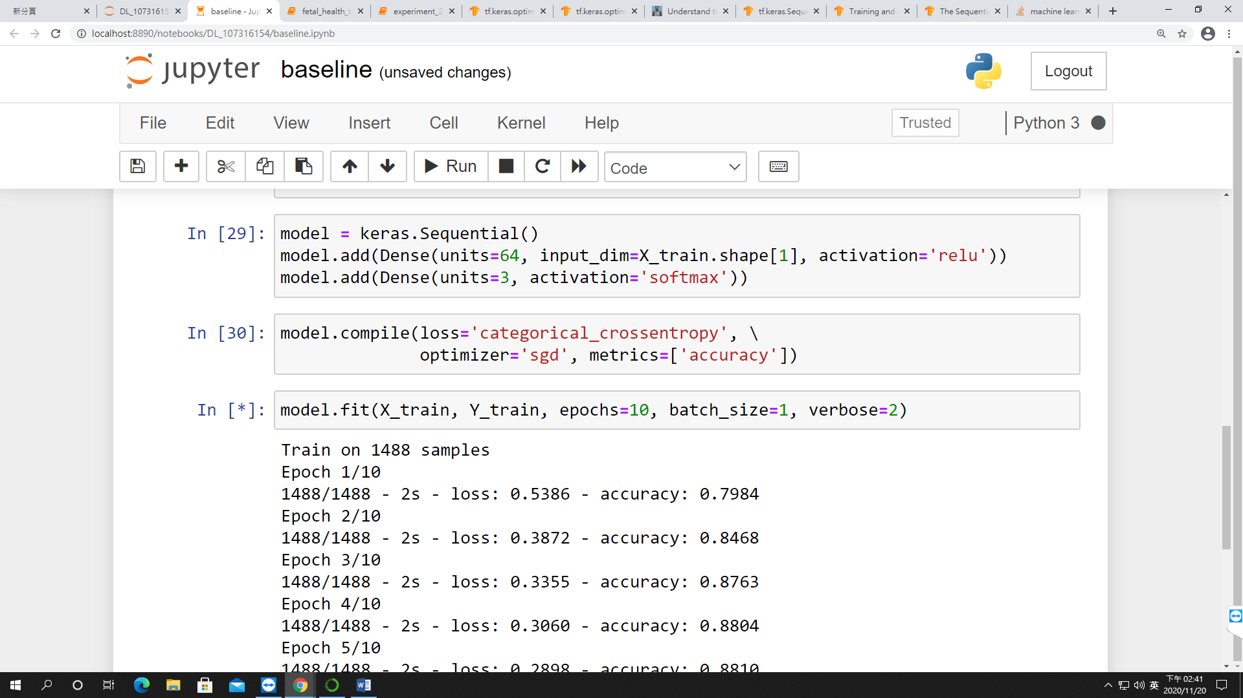

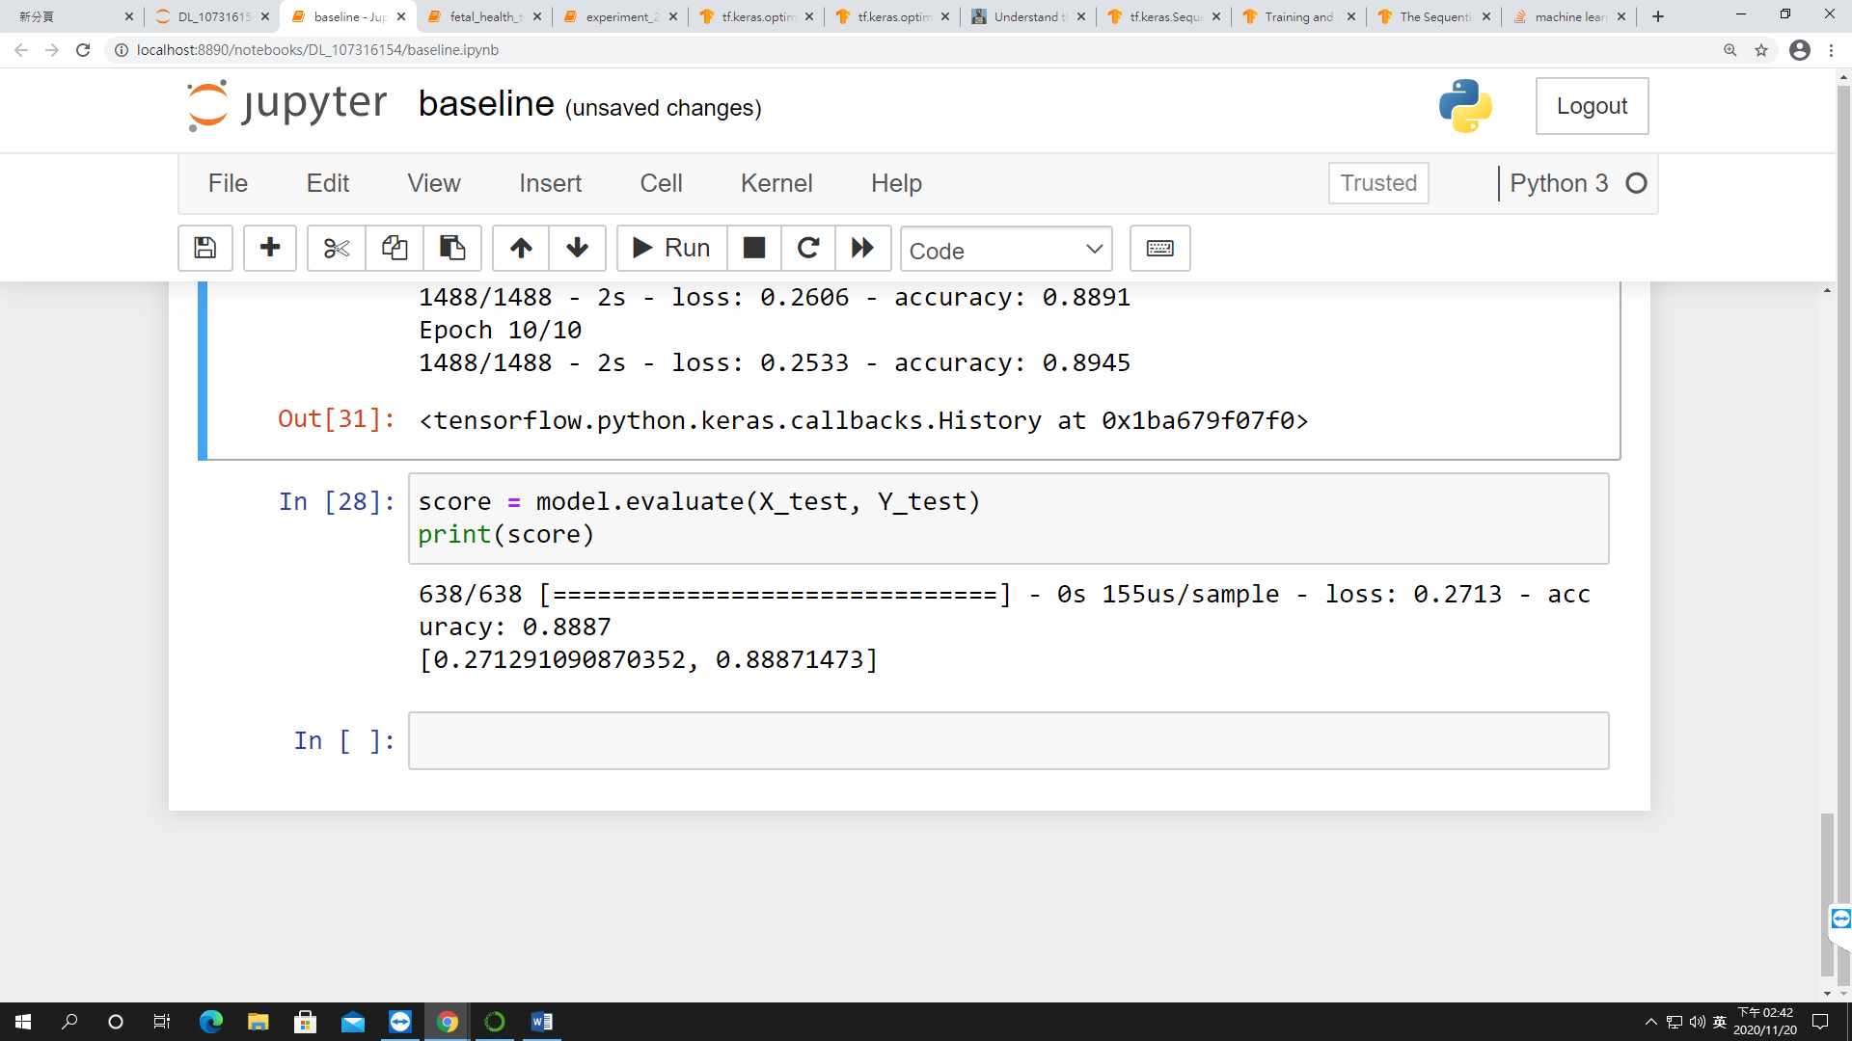

|  |
| --- |
| tf.keras.layers.Dense( units, activation=None, use_bias=True, kernel_initializer='glorot_uniform', bias_initializer='zeros', kernel_regularizer=None, bias_regularizer=None, activity_regularizer=None, kernel_constraint=None, bias_constraint=None, **kwargs) |

Optimization Vs Overfitting

Optimization

1. Number of layer
   1. Bring up the number will cause overfitting
2. Number of hidden units in each layer
3. Percentage of Dropout
4. Choice of Weight Initializer
5. Choice of Loss Function
6. Choice of Optimizer
7. Choice of Activation Function
   1. With Vs Without Back propagation
      1. With backpropagation: Sigmoid, Tanh
      2. Without backpropagation: Linear, ReLu (Rectified Linear Unit)

Consideration : power efficiency

Regularization

1. Choice of regularizer

Reference

Activation Function: <https://missinglink.ai/guides/neural-network-concepts/7-types-neural-network-activation-functions-right/>

Activation Function: <https://wandb.ai/shweta/Activation%20Functions/reports/A-Comparative-Study-of-Activation-Functions--VmlldzoxMDQwOTQ>

Terminate early

Overfitting