
Jonah Lewis NEA
Race-car game
Jonah LEWIS
NEA

Table of Contents
Introduction: 4
Initial Goal: 4
Analysis of the market: 4
End user: 5
Options when creating our product: 6
Analysis of top car design on the market: 6
Analysis of a top gameplay design on the market: 7
Choosing a model 7
Analysis of top virtual game on the market 8
Choosing a model 8
Interview snippets, Q and A: 9
Snippets 9
Summary 12
Midpoint: Hardware and Software review: 13
Avoiding physical components: 13
Advantages: 13
Disadvantages: 14
Resolve: 14
Refining our product: 15
Gameplay: 15
Introduction 15
Base game: 15
RAM system: 15
Builds: 16
Summary 17
Technicalities: 18
Choosing a network architecture: 18
Client-server network (first image): 18
Advantages: 19
Disadvantages: 19
Peer-to-peer (second image): 19
Advantages: 19
Disadvantages: 19
Resolve 19
Deciding which libraries to use: 20
GUI libraries: 20
Tkinter 20
Guizero 20
Resolve: 21
P2P libraries 21
Threading: 21
Time: 22
Socket: 22
Final measurable objectives: 23
2.3.4 The System shutdown hack stops the opponent from being able to input hacks and boosts but also stops their car from moving. It can be negated by the firewall which makes it important to bait opponents into using firewall before they can stop it. 24
2.3.5 The hyperthreading hack is powerful late-game after many have been used (since they can be used exponentially) but the set up costs lots of RAM so leaves the user vulnerable, hence it is a risky but rewarding play. 24
2.3.6 The spike deployment hack is less powerful than the system shutdown since doesn’t stop the car or opponent’s inputs, it only cuts their speed. Still very useful in long term if combined with the hyperthreading strategy to massively reduce opponent’s spee. 24
2.3.7 The builds will elevate the possibilities the game can 24
Design: 25
Detailed class diagram: 25
Significance: 25
Implementation: 28
Main complexity - synchronization of client-peer game instances through the use of Socket: 28
Network basic processes: 28
Main area of complexity - Utilizing the P2PNode instances to maintain synchronization between both the Game_Manager instances: 30
Keeping the players updated too through the combined use of threading and GUI functions: 34
precise complex code examples – Threading: 36
start_timer() 36
Recharge_ram() 37
precise complex code – advanced OOP 39
Polymorphism in Boosts_Hacks class 39
Evaluation: 39
Evaluation by objective: 39

Introduction:

Initial Goal:
The goal of my project is to have two players competing in a racing game where they use a GUI within python to control cars who travel in a circuit. By the end of this analysis, I will define and scope every different variant this project could take and evaluate which aspects will help me make the most successful product. This way I can confidently build the best game of the theme.

Analysis of the market:

Social and entertainment robotics industry has grown by a tremendous amount during the last decade. Entertainment robots are the second biggest sector of the robotics market, worth 3.1 billion USD in 2023 and calculated to rise exponentially over the coming years to 2030. This leaves great opportunity for a unique entertainment robot game to take a big share of this market.
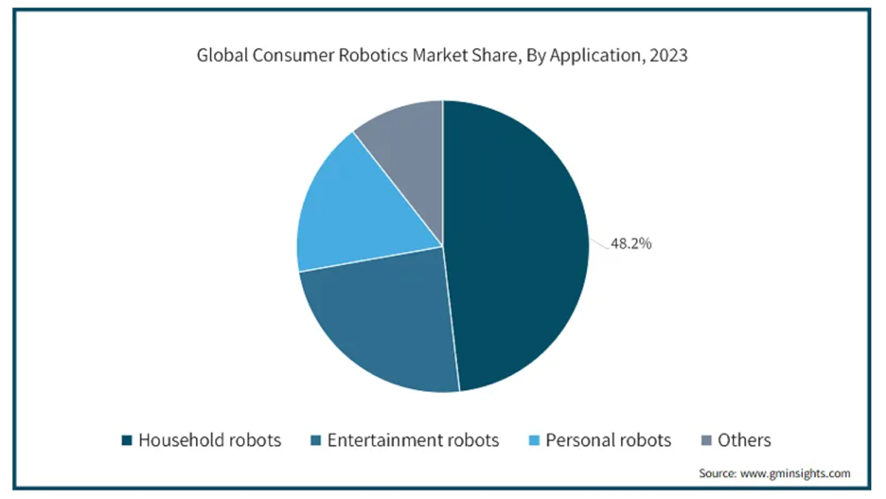
However, as we enter a competitive market, already containing suppliers with loyal customers, we need to have a unique selling point in our robot game. We can find this by looking at other top entertainment robotics firms’ models.
Sources:
Post covid robotics market analysis:
https://www.gminsights.com/industry-analysis/consumer-robotics-market#:~:text=Consumer%20Robotics%20Market%20size%20was,beyond%20traditional%20forms%20of%20leisure.
Post covid racing car market analysis: https://www.globenewswire.com/news-release/2022/03/29/2411810/0/en/Remote-Control-Toy-Car-Market-Research-Report-by-Age-Group-by-Type-by-Region-Global-Forecast-to-2027-Cumulative-Impact-of-COVID-19.html.

End user:
The end user would be the main consumers of entertainment robots who are looking for something more unique in a robot than the standard models on the market.
we can see from this market research report from 2022 that the primary consumer of remote-control racing cars are children aged 5-10. Although this is a good demographic to aim to please, it is a very crowded market and I believe it would be a good idea to aim a new model towards teens aged 13-17. This market is less crowded, and it makes it easier to add more unique features for our car as they would be better received by an older audience while also giving us a way to differentiate from other brands.
To appreciate the functionality of the robot, the consumers would mostly be STEM student subjects who can understand how to use them to their full ability, as consumer reports also indicate this trend in consumers. However, retaining its ease of use would be essential so that all people can use it to a high extent.
One drawback is that teens have a lesser spending power than little children who receive gifts from their parents, therefore, we would need to keep the selling price to a minimum by keeping costs to a minimum.

Options when creating our product:

Analysis of top car design on the market:
We will be analysing the top design on the market based on our end-user to get an idea of what consumers like about the model and why it is so frequently bought and what features support it.
According to the guides and data below, the top selling RC car model for ages 13-17 is the Thraxxus Rustler 4x4 VXL:
This car is better than all the others on the market for our target market because it combines a powerful engine with a sleek looking chassis. It has industry level components like the 70mph engine while also being creative in its design
Summary: Approximately £750 at RRP, has a Velineon 3500 brushless motor, capable of achieving speeds up to 70 mph with the appropriate battery and gear setup​, is a 1/10 scale model of a full-sized car.
This car is clearly for older people like the age demographic of 13-17 because of its larger size and very powerful engine which is currently top of the range making this a very high quality product
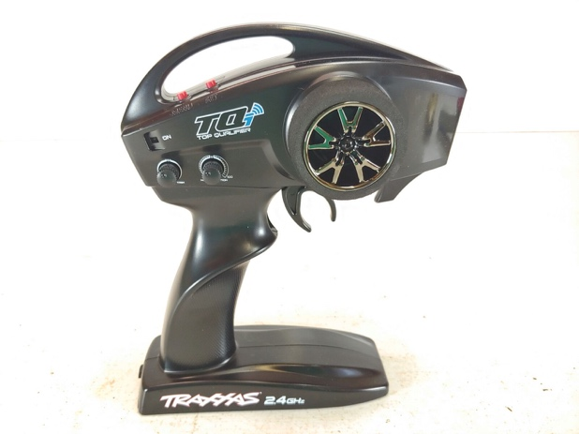


Sources:
https://www.rcgeeks.co.uk
https://futurism.com/best-remote-control-cars

Analysis of a top gameplay design on the market:

Choosing a model
A top gameplay design for remote control cars is widely recognized as being Scalextric. Having 67 years in business to perfect a single game, they are the best case to research to find the perfect balance of complexity and simplicity since their long exposure to the market would give them the best idea of what their consumers would want.
Scalextric has a main rival, Carrera. Scalextric is a better example to look at because they offer full usability in one kit, whereas Carrera usually need multiple kits to create a full course, this is something I won’t be doing as I want the game to be fully operational from purchase.
Additionally, Carrera doesn’t reflect our pricing system well, with one full circuit kit costing an average of £278, which is well above what our target market would be willing to pay. Scalextric offer sets as cheap as £90 which is much closer to our goal of being affordable for children aged 13-17.
Scalextric has multiple slot cars on a track which are controlled individually by players who race to get to the final lap first. What makes Scalextric unique is the ability to lose control and flip over if the player puts too much pressure on the accelerator around corners.
I will be taking one of their top selling models to present to our interviewee to find out what they like about the gameplay and what could be improved for their liking, I will take these ideas on board while making my final goal,

Source: https://www.which.co.uk/news/article/scalextric-vs-carrera-vs-anki-overdrive-7-crucial-things-to-know-before-you-buy-aGeDv1b1IQZM
Scalextric gameplay sample: https://youtu.be/n3LZbI4rGEU?si=tX5JszuzI9xBV9ip

Analysis of top virtual game on the market
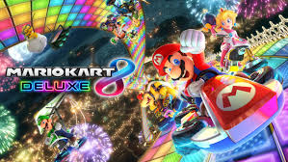
An alternative route we could take would be to make the game completely virtual. This would mean only retailing the game to the customer. The game would have to contain a way to race the cars virtually. This would probably mean adding a track with cars onto the same tab as the GUI we would make for them to control it.

Choosing a model

There are a few popular games like this, including “Mario kart 8 Deluxe” and “Forza Horizon 4”. Both these games are very different in how they play. Mario kart traditionally focuses more on using mystery boxes that you can pick up to give yourself abilities like slowing other players or making yourself faster. Whereas Forza focuses more on pure racing and technical skill. Since this will play like a more replayable, arcade style game, I think that Mario kart will be a better choice to investigate. Mario kart is also more popular with our age demographic to play with friends, whereas Forza is more popular as an online multiplayer game. This is more like our game which is to be played with friends locally.
Players each select their carts’ speed stats through customization options then proceed to a race where they use basic controls (only 7 possible inputs during the race) to finish first in the race by directing their car. They can pick up various items which can give them a tactical advantage against other players by either slowing them down of speeding yourself up. They even have defense measures as abilities which can counter others or lessen their effects. I will be including some questions regarding game mechanics like this in our interview so I can get a better idea of what aspects of Mario Kart make it enjoyable to our demographic. Equally it is a good way to see which mechanics of the game they dislike and I will avoid implementing.
After perusing the internet, I have found a demo video which summarizes the mechanics of Mario Kart 8 deluxe which I will show to our interviewee to give them a rough idea on what the game is about before I ask them for their opinions about it.
https://youtu.be/tKlRN2YpxRE?si=AZk4b2MoQMxDPr78

Interview snippets, Q and A:
Snippets:
Asking a STEM subject student what kind of racing game they would find enjoyable, who also meets the aforementioned requirements (such as being aged 13-17 and having the expected income of their age), they have been chosen at random and will give us a more specific angle to take when approaching the gameplay: the ideas I have gathered from their answers I write after each statement in pink.

What do you like about controlling robots in games in general? Why do you enjoy this?
“I like having the ability to control lots of different parts of the gameplay through my robot, this way I feel like I have more control over the outcome of the game, and I feel more rewarded for using skill and strategy since I can apply it more. However, I can find it boring when the technical skill of controlling the robot is the main focus of the game since this is quite overused”
I have inferred from this that they want to be able to have lots of different mechanics to help them win the game but also don’t like it when the main way to win is by controlling your robot through skill instead of strategy.
Do you feel like controlling a remote-control car is challenging? If so, what aspects are challenging to you?
“Controlling a racing car is generally challenging to get started with since they are all so different from each other. I have controlled racing cars in the past in video games and real-life numerous times and the skill is very appliable to different virtual games but it feels like all real life control systems are different and take time to learn.
They prefer to control cars virtually because it is more applicable to other similar games so all players would be able to meet the skill cap easier than with a control system in real life.
Would you be willing to play a traditional racing game consistently over a long period of time?
“Like I mentioned, I have already played car games a fair amount throughout my childhood so it honestly wouldn’t seem like such an interesting concept that I could play it for a long period of time.”
This backs up that they are bored with normal racing games and wouldn’t want to buy one at all
As a player, what do you like about the racing car below? What parts of the car do you like the design of?
https://www.youtube.com/watch?v=Nh0g43qPjnM

“I like the design on the body on the car, it isn’t too childish while also still looking flashy. The size and shape of the tires is good and makes it look very durable and offroad. The control system also looks easy to use and pretty self-explanatory, this makes it easier to play the game because you wouldn’t have to be looking down the whole time.”
They like the ideas of it having high specs and a durable looking chassis, they also want to control its complicated features with an easy-to-use control system so that they can focus on playing the game rather than controlling it
Below is a popular remote control car racing game. What do you like about the gameplay? Which features make you want to play?
https://youtu.be/n3LZbI4rGEU?si=tX5JszuzI9xBV9ip
“I like how players can overtake and cut across each other in the lanes, this is quite unique and makes the racing more aggressive overall. I also like how players can get punished for speeding by being thrown off the track too. This feature makes the game more complex; I like when features like this mix up gameplay because they raise the skill cap of the game. It’s also good that lots of people can play at the same time so that family and friends can join in.”
They basically just want some unique gameplay features that they haven’t seen before in a racing game so that its not repetitive.
As a player, what aspects do you dislike about game? How would you fix it?
“While the overtaking feature is a smart get-around, I feel that the game is still heavily skill based, in other words, it would take lots of time to get to a technical level where I could start thinking about which strategies to implement. I prefer it when I can apply my strategies from early on in otherwise I would probably get bored.
They still want the game to be more strategy based since they would want to be able to apply their transferable game sense without any technical limitations.
Would you play the game again? Does it give you enough versatility to keep playing many times?
“I would play a few times to explore the different strategies but then would most likely get bored since there is really only one way to win the game.”
They play the games to find unique ways of winning, this is the part they enjoy the most, having the chance to reward their creativity
If you answered no, what would you add to make it more replayable?
“I would add another way to win, I can’t really imagine how but maybe a way to damage other cars to make them lose or slow them”
They like the idea of more ways to win the race than just by being the best at racing

Have you ever played a remote-control car game where the cars can also use combat to win?
“No, I haven’t before in real life, only in video games but they were all very fun.”
Below is a short demo video for a popular video game where the cars do actually use combat to win, after watching the video can you give us an insight as to which parts you like from it? https://youtu.be/tKlRN2YpxRE?si=AZk4b2MoQMxDPr78
“I do often play Mario Kart with my friends because it’s really replayable. You get so many customization options with your car’s stats when you build them and additionally there’s so many different routes you can take when racing each other, like using the abilities to play aggressively or defensively.”
They like how the game is very versatile. They like the different strategic routes they can implement and the mystery box system gives them the options to.
Which parts of the game do you think could be improved for your liking?
One thing I do notice with Mario Kart is that the game is very skill based. I like to use different strategies for variation in my games but even if I think really hard and use a strong plan I still will lose most of the time because my friends go in without a strategy but are just better at the racing element because they have played the game for longer than me. I would prefer it if the game rewarded new players more by removing this element.
They would prefer the game if it was a pure strategy game and removed the technical skill component of the game for it to be more appealing to new players.
Do you prefer playing Mario Kart 8 Deluxe or Scalextric with your friends?
“Generally I prefer playing Mario Kart because it is easier to get a handle on than Scalextric since there’s no control system to have to learn and I also don’t need to set it up or store the physical set. I also like that Mario Kart has the option to play remotely if you want to, it just feels more versatile in gameplay and also accessability.
How much would you be willing to pay for a high-end, unique, racing car game featuring 2 cars? Give a bracket e.g. £60-£80.
“With all the features I would want, I would probably pay around £20-£40 for a unique, top end, racing game.”

Summary:
From the interview with our student, we can see that they would want a car with lots of features such as a good sleek, painted design, working bumper lights and offroad tyres. However they equally value an easy-to-use control system which they rarely fine in physical games. They said that they prefer playing Mario Kart (a virtual car racing game) than Scalextric (a physical car racing game) They feel like Mario kart offers more possibilities in gameplay and has a lower entry level than physical racing games. They like this because they want the opportunity to use strategies over technical skill. They said that they get bored of traditional racing games because they are repetitive, and they said that they enjoyed playing racing-fighting games on computers because they can offer more diverse gameplay. They also wouldn’t pay over £40 for a game, physical or virtual.

Midpoint: Hardware and Software review:

Avoiding physical components:

Advantages:
Inevitably, making a physical racing game would need a more complex control system. This is because the physical components would need more technical accuracy from the player to understand the responsiveness of the system and how the cars feel in handling. Our interviewee said that they dislike this element of the game where the players need a skill to control the cars which takes away from the strategy side. A way to avoid this is by removing the complexity by using virtual cars. This way it would be easier to abstract the precision in controlling a car. This way it would also be easier to control the skill level all the way throughout the project since as a developer I would have more control over a virtual car than a real one.
When making this racing game for 13–17-year-olds, I realized that the most important part of the project is to teach the audience good values and to help them understand how to respect each other and the planet. The best way to do this is to not set any negative examples.
All computing devices eventually create e-waste, electrical components which are difficult to recycle because they contain many different materials which each need different recycling treatments. E-waste is growing rapidly with the more cheap technology we create in the world, in 2020, only 17.4% of global e-waste was correctly recycled, the rest is in landfills and polluting our oceans.
It doesn’t seem ethical to contribute to this major problem by mass manufacturing more hardware in our cars so I have made the decision to make the cars race virtually instead of in real life, this way, we have zero carbon emissions and can rest easy knowing that we aren’t setting any bad examples for the youths.
Finally, on a business side, our interviewee said that they would pay a maximum of £40 for a racing game either physical or virtual. This game would include two racing cars and the software to control them with. After more perusing of the internet, I found the cheapest components that I could use to satisfy their requests and the total came to £148.80, not including the instruments needed to build them. This comes down to a cost of £74.40 per car. This is well over the full cost of the game if we charge £40, let alone the markup we would need to actually made a profit. Unless we reduce our costs by 500% this is not feasible. However, a game which is completely virtual would cost nothing, giving a mark-up percentage of infinity. This point isn’t as much of a factor as the other points in this decision-making process but is still worthy of note.

Disadvantages:
One problem that arises from this is how our interviewee said that they would get bored of playing a ‘traditional racing game’ and that it “wouldn’t seem like such an interesting concept that (they) could play it for a long period of time”. This is why they would prefer a physical racing game, since it is more unique. However, our strategy-combat style racing game still puts a spin on the whole concept, and our interviewee even said that they played similar games and “they were all very fun.” In other words, our game is becoming so unique already with its base system of stack-based action chains that it doesn’t even need to be physical for people to enjoy it, additionally, they may be even more attracted to it because of how it has zero harm to the environment, a concept which is already budding among older children.

Resolve:
This decision is also better because it makes the game even easier to set up and control. Before, the game required the player to set up the robot, calibrate laps and link its on-board system to the computer whereas now none of that is required. The game will be fully playable from the moment the players run their computers. Additionally, it makes more sense to have the view of the race within the same area of vision as the GUI rather than having to alternate between watching the race to avoid crashing and keep an eye on the stack bar.
Additionally, this would remove a huge cost from the game (sourcing the parts for and making the cars). This means that we could sell the game for less money to consumers which would easier fit the demographic’s spending power.
In summary, the game should be much more successful with a virtual car race for the sake of the environment and ease-of-use setting up the race and playing in it. All of this will make the game more appealing to the target demographic.

Refining our product:

Gameplay:

Introduction
Following the interview, I have scoped the final concept for the project. I have taken multiple parts from their reviewing of the games and general preferences which they have voiced. I believe I have designed an easy-to-control, strategy-based racing game which has a versatile and rewarding gameplay system.

Base game:
The game features two players controlling their cars’ actions on a virtual track. The player who’s car first reaches the finish line will win the race. This sounds quite generic but what makes this game unique is that the cars will navigate the track automatically. This removes the technical skill level required to play the game so that players can have an equal race where the strategy they implement is the only part which can control the output of the race. This was inspired by our interviewee describing how they don’t like losing in Mario Kart to other players simply because they’ve played the game longer than them.
At this point you may be wondering: if the cars are being controlled automatically then what can the players do to help win the race? This brings us onto the next feature of the game…

RAM system:
What makes this project more unique than other racing games is the “RAM” system. The RAM system allows players to use virtual currency (RAM) to either upload boosts to their own car or upload “hacks” the other player’s car. RAM will accumulate over time; levels indicated by the GUI. RAM can be used to activate different types of boosts or hacks, the cost being proportional to how severely it affects the gameplay, e.g. a hack to temporarily lower the opponent’s car speed might only cost 2 RAM while the cost of a hack which makes their car temporarily stop moving completely would cost 5 RAM instead.
Hacks and boosts can be activated at any point during the race via the on-screen GUIs each player has respective access to.
When a hack is activated through the GUI, the hack’s cost will be deducted from the RAM pool and the computer will communicate to the selected opponent’s computer via a network causing a warning to display on the victim’s screen, giving them a timer of how long they have to respond to the hack before it activates. They have a few second of input time before the hack executes, in this time, players can respond with other hacks and boosts to form a stack. After 5 seconds with no input from either players, the hack stack gets resolved from the top down. During this resolving period, players cannot activate any more hacks or boosts.
Hacks and boosts aim to increase the skill cap of the game and add replayability to the races by allowing players to test out different strategies and tactics against their opponents.
Players are required to use hacks and boosts to outsmart their opponent and implement strategies to get to the finish-line first.

Builds:
Another implementation in the game will be the ‘builds’ system. Before the race is instantized, players can choose between a few different ‘builds’. A build will give the player specific buffs during the race and can be combined with specific strategies to make powerful and diverse games. A build essentially acts like a game-long boost. This was inspired by the interviewee’s fascination with the customization system in Mario Kart, where players can choose different stats to be most prominent when building a car. This system adds replayability to the game and raises the amount of strategies that can be implemented and can provide coverage for them.
Below is a process diagram which represents a whole cycle of the game’s instantiation.
Both players choose builds
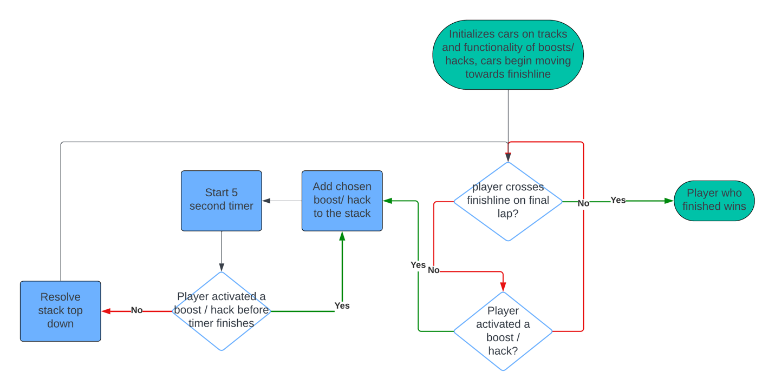
This diagram represents that the players need to use hacks / boosts while the cars are going around the track in order to meet the finish line first to win the game. They can respond to each other’s activations to match or even counter their opponent’s decisions through an intuitive portfolio of 8 hacks and boosts, they list as followed:

Name | Hack or boost | RAM upload cost | Description | Intended Purpose
Total ram pool | -- | -- | Max 12, recovers at a rate of 0.25 RAM per second | --
Nitro | boost | 3 | Gives a +50% increase in movement speed to targeted car. | Speed up to close range with opponent or distance from opponents
Spike deployment | boost | 2 | Reduces opponent’s movement speed by 20% | Counter to nitro and may be used to bait out a firewall
SYSTEM SHUTDOWN | Hack | 10 | Targeted car becomes unresponsive for a long time | Punishment for ever dropping below 5 available RAM. Countered by firewall.
Firewall | Boost | 5 | Makes the user immune to all hacks and boosts for a short duration and take less damage | Creates for interesting gameplay as it allows different tactics like baiting and blocking.
Hyperthreading | Boost | 8 | +50% RAM recharge rate for rest of game | Can be activated exponentially throughout the game making the last few moments for user in the race very powerful

Build Name | Effect
VPN shield | +20% chance to mitigate the effects of an enemy hack
Hyperthreading + | -2 RAM cost for each hack / boost
Virtual Memory Upgrade | +20% chance to double to effects of your hack/ boost
Overclock | Using a hack / boost increases movement speed by 10% of its cost for 10 seconds

Summary
I feel like this perfectly encapsulates a more advanced car racing game for our end user as it is unique with its hacking, boosting and RAM systems. I decided to remove the need to control the position on the track since a track would make gameplay more focused on timing and less on the USP, the hack and boost system. This combined with an easy-to-use control system would meet our end-user’s requirements.

Technicalities:
Using a GUI library (more on this in the libraries section), I will create a GUI which can present the options a player can take within the race and displays the player’s car’s stats such as the player’s RAM pool size and its regeneration rate. It will also display incoming and outgoing hacks and boosts in creative ways which make it easy to understand their effects.
The GUI will also create an abstracted view of the peer-peer that I will create to link the two devices so that they can ‘hack’ each other and communicate their states to each other such as being under the effect of ‘firewall’.

Choosing a network architecture:
The users will be connected in a network where they can communicate game states to each other. The two main network architectures are client server and peer-to-peer (P2P), this is what their structures look like:
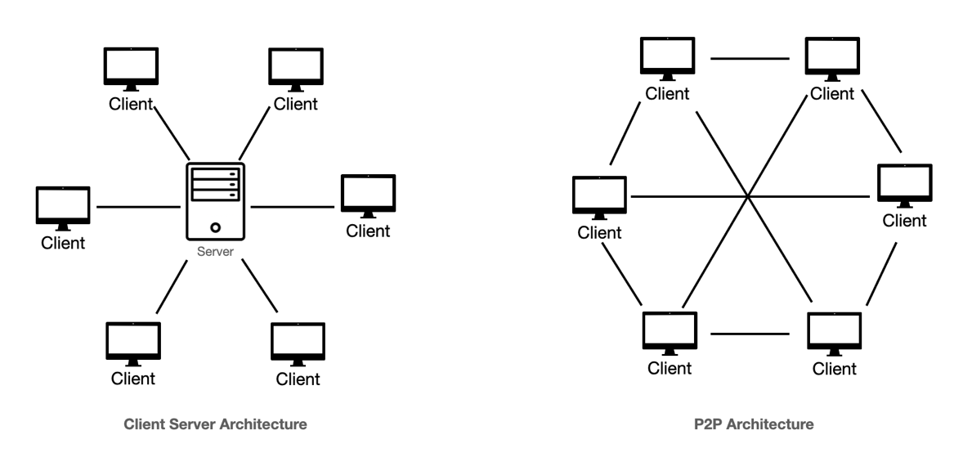

Client-server network (first image):
In a client-server network, devices called clients are all connected to a centralized node called a server which acts as a point of communication for all clients. Clients send requests to the server which then handles them accordingly, these requests are usually protocols like FTP and SMTP.

Advantages:
Client-server networks are much more scalable since it is easier to add another node and also easier to give updates too since the server handles all requests so it can apply updates to all nodes more effectively. It is also easier for an admin to manage the network while it is running since the server sees everything that is happening and permits it or denies it.

Disadvantages:
A client-server network would cost much more to make since it requires a physical node to act as a server, this would either need me to learn how to configure a single-purpose server or buy another computer to simulate this instead, both are very complex to set up. Additionally, if this server goes down, the whole network is broken which is quite unreliable.

Peer-to-peer (second image):
In a P2P network, there is no single central node which acts as a server, instead there are multiple devices connected as nodes which act as both servers and clients as necessary. The nodes communicate directly with each other. Since all nodes are equal, they all share the workload between them.

Advantages:
Peer-to-peer has reduced latency, which is very important to the nature of our game, since quick movements and reactions to hacks can sway the game in completely different angles. Additionally, a peer-to-peer network doesn’t require a central node like a client-server network which is useful because it means that I don’t need to source one since they would add to the cost of the game.

Disadvantages:
Since there is no dedicated single server in a peer-to-peer network, there is a lack of centralization which will mean that expanding the network to more than two players would be more of a challenge. This is also apparent by the fact that each device is sharing its resources so if any more peers are added its bound to cause performance issues. Additionally, if one node breaks then the whole network would go down.
Resolve:
After analysing both of these options, it seems like the peer-to-peer network is the more viable choice because the only disadvantages come from when we want to add a third node but since this is a set two player game, this is unnecessary to us. The advantages however outweigh those of the client-server network’s by not needing a central node and also allowing for low latency to respond to hacks easier. It also lets us focus our complexity on the actual game logic processing rather than how the server responds to the requests of the clients. Choosing this network architecture would save me both time and money.

Deciding which libraries to use:

GUI libraries:
Since I am creating a GUI for the users to control their cars with, it is fundamental that I have a pre-compiled GUI library to work with when making all these objects like buttons and text boxes for the user to interact with. The two largest professional GUI design libraries are Tkinter and Guizero. Here I will discuss advantages and disadvantages of using either of them and ultimately reach a conclusion on which one would be more appropriate for my project.

Tkinter
Tkinter is python’s standard library for GUI creation since it comes preinstalled on any python IDE and only needs to be imported to use. It provides a lower level tool-kit to create and customize GUIs to very high levels. It acts as a very scalable base and contains an extensive set of different widgets like buttons, textboxes and labels.
Since Tkinter is a low level python library, it has a very steep learning curve but in return offers a huge amount of control to the user over their GUI with deep customization and also gives a deep understanding of how GUIs work in general since it is hardly abstracted at all.

Guizero
Guizero is a high-level python library which is designed to be both simple and intuitive. It uses Tkinter and simplifies many aspects of it, allowing for it to be used without needing to know extensively the intricacies of GUI design. It still has very high viability since allows programmers to use most methods available in Tkinter but in a more simple, logical way. This means that it has a much less steep learning curve than Tkinter.
One disadvantage however would be that since the library uses so much abstraction to make it easier to implement GUIs, programmers would have less control over the specialized parts of GUI design, such as memory usage, which would make a big project slower to run and less efficient.

Resolve:
The GUI design is a large part of the project since it needs to be very user-friendly for the players to easily navigate through it in the heat of battle. Therefore, it is essential that it offers enough accessibility features for the user to feel comfortable using it. Guizero offers all of the features which would make a sufficiently easy-to-use GUI and using more than this would hinder the design flow since to program this it’s not necessary for me to have a perfect idea of how GUIs work. Additionally, it would be easier to document the code when I have a better logical idea of what is going on and can write code in my own flow of logic. This is especially important since the whole project combines so many different libraries and ideas. Therefore, I am choosing Guizero to program this code with for its simplicity.

P2P libraries
When making the methods of the P2P network, it is essential that I use features from multiple other pre-installed python modules to be able to simulate a real P2P network’s processes as effectively as I can. This includes searching for peers in a network, simultaneous execution of methods and accessing network sockets and creating ports.

Threading:
One essential feature required in the project will be the ability to utilize multi-threading. Multi-threading in python simulates multithreading in the core, where tasks can be executed simultaneously. This will be needed in our project because it features a live event where players respond and be updated about the game state while it is running. One example would be that we need to constantly run threads in the background for the network to be able to listen for communication protocols from the other peer. There are various modules in python which can be used to simulate multi-threading, but I will be using the most common one known as ‘Threading’ because it is prebuilt into python and very versatile in its use and offers lots of prebuilt functions. One example of this would be how it can create multiple threads with the same template and activate on different function calls. This will be helpful for communicating multiple state changes simultaneously.
Various methods in the module can be called to create, handle and determine the nature of threads instantiated by the module’s thread constructor. Through these methods, we can manipulate threads to our various needs throughout the programs, therefore the module is reusable and a clear choice to bridge the connection between our network and GUI functions.

Time:
The network system is very time dependent on processes happening in the correct order, since the initialization uses two devices all acting on standard network protocols which all need to be activated in correct sequence. If state changes are sent to the client too quickly, the server thread might get overwhelmed with requests, so it is very important to use a function to delay the speed of sending messages. The most standard way to do this is to use the ‘Time’ module, another pre-installed python module which hence doesn’t need to be installed and initialized. The sleep() function is a component in the time module and takes one input in milliseconds to delay the program or thread by that amount of time.
Since the module is preinstalled and very simple to use, it is the best choice to implement to solve this network problem. It is also going to be a big help in controlling the smoothness of the GUI appearance for the user, delaying certain inputs to allow for animation time will make it easier for the user to understand what is going on and what actions they can take in response.

Socket:
When communicating in a network, we need to use certain parts of the hardware designed to connect to internet and listen for messages from the internet. Since both of these actions can only be done by controlling specialized hardware, they would need low-level code and the programmer to understand how the actual components work. However, we could instead use a precompiled library to abstract the hardware part while still giving us control over how the network works. The “Socket” module is another pre-installed library designed and implemented in python to abstract the hardware parts of network communication and allow the programmer to focus on the direct communication between the user and client.
The module helps to visualize sockets by allowing the programmer to create objects through which clients can connect to through the use of the internet to make a socket through which they can transfer data.
One benefit of the socket module is that it is programmed to handle cross-platform relationships. Since the game should be able to be played on any device this is necessary to the project.

Final measurable objectives:
- The control system will be engaging and easy for the user to interact with.
  - The user will be prompted to connect with another user over a p2p network, having entered their IP address (they will we told via textbox where they can find this information on their computer)
  - There will be a track which is displayed in the middle of the menu with both the user and their opponent’s car clearly colour coded.
  - The users will have the game rules simply explained to them before being prompted to choose a well-described ‘build’.
  - When a player uses a hack or boost, the chosen name will be displayed in the leftmost position of the dynamic, simultaneous stack for both players to see and respond to.
  - There are lists of hacks and boosts which run down the left and right sides of the control system, they are clearly stated, and their RAM costs are marked accordingly. They are dynamic, updating regularly depending on the game states. They can be interreacted with to be activated.
  - the boosts and hacks will lock visually during the stack resolve stage to show that they can’t be activated to the player
  - When a player uses the hacks and boosts they can watch as their ram pool decreases depending on its cost, this is displayed at the top of the screen for them to clearly see, the RAM bar will slowly refill at the set intervals
  - The hacks and boosts automatically get added to the resolve stack when activated and resolve on a timer rather than input so don’t distract the player from thinking.

- The gameplay will be fully fair, purely strategic and versatile.
  - Both players will have an equal chance of winning the game
    - There is no technical skill required to win the game.
    - Players can only use hacks and boosts to change the course of the race combined with the build they chose at the start of the race.
    - The cars will not be controlled on the track manually.
    - Lots of input time and slow graphics so even new players immediately understand the game states.
  - The player with the higher level of strategy will win.
    - The different hacks and boosts will act situationally so the player who knows when to use theirs has an advantage.
    - The dynamic stack system for the hacks and boosts will act as another way for players to use strategy to their advantage.
    - The limited RAM supply gives players a heightened strategy level to which they can perform if they possess the intellect.

  - There will be numerous different, diverse strategies to win the game.
    - There will be many hacks and boosts, all providing with different situational utility to provide many different strategies when combined with eachother
    - The Nitro boost allows to increase movement speed, it costs fairly low but can be the difference between being able to respond to a hack and not.
    - The Firewall hack costs a medium amount but allows the user, for the next few seconds of the race to be immune from all negative hacks and stop the other player from being able to boost themselves, hence a very powerful utility in either preventing opponent from boosting themselves but also blocking themselves from all damaging hacks like display exploit or system shutdown.
    - The System shutdown hack stops the opponent from being able to input hacks and boosts but also stops their car from moving. It can be negated by the firewall which makes it important to bait opponents into using firewall before they can stop it.
    - The hyperthreading hack is powerful late-game after many have been used (since they can be used exponentially) but the set up costs lots of RAM so leaves the user vulnerable, hence it is a risky but rewarding play.
    - The spike deployment hack is less powerful than the system shutdown since doesn’t stop the car or opponent’s inputs, it only cuts their speed. Still very useful in long term if combined with the hyperthreading strategy to massively reduce opponent’s speed.
    - The builds will elevate the possibilities the game can take to make for more developed strategies and specialization in aspects of the game.

Design:

Detailed class diagram:
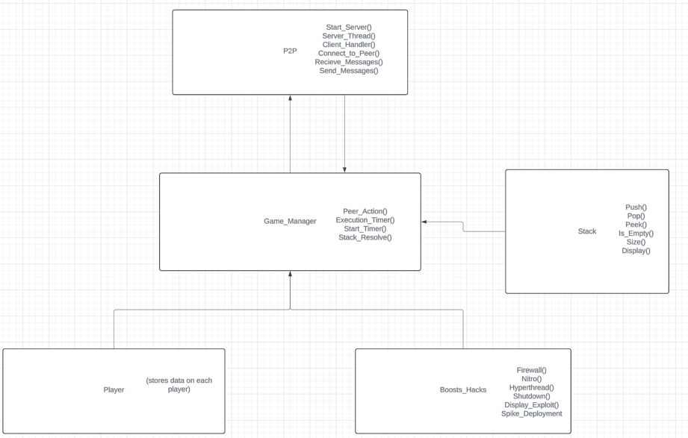

Significance:
the stack is managed by the Game_Manager class since it uses the operation stack to know what to resolve and uses its methods to manage it. The P2P class contains all the network initialization and methods which the Game_Manager needs to have access to in order to receive and interpret messages but equally to send messages, the P2P class needs access to Game_Manager class too, hence they are linked in aggregation. Since so many threading and timing functions are involved and overlap with each other’s classes so frequently, I used aggregation in most of the other classes so that they can all have an instance of a Game_Manager as an attribute in order to be able to monitor threads and to make their own from the Game_Manager class as they need to. More on the aggregation methods in the implementation stage.
An instance of a GUI class gets passed into the Game_Manager. The Game_Manager calls its methods in threads to constantly update it. Through this GUI, the player will control their virtual car’s actions, and have an abstracted view of the hack/boost stack and monitor the race progress, the initial design would look like this but may be tweaked to be simpler for the user to understand.
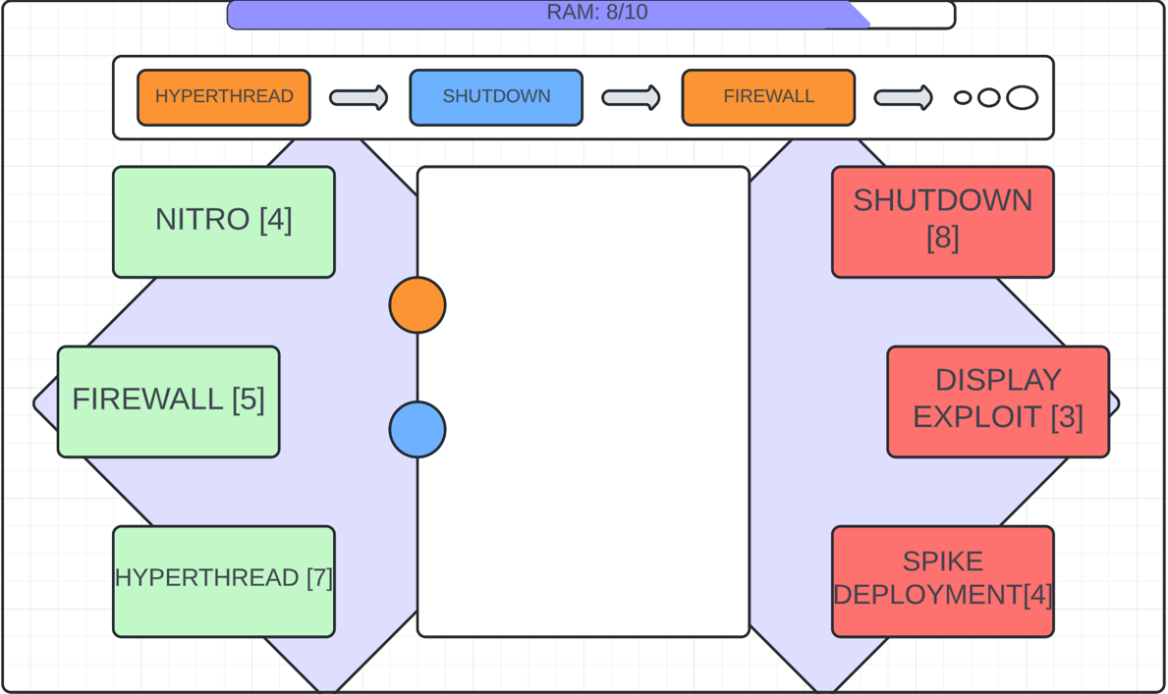
This GUI encompasses the ease-of-use the game boasts while also being functional and visually pleasing. We have a track in the middle with colour coded cars belonging to the player and their opponent, they will move round the track at a specific rate being able to overtake each other.
On the left and right of the screen, there are buttons indicating the various hacks and boosts that the game provides, a player can click on it for it to be added to the action line above, where a 5 second timer starts. Players’ responses will accumulate on this line for everyone to see clearly and their resolutions will be clear too on the screen, for example, in the program log, it will clearly state the changes of player’s stats if they need to see
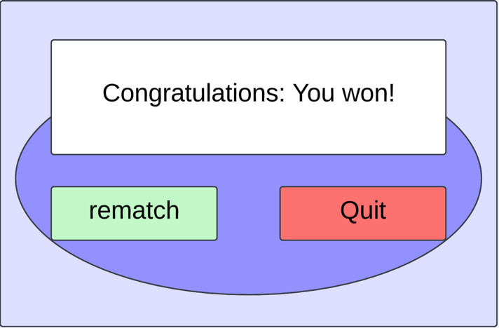
When a player completes the final lap by crossing the finish line, all buttons will disappear and be replaced with a message congratulating the winner, there will be the option for a rematch if they want

Dataflow diagram

The dataflow diagram shows the processes of a single game from the point that both players initialize their sides of the game. It’s difficult to represent the function of threads and pushbuttons on a dataflow diagram so I will explain the processes below to make it clearer:
The game initializes by giving the player full functionality of the boosts and hacks to use in gameplay and places both cars moving on the start line.
Next, two decisions are constantly being reviewed, the first being deciding if a player has crossed the finish line on the final lap. Each time a player crosses the finish line, a thread checks if it’s the final lap, if it is then they are declared the winner, and the game will end after displaying a message to both players.
The second decision at this point is checking if a player has activated a boost or hack through a button on the GUI. If a boost or hack has been activated, it will be added to the resolving stack and a five second timer will start. If a player activates another boost or hack during this time, the step repeats, adding it to the stack and refreshing the timer. This cannot happen indefinitely since players will either run out of RAM or decide that they don’t want to respond. During this time, the first thread is still always running to make sure that if the game ends during this step, the stack will be terminated correctly.
Once the active timer runs out, the stack will resolve top-down, the sequential resolution ensures that each player’s actions get applied in the order they were activated. The players then experience the effects of the boosts and hacks that get resolved. This could influence their car’s speed, opponent’s car’s speed or other attributes. The game then loops back tp monitoring if a player crosses the finish line on the final lap.
The flow is simple but is also direct in making sure that players influence the race through skillful use of hacks and boosts. The idea of the sequential stack stops it from being a technical skill game by removing chaotic overlaps in timing.

Implementation:

Main complexity - synchronization of client-peer game instances through the use of Socket:
The main problem we face when making a live interaction between two machines is the synchronization of game states. Throughout the program I have used a series of methods to keep both players in sync with each other and collectively progress in the game. Some of the more complex methods I used are included below:
The P2PNode class is responsible for establishing the P2P connection between the two clients, it creates a socket between the two addresses entered into the program so that messages can be sent directly between the two players.

Network basic processes:
To establish the connection, the start_server() and _server_thread() methods set up a server on each player’s device so that it can allow the other player to connect as a client
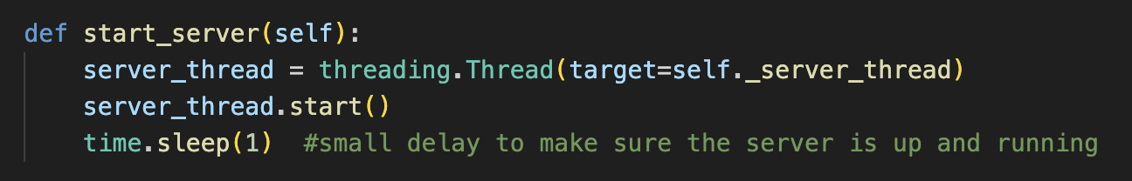
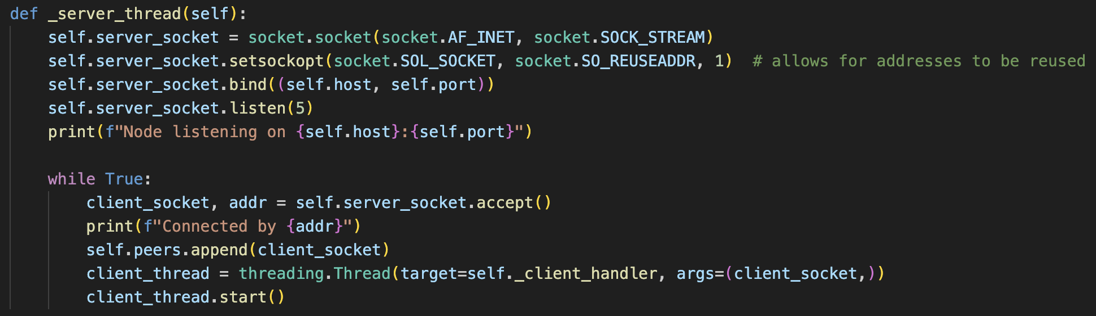
The connect_to_peer() method allows for the initial connection test to be made between the servers by sending an encoded message from its port across the socket. If the message has been sent correctly, then the method will return a confirmation that the server is ready to start the game.
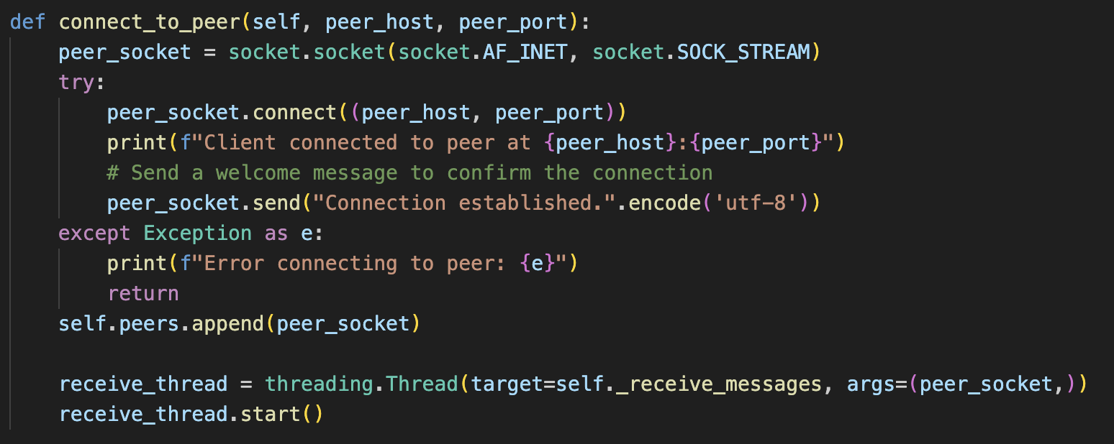
The send_message() and _receive_messages() methods are used together in tandem to encode text as packets and send them to the peer who will decode it into a string so that it can be used in various functions. The way this is done so seamlessly is by creating a thread which constantly runs the _recieve_messages() method to be able to receive a message during any game state.

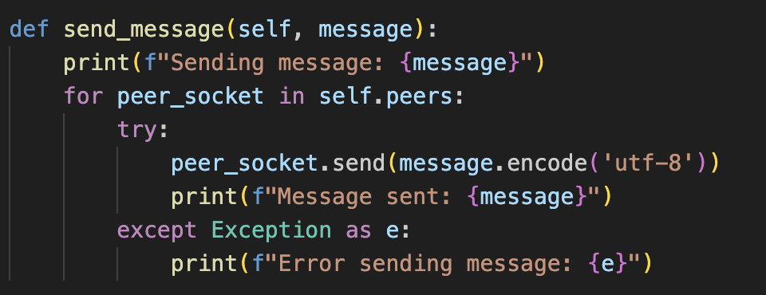
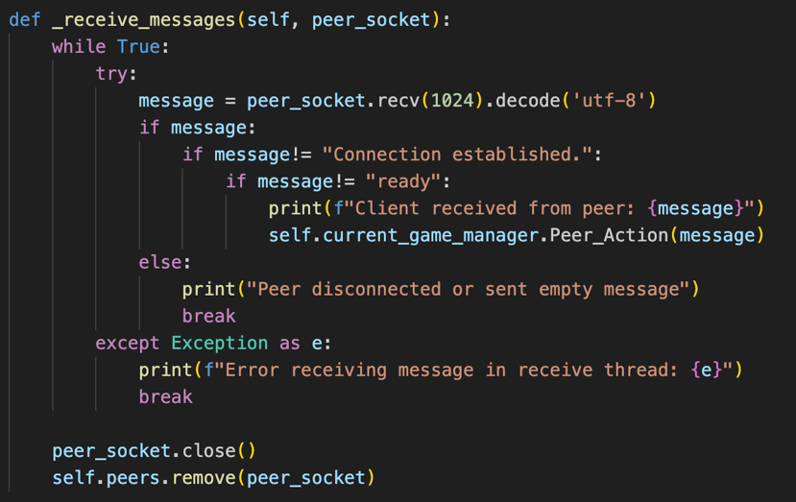
The _client_handler thread also helps to generally manage the connection with the peer by handling incoming messages from clients who connect to the node as a server. This is different from the _recieve_messages thread which handles messages from a peer connecting as a client.
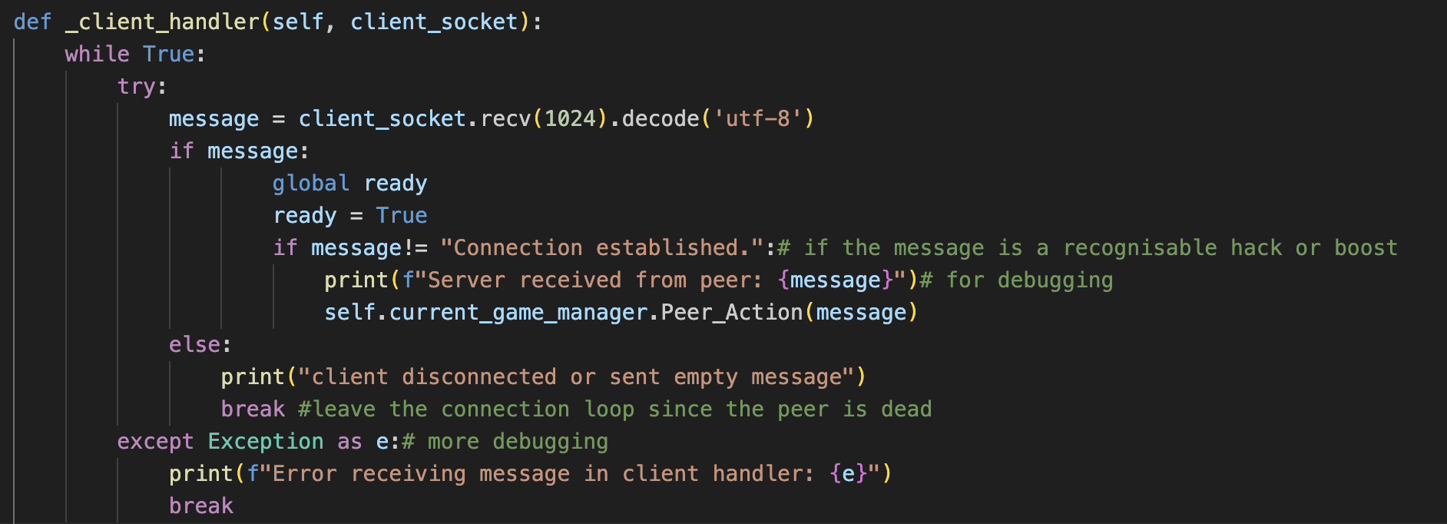
Since only a single connection is being made, an instance of this class, ‘node’ is created in the main program and accessed by all the classes.

Main area of complexity - Utilizing the P2PNode instances to maintain synchronization between both the Game_Manager instances:

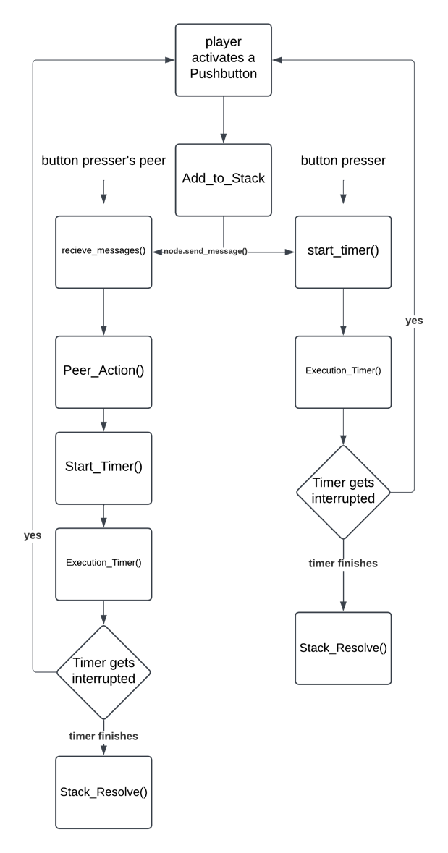
The Game_Manager class orchestrates the synchronisation of the hacks and boosts by adding them all to an instance of the Stack class, passed in as op_stack to the Game_Manager’s constructor.
The main challenge of synchronisation within the program refers to the execution of hacks and boosts across devices and most importantly, establishing the correct targets. The Add_to_Stack(target) method gets called each time the game instance’s player activates one of the Pushbuttons within the GUI.
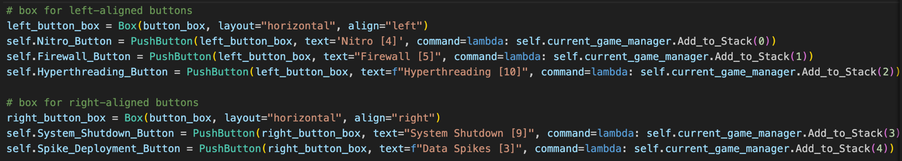
The index of the boost or hack in the list is passed in as a parameter so that the method instance knows which hack or boost is being activated.
Along with other local gameplay mechanics, the instance will use the send_message() method to notify the peer that the local player has added a boost or hack to the stack. This is done by concatenating the activating player’s port (to identify them) to the boost/hack ID. The data gets pushed to the local player’s stack too before calling the StartTimer() method
The other player’s _recieve_message() thread will pick up this message and cause it to activate the Peer_Action method which has the same functionality as the Add_to_Stack(target) method only without sending a message to the opponent in order to avoid a loop of messages. The reason it doesn’t need to check any conditions is because to be sent over the network, it must have been approved by the Add_to_Stack(target) method which does all the necessary checks anyway before sending it across the socket, similar logic can be observed throughout the synchronization processes.
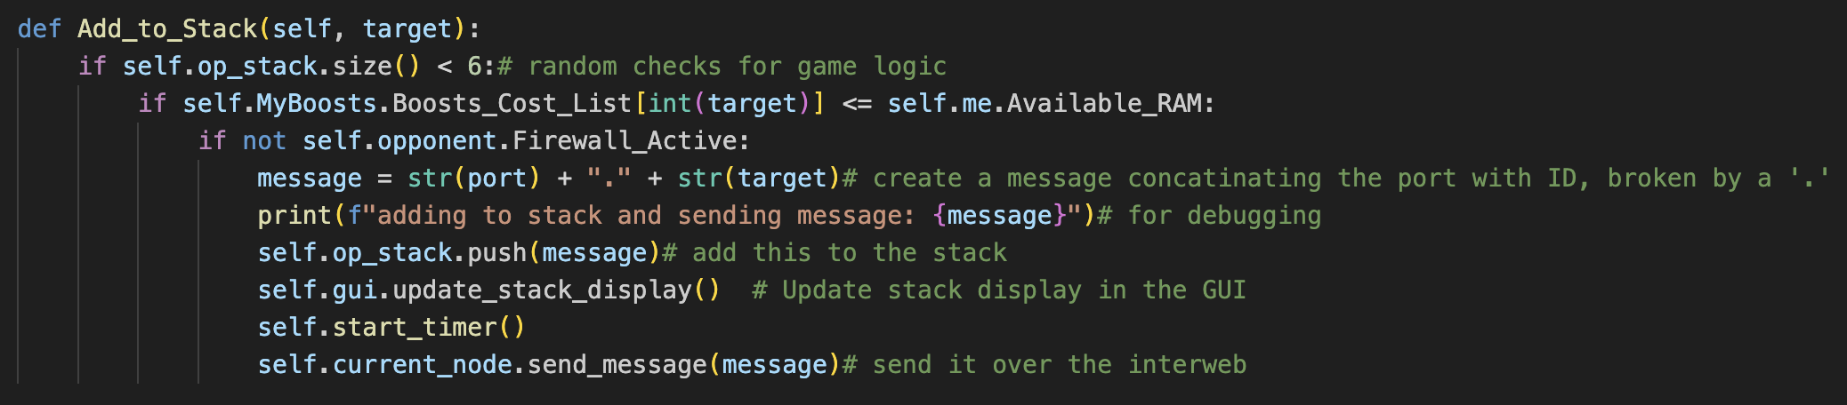
At this point, both player’s instances of op_stack has been updated to contain a message of f“{port}.{boostID}”, for example this could be “5000.1”, or “5001.1” depending on which player activated the boost with ID 1. It equally could be, “5000.1” or “5000.2” depending on which boost was activated by the player with open port 5000.
Additionally, both players have an instance of start_timer() running, which is tasked with killing all threads of Execution_timer() if it is already running in order to stop an overlap of timers (more detail on this later). Once this is sorted out, Execution_timer() is called as a thread for both players which essentially starts the five second timer after checking that an active Firewall hack isn’t able to negate it and the player has enough RAM to activate it in the first place. Before starting the timer, the method also checks whether the top item in the stack is a hack or a boost since this is the item that will be acted on. Depending on if the ability affects the host or the opponent will change the target player which is decided through a selection process. This will be different for both players and players are distinguished by the port component of the item.
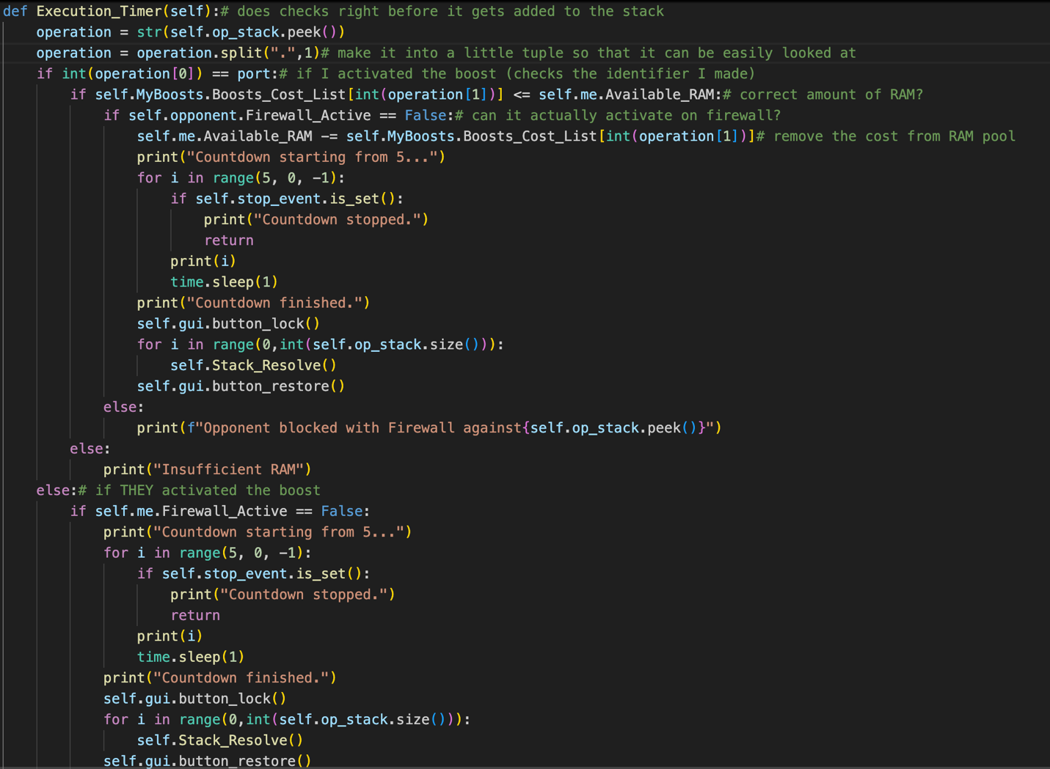
The timer begins and if it reaches 0, the Stack_Resolve() method will get called for both players. This is where final checks like Firewall == True are calculated before the action gets resolved as a thread in a fantastic line of code with 6 sets of brackets.
If the timer doesn’t reach 0, so if another item gets pushed to the stack, then the start_timer thread safely kills the Execution_Timer that’s running currently unless its already executing. To avoid it killing it while its executing, the buttons lock during the resolve stage, making it impossible for the player to edit the stack.
By following the same sequence and timings, both devices apply boosts and hacks in sync so that they can maintain a consistent game state.
The purpose of there being two different sets of checks before an execution thread can be made is because of the nature of Firewall. Active Firewall is meant to negate your opponent’s request to add hacks or boosts to the stack but also functions as a negate for actions within the stack if they are already there when a Firewall gets activated. This is why Firewall is checked both in the Stack_Resolve() and also Execution_Timer()/ Add_to_Stack().

Keeping the players updated too through the combined use of threading and GUI functions:
This is how the game itself stays updated on what’s happening, but the player’s ease of understanding is a separate problem. To get around this I have used some selection processes to check which player is doing an action based on the port so that different messages can display depending on this.
Below are two examples of where the port identification system impacts the player’s understanding of the game state:
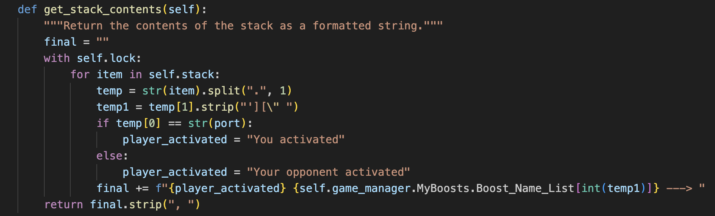
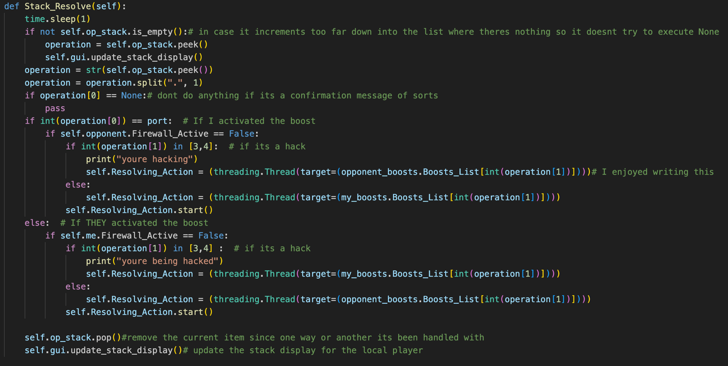
Here we can see a selection process around the port number being equal to the first half of the tuple item within the op_stack. Different messages will appear to the player depending on the result of this calculation to make it clearer what’s going on.
For example if we passed “5000.2” into the get_stack_contents() method where our port is 5000 and our opponent’s port is 5001, we would get returned “You activated hyperthreading” whereas if we passed in “5001,4” we would get returned “Your opponent activated data spikes”. This level of description is necessary to help the player understand what’s happening since the direct stack contents are at such a low level.
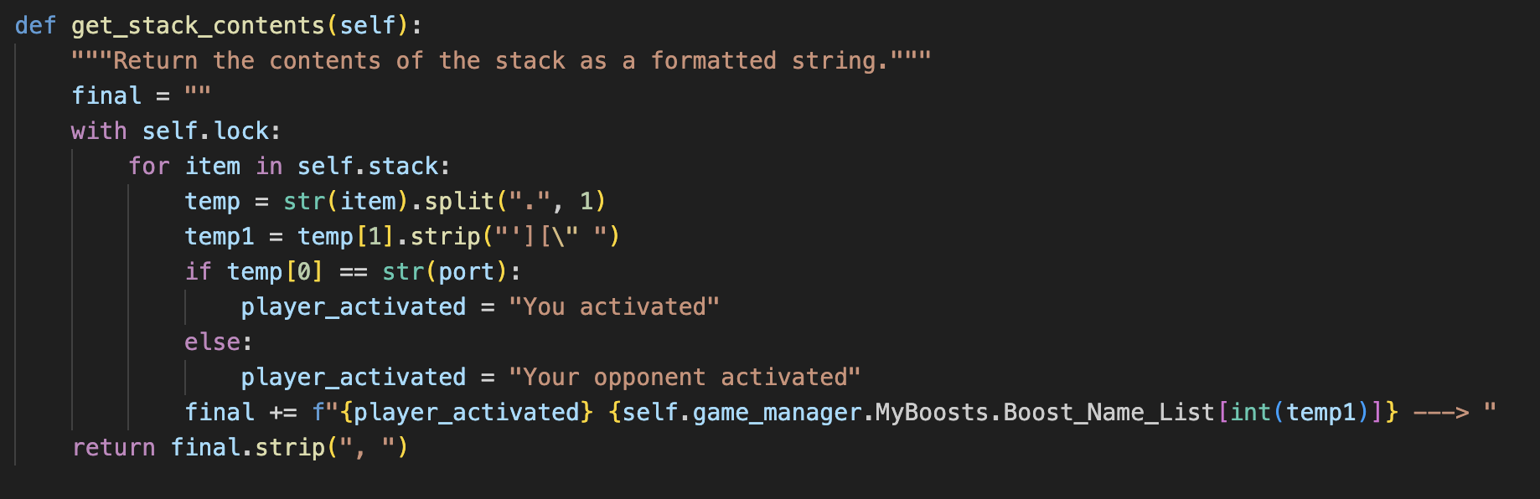
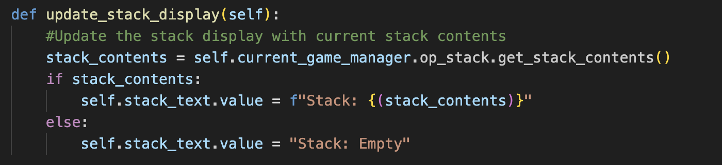
- Additional checks in the more specialized method, update_stack_display()
Additionally, all throughout the aforementioned stack synchronisation process within Game_Manager, the stack method, get_stack_contents() has been called numerous times through the GUI method, update_stack_display() so that the text box for the players representing the stack gets updated at each stage so that players can use a live feed to influence their actions.
For example, this line is run right at the end of the stack_resolve() method since by the end of the method calling, there will always be one item popped from the stack, which needs to be displayed to both players.
Similarly, instances of update_ram_display() and update_lap_display() are initialized in the GUI class’s constructor as threads to constantly be able to show the player the variables of the race since they would also influence their actions.
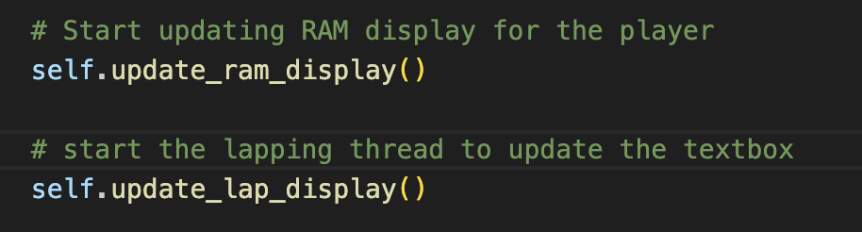
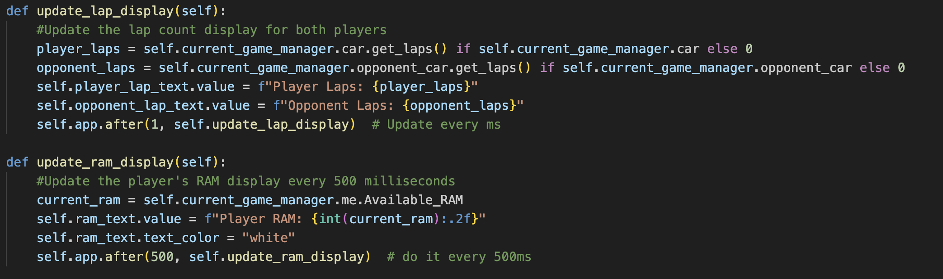
Here we are utilizing the built-in threading function of Guizero which updates the ram_display and also the lap_display in a non-blocking way so that the rest of the program can run with this in the background.
This also required a deep understanding of the Threading module for real-time actions. One of the most complex integrations of this module is my usage of the stop_event and join() functions within the start_timer() method.

precise complex code examples – Threading:

What threads are running?
naturally, threading is used very frequently throughout the program because of the nature of a live game that makes use of the internet. At all times while the program is running, there are at least 8 active threads that are individually handled correctly to be sustainably used. Below is a diagram to make the threading logic for the program clearer:
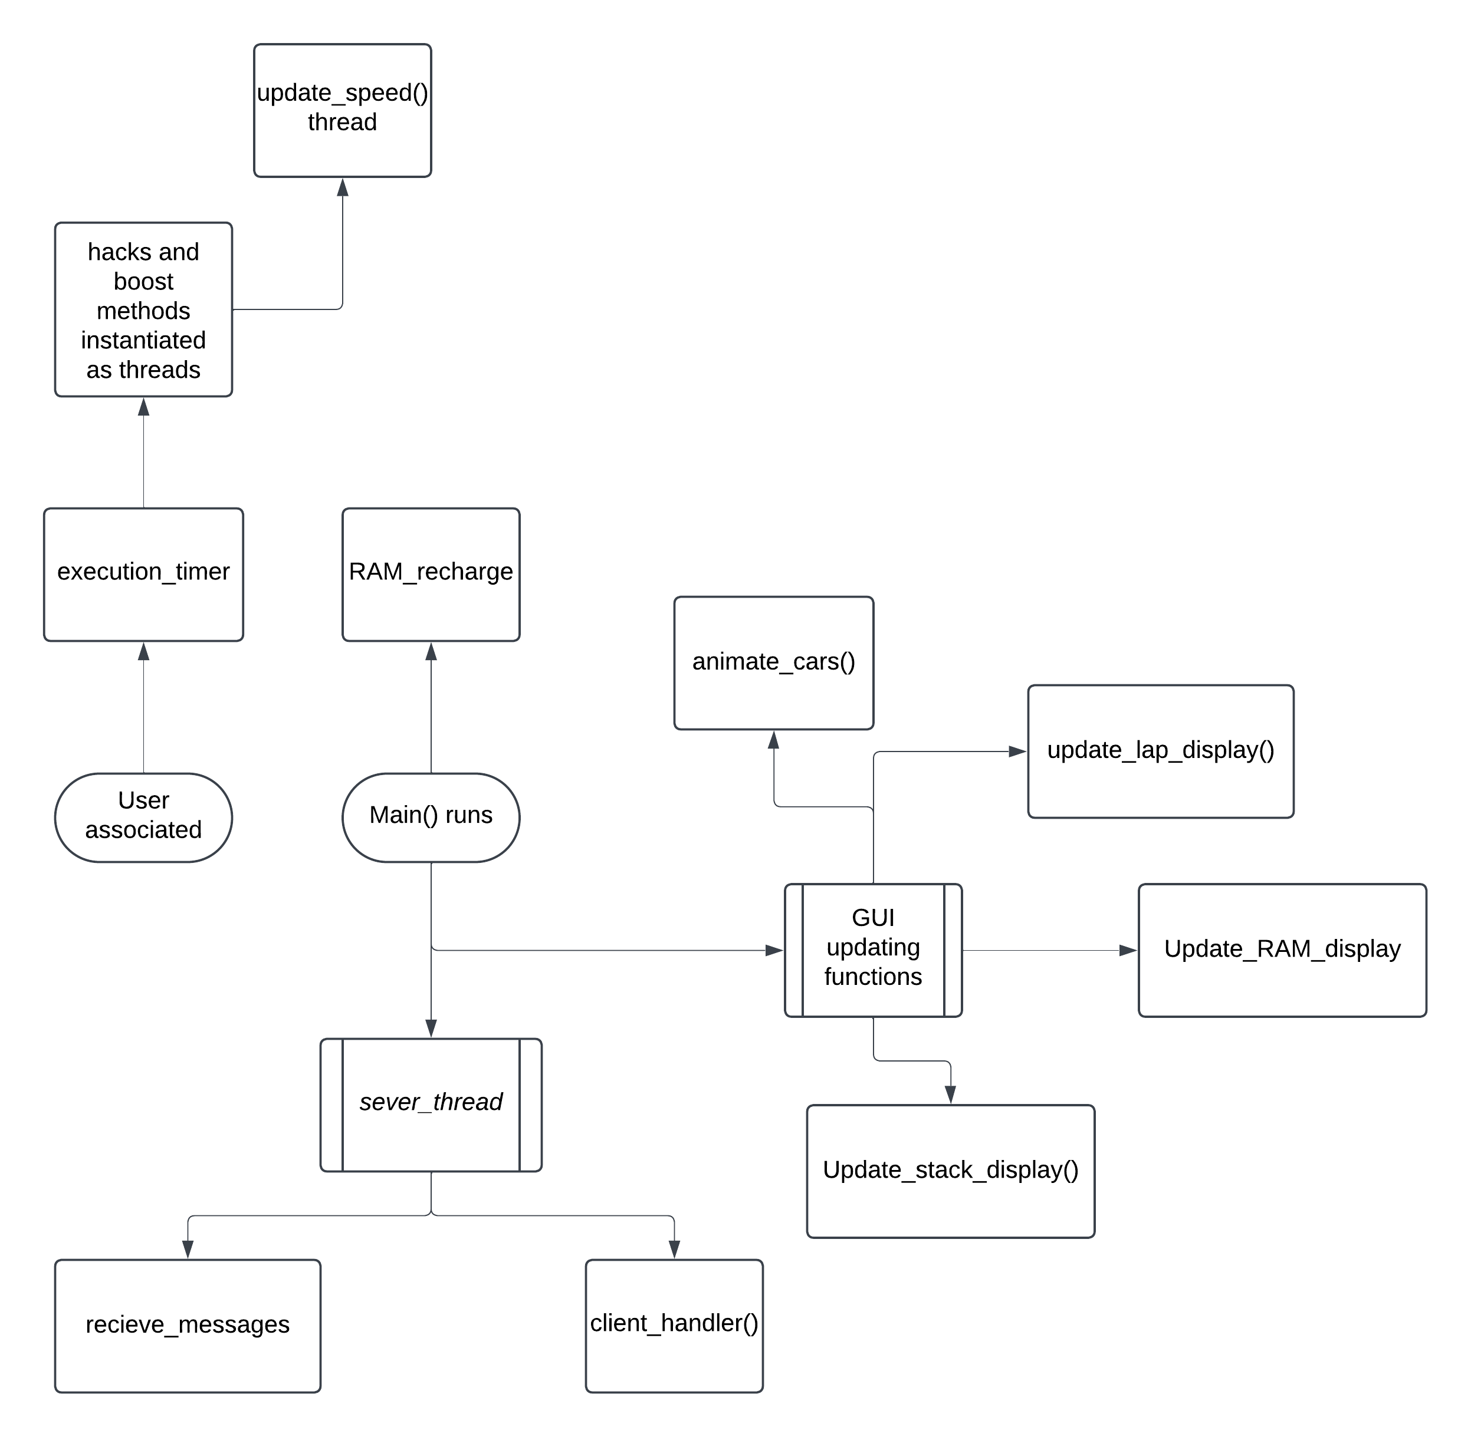
As you can see the 7 threads attached to Main() will always be running throughout the program with the potential for many more to be running if the user acts in certain ways. Each different hack and boost activation creates its own thread so potentially over 8 more could be running at the same time, making 15 threads total.
Below are a couple examples of the most complex areas of the threading logic I implemented across the whole program:

start_timer()
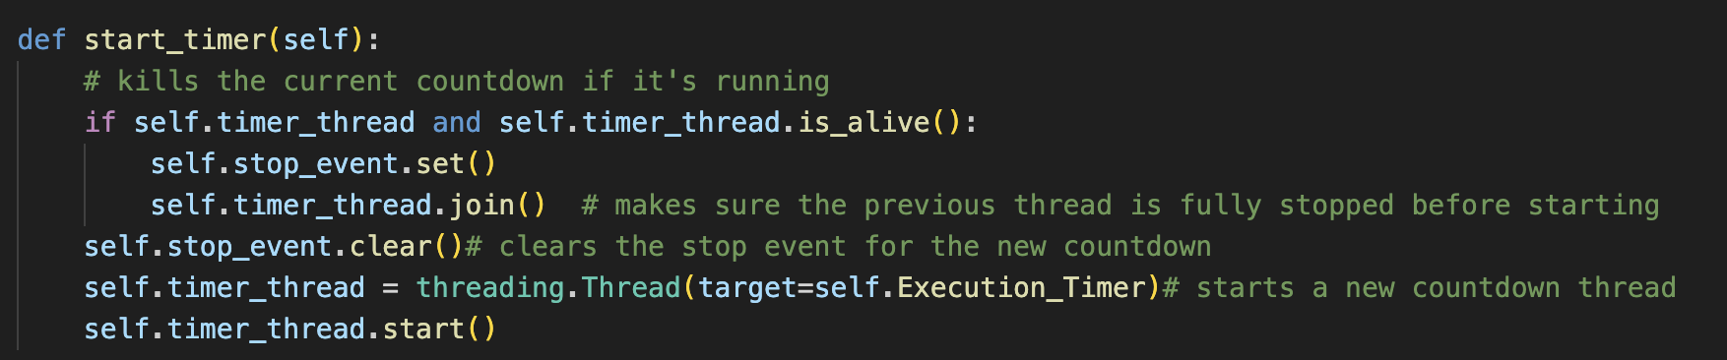

Explanation:
Start_timer checks if a countdown thread (timer_thread) is already running. If it is, it sets the ‘stop_event’ flag, which signals the thread to stop and waits (using join() ) for it to finish. This is done to make sure that only one countdown thread runs at a time.
Next, a new timer_thread is created, running Execution_Timer(). This thread performs a countdown while also checking periodically the stop_event to see if it should stop.
This countdown logic is implemented in the Execution_Timer where it counts down from 5 to 1, using the time.sleep() function to wait one second between each decrement. If stop_event is set during the countdown then it terminates immediately.

Complexity:
This system uses carful coordination of thread states (stopping and starting) and the use of stop_event to allow a streamlined cancellation of the countdown if another item gets added to the list.
Synchronizing access to the timer thread using stop_event and join() allows for smooth control over the countdown process without making any overlaps in countdowns or conflicts.

Summary:
The use of the threading here adds complexity since it combines real-time timing control with conditional checks and requires synchronization to stop countdown overlap

Recharge_ram()
Another example of complex use of threading would be the recharge_ram method in the Player class. It is used as a thread and continuously recharges the player’s RAM at a variable rate and allows for this rate to be changed in an encapsulating way with the update_recharge_rate() method

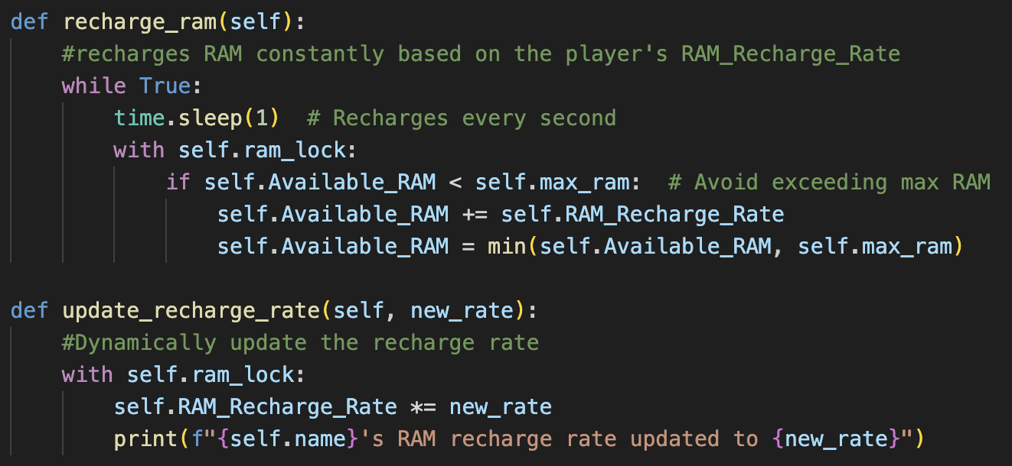

Explanation:
The recharge_thread is created as a daemon thread, meaning that it will automatically stop when the main program exits so that no extra handling is required for it.
To make sure that the Available_RAM doesn’t exceed the maximum allowed, the method uses a ram_lock to ensure thread-safe access. ram_lock prevents potential race conditions if multiple threads (like other boosts/hacks) try to access or modify Available_RAM in a concurrent way.

Complexity:
This threading example uses continuous background operation with locking for safe access to shared data (like Available_RAM). Without a lock, concurrent access to Available_RAM would potentially lead to inconsistencies, especially if multiple boosts/hacks attempt to modify RAM at the same time.
Managing a continuously running thread, especially with daemon properties, needs careful design so that the thread’s operations stay in sync with all the player’s interactions and game events

Summary:
This example is complex since it combines background processing with data synchronization, which is essential in multiplayer, networked games to keep resource levels (the Available_RAM in this case) accurate for each player

precise complex code – advanced OOP

Polymorphism in Boosts_Hacks class

Explanation:
In the Boosts_Hacks class, the lists of boosts/hacks, activation costs and names are all represented in structured lists. Polymorphism allows for them to be handled in a uniform approach in the Stack_Resolve() method.
The way this works is that after a boost or hack gets pushed to the stack and is ready to be executed, Stack_Resolve() invokes the appropriate method from the boost _list without needing to know which specific boost or hack it is.
This abstraction lets Stack_Resolve() handle all boosts and hacks dynamically, ensuring that each is applied according to its specific logic without needing separate calls or conditions for each type since this would be unnecessary

Complexity:
The complexity here comes from managing the unique effects of each hack and boost while also keeping the method generalized. Each method has distinct interactions with the variables of the game, but Stack_Resolve only needs to know that the method exists. The referencing used within the 6-bracket line is very meticulous to minimize the amount of association but maximise its modularity.

Summary:
The use of the polymorphism in for boosts and hacks allows Stack_Resolve() to apply diverse effects seamlessly through a single interface. Overall this keeps the Stack_Resolve() method’s stack processing organised and efficient. This polymorphism increases the reusability of the code since if a new boost/hack was added, nothing in the method would have to be changed, making it more expandable.

Every other method:
Skill | Model/algorithm | Brief description | Page number/line in code
Advanced data structure handling | Traversing, adding to, reading, removing from a dynamic data structure (stack) | Utilizing my stack class’s methods to handle the op_stack in a completely encapsulated manner. | Main.py 564-608
Advanced object-oriented programming | Local use of instantiating objects | Creating local threads and GUI widgets within classes | Local thread instantiation in line main.py 198
Advanced object-oriented programming | Class association methods | Passing in localized access to associated classes through getter methods to have mutual association | Used in main.py lines 627, 629, 634, 635.
Complex client server scripting | Network that supports a complex data model | P2PNode class acts like a p2p communication handler | P2PNode class in main.py 465
Complex User-Defined Algorithms | Complex user-defined algorithms for action scheduling between players | The game_manager class does scheduling and execution of player actions, so that they are executed in sequence for both local and peer actions. | Execution_timer, Stack_resolve  Main.py() lines 92 and 142
Error handling for network | Error handling | Uses advanced error handling within threads to output readable messages to the user if the P2P connection fails | Throughout the whole P2PNode class: from line 465.  Shown most in the _client_handler() method and the _recieve_messages() methods

Evaluation:

Evaluation by objective:

Objective No. | Objective overview | My evaluation | User feedback | Evidence
 | Easy-to-use control system | Objective fully met | “the game itself is really easy to get the hang of because of how the menu looks” | Described in breakdown underneath and in the interview
1.1 | User connects to the peer with easy-to-follow error handling | Objective met |  | Lots of error handling and logs in the networking method _client_handler() to keep consistency and communication with the user, lines 495-510 for client_handler()
1.2 | There is a track in the middle of the screen with players colour coded | Objective fully met |  | Players have different colours/images to represent their cars to make it easier to understand
1.3 | User can select a build | Objective not met |  | I decided to prioritise the creation of the main game processes with hope of adding this later.
1.4 | Actions displayed live in the stack | Objective fully met |  | Main.py line 567, called first time at line 82
1.5 | Boosts and hacks are listed down the left and right sides of the track | Objective fully met |  | Main.py lines 288-298, buttons specifically aligned in boxes
1.6 | Buttons lock to make it easier to understand for the player | Objective fully met |  | Main.py line 125 is an example of utilizing the self defined GUI method, button lock
1.7 | RAM pool will deplete and recharge clearly constantly | Objective fully met |  | Explained thoroughly in complex code examples section.
1.8 | Actions resolve automatically from the stack | Objective fully met |  | Also explained thoroughly in the complex code examples section
2 | Gameplay is fully fair, strategic and diverse | Objective fully met | “I find the game fair because of how many different paths you can take” | Described in second interview below
2.1 | Both players have an equal chance of winning | Objective fully met |  | “I really do think that everyone has an equal chance of winning because of how easy the game is to pick up. After that its like the more you play it, the better you can develop your strategies”
2.1.1 | There is no technical skill required | Objective fully met | “easy-to-use” and “beginner friendly”
2.1.1.1 | Players can only use hacks and boosts to change the game course | Objective fully met |  | The only button set in the GUI is for activating boosts and hacks to keep the system easy-to-use
2.1.1.2 | The cars will be controlled on the track automatically | Objective fully met |  | Shown in main.py 364-375 where a GUI method repeats updating the cars
2.1.1.3 | Lots of input time given to the players | Objective fully met |  | Players have 5 seconds to activate abilities in sequence and 1 second between each resolution
2.1.2 | The player with the higher level of strategy wins | Objective fully met | “you can have properly developed fights”
2.1.2.1 | The different hacks and boosts are situational | Objective fully met | “lots of ways to use the RAM”
2.1.2.2 | The nature of the stack resolution adds to strategy | Objective fully met |  | Complexity shown in the testing video where different logics are explained
2.1.2.3 | The RAM system adds to the strategy of the game | Objective fully met | “even the RAM itself lets me outplay the other player” | Also described thoroughly in the testing video
2.1.3 | There are numerous diverse strategies to win the game | Objective met | “after playing more I started to realise how many different things I could do” | Described throughout the testing video again (all below hacks and boosts shown and described in the video) and proven in interview
2.1.3.1 | Nitro will be fully functional | Objective fully met
2.1.3.2 | Firewall will be fully functional | Objective fully met
2.1.3.3 | System shutdown will be fully functional | Objective fully met
2.1.3.4 | Hyperthreading will be fully functional | Objective fully met
2.1.3.5 | Spike deployment will be fully functional | Objective fully met

Feedback from interviewee:
A second interview reviewing the game with the original interviewee after playing many matches together resulted in lots of feedback about how I could have approached the project differently and also what I did correct.
First, she said that the game was complex in terms of strategies to use, which was a good thing, because it let her play many times without getting bored, therefore objective number 2.1.3 has been proven to be fully met. “After playing more I started to realise how many different things I could do”. Shows that the game is engaging.
Next, I asked about how they found the game’s accessibility/ ease-of-use. She said that it was very easy to understand the controls since the game made it so easy to play. “I picked it up really quickly because of how beginner-friendly the control system is”. She liked how the cars are controlled automatically and the actions in the stack resolve themselves. This proves objective number 1 (easy-to-use control system). The only feedback was to change the colour scheme for the windows computer since the guizero library colours the background lighter than the mac one, making it hard to see some widgets. This is a very quick fix and I will do this.
My last question was about how fair the game was. I was told that the game is very fair by nature, but its execution allows for less fair gameplay. “Even though it’s not a huge problem, sometimes you can creep ahead of your opponent slightly since the cars don’t align with each other on the other player’s screen.” This refers to the small delays in the sending and receiving of messages across the Mac and Windows PCs, where for example, a nitro will always get activated first on the host’s machine since there isn’t a system in place to delay it to allow the signal to travel over the network.
This is less of a problem for the fairness since both players can take advantage of this equally, so no single player is getting an advantage over another. It’s more of a problem just in game logic and I will implement a wait system to make sure that timings line up perfectly with each other but for now I’m not too concerned about this.
In summary, they were wooed by the ease-of-use and the strategic elements of the game, their main requests, but the fairness of the game could be tweaked slightly to help support these values more.
In light of this, I will undergo more solution around the fairness of the game by making sure that all the timings activated across the network line up with each other by recording an average delay and making the faster machine wait the difference so that they can execute simultaneously. I will also implement more checks that the two machines are fully synced up.

All the code formatted:

