Akrom S

Exercises:

1)

A)

<%@ Page Language="VB" %>

<html>

<body>

<form id="form1" runat="server">

<% For i As Integer = 16 To 24 Step 2%>

<div style="font-size: <% Response.Write(i)%>">

Hello World<br>

</div>

<% Next%>

</form>

</body>

</html>

B)

<%@ Page Language="VB" %>

<html>

<body>

<form id="form1" runat="server">

<%=DateTime.Now.ToString() %>

</form>

</body>

</html>

Website that I found the answer:

<https://docs.microsoft.com/en-us/troubleshoot/aspnet/inline-expressions>

2) True

3) It saves previous state, so the data that is been entered is saved even after reposting the page.

No server resources required

4) The view state is stored in the page itself, so it increases page size.

Makes the page load slow because it handles all event handlers.

5) No

6) partial

7)

public void NumOfQualifications(object s, EventArgs e) {

int count = 0;

if (checkbox1.checked)

{

count++;

}

if (checkbox2.checked)

{

count++;

}

if (checkbox3.checked)

{

count++;

}

textbox.text = count.ToString();

}

Project:

<%--******************************

* emailAddress.aspx

* Akrom S

*

* This generates an email and sends

* the page to a new page

******************************--%>

<%@ Page Language="C#" CodeFile="emailAddress.aspx.cs"

Inherits="EmailGenerator" AutoEventWireup="False"

ViewStateMode="Disabled" %>

<!DOCTYPE html>

<html lang="en">

<head>

<title>Email Address Generator</title>

<style>

#vldFirstName,

#vldLastName,

#vldFaculty {

color: red;

}

</style>

</head>

<body>

<h1>E-mail Address Generator</h1>

<form runat="server">

<%-- First and last name textboxes with validator below them --%>

<p>

First name:

<asp:TextBox ID="firstName" TextMode="SingleLine" Columns="20"

runat="server"/>

<asp:RequiredFieldValidator ID="vldFirstName"

ControlToValidate="firstName"

ErrorMessage="Enter your first name." runat="server"/>

</p>

<p>

Last name:

<asp:TextBox ID="lastName" TextMode="SingleLine" Columns="20"

runat="server"/>

<asp:RequiredFieldValidator ID="vldLastName"

ControlToValidate="lastName"

ErrorMessage="Enter your last name." runat="server"/>

</p>

<%-- Radio buttons list with validator below them --%>

<p>Type of email address:</p>

<asp:RadioButtonList ID="rbList" runat="server">

<asp:ListItem Text="full-time faculty" Value="@park.edu"/>

<asp:ListItem Text="adjunct faculty"

Value="@adjunct.park.edu"/>

</asp:RadioButtonList>

<asp:RequiredFieldValidator ID="vldFaculty"

ControlToValidate="rbList"

ErrorMessage="Select full-time or adjunct."

runat="server"/><br>

<%-- Buttons to submit(redirects the page) and reset(removes all

Input values) --%>

<asp:Button Text="Submit" OnClick="Submit" runat="server"/>

<asp:Button Text="Reset" OnClick="Reset" CausesValidation="false"

runat="server"/>

</form>

</body>

</html>

/*********************************************************

* emailAddress.aspx.cs

* Akrom S

*

* This code-behind file for generating an email address

* based on first name, last name, and faculty

*********************************************************/

using System;

using System.Web.UI;

public partial class EmailGenerator : Page

{

public void Submit(object s, EventArgs e)

{

Response.Redirect("emailAddressResult.aspx?" + "firstName=" +

Server.UrlEncode(firstName.Text) + "." +

"&lastName=" + Server.UrlEncode(lastName.Text) +

Server.UrlEncode(rbList.SelectedValue));

} // end Submit

public void Reset(object s, EventArgs e)

{

firstName.Text = null;

lastName.Text = null;

rbList.SelectedIndex = -1;

} // end Reset

} // end class

<%--******************************

* emailAddressResult.aspx

* Akrom S

*

* This is a redirected page for result of a generated email address

******************************--%>

<%@ Page Language="C#" CodeFile="emailAddressResult.aspx.cs"

Inherits="EmailGeneratorResult"

AutoEventWireup="True" ViewStateMode="Disabled" %>

<!DOCTYPE html>

<html lang="en">

<head>

<title>Email Address Generator RESULTS</title>

<style>

.underline {

text-decoration: underline;

}

</style>

</head>

<body>

<p>Here's your generated e-mail address:</p>

<form runat="server">

<p>

<asp:Label ID="message" CssClass="underline" runat="server"/>

</p>

</form>

</body>

</html>

/*********************************************************

* emailAddressResult.aspx.cs

* Akrom S

*

* This code-behind file for the result of generated email address

* based on first name, last name, and faculty

*********************************************************/

using System;

using System.Web.UI;

public partial class EmailGeneratorResult : Page

{

public void Page_Load(object s, EventArgs e)

{

message.Text = Request.QueryString["firstName"];

message.Text += Request.QueryString["lastName"];

message.Text += Request.QueryString["rbList.SelectedValue"];

} //end Page_Load

} // end class

Screenshots:

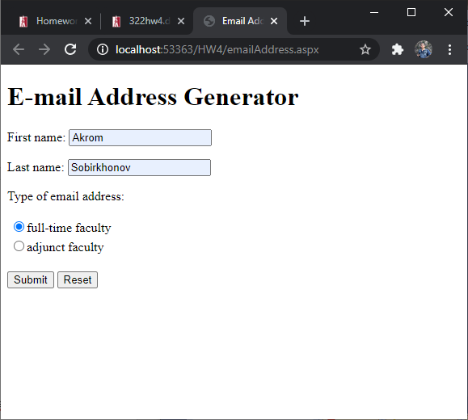

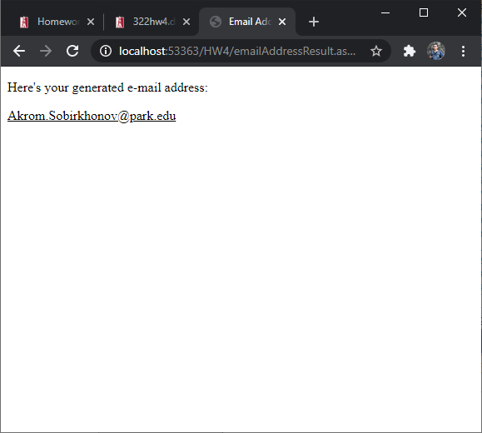

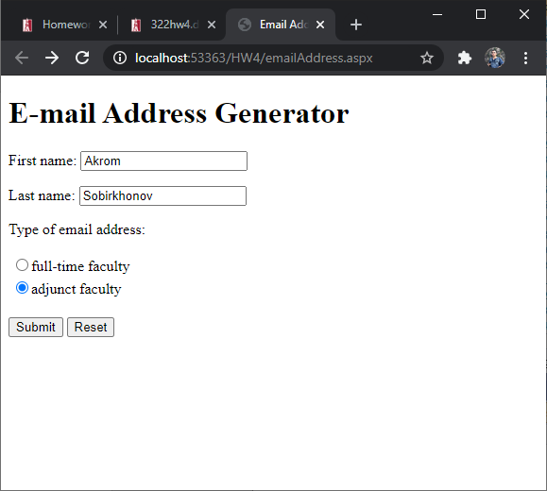

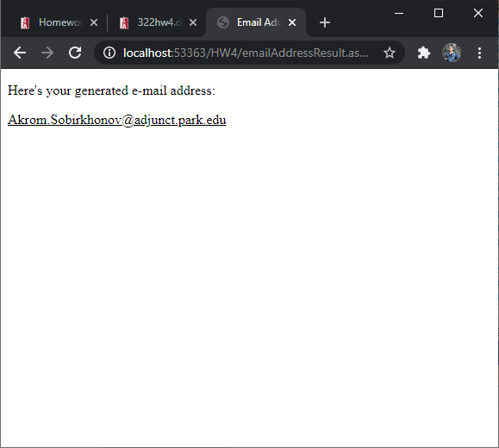

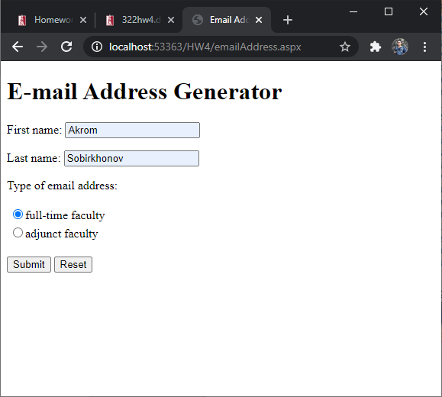

Now clicking Reset button

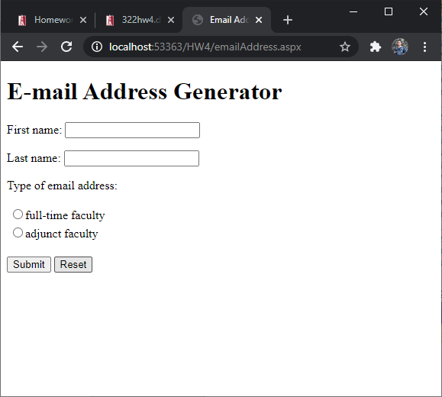

Extra credit:

