Akrom S

Exercises:

4) greater than “>” element (child selector)

5) lowest priority rung will be browser’s native default settings, which is a user agent style sheet

7) a

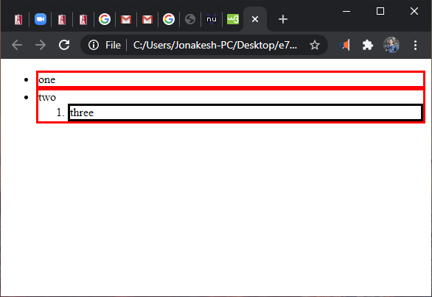

7) b

CSS rule for:

ul li {border-style: solid;}

uses descending selector syntax, and specifies to have solid borders for all lists inside the unordered list

CSS rule for:

ul > li {border-color: red;}

uses child selector, and specifies to have red border lines ONLY for children of unordered list for all lists. So, in this case, ordered list <ol> does not apply this CSS rule. To apply, need to change this css code to

ul \* {border-color: red;}

/\* I don’t know if my words make sense to you, but I did understand this question and I know how to use them \*/

Additional exercise:

<http://teach.park.edu/~asobirkhonov/cs240/hw4/pope.html>

Project:

<!DOCTYPE html>

<html lang="en">

<head>

<meta charset="utf-8">

<meta name="author" content="Akrom S">

<title>Pope Francis</title>

<style>

body {background-color: lightyellow;}

header {background-color: lightcyan;}

header \* {margin: 0; padding: 2.5px;}

section > h2 {background-color: lightblue; color: white;}

aside > figure {

float: right;

margin: 5px;

padding: 10px;

}

ul {list-style-type: circle;}

address {display: inline;}

</style>

</head>

<body>

<header>

<h1>Pope Francis I</h1>

<h2>

Bishop of Rome, Vicar of Jesus Christ, Successor of the Prince of the Apostles, Supreme Pontiff of the Universal Church, Primate of Italy, Archbishop and Metropolitan of the Roman Province, Sovereign of the State of Vatican City, Servant of the Servants of God.

</h2>

</header>

<article>

<section>

<aside>

<figure>

<img src="../images/pope.jpg" alt="Pope Francis waving to people"

width="400">

</figure>

</aside>

<h2>Quotes:</h2>

<ul>

<li>"We all have the duty to do good."</li>

<li>"Money must serve, not rule."</li>

<li>"I am a sinner."</li>

<li>"Working for a just distribution of wealth is not mere

philanthropy. It is a moral obligation."</li>

</ul>

</section>

<section>

<h2>Interesting facts:</h2>

<ul>

<li>Worked as a bar bouncer to pay for college.</li>

<li>Washes feet of incarcerated women.</li>

<li>Lives in a small apartment behind a gas station.</li>

<li>Orders Domino's take-out every Thursday.</li>

</ul>

</section>

</article>

<footer>

Report problems to the webmaster at <address>jorge.bergoglio@vaticancity.rign</address>

</footer>

</body>

</html>