Akrom S

Exercises:

1.

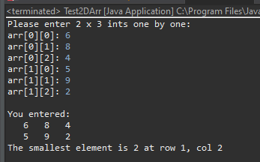

2.

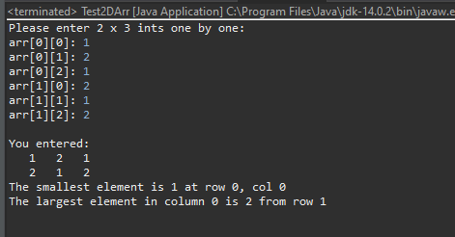

3.

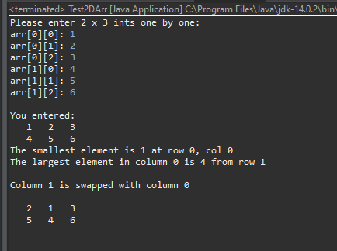

5. I think findColMax was a little bit hard for me, I was stuck on my loop and was trying all kinds of ways. I did mange to get to findMin really fast, but once I got to the indexResult, I was typing wrong parameters. I was not able to do extra credit, I don’t know how to rotate right. I tried to use swapping, but still not get it.