8_CINEMA_LOCALSTORAGE_JSON

LocalStorage and sessionStorage are a built-in feature of web browsers that allows websites to store small pieces of data directly inside your browser. This allows the site to remember things without needing a server.

To store data in localStorage, use the setItem() method. To retrieve data from localStorage use the getItem() method

Chrome

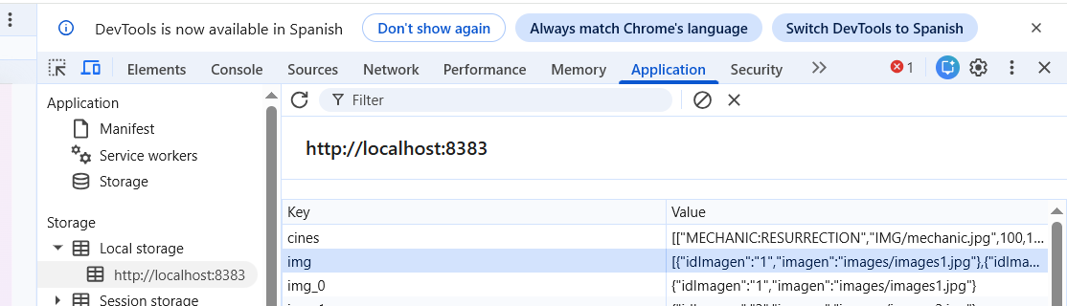

We have an application that manages a multiplex cinema with 4 screens. We are going to use JSON and localStorage to save the information

Since data does not exist in localStorage the first time we run the application, we are going to create a variable containing the following data:

if (!savedData ) {

var data=

[["MECHANIC:RESURRECTION","IMG/mechanic.jpg",100,100 ],

["UN MONSTRUO VIENE A VERME","IMG/unmonstruo.jpg",150,150],

["EL HOGAR DE MISS PEREGRINE PARA NIÑOS PECULIARES", "IMG/missperegrine.jpg",75,75],

["OZZY","IMG/ozzy.jpg",50,50]];

localStorage.setItem("cines", JSON.stringify(data));

savedData= JSON.parse(localStorage.getItem("cines"));

}

The subsequent times we open the app, the 'cinema' variable already exists, so we read it and retrieve the data. In the provided code, we check if the variable exists in localStorage; if it doesn't, we create it with the provided data, and if it does, we read it and save this data into an array.

Once the data is retrieved, we display the following image where we can see the posters for the four screens.

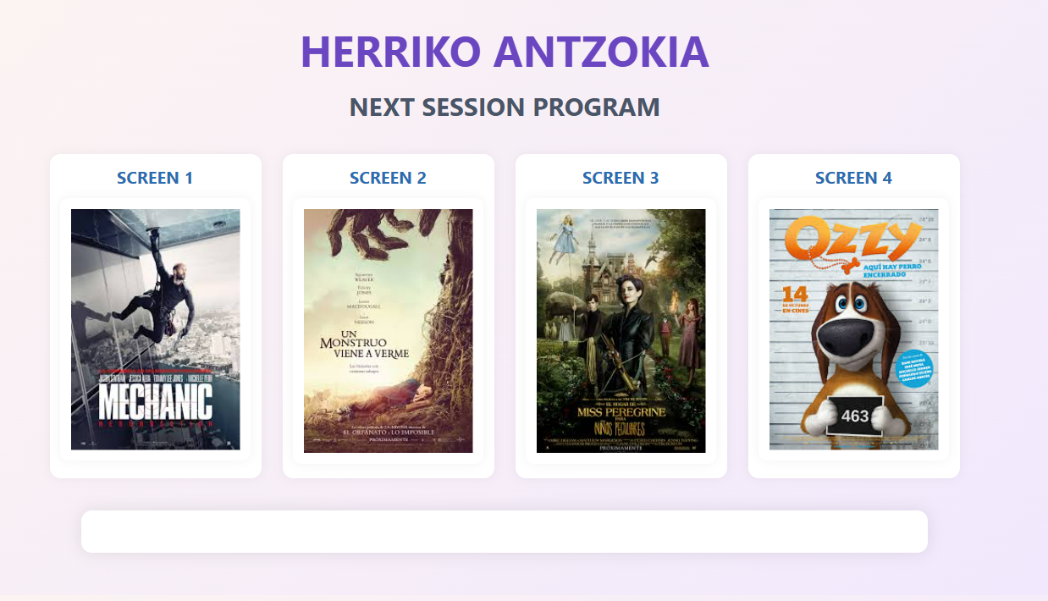

When we click on one of these screens, the next div is displayed, containing the movie's title and summary, along with a ticket purchase form.

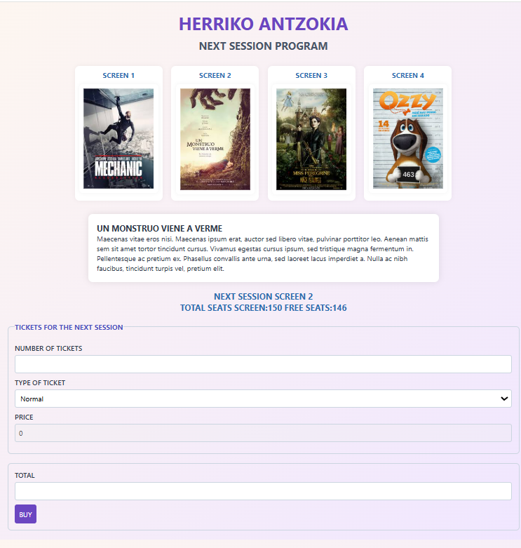

Every time we type a character in the number of tickets field, we verify that it is a number; if it isn't, nothing is typed. Once the digit is written, the total price is automatically calculated, recalculating the total as we keep adding digits. We have a select dropdown with two options: normal (€8) and discount (€5); depending on the chosen option, the ticket price changes, and so does the total to pay.

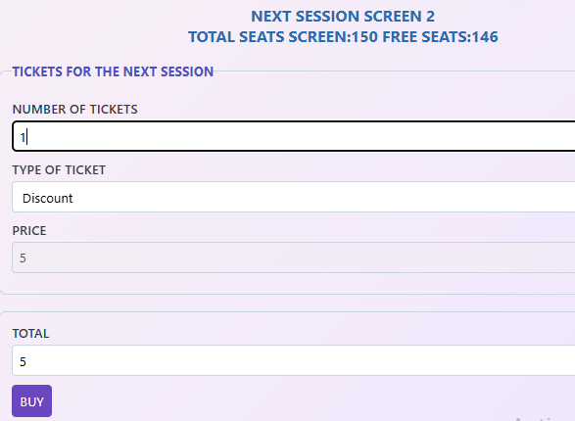

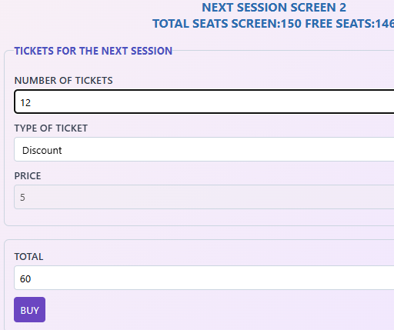

Once the number of tickets to purchase is selected, the 'Buy' button is pressed. This checks whether the number of requested tickets is less than or equal to the available tickets; if so, the sale goes through, and these tickets are deducted from the number of free seats. After this, the resulting JSON from the modified array is saved in localStorage. If more tickets than those available are requested, an error message is displayed. 