Client/Server Reliable Chat Application

Jonathan Hanna and Colin Reardon
Github

Comp 3825

11/30/2025

Table of Contents:
- How we did it (brief code description and description of tutorial or AI prompts)
  - Chatting between multiple (more than 2) clients
  - Replies to previous messages
  - Message deletion
  - Temporary messages
- Design Document
- Code Framework
- Full Codebase
- Instructions on how to install and run
- Screenshots of input and output

How we did it
This websocket chat server is a lightweight, multi‑client system that allows more than two users to chat together in real time by broadcasting public messages to all connected clients, while also supporting private direct messages between specific users. Each client is assigned a unique ID and name, and the server maintains a list of active participants that is updated whenever someone joins or leaves. Beyond simple messaging, it includes several advanced features: users can reply to previous messages by referencing their ID, delete messages either by ID or by removing the most recent one, and even send temporary messages that automatically expire after a set time. These temporary messages are scheduled for deletion using asynchronous tasks, ensuring they disappear from the shared history consistently across all clients. Together, these features make the server more than just a basic chatroom, providing structured conversation threads, moderation tools, and ephemeral communication, all while handling multiple simultaneous connections smoothly.

Tutorial Used: “Simple Chat Room Using Python” from GeeksforGeeks (Simple Chat Room using Python - GeeksforGeeks). This tutorial gave the basic setup for a chat room before adding any of the additional features in our code. For the backend, we used the code from this tutorial to start out our server.py file. The tutorial had us use clients to store active WebSocket connections, handle(ws) to register the client and listen for messages. ANd finally websockets.serve(handle, “localhost”, 6789) to start the WebSocket server on localhost:6789. For the frontend, the tutorial showed us how to make a simple html file, client.html. This temporary front end was able to display a space for users to type messages and then sent the messages to the server, and finally displayed the messages in the chat log. We ultimately went away from this approach and used a gui using GTK.

Following the use of the tutorial we moved into prompting Chat GPT to help create the additional features for the server and to create a more user friendly front end.
- add a /delete command to delete specific messages
- add /reply command to reply to specific messages
- /tmp to make temporary messages
- /exit to close connection on client side, give a user name for each new connection.
These prompts all used Chat GPT to expand upon server.py and add the additional features needed in our code.
- Front end: "based on client html write a python based front end for server.py"
- give it the client a gui using GTK
- once a message is deleted reload the message history so the deleted message does not show
These prompts were all for the front end and were used for Chat GPT to reimagine our simple html into a python based gui using GTK.

Design Document

Figure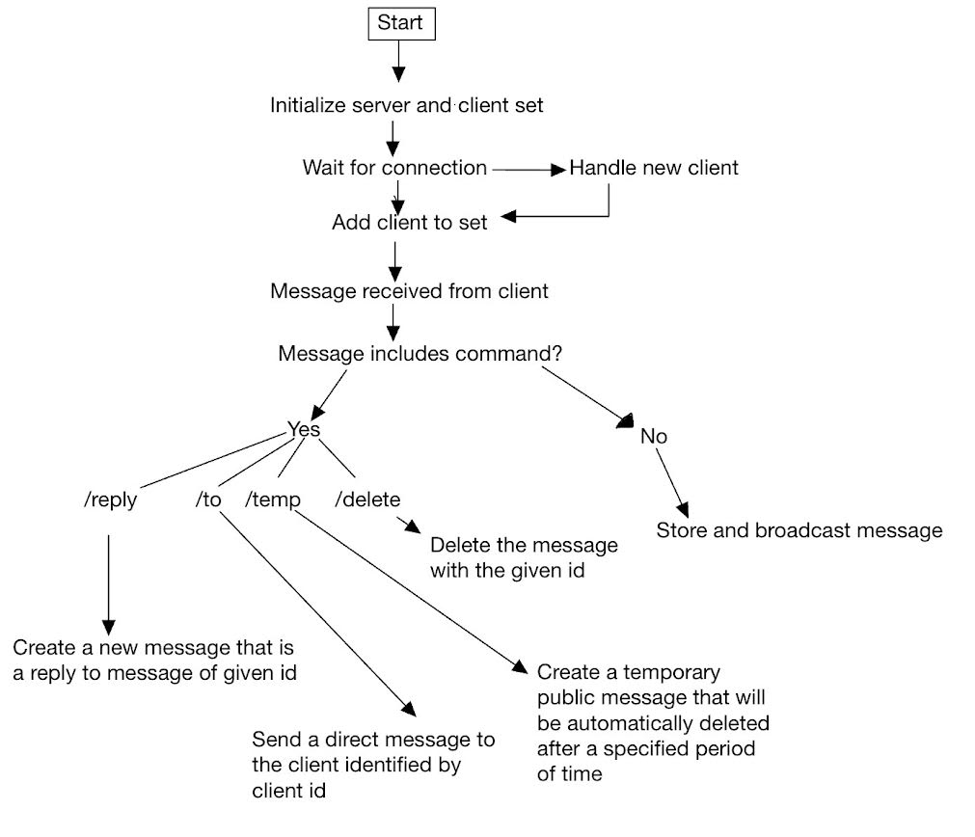
Figure 1: Flowchart of message sending process.
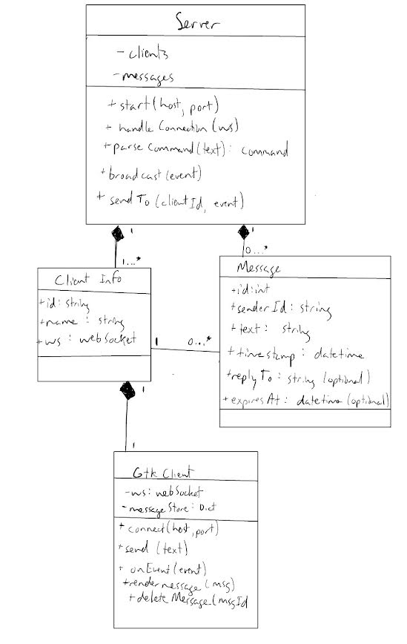
Figure 2: UML diagram.

Code Framework
Code framework for server.py:
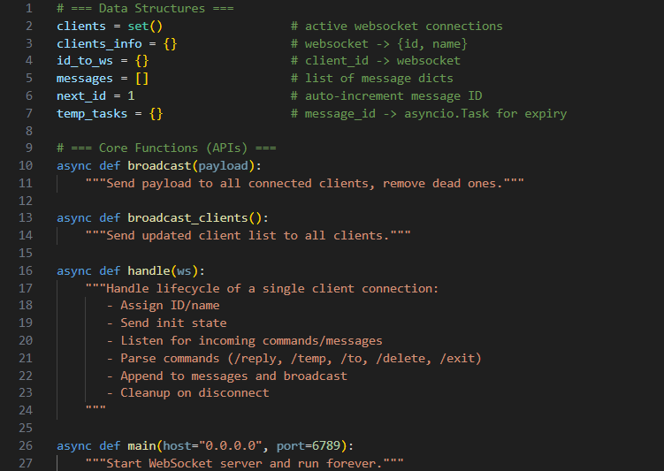
Code framework for client.py:
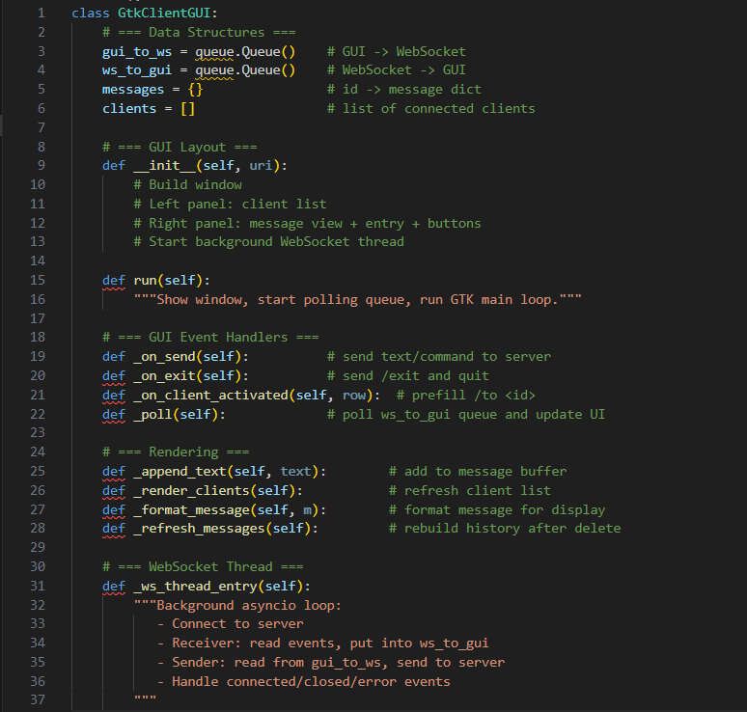

Full Codebase
Server.py (Link to Github):
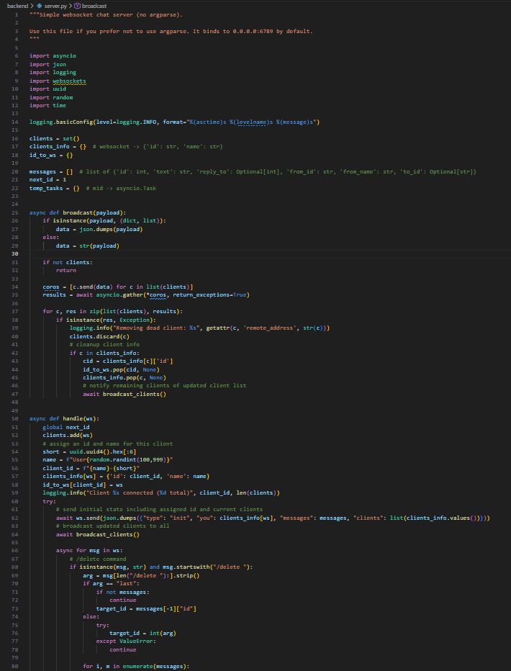
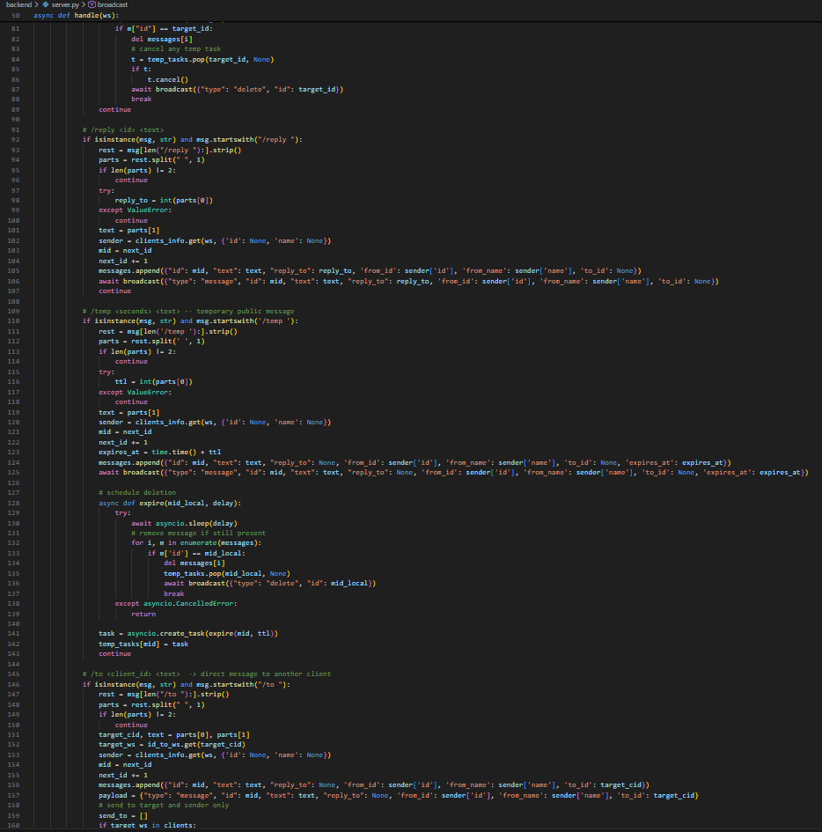
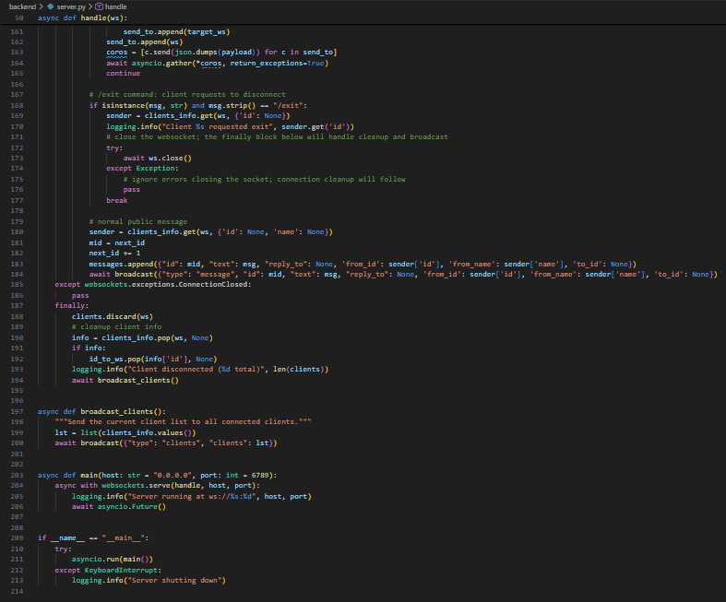
Client.py (Link to Github):
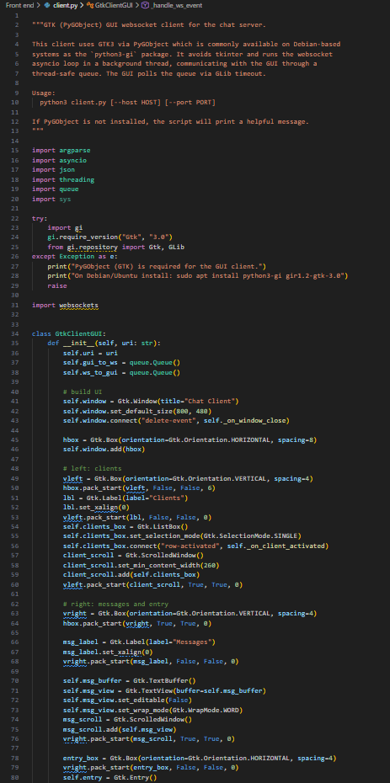
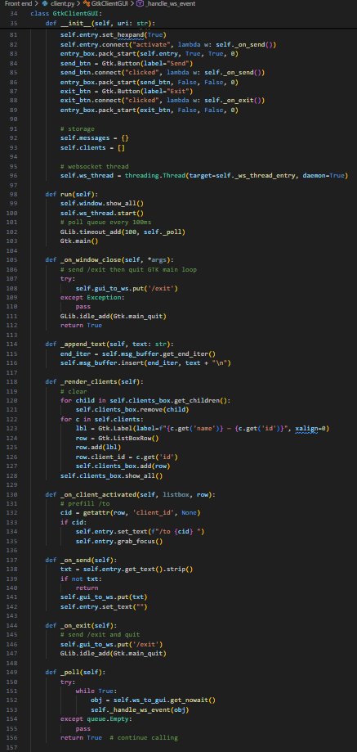
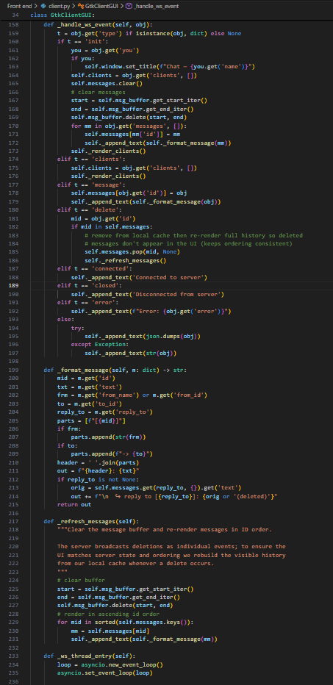
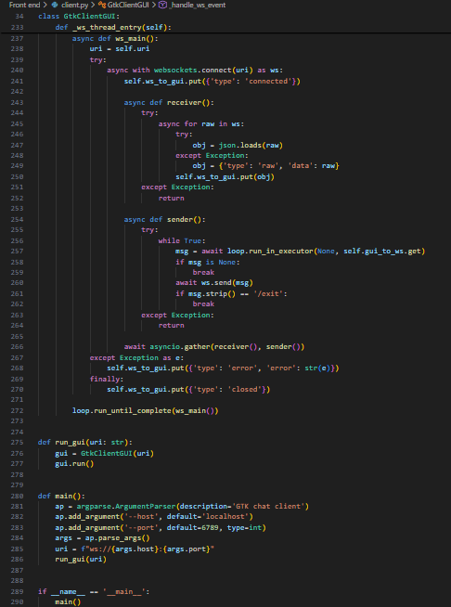

Instructions of how to install and run
To start, first clone the github or download the code on your local machine. These instructions also will assume you have Ubuntu 22.04 or later and Python 3.12 or later. Now, we will need to install some dependencies and to do that, run the following instructions in the terminal:
- Sudo apt update
- sudo apt install python3-gi gir1.2-gtk-3.0
- sudo apt install python3-websockets
Now, we will need to run the server, by first navigating to the server code directory and then starting the server:
- cd path/to/Network_Final-Proj/Server
- python3 server.py
And finally, in a new terminal start the front end:
- cd path/to/Network_Final-Proj/Front\ end
- python3 client.py
Now to actually use the server you can send messages using the gui. Additionally, using the input field in the gui, you can do the following:
- `/delete <id>` — delete the message with the given id. Also supports `/delete last` to delete the most recent message.
- `/reply <id> <text>` — create a new message that is a reply to message `<id>`.
- `/temp <seconds> <text>` — create a temporary public message that will automatically be deleted after <seconds> seconds. The server includes an `expires_at` (epoch seconds) field in the broadcasted message so clients can display expiry info.
- `/to <client_id> <text>` — send a direct message to the client identified by `<client_id>` (use the client list shown in the UI to pick an id).

Screenshots of input and output
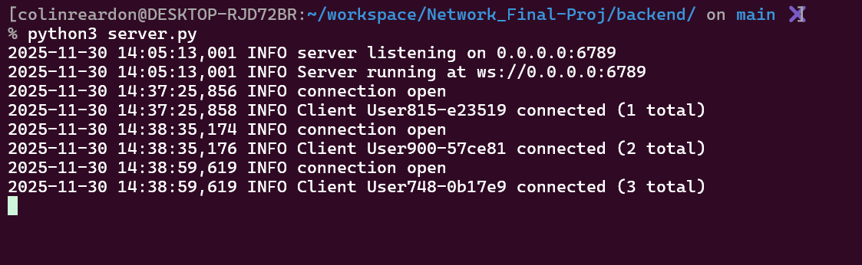
Image 1: Starting the server.
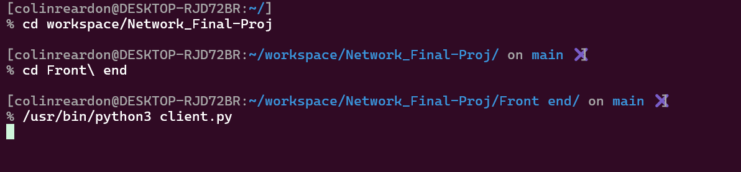
Image 2: Starting a client instance.

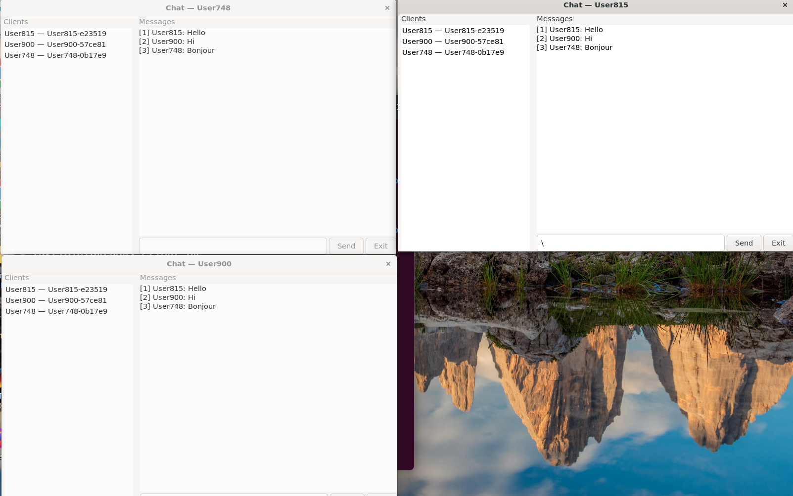
Image 3: Messaging between 3 clients all at once.

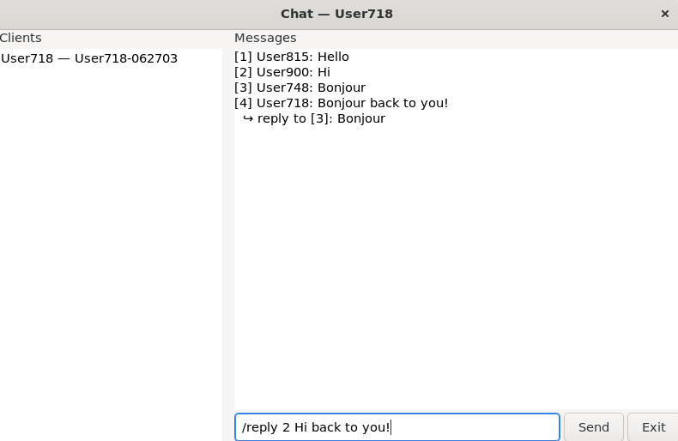
Image 4: Input for a reply message.
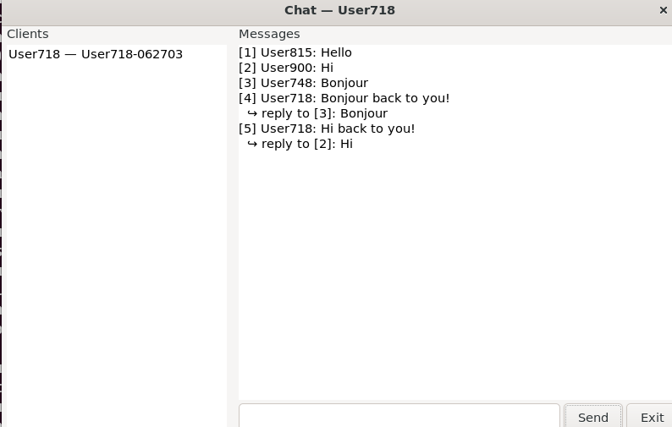
Image 5: Output for a reply message.
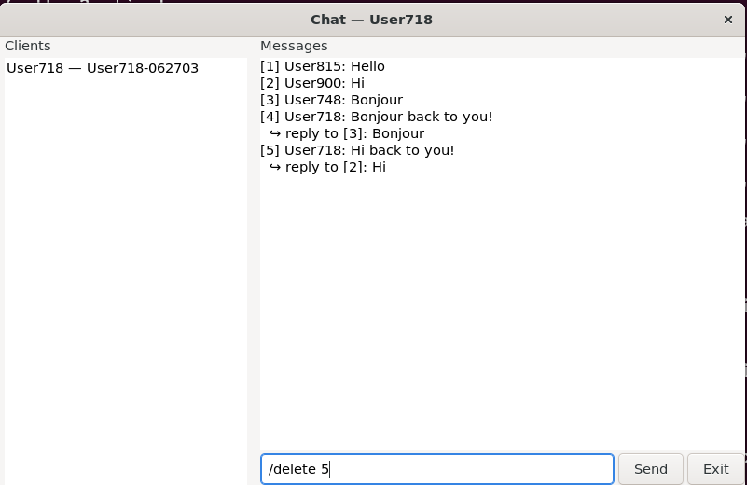
Image 6: Input for deleting a message by message ID.
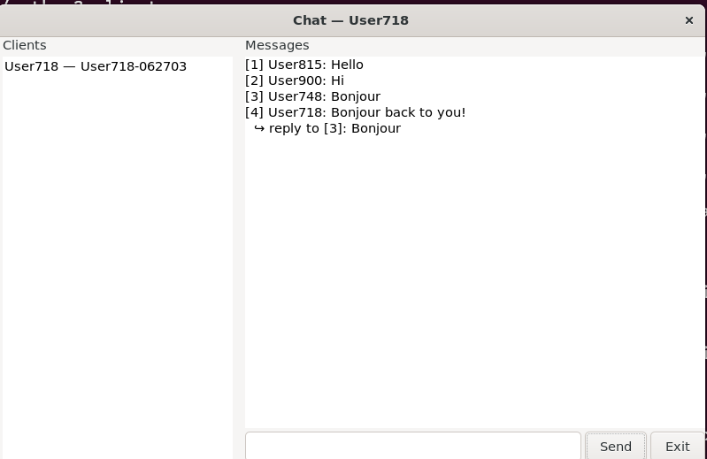
Image 7: Output for after deletion of message 5.
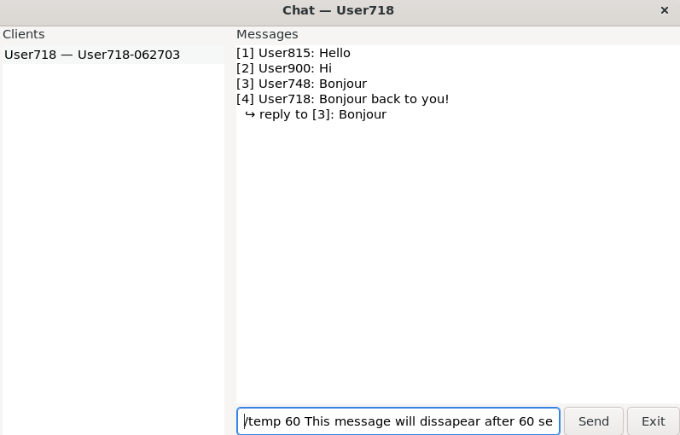
Image 8: Input for temporary image.
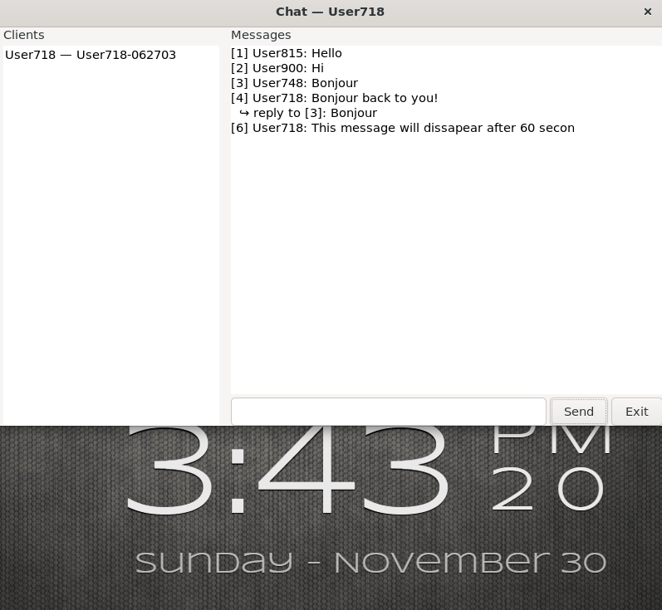
Image 9: Output of temporary message right after it was sent.
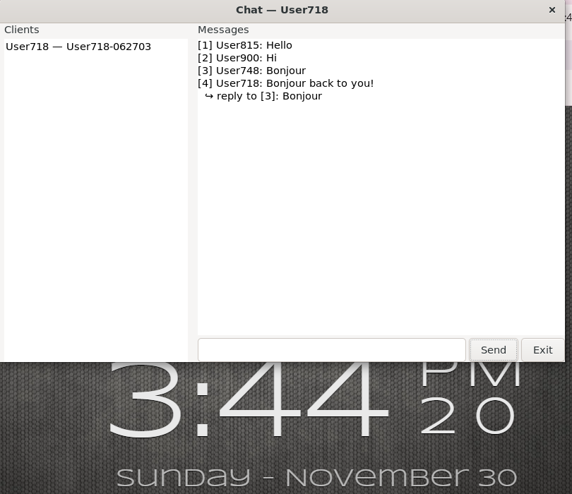
Image 9: Output of temporary message after the 60 seconds ran out.

