CS6014 – Jon Pulsipher – Packet Delay + Measurement – 1/7/26

Q1: Internet Delay
500 bytes - 10 ms, 2.8 ms, 2.4 ms, 4 ms, and 5.5 ms
1000 bytes - 11.0 ms, 10 ms, 2.8 ms, 3.0 ms, and 5.5 ms
8.2 + 7.2 + 0 + 0.2 + 2.7 → average 3.66ms.
Transmission(propagation): 2ms
Transmission(transmission): 0.4ms for 500 bytes
Transmission(queueing): mins are 2.4ms and 2.8ms

What is the average queuing delay experienced by the 1000-byte packets?
3.66ms

What are reasonable estimates of transmission and propagation delays that will be experienced by a packet of size 600 bytes sent through the link K?
Propagation delay remains at 2ms, and size-dependent transmission delay will be 0.48ms if 0.4ms/500bytes holds.

Q2: Traceroute
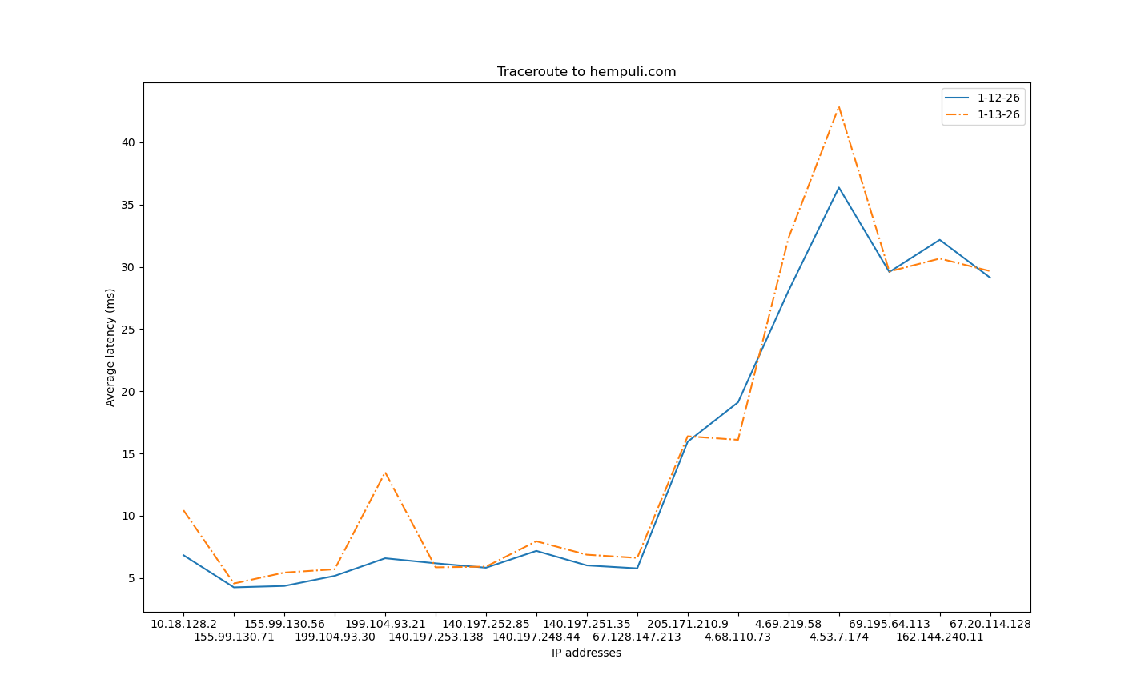
Part B: Suppose one of the three traceroute delay values between the source and a given router hop turns out to be unusually high. What are two possible causes for this unusually high delay?
1) Queuing delay. Other packets may have taken priority for the delayed hop and not the others.
2) An unpredictable processing or transmission delay on the targeted router, which could be anything. Maybe someone assembled it with cans and string, but still managed to receive and respond with the appropriate protocol.

Q3: Ping

Average delay to uva.nl (University of Amsterdam) is 5.092ms

