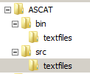
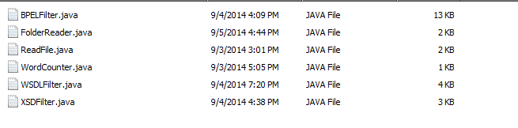
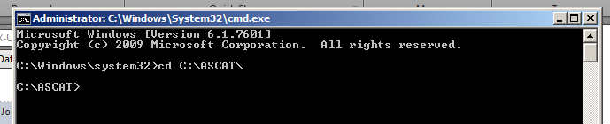
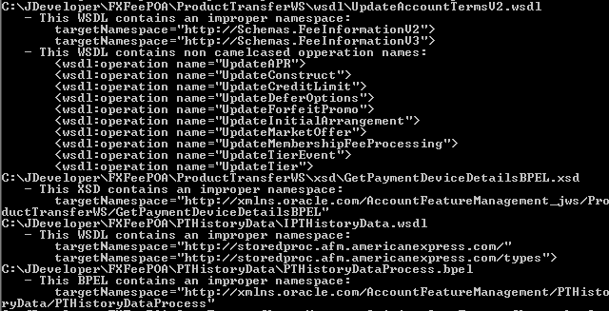
Automated Standards Compliance Assessment Tool (ASCAT)

This tool is used to filter our composite files and find non-standard item violations.

To use the tool, please take this file and put it somewhere in your local computer.

Inside, you will find these files.

We have 4 folders.

Inside the textfiles folder, you can find these java files.

Run your command prompt and change your directory location to the location inside the ASCAT folder.

Run this line of code:
javac -d bin -sourcepath src src\textfiles\FolderReader.java
This will compile all the java files into classes.
Now we will need to run the code.

Use this command:
java -classpath bin textfiles.FolderReader (directory of the composite or composites that you want to check)
In this example, we are using the folder C:\JDeveloper\FXFeePOA.
The code will iterate through all files and directories in the path you inputted. It will then print all the violations that it has found.

As of 9/5/2014, here are the violations which ASCAT can filter:
Filter XSDs, BPELs, and WSDLs. For the latter, will only pick up non wrapper and ref wsdls.
Search for non-standard BPEL activity names.
Assigns
Scopes
Invokes
Transformations
Count and then validate the number of words of the names of specific files. Print a flag if the number of words goes over the suggested amount.
Search and flag non-standard WSDL, XSD, and BPEL namespaces.
Search and flag wsdls for operation names which are not camel cased.

Here is an excerpt of violations found (for enhancement, these should be printed to a file):

