Analysis of Poland’s Economic and Trade Performance
Executive Summary
Poland’s growth since the collapse of the Soviet Union has seen continued gains in productivity until today, augmented by rapid growth in capital investment since Poland joined the EU in 2004. Poland’s export patterns show a shift away from traditional sectors such as raw textiles and agricultural products towards more finished and industrially manufactured textiles along with industrial materials and goods more generally. Trade patterns for Poland reveal potential shortcomings in Poland’s integration with its neighbors and key partner nations, especially within the context of its relationship with the EU and other EU states. As Poland continues to invest in growing its manufacturing base domestically, it must invest in building stronger relationships with its trading partners and examine whether its relationship with the EU may be creating inadvertent barriers to trade within the economic bloc.
Background: Economic Performance
During this period, Poland experienced consistent economic growth that was driven by different factors. In the 1980s, Poland's TFP was relatively stagnant. However, productivity started increasing in 1991, coinciding with the collapse of the Soviet Union and the end of communist rule over Poland in 1989. During this period, growth appears to have been largely driven by this increase in productivity, whereas per capita capital investment in Poland remained largely stable. However, starting in 2004, when Poland joined the European Union, it began to experience a more notable increase in capital investment along with continuing productivity growth. During this period, Poland's productivity more than doubled between 1980 and 2019.
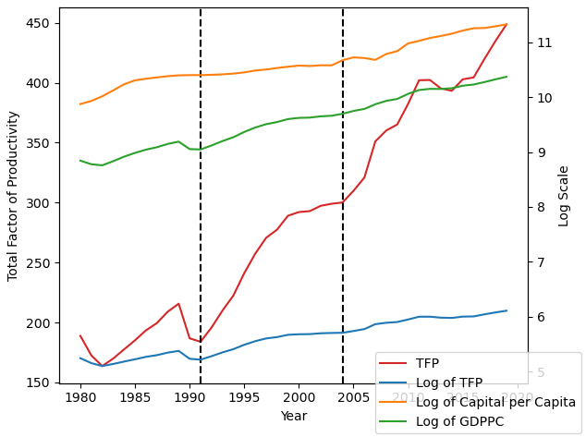
Figure 1: Productivity Trends in Poland, 1980-2019
Export and Comparative Advantage Assessment
Poland’s export data suggests a relatively diversified industrial and trade performance, with revealed comparative advantages greater than 1 in more than half of the HS2 sectors both in 2000 (50 sectors) and 2021 (61 sectors). However, the trade data from this period also suggests changing export and competitiveness patterns. As shown in the table, the sectors with some of the largest absolute RCA declines between 2000 and 2021 were among the most competitive sectors in 2000 – including HS 60 (Knitted or Crocheted Fabrics), HS 59 (Impregnated, Coated, Covered, or Laminated Textile Fabrics; Textile Articles Suitable for Industrial Use), and HS 51 (Wool and Fine or Coarse Animal Hair, Including Yarns and Woven Fabrics Thereof; Horsehair Yarn and Woven Fabric). The sectors in which Poland’s economy appears to be gaining the most competitiveness based on RCA are HS62 (Articles of Apparel and Clothing Accessories, not Knitted or Crocheted), HS 61 (Articles of Apparel and Clothing Accessories, Knitted or Crocheted), and HS 1 (Live Animals). This perhaps suggests a shift from a focus on raw materials to the production of finished goods, especially in textile-related industries. Whereas in 2000, the most competitive sectors based on RCA in Poland were HS 59 (Impregnated, Coated, Covered, or Laminated Textile Fabrics; Textile Articles Suitable for Industrial Use), HS 5 (Products of Animal Origin), and HS 60 (Knitted or Crocheted Fabrics), the most competitive sectors in 2021 were HS 48 (Paper and Paperboard, Articles of Paper Pulp, Paper, or Paperboard), HS 83 (Miscellaneous Articles of Base Metal), and HS 89 (Ships, Boats, and Floating Structures). This further confirms a change towards more industrially oriented production as opposed to solely focusing on agricultural goods.

Largest Changes in Revealed Comparative Advantage (RCA) For Poland, 2000-2021
Largest Gains |  | Largest Losses
HS2 | ΔRCA | HS2 | ΔRCA
62 | 1.764 | 51 | -1.379
61 | 1.382 | 52 | -1.419
1 | 1.372 | 30 | -1.435
24 | 1.302 | 59 | -1.676
95 | 1.248 | 60 | -1.783

Figure 2 suggests a degree of ‘clustering’ in which sectors are gaining or losing competitiveness. In sectors 1-24 (most agricultural goods), there is less of a consistent pattern, showing that in agriculture, some sectors gained competitiveness while others declined. Meanwhile, in goods coded as HS 25-60, which cover many natural materials and some finished goods, the majority of sectors declined in competitiveness. In contrast, in goods covered by HS codes 61-99, which cover metals and industrial goods along with finished goods often more dependent on industrial manufacturing, most of these sectors saw gains in revealed comparative advantage. Therefore, the trends in Figure 2 further suggest a shift towards more industrial capacity between 2000 and 2021 in the Polish economy.

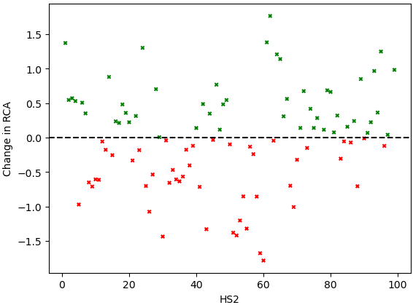
Figure 2: Change in RCA Between 2000 and 2021 by Sector
Imagining Global Trade Without the WTO
The gravity model regression performed for Poland’s trade relationships in 2020 aligns with the key findings in the gravity model. For a 1% increase in the distance between Poland and its trading partners, trade values decline 1.428%, and for a 1% increase in the destination partner GDP, trade values increase 0.960%. Both results are statistically significant. These are also the only variables in the model shown in Figure 3 that are statistically significant (common language shows as significant, but no other country in the world uses Polish as its national language). The regression model suggests that the destination trading partner being a member of the WTO correlates with a 105.32% higher volume of trade between Poland and that partner. However, this result is not statistically significant, making it difficult to predict the effects that WTO dissolution may have on Poland’s trade relationships. Interestingly, the coefficient for the variable corresponding to whether the destination partner also being an EU member is negative, which is somewhat unexpected for a trading bloc like the EU. However, the result is not statistically significant.
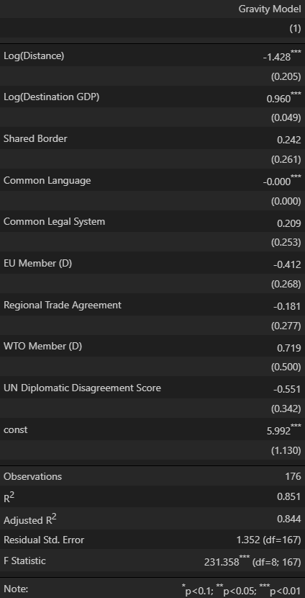
Figure 3: Gravity Model for Poland’s Trade, 2020 Data
Barriers to Trade
In the absence of broader multilateral organizations like the WTO, Poland should look at strengthening its economic ties with its neighbors and regional partners. Economic blocs like the EU, which Poland is a member of, are normally intended to reduce frictions related to trade and economic activity. As previously noted, the fact that the gravity model predicts reduced trade volumes between Poland and other EU member states is interesting, and Poland should perhaps investigate this result further. Perhaps there may be structural barriers related to Poland’s relationship to other EU states that are currently preventing the theoretical benefits of membership in the EU from materializing for Poland. And insofar as having a common legal system is associated with a positive (although non-significant) effect on trade volume, Poland should investigate reducing legal and administrative burdens related to trade with partners that may have more dissimilar legal systems.
Summary Discussion
Poland’s economic growth over the last two decades is characterized by a shift towards more industrial production, which has only been accelerated by growing capital investment following EU membership in 2004. Developing a more robust industrial base may prove beneficial not just from an economic perspective, but also be valuable to Poland from a national security perspective given its position on the Eastern flank of NATO and the EU. In addition to continuing leveraging its strengths in industrial sectors, Poland should evaluate its relationships with key partners in the region. Since the collapse of the Soviet Union, Poland has been one of the fastest growing economies in Central and Eastern Europe. However, in recent years, its relationship with international bodies like the EU has been rockier at times, which may also be preventing Poland from getting the most it can out of membership in multilateral institutions like the EU. Therefore, Poland should look at bolstering such ties in the future.

