<https://www.geeksforgeeks.org/linked-list-set-1-introduction/>

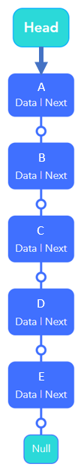

ad