Annotation Guidelines

Introduction
Hello annotator, welcome to the Violence in Narrative Discourse project.
Our project aims to develop a corpus of human-annotated text passages, showcasing the different ways in which violence and aggression is portrayed in literature. This corpus will be used in the creation of automated text-classification tools, helping us to deepen our understanding of the depiction of violence in modern literary media.
Your task as annotator will be to identify sentences of violent nature in the provided material and to specify which category of violence they belong to. Further you’ll annotate information important to the understanding of the context in which the violence occurred, such as the victim and perpetrator of violent acts.
This document is organized as follows:
First a general overview of the annotation process is provided. In later segments the two steps of the annotation process are described in more detail. All attributes and categories are underlined, and have sections of their own in which they are described in more detail. Examples for each attribute and category can also be found in these sections.

The annotation process - Overview

Step 1: Finding and classifying violent sentences
First you’ll read through the provided text document and find any and all sentences containing violent language, depicting violence or describing the outcome of a previous violent event.
This could mean anything from the description of bloody clothes, people hitting or killing each other, people verbally lashing out or insulting one another, self-harm, someone expressing the wish to hurt someone, to a building being described as “cruel looking”.
For each sentence you mark as violent, you’ll classify which main category they belong to. These categories specify if the violence in a sentence is of physical or verbal nature, or something else (other).
Continue with your annotation until you classified all occurrences of violence in the provided text passage.

Step 2: Annotating attributes of violent sentences
Once all sentences of violent nature have been found, you’ll go back to the beginning of the provided document and start annotating the additional features of all sentences selected in the previous step.
No new sentences are to be added to the selection in this step, instead the annotation of the already sentences will be enriched by filling out all additional information in the form of the features present in the sentence.
These features, if present, describe between which characters the violent act occurred (who is victim, who is perpetrator?), if the participants in the action have some relation to one another or are directing their aggression against a relationship rather than an individual person, if the act is actually happening or just ideated.
Further they allow the classification into certain types of aggression.
You will, for each sentence, go over the list of features and review whether the sentence meets the requirements for the feature. If the requirements are met, the feature is to be added to the annotation. If the requirements aren’t met, you won’t add the feature to the annotation.
Once all sentences have been annotated in this manner, your submission will be compared with the annotations of other annotators on the same document section. During this comparison, an inter-annotator agreement will be calculated. With high enough agreement, the annotations will be accepted as valid and will enter our gold standard.

Finding violent sentences

Violent sentences are sentences which meet one or more of the following requirements:
- A person causes physical harm to a person
- A person damages an object
- A person gets harmed
- A person causes emotional harm
- A person gets emotionally harmed
- Violence is described
- A Metaphor implies violence
Within brat, the annotation tool you’ll use to annotate the sentences, you will highlight the entirety of the sentence (a multi-word span), starting with the first word and ending with the last word before the period, and mark the sentence by giving it the entity type: violent sentence.
The resulting annotation might look something like this:

Annotating violent sentences

Within a violent sentence there are various pieces of information to be found, which all need to be annotated accordingly.
As you already annotated the sentence as a violent sentence, it is a given that some form of violence or aggression is present. First you’ll annotate what aggression type is present in the sentence. For this, you will annotate a multi-word span containing the violent/aggressive act. This span will be at a minimum a word, and at a maximum the entirety of the violent sentence.
In our example sentence
the span of text that describes the actual act of aggression is this:
Once the span of text is selected, you’ll annotate it using the fitting event type. Which event type is appropriate will be discussed in the aggression type section of this guideline. This might look something like this:
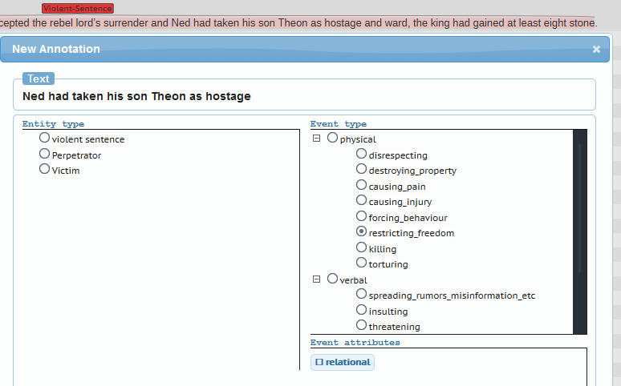
Once an event type is selected, you’ll have to consider if the violent act has a relational component. For this you have to ask yourself if at least one of the following two conditions is met:
- The perpetrator has a relationship (familial, romantic, economic, etc.) to the victim
- The perpetrator is trying to harm a relationship (familial, romantic, economic, etc.) the victim has to someone else
If one of those two conditions is met, mark the event as relational in the event attributes:
In this example, the wording of ‘his son Theon’ makes it clear that the action has a relational component.
The next step is to decide whether the action is actually happening or just ideated. For this you have to ask yourself if at least one of the following conditions is met:
- The perpetrator plans an action, but has not implemented it yet
- The perpetrator has no plans to implement the action, but still thinks about it
- A hypothetical situation is described which contains a violent action
If one or more of these conditions is met, mark the event as ideation in the event attributes:
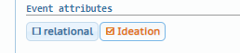
If the sentence is not a “physical” or “verbal”, but an “other” event type, you might find that the available options aren’t able to accurately describe what is going on in the sentence.
In such a case, mark the sentence as other without a subcategory,
and write a description of what you encountered into the notes field:
Once you have filled out all information, confirm your annotation by pressing OK.
The result might look something like this:
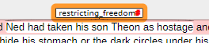
Next you’ll need to identify victim and perpetrator of the action, if such information is available. There are sentences which do not have victim or perpetrator, there are sentences where the information is available, but not within the sentence itself, and there are sentences where the information is readily available.

Scenario 1: Victim/Perpetrator can be found within the violent sentence.
If victim or perpetrator can be found within the violent sentence itself, you will annotate them at this location. For this, you’ll create a span of text, selecting the victim or perpetrator. This can be a single word, or a multi-word span.

Scenario 2: Victim/Perpetrator cannot be found within the violent sentence
If victim or perpetrator cannot be found within the violent sentence itself, you will have to look within the rest of the chapter, to see whether the victim or perpetrator can be determined by context.
If you do find victim or perpetrator outside the violent sentence, annotate them at the nearest occurrence within the text. For this, you’ll create a span of text, selecting the victim or perpetrator. This can be a single word, or a multi-word span.

Scenario 3: Victim/Perpetrator cannot be found.
If victim or perpetrator cannot be found within the violent sentence or the rest of the chapter, do nothing.
---
Regardless of which scenario applies, the annotation for the span of text itself is always the same:

Identifiers can be the name of a character, title of a character, description of a character, pronouns and similar things.
Once the victim/perpetrator is selected, annotate the text span as entity type: perpetrator (if the character is the one perpetrating the violent act), or as entity type: victim (if the character is on the receiving end of the violent act).
This might look something like this:
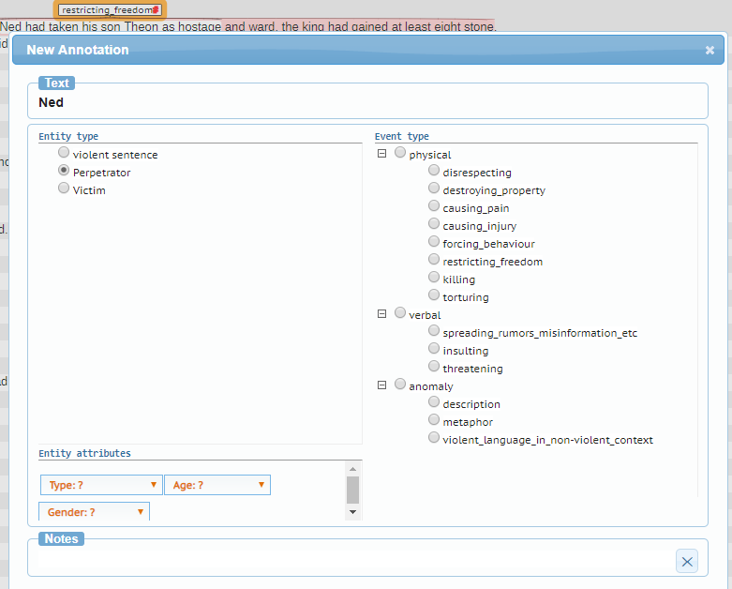
If information is available about the victim/perpetrator, you’ll then fill in the entity attributes.
The entity attribute type allows you to specify whether the entity is a human, a humanoid, a non-human or an object.
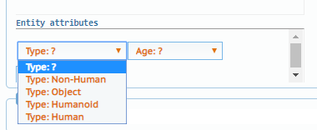
A human is self-explanatory, and will make up the majority of entities.
A humanoid is an entity that looks similar to a human in that it has two legs, two arms, a head and walks upright, but is not actually human.
A non-human is an entity that is alive, doesn’t look humanoid and isn’t a human.
An object is anything that isn’t alive and doesn’t look humanoid and isn’t a human or non-human.

The entity attribute age allows you to specify whether the entity is underage or considered an adult (of age).
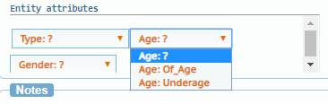
Of_Age means that the entity is legally (within the context of the piece of literature) an adult.
Underage means that the entity is legally (within the context of the piece of literature) considered to be a child / not an adult.
If it is unclear whether the entity is of age or underage, leave the setting at the default value of Age:?

The entity attribute gender allows you to specify whether the entity is male or female.
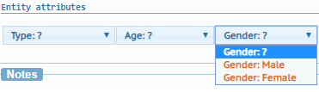
If it is unclear whether the entity is male or female, or if such a description would be inaccurate, leave the value at the default setting of Gender: ?
Once you’ve assigned the entity type and filled out the entity attributes, confirm your annotation by pressing OK.
Your result might look something like this:
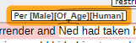
Repeat this step, until you’ve annotated all victims and perpetrators that belong to the violent act within the violent sentence.

Once you annotated all entities and events, proceed to the next violent sentence.

Unit of Analysis

Sentences
Sentences are a unit of analysis. They start at the first word of the sentence and end with the last word before the terminating punctuation (period, exclamation mark, question mark) in the sentence.
Three dots (...) generally aren’t terminating punctuation and should only be treated as such, if the following sentence indicates this by starting in upper case.
This also applies to sentences which contain sub-sentences, such as speech.
Example:
- "Ah, Ned," he said, "you are still too serious."
The sentence starts with Ah and ends with serious.
- "Lyana was... fond of flowers."
The sentence starts with Lyana and ends with flowers.

Chapter
Chapters are a unit of analysis. They are individual documents provided to you for your annotation task. They are made up of many sentences.

Main categories

Non violent
Sentences are assumed to be non-violent as default. Non violent sentences do not need to be annotated.

Violent
Sentences that are violent need to be marked as such. See Aggression Type for examples.
Violent sentences must belong to at least one of the following three categories:

Physical
Intentional hostile acts that cause physical harm to a target or the target’s possessions. See physical aggression types for examples.

Verbal
The act of directing aggressive or violent statements against a target. It also elicits hostility for its target.
Includes indirect, passive and ideated (non-spoken/thought) aggression.
See verbal aggression types for examples.

Other
Sentences which are neither verbal nor physical aggression, but still indicate aggressiveness or inaccurately appear to fall into the other two categories.
E.g. Descriptions, metaphors, ambiguous language
See other aggression types for examples.

Features

Victim
The person on the receiving end of an aggressive/violent act.

Attributes:
- Type: Whether the victim is Human, Humanoid, Non-Human or an Object.
- Age: Whether the victim is of age/an adult, or is underage/a child.
- Gender: Whether the victim is male or female.
An identification within the sentence is preferable to one outside the sentence.
An identification near the sentence/within the same context is preferable to an identification further away.
An identification containing the full name of the character is preferable to an identification by characteristics and description (e.g. “the tall man”, “the old lady”), which is still preferable to identification by pronoun (he/she/it).

Perpetrator
The person committing the aggressive/violent act.

Attributes:
- Type: Whether the perpetrator is Human, Humanoid, Non-Human or an Object.
- Age: Whether the perpetrator is of age/an adult, or is underage/a child.
- Gender: Whether the perpetrator is male or female.
An identification within the sentence is preferable to one outside the sentence.
An identification near the sentence/within the same context is preferable to an identification further away.
An identification containing the full name of the character is preferable to an identification by characteristics and description (e.g. “the tall man”, “the old lady”), which is still preferable to identification by pronoun (he/she/it).

Aggression type
The classification of the aggression. Several categories may apply.

Attributes:
- Relational: Whether the aggressive/violent act is between people that have a relationship to one another/is targeting the relationship of the victim to another person.
A relationship may be familial (related, married to, etc.), romantic (in love with, married to, etc.), platonic (friendship, etc.), economic (employed by, indebted to, etc.) and so on.
- Ideation: Whether the aggressive/violent act is actually carried out, or just thought of.

Physical aggression types
- Disrespecting the victim
- Destroying property
- Causing pain
- Causing injury
- Killing
- Torture

Verbal aggression types
- Disrespecting the victim
- Spreading rumors/misinformation/etc.
- Insulting
- Threatening

Other aggression types
- Description
- Metaphor
- Violent language in non-violent context

