Abundance Plot Manual

1. User Interface (UI)

In the upper-right section of the user interface, you will find a set of controls for customizing the plot:

- Toggle Legend: Enables or disables the display of the legend in the plot.
- Toggle Header: Enables or disables the display of the header in the plot.
- Levels: Allows selection of the data set to visualize. Available options include:
  - Protein – available after uploading protein-level data.
  - Phosphosite – available after uploading the phosphosite-level data.
  - Phosphoprotein – available after initializing a collapsing pipeline for the phosphosite-level data.
- Plot Width, Height, and DPI: Adjust the dimensions and resolution of the plot for download.
- Download Format: Choose the file format for downloading the plot, including PNG, JPG, SVG, or PDF.
- Download Button: Exports the plot according to the selected settings. Note that changes in size affect only the downloaded plot and do not modify the display in the interface.
- Choose Condition: Allows selection of a specific condition to visualize. Users can choose a single condition to generate an interactive condition-specific plot or select “All Conditions” to generate a static plot showing all conditions.
- Select {level}(s) to highlight: Enables highlighting of specific features (proteins, phosphosites, or phosphoproteins) in the plot. Selected features appear in a distinct color (e.g., red) to allow quick visual identification and comparison against all other features.

2. Abundance Plot

The abundance plot functionality is implemented using two complementary functions, each designed to visualize the distribution of feature intensities at different levels and aggregation modes:

- abundance_plot – Generates condition-level scatter plots, where each point represents a feature’s mean intensity within a condition.
- interactive_abundance_plot – Produces sample- or condition-specific interactive plots, allowing users to explore individual features, highlight selected features, and display detailed information on hover.

These two views allow users to inspect the global abundance patterns of proteins, phosphosites, or phosphoproteins, to explore specific features of interest.

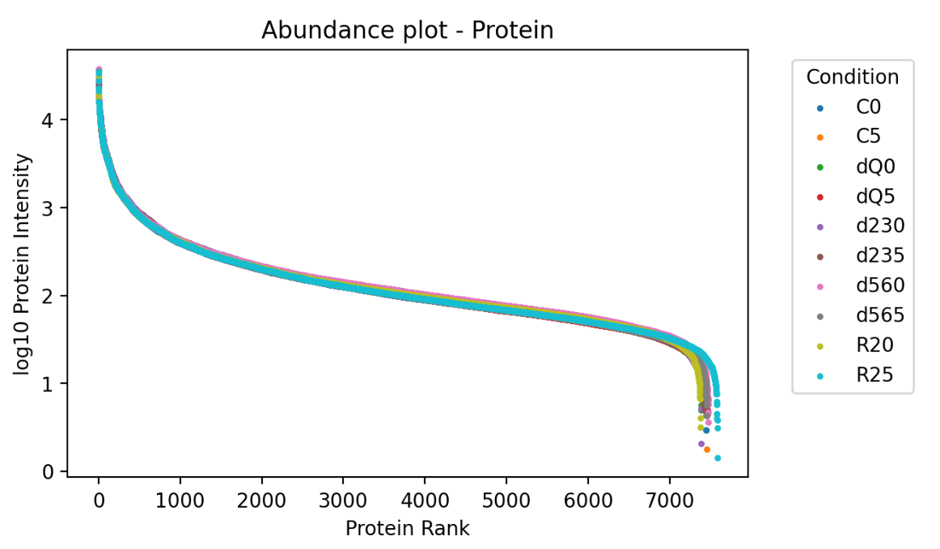
Figure 1: Static Abundance Plot for “All Conditions”.

In the static abundance plot created by abundance_plot, all samples belonging to the same condition are first averaged feature-wise across the column dimension. For each feature, the mean intensity across replicates is computed and then log₁₀-transformed after adding 1 to avoid undefined values at zero:

$$\text{log10Intensity}={log⁡}_{10}(\text{mean intensity across replicates}+1)$$
These log-transformed mean intensities are ranked within each condition to produce a feature order for visualization. Each feature is then plotted as a point, with the x-axis representing its rank, from highest to lowest intensity feature, and the y-axis showing the log₁₀-transformed intensity. Colors distinguish conditions, and optional legends and headers provide context. This aggregated view highlights the global distribution of feature intensities while minimizing sample-specific noise.

The interactive plot created by interactive_abundance_plot allows deeper exploration of specific conditions or features. For a selected condition, individual feature intensities are averaged across all replicates and log₁₀-transformed in the same way. Users can highlight specific proteins, phosphosites, or phosphoproteins. For phosphoproteins, additional summarization can truncate extensive PTM information to improve readability. Features of interest are highlighted in red, while other features remain blue, and hover data provide detailed quantitative context. The ranking procedure and intensity transformation are identical to the static plot, ensuring consistency between views.

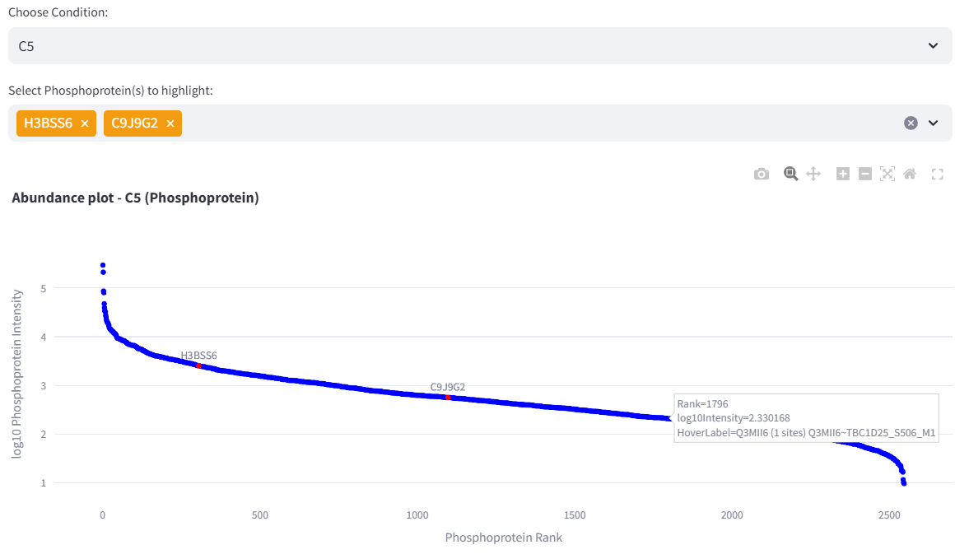
Figure 2: Interactive Abundance Plot for a given Condition highlighting the Phosphoprotein “H3BSS6” and “C9J9G2”, while hovering “Q3MII6” revealing its log10Intensity, Rank, Name and associated Phosphosites.

By presenting feature intensities in rank order, abundance plots allow users to assess the dynamic range of the dataset, identify highly abundant or low-abundance features, compare conditions, and examine the overall shape and distribution of intensity values. Well-behaved datasets exhibit smooth, gradually decreasing intensity curves, consistent patterns across replicates, and moderate variation among features. Any sharp deviations or outliers may indicate biological differences or technical variability.

