Boxplot Intensity Manual

1. User Interface (UI)

In the upper-right section of the user interface, you will find a set of controls for customizing the plot:

- Toggle Outliers: Enables or disables the display of outliers in the plot.
- Toggle Header: Enables or disables the display of the header in the plot.
- Toggle IDs: Enables or disables the display of the sample IDs in the plot.
- Toggle Legend: Enables or disables the display of the legend in the plot.
- Levels: Allows selection of the data set to visualize. Available options include:
  - Protein – available after uploading protein-level data.
  - Phosphosite – available after uploading the phosphosite-level data.
  - Phosphoprotein – available after initializing a collapsing pipeline for the phosphosite-level data.
- Type: Allows selection between two visualization modes:
  - Mean – displays one boxplot per condition, using the mean intensity across all samples belonging to that condition. This summarizes each condition as a single distribution.
  - Single – displays one boxplot for every individual sample, allowing comparison of sample-specific intensity distributions rather than aggregated condition means.
- Show Original Sample Names in Table: When enabled, the accompanying table displays the original sample names instead of the internally generated labels.
- Toggle Text: Enables or disables the display of numeric values on the bars.
- Text Size: Adjusts the size of the text displayed over the bars when enabled.
- Plot Width, Height, and DPI: Adjust the dimensions and resolution of the plot for download.
- Download Format: Choose the file format for downloading the plot, including PNG, JPG, SVG, or PDF.
- Download Button: Exports the plot according to the selected settings. Note that changes in size affect only the downloaded plot and do not modify the display in the interface.

2. Boxplot Intensity

The intensity boxplot functionality is implemented using two complementary functions, each designed to visualize the distribution of log₂-transformed intensity values at different aggregation levels:

- boxplot_int – Generates condition-level boxplots, where each box represents the distribution of mean feature intensities for a given condition.
- boxplot_int_single – Produces sample-level boxplots, where each box represents the distribution of all measured features within a single sample.

These two views allow users to inspect both sample-specific variation and condition-level consistency, supporting quality assessment of proteomic and phosphoproteomic datasets.

In the single-sample boxplot produced by boxplot_int_single, every box represents one sample (i.e., one column from the intensity matrix). All measured features belonging to that sample contribute to the resulting distribution. This visual perspective allows users to assess comparability between samples, identify shifts in global signal intensity, detect anomalies specific to individual samples, and examine the overall shape of the intensity distribution, including its symmetry, spread, and any signs of skewness.

The condition-level boxplot created by boxplot_int works differently. All samples belonging to the same condition are first averaged feature-wise across the row dimension. This produces, for each condition, a vector of mean intensities that is then used to construct the boxplot. In this aggregated representation, noise and sample-specific fluctuations are reduced, allowing users to concentrate on broader biological or experimental differences between conditions. The resulting plot emphasizes the general structure and distribution of intensities per condition and facilitates the evaluation of consistency within groups of replicates.

Both visualization modes rely on the standard statistical definition of a boxplot. At the center of each box lies the median, representing the 50th percentile of all intensity values. The box itself spans the interquartile range (IQR), which is defined by the 25th percentile (Q1) and the 75th percentile (Q3). Thus, the box covers the central half of the distribution:

$$IQR=Q3-Q1$$
From the edges of the box, whiskers extend to the most extreme values that still fall within a mathematically defined acceptable range. This range is determined by 1.5 times the IQR. The lower whisker reaches the smallest value greater than or equal to:

$$Q1-1.5×IQR$$
and the upper whisker extends to the largest value less than or equal to:

$$Q3+1.5×IQR$$
Any data points lying beyond these whisker boundaries are considered outliers. When outlier display is enabled, these values appear as individual markers. In proteomics, such outliers are common due to very high- or low-abundance proteins, but they can also highlight technical abnormalities if present in large or systematic patterns.

In well-behaved datasets, boxplots for samples or conditions show similar overall shapes, comparable IQR heights, and median values that do not differ excessively without biological reason. The distributions should appear reasonably symmetric after log₂ transformation, and outliers should be present only in moderate, expected amounts. When condition-level aggregation is used, boxes representing replicates of the same group should look alike, reflecting consistent signal patterns within that condition.
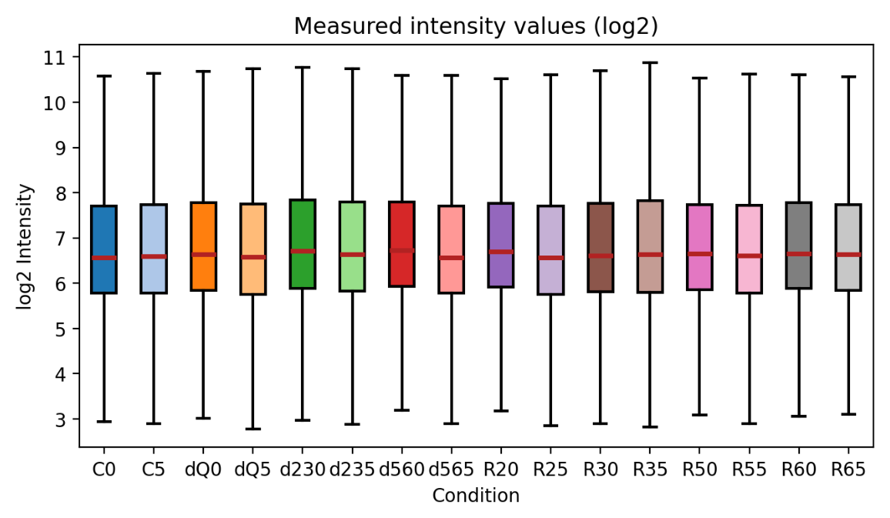
Figure 1: Condition-wise Intensity Boxplot.

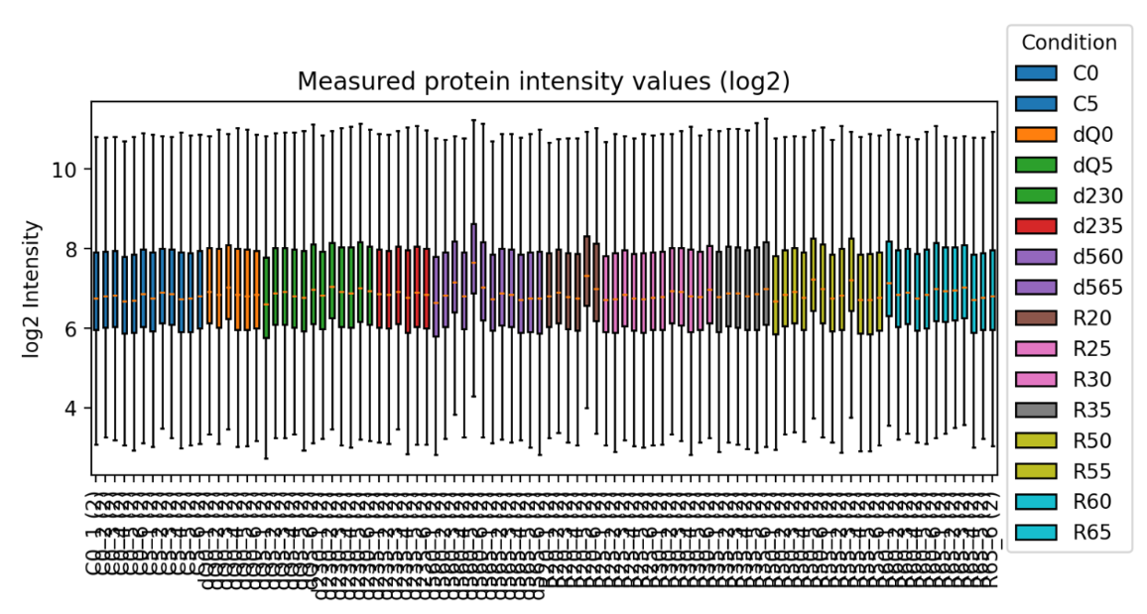
Figure 2: Sample-wise Intensity Boxplot.

3. Boxplot Intensity Tables

The boxplot tables are implemented through two dedicated functions, and they report the same statistical values that define the corresponding boxplot visualizations:

• prepare_boxplot_df – Computes a condition-level summary of intensity distributions by aggregating all samples belonging to each condition.
• prepare_boxplot_single_df – Computes a per-sample summary of intensity distributions, optionally preserving the original sample names.
The condition-level table lists each condition together with the mean, median, first quartile (Q1), third quartile (Q3), and the lower and upper whisker limits derived from the 1.5 × IQR rule. This provides a concise numerical overview of how intensity distributions differ between conditions.

The per-sample table contains the same statistics—mean, median, Q1, Q3, and whisker boundaries—for every individual sample. When enabled, it also includes the original sample names before internal renaming. Both tables present the exact values used to build the boxplots, allowing users to compare intensity distributions quantitatively across samples or conditions.

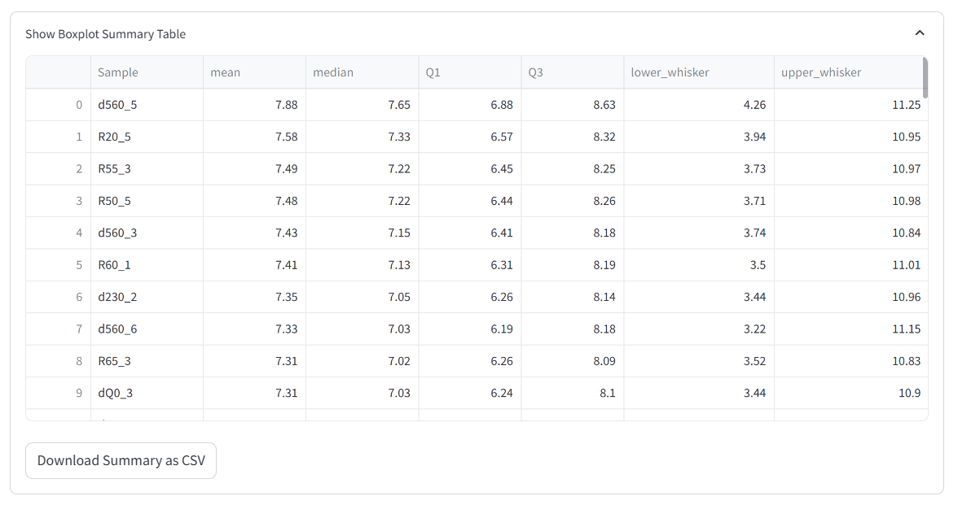
Figure 3: Summary Table.

