Coefficient of Variation Plot Manual
1. User Interface (UI)

In the upper-right section of the user interface, you will find a set of controls for customizing the plot:

- Toggle Outliers: Enables or disables the display of outliers in the plot.
- Toggle Header: Enables or disables the display of the header in the plot.
- Toggle Legend: Enables or disables the display of the legend in the plot.
- Levels: Allows selection of the data set to visualize. Available options include:
  - Protein – available after uploading protein-level data.
  - Phosphosite – available after uploading the phosphosite-level data.
  - Phosphoprotein – available after initializing a collapsing pipeline for the phosphosite-level data.
- Toggle Text: Enables or disables the display of numeric values on the bars.
- Text Size: Adjusts the size of the text displayed over the bars when enabled.
- Plot Width, Height, and DPI: Adjust the dimensions and resolution of the plot for download.
- Download Format: Choose the file format for downloading the plot, including PNG, JPG, SVG, or PDF.
- Download Button: Exports the plot according to the selected settings. Note that changes in size affect only the downloaded plot and do not modify the display in the interface.

2. Coefficient of Variation Plot

The coefficient of variation visualization is implemented through a dedicated function that summarizes the variability of feature intensities within each condition:

- cov_plot – Computes the condition-wise coefficient of variation (CV) for every feature and visualizes the resulting distributions as condition-level boxplots.

This plot provides an intuitive way to assess replicate consistency within each condition. Since the CV expresses variability relative to the mean, it is well suited for log-transformed intensity data and is a common metric for evaluating the reliability of quantification in proteomics and phosphoproteomics experiments.

For each condition, only groups with at least two samples are used, ensuring that variability estimates are statistically meaningful. All samples belonging to the same condition are extracted, and for every feature, the mean and standard deviation across replicates are calculated. The coefficient of variation is then computed as:

$$CV=\left(\frac{SD}{mean}\right)x 100$$

Features for which the CV is undefined (e.g., due to missing or infinite values) are removed. The remaining CV values form the distribution from which the condition-specific boxplot is constructed. This approach results in one box per condition, each representing the spread of variability observed across all quantified features within that group.

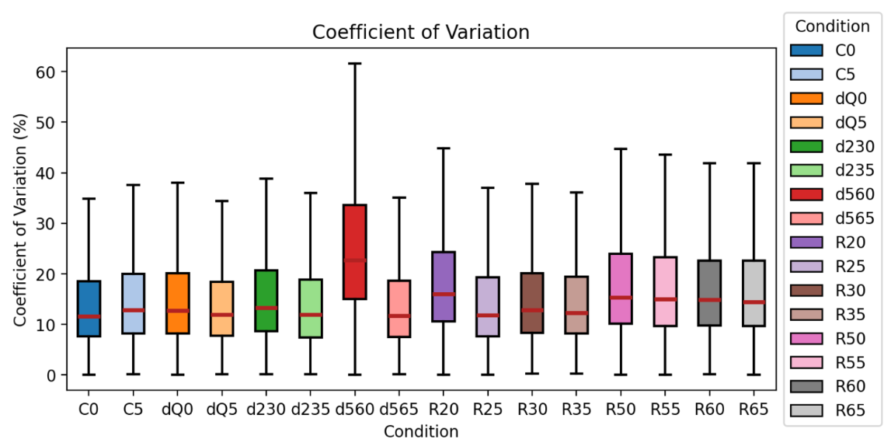
Figure 1: Coefficient of Variation Plot.

Both visualization modes rely on the standard statistical definition of a boxplot. At the center of each box lies the median, representing the 50th percentile of all CV values within the condition. The box itself spans the interquartile range (IQR), which is defined by the 25th percentile (Q1) and the 75th percentile (Q3). Thus, the box covers the central 50% of the CV distribution:

$$\text{IQR}=Q3-Q1$$
From the edges of the box, whiskers extend to the most extreme values that still fall within a mathematically defined acceptable range. This range is determined by 1.5 times the IQR. The lower whisker reaches the smallest value greater than or equal to:

$$Q1-1.5×\text{IQR}$$
and the upper whisker extends to the largest value less than or equal to:

$$Q3+1.5×\text{IQR}$$
Any CV values lying beyond these whisker boundaries are considered outliers and, when enabled, appear as individual markers. In proteomics datasets, a few outliers are normal due to highly variable features, but systematic or excessive outliers may indicate technical inconsistencies or poor replicate reproducibility.

In well-behaved datasets, CV boxplots for different conditions show similar overall shapes, comparable IQR heights, and median values that are not excessively different without biological reason. Narrow, symmetric boxes with medians toward the lower end indicate consistent measurements across replicates, while wide boxes, high medians, or many outliers highlight higher variability or potential quality issues within the condition.

3. Coefficient of Variation Table

The CV table provides a condition-level summary of replicate variability, reporting the same statistical values used to generate the corresponding CV boxplots:

- prepare_cov_df – Computes a condition-level summary of replicate variability for each feature and reports the key boxplot statistics.

For each condition, the table lists the mean, median, first quartile (Q1), third quartile (Q3), and the lower and upper whisker limits derived from the 1.5 × IQR rule. This offers a concise numerical overview of variability across replicates, making it easy to compare consistency between conditions.

By presenting these exact values, the table complements the CV boxplots and enables precise, quantitative assessment of replicate reproducibility.

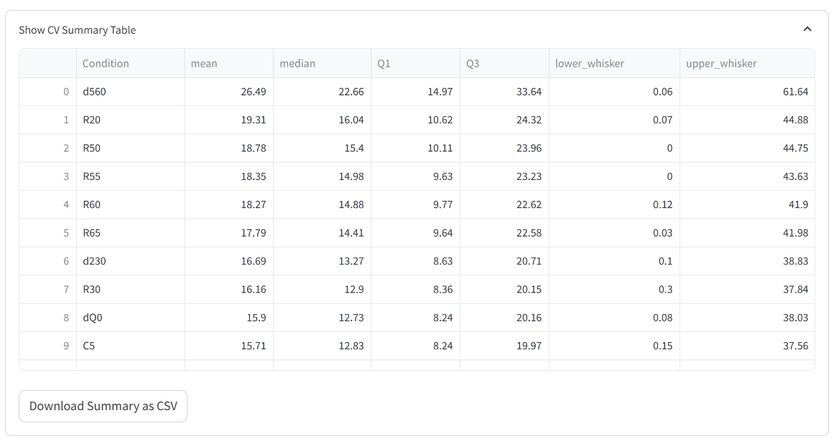
Figure 2: Summary Table.

