Correlation Plot Manual

1. User Interface (UI)

In the upper-right section of the user interface, you will find a set of controls for customizing the plot:

- Toggle IDs: Enables or disables the display of the sample IDs in the plot.
- Toggle Legend: Enables or disables the display of the legend in the plot.
- Levels: Allows selection of the data set to visualize. Available options include:
  - Protein – available after uploading protein-level data.
  - Phosphosite – available after uploading the phosphosite-level data.
  - Phosphoprotein – available after initializing a collapsing pipeline for the phosphosite-level data.
- Type: Allows selection between two visualization modes:
  - Matrix – displays the correlation matrix as a colored heatmap, where color intensity represents the strength and direction of correlation between samples.
  - Ellipse – represents correlations using ellipses whose shape, angle, and color encode correlation strength and sign. Strong correlations appear as narrow ellipses, positive correlations tilt in one direction, and negative correlations tilt in the opposite direction.
- Plot Width, Height, and DPI: Adjust the dimensions and resolution of the plot for download.
- Download Format: Choose the file format for downloading the plot, including PNG, JPG, SVG, or PDF.
- Download Button: Exports the plot according to the selected settings. Note that changes in size affect only the downloaded plot and do not modify the display in the interface.

2. Correlation Plot

The correlation plot functionality is implemented using a function designed to visualize the Pearson correlation of samples at different aggregation levels:

- corr_plot – Generates a correlation map that displays the pairwise Pearson correlations among samples. The plot can be rendered either as a traditional correlation heatmap or as an ellipse-based representation, each providing complementary perspectives on sample similarity structure.

This visualization enables users to examine the global relationship patterns across samples, assess the consistency of biological replicates, and detect potential technical anomalies such as batch effects, mislabeled samples, or outliers with unusually weak correlations.

In both modes (Matrix/Ellipse), the function first computes the sample–sample Pearson correlation matrix:

$$r_{ij}=\frac{cov⁡(x_{i},x_{j})}{σ_{x_{i}} σ_{x_{j}}},$$

where $x_{i}$and $x_{j}$represent the log₂-transformed intensity vectors of two samples.
To enhance interpretability, hierarchical clustering is applied to the distance matrix defined as:

$$d_{ij}=1-r_{ij},$$

and the correlation matrix is reordered according to the resulting dendrogram. This groups highly similar samples together and reveals block-like structure in datasets with coherent replicate behavior.

In Matrix mode, the reordered correlation matrix is visualized as a heatmap using a diverging color scale, where strong positive correlations approach red, weak or negative correlations approach blue, and values near zero appear in the center of the scale. This representation provides a direct, quantitative view of linear relationships between samples.

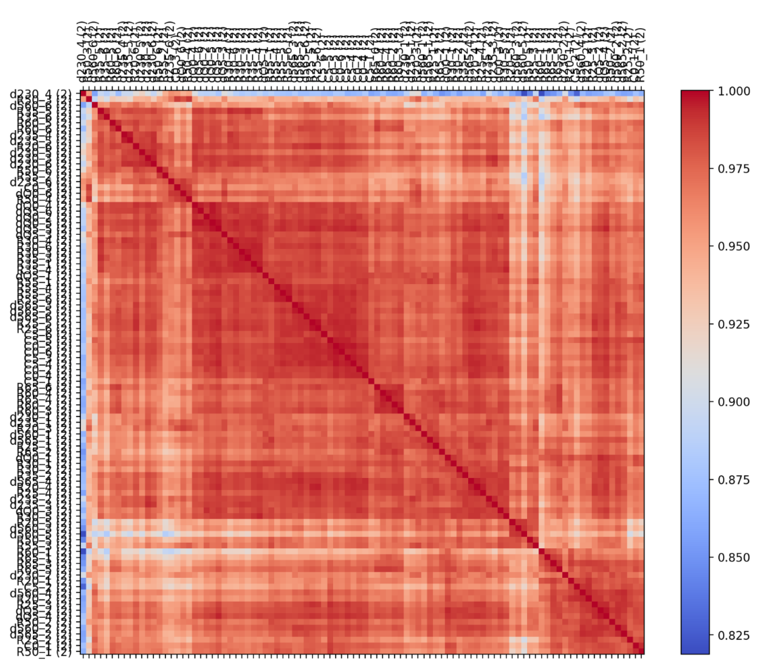
Figure 1: Correlation Plot: Matrix Mode.
In Ellipse mode, each correlation value is encoded geometrically: the ellipse becomes narrower as $∣r∣$approaches 1, and more circular as $∣r∣$approaches 0. The orientation reflects the sign, ellipses rotate in opposite directions for positive and negative correlations. This graphical encoding emphasizes changes in correlation magnitude and can highlight subtle deviations even within uniformly high-correlation datasets.

Correlation plots serve as a quality-control tool for assessing sample similarity. Well-behaved datasets typically exhibit strong, consistent within-group correlations and smooth clustering patterns. Conversely, weak, asymmetric, or erratic correlation structures may signal technical noise, batch effects, or anomalous samples requiring further investigation.

