Coverage Plot Manual
1. User Interface (UI)

In the upper-right section of the user interface, you will find a set of controls for customizing the plot:

- Toggle IDs: Enables or disables the display of the sample IDs in the plot.
- Toggle Header: Enables or disables the display of the header in the plot.
- Toggle Legend: Enables or disables the display of the legend in the plot.
- Levels: Allows selection of the data set to visualize. Available options include:
  - Protein – available after uploading protein-level data.
  - Phosphosite – available after uploading the phosphosite-level data.
  - Phosphoprotein – available after initializing a collapsing pipeline for the phosphosite-level data.
- Type: Allows selection between two visualization modes:
  - Normal: displays the per-sample bar plot showing the count of non-missing values for each sample.
  - Summary: displays the condition-level summary plot, including mean values, standard deviations, and individual data points.
- Show Original Sample Names in Table: When enabled, the accompanying table displays the original sample names instead of the internally generated labels.
- Toggle Text: Enables or disables the display of numeric values on the bars.
- Text Size: Adjusts the size of the text displayed over the bars when enabled.
- Plot Width, Height, and DPI: Adjust the dimensions and resolution of the plot for download.
- Download Format: Choose the file format for downloading the plot, including PNG, JPG, SVG, or PDF.
- Download Button: Exports the plot according to the selected settings. Note that changes in size affect only the downloaded plot and do not modify the display in the interface.

2. Coverage Plot

The coverage functionality is implemented through three dedicated functions, each designed for a specific data structure and visualization type:

- coverage_plot – Visualizes coverage for protein-level and phosphosite-level datasets in wide format.
- coverage_plot_pep – Processes long-format peptide-level data, generating an equivalent coverage plot adapted to peptide structures.
- coverage_plot_summary – Produces a condition-level summary visualization from wide-format data, aggregating sample information within each condition.

The coverage plot quantifies the degree of data completeness per sample. For each sample (column):

- Missing values (NA) are counted within the sample (column).
- The total number of features in the dataset, for example proteins or phosphosites, is determined by the total number of data frame rows.
- The number of detected features per sample is calculated as:
Detected Features = Total Features minus Missing Values per Sample

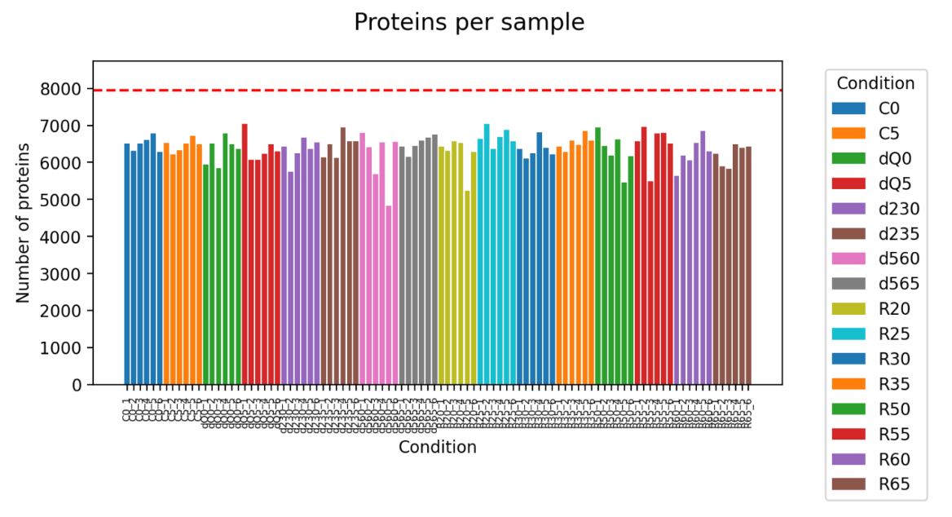
Figure 1: Normal Coverage Plot.

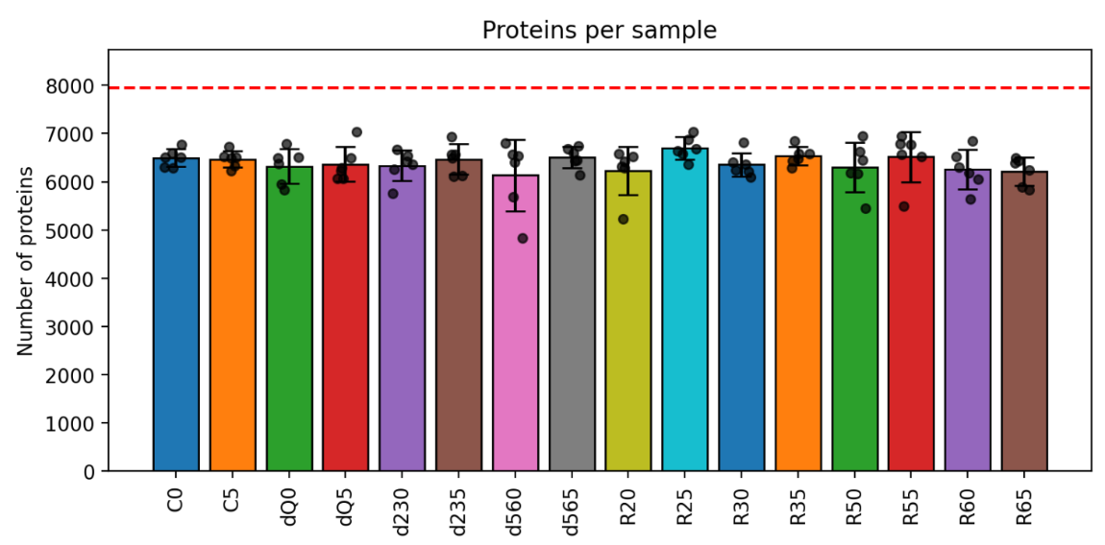
Figure 2: Summary Coverage Plot.

The number of proteins detected in each sample is visualized in a bar chart, with bar colors indicating the condition assigned to each sample. A red horizontal line marks the total number of features in the dataset, representing the full number of rows in the data frame. The summary version of the plot displays only the mean number of detected proteins per condition. Individual points represent the values of the individual samples, and the error bars show the standard deviation within each condition.

3. Coverage Tables

The coverage tables are implemented through two more dedicated functions, the values shown are same as displayed in the coverage plots:

- prepare_coverage_df – Prepares a per-sample summary of detected features from wide-format data.
- prepare_coverage_summary_df – Prepares a condition-level summary of detected features from wide-format data.

The per-sample table shows each sample, the number of detected features, and optionally the original sample name. Includes a row for “All samples” with the total number of features. The condition-level summary table shows each condition with the mean, minimum, maximum, and standard deviation of detected features across samples within a condition.
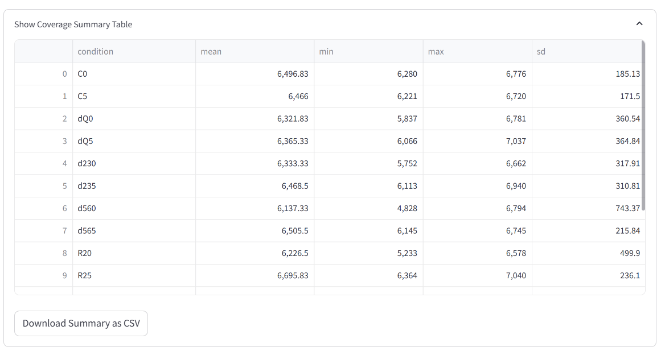
Figure 3: Summary Table.

