Data Info Manual

1. User Interface (UI)

In this section of the user interface, your experimental data will be displayed. Depending on your experiment, protein, phosphosite, and/or phosphoprotein data may appear. All datasets can be downloaded directly from the interface.

The first section lists the names of the raw files used for the analysis:

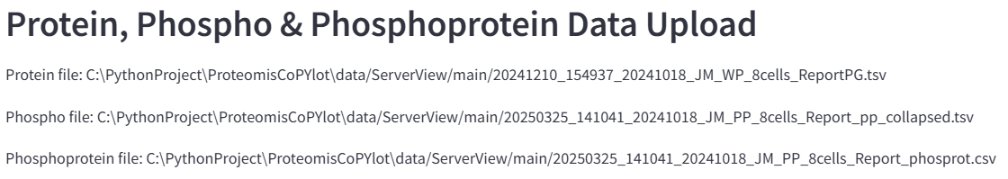
Figure 1: Raw file names in the UI.

The second section displays the log₂-transformed datasets. These data can also be filtered and/or imputed. The corresponding column headers indicate the dataset type:

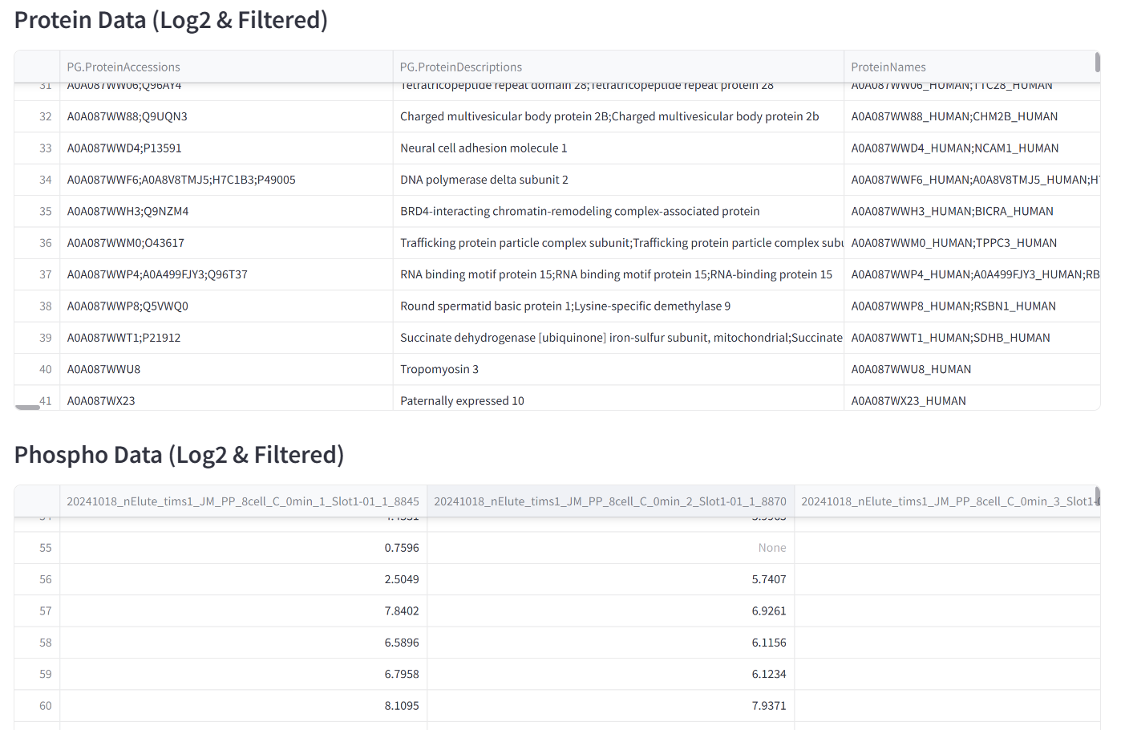
Figure 2: Displayed data sets.

At the bottom of the interface, you can review the processing steps applied to each dataset. This includes any filtering and/or imputation that was performed. The resulting dimensions of each dataset, reported as rows and columns, are also shown. If a phosphoprotein dataset was generated, the method used to collapse phosphosites is displayed as well.

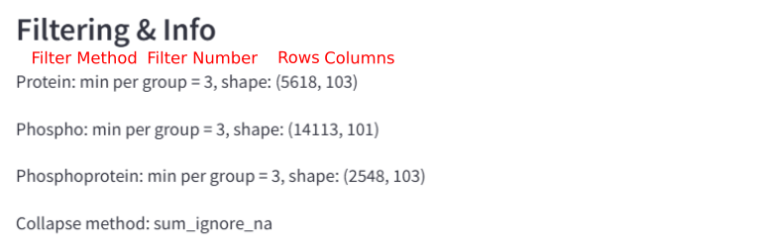
Figure 3: Data filtering and information.

2. Filtering Methods

Filtering can be performed using two methods: “per group” and “in at least one group.” Each filtering method is associated with a filtering value, which is a non-negative integer. This value specifies the minimum number of valid (non-NA) entries required in a row for the row to be retained according to the selected method.

2.1 Filtering “per group”

The “per group” filtering method requires that each group or condition contains at least the specified number of valid values for a row to be retained.

Table 1: Filtering “per group”
Feature | A1 | A2 | A3 | B1 | B2 | B3 | Filter num
1 | 1.34 | 2.45 | 1.42 | NA | 3.43 | 3.44 | 3
2 | 1.34 | 2.45 | 1.42 | 5.32 | 3.43 | 3.44 | 3

In this example, there are six samples distributed across two conditions (Condition A and Condition B). For Feature 1, at least three valid values are required in each condition. This requirement is met for Condition A but not for Condition B, which contains only two valid values. As a result, Feature 1 is discarded, and its row is removed. For Feature 2, both conditions meet the minimum requirement, so Feature 2 is retained in the filtered dataset.

2.2 Filtering “in at least one group”

The “in at least one group” filtering method requires that a row contains at least the specified number of valid values in at least one condition for it to be retained.

Table 2: Filtering “in at least one group”
Feature | A1 | A2 | A3 | B1 | B2 | B3 | Filter num
1 | 1.34 | 2.45 | 1.42 | NA | 3.43 | 3.44 | 3
2 | 1.34 | NA | 1.42 | NA | 3.43 | 3.44 | 3

In this example, there are six samples distributed across two conditions (Condition A and Condition B). For Feature 1, at least three valid values are required in at least one condition. This requirement is satisfied by Condition A, which contains three valid values, so Feature 1 is retained in the filtered dataset. For Feature 2, neither Condition A nor Condition B contains three valid values (each has only two valid values). As a result, Feature 2 is discarded, and its row is removed from the filtered dataset.

3. Collapse Method

The “transform_phosprot” function provides four methods to summarize phosphosite-level data into phosphoprotein-level data. Each method handles missing values differently, allowing flexibility depending on the nature of the experimental data and the desired treatment of incomplete measurements.

The first method, “sum_ignore_na”, also sums values across samples, but it ignores any missing values. Only the present, non-missing values contribute to the sum. This method is appropriate when one wishes to retain phosphoproteins that have partial measurements, without letting missing values prevent aggregation.

Table 3: Collapse “transform_phosprot” using “sum_ignore_na”
Feature | A1 | A2 | A3 | B1 | B2 | B3
ABC_Y211 | 1 | NA | 3 | NA | 4 | 6
ABC_S344 | 2 | NA | 4 | 3 | NA | 5
ABC | 3 | NA | 7 | 3 | 4 | 11

The second method, “sum_propagate_na”, calculates the sum of values across samples but propagates missing values. In this method, if any value is missing for a phosphoprotein in a given condition, the aggregated sum becomes NA. This ensures that uncertainty due to missing data is carried through to the phosphoprotein level and can help avoid misleading totals when data is incomplete.

Table 4: Collapse “transform_phosprot” using “sum_propagate_na”
Feature | A1 | A2 | A3 | B1 | B2 | B3
ABC_Y211 | 1 | NA | 3 | NA | 4 | 6
ABC_S344 | 2 | NA | 4 | 3 | NA | 5
ABC | 3 | NA | 7 | NA | NA | 11

The third method, “sum_mean_impute”, begins by imputing missing values with the mean of the corresponding condition. Once missing values are filled, the function sums the values across all samples for each phosphoprotein. This approach is useful when one wants to retain all phosphoproteins, assuming that missing values can be reasonably approximated by the condition-specific mean.

Table 5: Collapse “transform_phosprot” using “sum_mean_impute”
Feature | A1 | A2 | A3 | B1 | B2 | B3
ABC_Y211 | 1 | NA | 3 | NA | 4 | 6
ABC_S344 | 2 | NA | 4 | 3 | NA | 5
ABC | 3 | 5 | 7 | 8 | 8 | 11

The fourth method, “mean”, calculates the mean of the values across all samples for each phosphoprotein. Missing values are ignored in the calculation, so the mean is determined only from available measurements. This approach is suitable when relative abundance is more informative than total abundance, and it reduces the impact of missing measurements without discarding the protein entirely.

Table 6: Collapse “transform_phosprot” using “sum_mean”
Feature | A1 | A2 | A3 | B1 | B2 | B3
ABC_Y211 | 1 | NA | 3 | NA | 4 | 6
ABC_S344 | 2 | NA | 4 | 3 | NA | 5
ABC | 1.5 | NA | 3.5 | 3 | 4 | 5.5

