Histogram Intensity Manual

1. User Interface (UI)

In the upper-right section of the user interface, you will find a set of controls for customizing the plot:

- Toggle Header: Enables or disables the display of the header in the plot.
- Toggle Legend: Enables or disables the display of the legend in the plot.
- Levels: Allows selection of the data set to visualize. Available options include:
  - Protein – available after uploading protein-level data.
  - Phosphosite – available after uploading the phosphosite-level data.
  - Phosphoprotein – available after initializing a collapsing pipeline for the phosphosite-level data.
- Plot Width, Height, and DPI: Adjust the dimensions and resolution of the plot for download.
- Download Format: Choose the file format for downloading the plot, including PNG, JPG, SVG, or PDF.
- Download Button: Exports the plot according to the selected settings. Note that changes in size affect only the downloaded plot and do not modify the display in the interface.

2. Histogram Intensity

The histo_int function initializes and generates the histogram of intensity values. It processes the log₂-transformed intensity data and plots them as density histograms. The x-axis represents the log₂ intensity values, while the y-axis indicates their relative frequency.

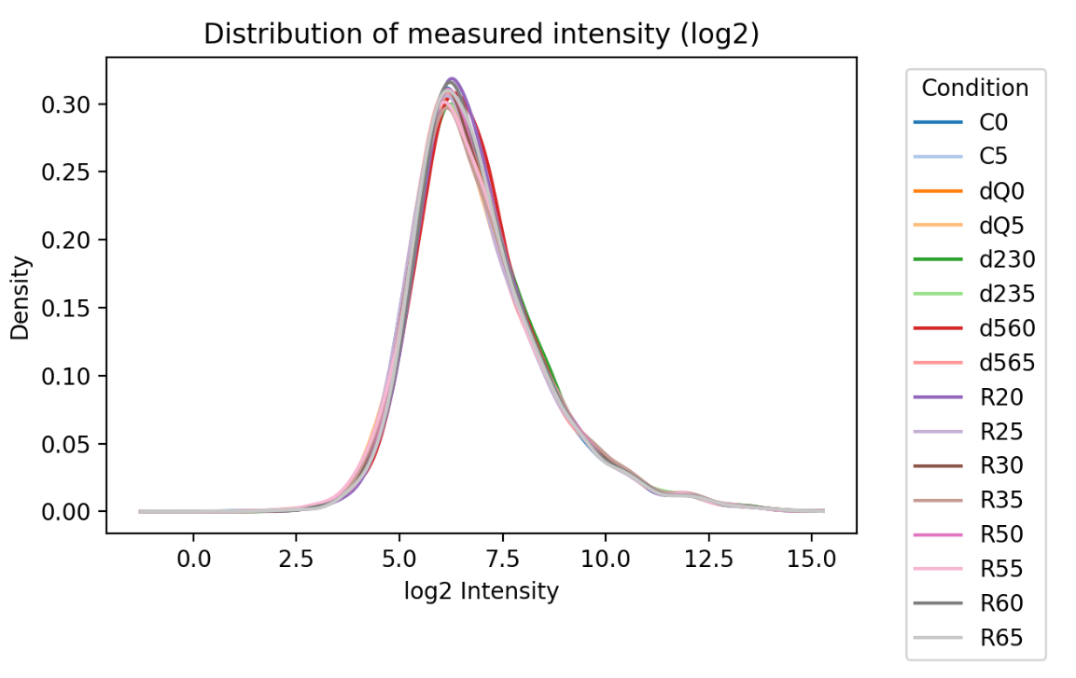
Figure 1: Histogram of condition-wise mean log2-intensity values and their relative frequency.
Intensity values are evaluated on a per-condition basis: for each feature (e.g., protein), the mean value across all replicates (row-wise) within the conditions are calculated. The resulting condition-specific vectors are then used for visualization. Each condition is displayed as a separate histogram, distinguished by color.

These histograms provide an overview of the data distribution, allowing users to assess whether the values approximate a normal distribution or show deviations from it. For high-quality data, not only should each condition exhibit an approximately normal distribution, but the overall distributional shapes across conditions should also be similar.

