Missing Value Heatmap Manual

1. User Interface (UI)

In the upper-right section of the user interface, you will find a set of controls for customizing the plot:

- Toggle Header: Enables or disables the display of the header in the plot.
- Toggle IDs: Enables or disables the display of the sample IDs in the plot.
- Levels: Allows selection of the data set to visualize. Available options include:
  - Protein – available after uploading protein-level data.
  - Phosphosite – available after uploading the phosphosite-level data.
  - Phosphoprotein – available after initializing a collapsing pipeline for the phosphosite-level data.
- Plot Width, Height, and DPI: Adjust the dimensions and resolution of the plot for download.
- Download Format: Choose the file format for downloading the plot, including PNG, JPG, SVG, or PDF.
- Download Button: Exports the plot according to the selected settings. Note that changes in size affect only the downloaded plot and do not modify the display in the interface.

2. Missing Value Heatmap

Similar to the missing value plot, the missing value heatmap visualizes missing data; however, it preserves the structure of missing values:

- Missing values (NA) are displayed in a distinct color (e.g., yellow), while valid values are shown in another color (e.g., black).
- This allows patterns of missing values to be observed both across samples (columns) and features (rows).

The missing value heatmap is generated using the missing_value_heatmap function, which works as follows:

Table 1: Example Processing of Heatmap Function – Original table
Feature | A1 | A2 | B1
1 | 2.31 | 4.32 | 3.55
2 | NA | 4.32 | NA
3 | 2.31 | 4.32 | NA

Table 2: Example Processing of Heatmap Function – Processed table
Feature | A1 | A2 | B1
1 | 2.31 | 4.32 | 3.55
2 | NA | 4.32 | NA
3 | 2.31 | 4.32 | NA

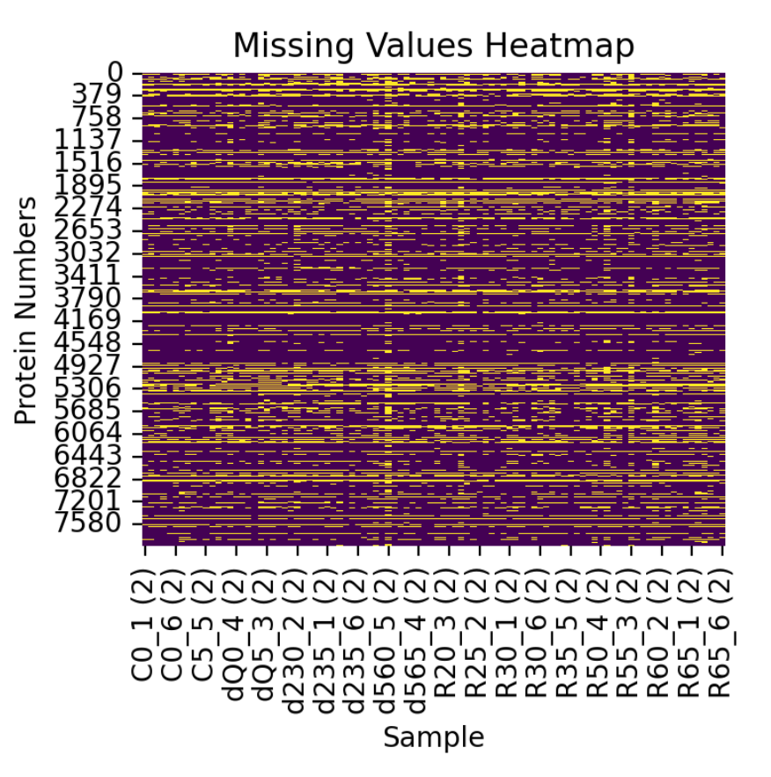
Figure 1: Example Missing Value Heatmap

In the example heatmap:
- A yellow vertical stripe indicates a sample with many missing values.
- Yellow rows indicate proteins with missing values across several samples.
- This representation enables users to quickly identify systematic missingness or trends in the dataset.

