Missing Value Plot Manual

1. User Interface (UI)

In the upper-right section of the user interface, you will find a set of controls for customizing the plot:

- Toggle Header: Enables or disables the display of the header in the plot.
- Levels: Allows selection of the data set to visualize. Available options include:
  - Protein – available after uploading protein-level data.
  - Peptide and Precursor – available when uploading the full report.
  - Phosphosite – available after uploading the phosphosite-level data.
  - Phosphoprotein – available after initializing a collapsing pipeline for the phosphosite-level data.
- Bin Missing Values: Groups smaller bars into a single larger bar to improve visualization of large data sets. Features (e.g. proteins) that have more missing values than the input number are combined into this summary bar.
- Toggle Text: Enables or disables the display of numeric values on the bars.
- Text Size: Adjusts the size of the text displayed over the bars when enabled.
- Bar Color: Allows customization of the color of the bars in the plot.
- Plot Width, Height, and DPI: Adjust the dimensions and resolution of the plot for download.
- Download Format: Choose the file format for downloading the plot, including PNG, JPG, SVG, or PDF.
- Download Button: Exports the plot according to the selected settings. Note that changes in size affect only the downloaded plot and do not modify the display in the interface.

These controls provide flexibility for visualizing and exporting your data while maintaining clarity, even for large or complex datasets.

2. Missing Value Plot

The missing value plot functionality is implemented through three distinct functions, each tailored to specific types of data:

- missing_value_plot – Handles protein and phosphosite-level data.
- missing_value_plot_prec – Processes the full report and summarizes missing values at the precursor level.
- missing_value_plot_pep – Processes the full report and summarizes missing values at the peptide level.

These separate functions are necessary because the input formats differ: protein and phosphosite data typically use a “wide” format, while the full report uses the “long” format.
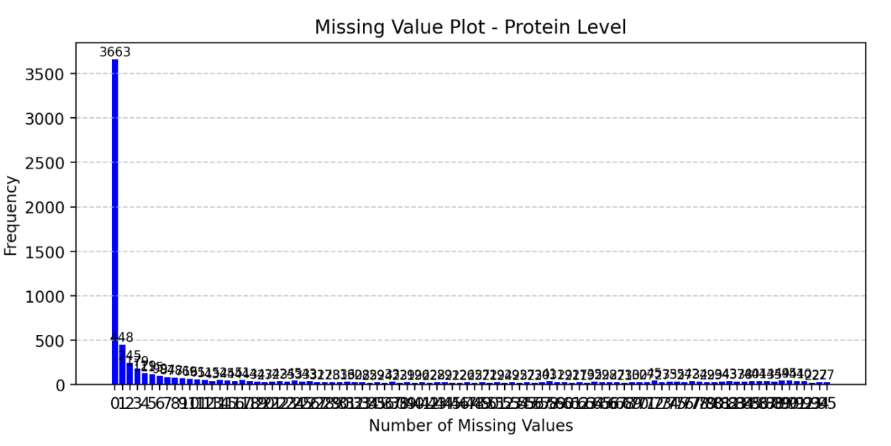
Figure 1: Example Missing Value Plot

In the example plot, the data can be interpreted as follows:

- 3663 proteins have no missing values (0 on the x-axis), meaning each protein has valid measurements in all samples.
- 448 proteins have exactly one missing value (1 on the x-axis), meaning that out of 96 samples, 95 contain valid values and 1 is missing. The specific sample with the missing value is not distinguished in this plot.
- 27 proteins have 95 missing values (95 on the x-axis), indicating these proteins were reported in only a single sample.

This plot provides a clear overview of data completeness across the dataset, allowing users to quickly assess the prevalence and distribution of missing values at the protein level.

The method by which the function calculates missing values and summarizes them for plotting is illustrated in the example below.

- The function counts the number of missing values (NA) per feature / row (e.g., protein).
- It then aggregates these counts to determine how many features have a given number of missing values.
- The resulting summary is visualized as a bar plot, where the x-axis represents the number of missing values and the y-axis represents the number of features with that number of missing values.

This approach provides a concise overview of data completeness and allows users to quickly identify patterns in missing data across the dataset.

Table 1: Example Processing of Missing Values – Original Table
 | A1 | A2 | B1 | Number of Missing Values
Protein 1 | 3.34 | 3.54 | NA | 1
Protein 2 | 3.34 | 3.54 | 2.67 | 0
Protein 3 | 3.34 | NA | 2.67 | 1

Table 2: Example Processing of Missing Values – Summary Table for Plot
Number of Missing Values | Count
0 | 1
1 | 2
2 | 0

