Missing Value Tables Manual

1. User Interface (UI)

In the upper-right section of the user interface, you will find a set of controls for customizing the tables:

- Levels: Allows selection of the data set to visualize. Available options include:
  - Protein – available after uploading protein-level data.
  - Phosphosite – available after uploading the phosphosite-level data.
  - Phosphoprotein – available after initializing a collapsing pipeline for the phosphosite-level data.
- Outlier Threshold: Percentage of missing values within a sample for it being declared an outlier.

2. Missing Value Tables

The initial output displayed in the user interface indicates the overall percentage of missing values across the entire data frame.

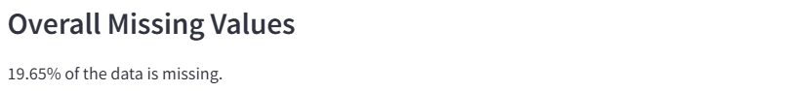

Figure 1: Text output showing the percentage of missing values of the whole data frame.

The first table contains three columns: the sample name, the number of missing values (NA) within that sample (column), and the percentage of missing values per sample. The percentage is calculated as the number of missing features (e.g., proteins) divided by the total number of features.

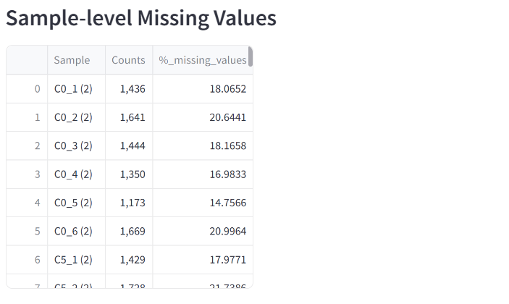
Figure 2: Table showing sample-wise missing values.

The next table identifies samples that are considered outliers based on their percentage of missing values. A sample is classified as an outlier if its missing-value percentage exceeds the specified Outlier Threshold parameter.

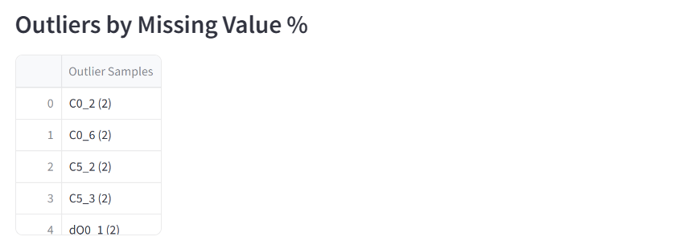
Figure 3: Outlier by missing-values percentage table.

The final table contains three columns: the number of missing values, the number of features that exhibit exactly this number of missing values (regardless of their position), and the percentage of features corresponding to that count (features corresponding/all features). This table is equivalent to the Missing Value Plot, with the addition of percentage information. For more details, refer to the documentation on the Missing Value Plot.

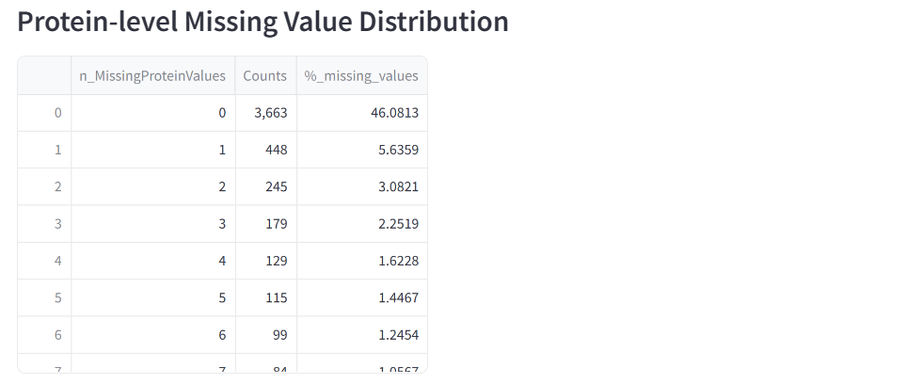
Figure 4: Table showing feature-wise missing values.

