Pearson Correlation Plot Manual
1. User Interface (UI)

In the upper-right section of the user interface, you will find a set of controls for customizing the plot:

- Toggle Header: Enables or disables the display of the plot title and correlation statistics (Pearson r and p-value).
- Levels: Allows selection of the data set to visualize. Available options include:
  - Protein – available after uploading protein-level data.
  - Phosphosite – available after uploading the phosphosite-level data.
  - Phosphoprotein – available after initializing a collapsing pipeline for the phosphosite-level data.
- Mode: Selects the method of comparison:
  - Single – plots the correlation between two individual samples.
  - Condition – plots the correlation between the mean intensities of two conditions, aggregating all replicates.
- Sample/Condition 1: Selects the first sample or condition to compare. For condition mode, all replicates within this group are averaged to compute the mean intensity per feature.
- Sample/Condition 2: Selects the second sample or condition to compare. For condition mode, all replicates within this group are averaged to compute the mean intensity per feature.
- Alias for Sample/Condition: Allows the user to provide a custom label for the selected sample or condition, which will appear on the plot axes and in the header instead of the original sample or condition name.
- Dot Color: Sets the color of the points in the scatter plot.
- Dot Size: Controls the size of the points in the scatter plot.
- Plot Width, Height, and DPI: Adjust the dimensions and resolution of the plot for download.
- Download Format: Choose the file format for downloading the plot, including PNG, JPG, SVG, or PDF.
- Download Button: Exports the plot according to the selected settings. Note that changes in size affect only the downloaded plot and do not modify the display in the interface.

2. Pearson Correlation Plot

The Pearson Correlation module provides an interactive view of linear relationships between protein or phosphosite intensities, enabling users to assess reproducibility, detect outliers, and compare conditions or individual samples. This analysis is particularly useful for quality control, validation of replicates, or exploring condition-specific correlations.

- correlation_xy_intensity_single – Generates a scatter plot comparing two individual samples. Each point represents a protein or phosphosite, with coordinates corresponding to the log₂-transformed intensities in the two selected samples. A linear regression line is fitted to the data, and the Pearson correlation coefficient (r) and associated p-value are displayed in the plot header.
- correlation_xy_intensity – Generates a scatter plot comparing two conditions. The function computes the mean intensity of each protein or phosphosite across all replicates within each condition. Points represent the aggregated mean intensities per protein/phosphosite, with a linear regression line and Pearson correlation statistics displayed in the header.

For both functions, the plotting workflow is as follows:

- Extract the relevant intensity values for the selected samples or conditions.
- Remove entries with missing values to ensure valid correlation computation.
- Compute the Pearson correlation coefficient and associated p-value.
- Plot the data as a scatter plot, optionally including a header with correlation statistics.
- Fit and overlay a linear regression line to visualize the trend between the two datasets.

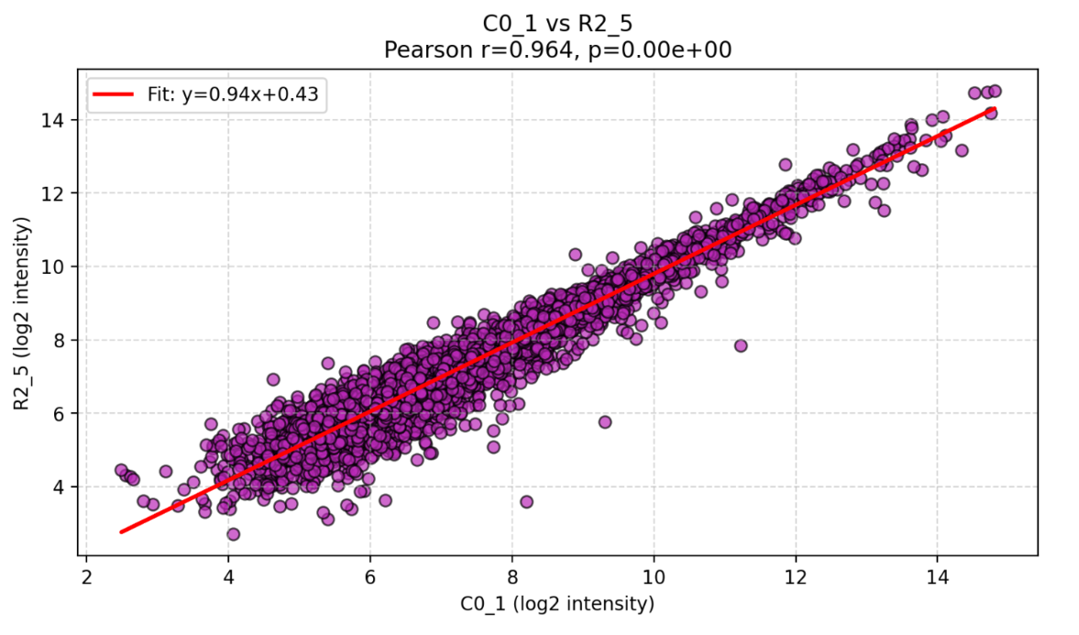
Figure 1: Correlation of protein intensities between two samples.

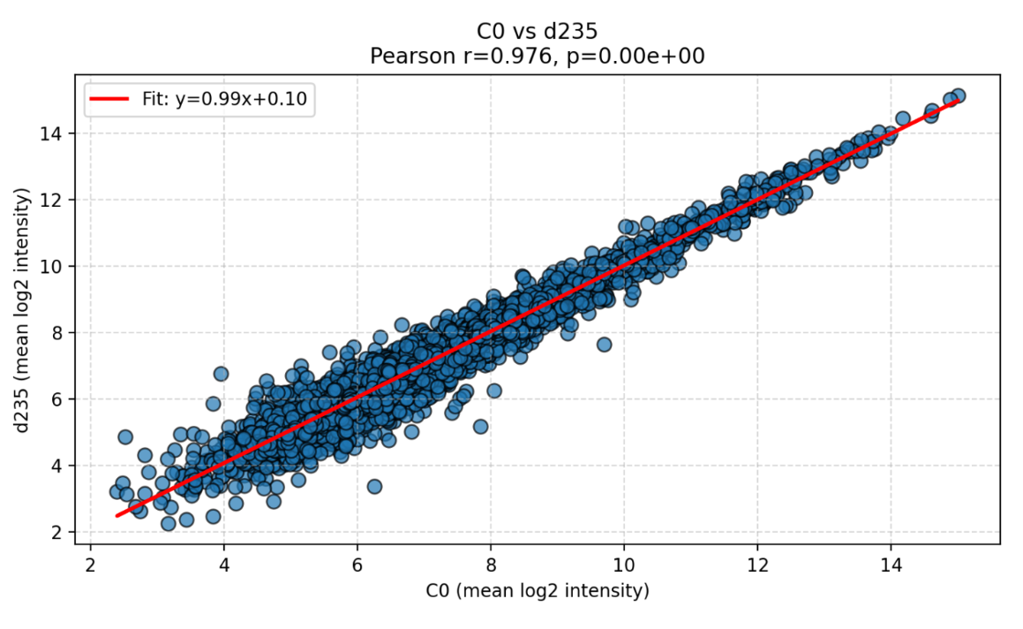
Figure 2: Correlation of mean protein intensities between two conditions.

This visualization allows users to:

- Evaluate reproducibility between replicates or samples.
- Identify outliers or samples with atypical intensity distributions.
- Compare conditions at the protein or phosphosite level to assess global changes in expression patterns.
- Quickly interpret correlation strength through both numerical metrics and visual trends.

By providing both sample-level and condition-level comparisons, Pearson Correlation offers a flexible and intuitive approach to exploring data consistency and relationships across experimental datasets.

