Phosprot Regulation Plot Manual

1. User Interface (UI)

In the upper-right section of the user interface, you will find a set of controls for customizing the plot:

- P-value threshold: Defines the statistical cutoff for significance. Features with adjusted p-values below this threshold are considered significantly different between the two selected conditions.
- Log2 FC threshold: Specifies the minimum absolute log₂ fold change required for calling a feature up- or downregulated. Only features exceeding this magnitude and meeting the p-value criterion are labeled significant.
- Use uncorrected p-values: When enabled, significance is determined using raw p-values instead of FDR-adjusted values. This removes multiple-testing correction and applies the threshold directly to the unadjusted test statistic.
- Show phosphosites in hover: When enabled, the interactive scatter plot includes phosphosite-level detail in the hover tooltips. Up- and downregulated sites are listed per protein, truncated when necessary to avoid overly long labels.
- Test Type: Selects the statistical testing framework used to compute differential abundance:
  - Unpaired – performs an independent-samples t-test, using pooled variance and appropriate degrees of freedom.
  - Single – computes within-sample differences and applies a paired t-test to the resulting vector of differences.
- Condition 1: Specifies the first condition to be compared; all samples belonging to this group form the reference distribution.
- Condition 2: Specifies the second condition; feature intensities from this group are contrasted with Condition 1 to compute log₂ fold changes and t-statistics.

2. Phosprot Regulation Plot

The Protein-level Phosphosite Regulation module provides an interactive view of differential phosphorylation at the protein level, aggregating information from individual phosphosites. This analysis allows users to identify proteins with up- or downregulated phosphorylation between two selected conditions and to explore how multiple phosphosites contribute to these changes.

- phosprot_regulation – Generates an interactive scatter plot summarizing phosphosite-level regulation at the protein scale. For each protein, the function computes log₂ fold changes between the selected conditions and performs statistical testing to identify significant differences. Up- and downregulated phosphosites are aggregated per protein, and their summed log₂ intensities are used to define the coordinates of the plot. Each point represents one protein, with optional hover information displaying the counts and identifiers of contributing phosphosites.

Important: The function itself does not impose any significance cutoff. Log₂ fold changes and p-values are calculated for all phosphosites but not utilized in this version of the function.

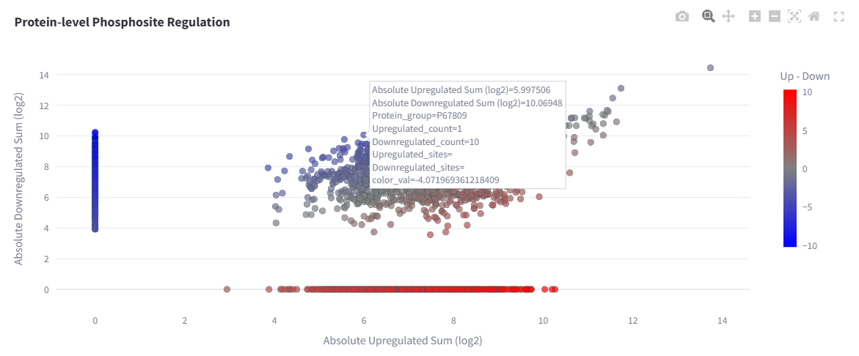
Figure 1: Protein-level Phossite Regulation Plot showing up- and downregulated phosphosites aggregated on phosphoproteins split in their positive and negative contributions.

The resulting scatter plot positions each protein according to its total upregulated (x-axis) and downregulated (y-axis) phosphosite contributions. Points are colored along a gradient reflecting the relative balance between up- and downregulation. Hovering over a protein reveals detailed site-level information, including the number of up- and downregulated phosphosites and their identifiers, truncated if necessary to maintain readability.

This visualization allows users to:

- Identify proteins with strong differential phosphorylation signatures.
- Assess whether regulation is driven by many small changes or a few high-intensity sites.
- Compare the global balance of up- versus downregulated phosphosites across the dataset.
- Explore detailed phosphosite information without leaving the protein-level context.

By integrating statistical testing, fold-change thresholds, and phosphosite-level aggregation, Protein-level Phosphosite Regulation provides a concise yet informative view of condition-specific phosphorylation dynamics at the protein scale.

