Phossite Coverage Plot Manual

1. User Interface (UI)

In the upper-right section of the user interface, you will find a set of controls for customizing the plot:

- Toggle IDs: Enables or disables the display of the sample IDs in the plot.
- Toggle Header: Enables or disables the display of the header in the plot.
- Toggle Legend: Enables or disables the display of the legend in the plot.
- Type: Allows selection between two visualization modes:
  - Normal: displays the per-sample bar plot showing the count of non-missing values for each sample.
  - Summary: displays the condition-level summary plot, including mean values, standard deviations, and individual data points.
- Class I Color: Sets the bar color used for displaying phosphosites with PTM localization ≥ 0.75.
- Not Class I Color: Sets the bar color used for displaying phosphosites with PTM localization < 0.75.
- Plot Width, Height, and DPI: Adjust the dimensions and resolution of the plot for download.
- Download Format: Choose the file format for downloading the plot, including PNG, JPG, SVG, or PDF.
- Download Button: Exports the plot according to the selected settings. Note that changes in size affect only the downloaded plot and do not modify the display in the interface.

2. Phossite Coverage Plot

The phosphosite coverage functionality extends the standard coverage analysis to PTM-level datasets by distinguishing between confidently localized phosphosites (Class I) and lower-confidence assignments. It is implemented through two dedicated functions:

- phossite_coverage_plot – Generates a per-sample coverage plot for phosphosites, separating Class I (PTM localization ≥ 0.75) and Not Class I sites.
- phossite_coverage_plot_summary – Produces a condition-level summary view, reporting the mean and standard deviation of detected phosphosites across replicates within each condition.

Both functions apply the same core principles described in the coverage plot manual. For each sample, missing values (NA) are counted, the total number of phosphosites in the dataset is determined, and the number of detected sites is computed by subtracting missing values from the total. This calculation is performed separately for Class I and Not Class I sites.

The per-sample plot displays stacked bars: Class I sites form the lower segment, while Not Class I sites are stacked above them, clearly illustrating the relative contribution of confidently localized versus less certain sites. Sample names are annotated according to condition and replicate structure, allowing straightforward interpretation of data completeness across experimental groups.
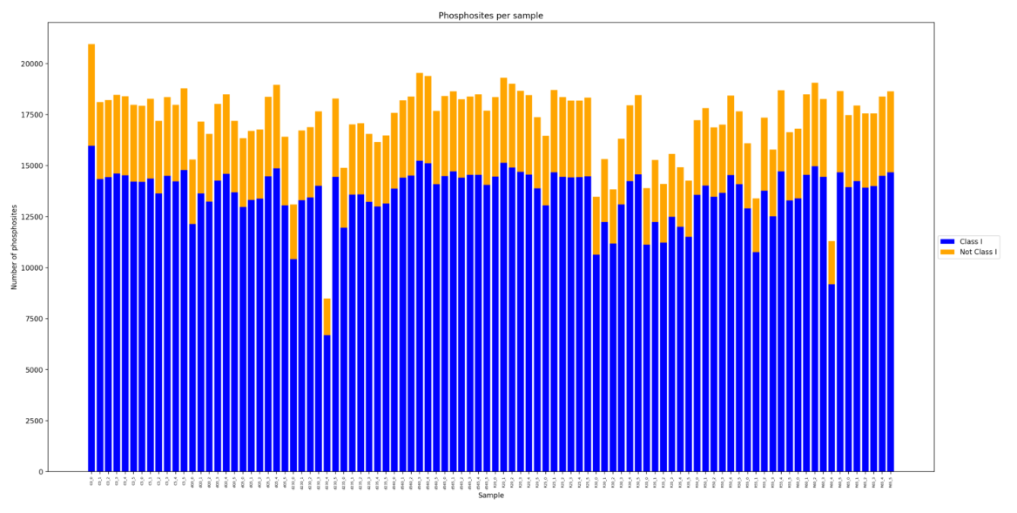
Figure 1: Normal Phossite Coverage Plot.

The summary version aggregates these values at the condition level. Bars represent the mean number of detected Class I and Not Class I phosphosites per condition; individual replicate values are overlaid as points, and error bars indicate the standard deviation. This visualization provides an immediate overview of phosphosite detectability and localization confidence at the condition scale.

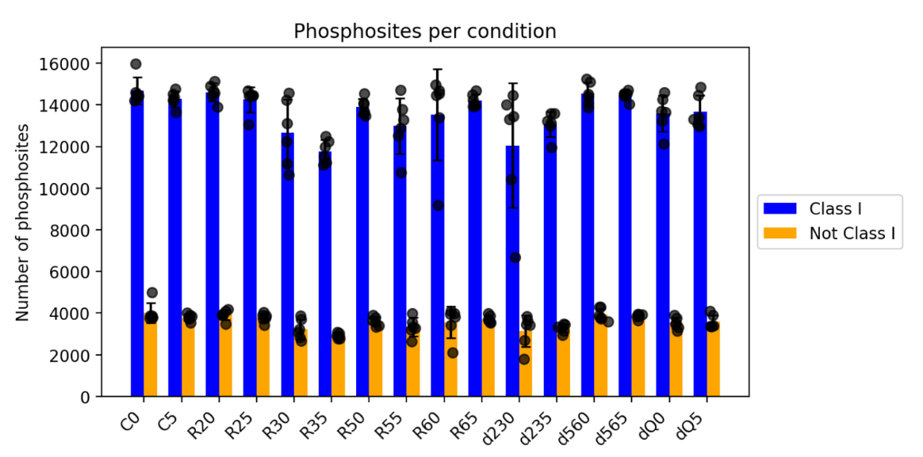
Figure 2: Summary Phossite Coverage Plot.

Together, these plots offer a concise but informative assessment of phosphosite-level data completeness while maintaining full compatibility with the conceptual framework of the general coverage plot.

