Phossite Distribution Plot Manual

1. User Interface (UI)

In the upper-right section of the user interface, you will find a set of controls for customizing the plot:

- Cutoff: Limits the distribution by excluding proteins with exceptionally high phosphosite counts. The cutoff is applied as an upper quantile threshold, removing proteins whose number of phosphosites exceeds the specified percentile.
- Bar Color: Sets the color of the bars in the distribution plot, allowing customization of the visual appearance.
- Plot Width, Height, and DPI: Adjust the dimensions and resolution of the plot for download.
- Download Format: Choose the file format for downloading the plot, including PNG, JPG, SVG, or PDF.
- Download Button: Exports the plot according to the selected settings. Note that changes in size affect only the downloaded plot and do not modify the display in the interface.

2. Phossite Distribution Plot

The phosphosite distribution functionality provides an overview of how many phosphosites are detected per phosphoprotein across the dataset. This visualization helps users assess the structural complexity of phosphorylation patterns, identify proteins with unusually high numbers of modification sites, and detect potential biases in site assignment or peptide coverage.

- phossite_dist – Generates a bar chart showing the frequency distribution of phosphosite counts per phosphoprotein. Each bar represents the number of proteins that contain a specific number of detected phosphosites.

The function requires two columns: Phosphoprotein, identifying the parent protein, and site_num, indicating how many phosphosites were assigned to each protein. After converting the site count information into numeric form and removing invalid entries, the distribution is computed by counting how many proteins exhibit each possible number of phosphosites.

An optional cutoff parameter allows users to exclude extreme high-site proteins, which may represent outliers or unusually large protein groups. The cutoff is applied by removing proteins whose phosphosite counts fall above a user-defined quantile threshold, thereby focusing the visualization on the central distribution of the dataset.

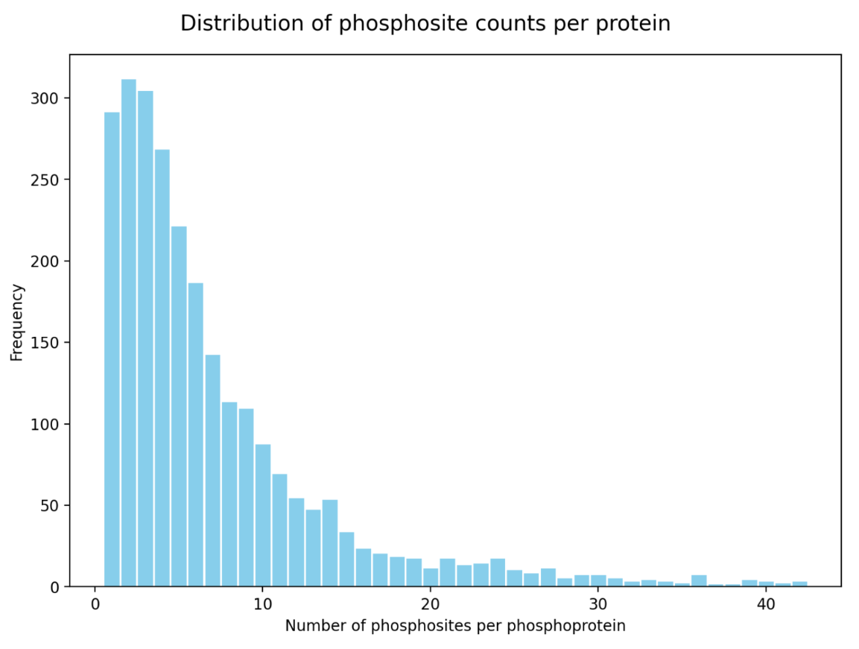
Figure 1: Phossite Distribution Plot showing the number of phosphosites per phosphoprotein.

The resulting bar plot displays phosphoprotein counts along the y-axis and the number of phosphosites along the x-axis, with tick marks spaced at regular intervals for clarity. This distribution helps users evaluate whether phosphorylation is broadly dispersed across many proteins with few sites or concentrated in a subset of proteins with extensive modification. When well-behaved, datasets show a right-skewed distribution with most proteins carrying only a small number of phosphosites, whereas broad or multi-modal distributions may indicate complex signaling patterns, differences in digestion efficiency, or dataset-specific enrichment characteristics.

