Phossite Plot Manual

1. User Interface (UI)

In the upper-right section of the user interface, you will find a set of controls for customizing the plot:

- Cutoff: Sets the minimum PTM localization probability required for a phosphosite to be included in the plot. Only entries with PTM_localization ≥ Cutoff are counted, allowing users to restrict the analysis to confidently localized sites.
- Bar Color: Defines the color used for the horizontal bars in the plot. This option allows users to customize the visual style of the phosphoprotein, phosphopeptide, and phosphosite bar chart.
- Plot Width, Height, and DPI: Adjust the dimensions and resolution of the plot for download.
- Download Format: Choose the file format for downloading the plot, including PNG, JPG, SVG, or PDF.
- Download Button: Exports the plot according to the selected settings. Note that changes in size affect only the downloaded plot and do not modify the display in the interface.

2. Phossite Plot

The phosphosite summary plot functionality provides a compact, high-level overview of the number of phosphoproteins, phosphopeptides, and phosphosites detected in a dataset after applying a user-defined localization cutoff. This visualization is implemented through dedicated functions that count and display the abundance of key phosphoproteomics features in a horizontal bar chart.

- simple_phos_site_plot – Generates a summarized bar plot that reports how many unique phosphoproteins, phosphopeptides, and phosphosites remain in the dataset following the selected PTM localization threshold. By filtering data according to a minimum localization probability, the function ensures that only confidently assigned modification sites contribute to the final counts.

For each dataset, the function applies the chosen localization cutoff to remove low-confidence identifications. After filtering, three non-overlapping entities are quantified:

- Phosphoproteins – the number of distinct protein groups containing at least one site meeting the cutoff.
- Phosphopeptides – the number of unique peptide sequences carrying localized modifications.
- Phosphosites – the number of unique modification sites represented by their PTM collapse keys.

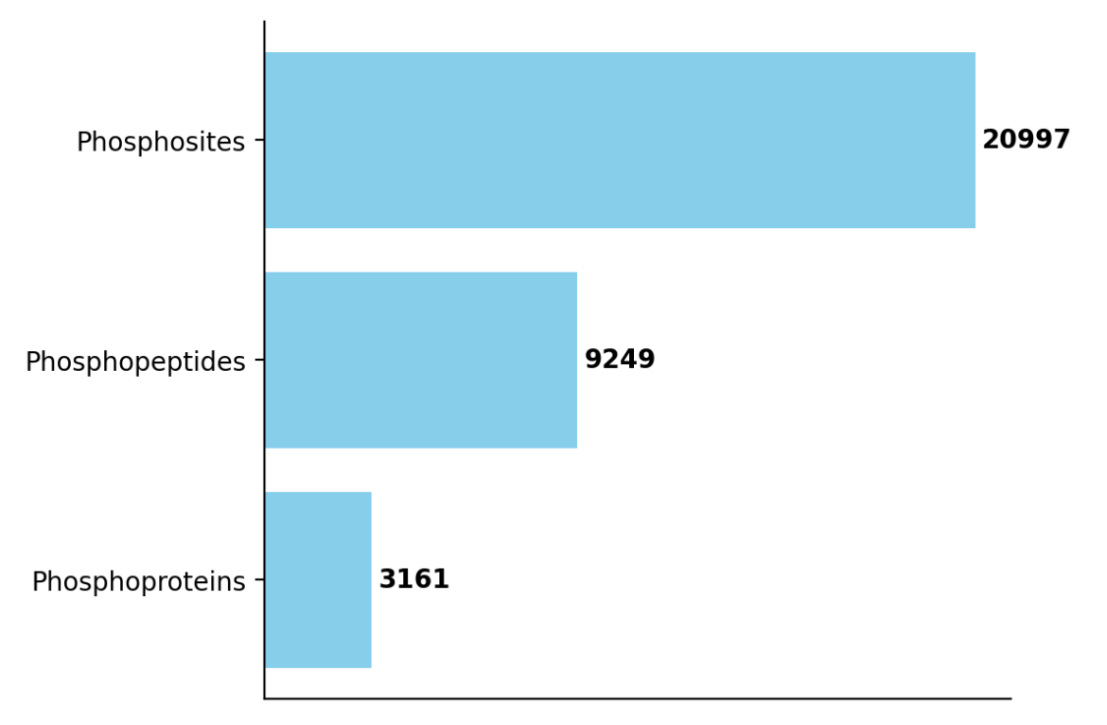
Figure 1: Phossite Plot showing the number of unique phosphosites, phosphopeptides and phosphoproteins within a dataset above a given PTM_localization cutoff.

The resulting counts are plotted as horizontal bars, arranged in descending order to emphasize the relative sizes of each category. A label is added at the end of each bar to communicate the exact numerical value alongside the visual representation.

In well-structured datasets, the numbers of phosphopeptides and phosphosites typically exceed the number of phosphoproteins, reflecting the hierarchical structure of protein modification. A sharp drop in counts after applying a cutoff localization may indicate that many sites carry low-confidence assignments, whereas stable counts across cutoff values suggest high-quality PTM localization. The summary plot therefore provides an immediate and intuitive assessment of dataset depth, localization reliability, and phosphoproteomics coverage.

