Principal Component Analysis Plot Manual

1. User Interface (UI)

In the upper-right section of the user interface, you will find a set of controls for customizing the plot:

- Toggle Legend: Enables or disables the display of the legend in the plot.
- Toggle Header: Enables or disables the display of the header in the plot.
- Levels: Allows selection of the data set to visualize. Available options include:
  - Protein – visualizes PCA based on protein-level data.
  - Phosphosite – visualizes PCA based on phosphosite-level data.
  - Phosphoprotein – Visualizes PCA based on collapsed phosphoprotein-level data.
- Type: Allows selection between two visualization modes:
  - Normal – generates a static 2D or 3D matplotlib PCA plot.
  - Interactive – generates an interactive Plotly PCA plot with zooming, rotation, and hover information.
- Dimensions: Determines whether the PCA is shown in two or three dimensions:
  - 2D – Plots the first two principal components (PC1 vs PC2).
  - 3D – Plots the first three principal components (PC1 vs PC2 vs PC3).
- Add Ellipses: When enabled, draws ellipses around the 2D clusters to visualize the spread of each condition.
- Dot size: Adjusts the size of the points representing samples in the plot.
- Plot Width, Height, and DPI: Adjust the dimensions and resolution of the plot for download.
- Download Format: Choose the file format for downloading the plot, including PNG, JPG, SVG, or PDF.
- Download Button: Exports the plot according to the selected settings. Note that changes in size affect only the downloaded plot and do not modify the display in the interface.

2. Principal Component Analysis Plot

The PCA visualization is implemented through two complementary functions, each designed to explore the relationships between samples based on their measured features:

- pca_plot – Generates static 2D or 3D PCA plots using matplotlib, allowing users to visualize clusters of samples across conditions.
- pca_plot_interactive – Produces interactive 2D or 3D PCA plots with Plotly, enabling zooming, rotation, and hover information for each sample.

PCA reduces the dimensionality of the dataset by identifying new axes, called principal components (PCs), that capture the largest sources of variation in the data. These components are linear combinations of all measured features, meaning that each feature contributes to the position of every sample along a principal component according to its variance and covariance with other features. The first principal component (PC1) is chosen to explain the maximum possible variance across all samples, the second component (PC2) captures the next largest variance while being orthogonal to PC1, and so on. By projecting samples onto these axes, PCA condenses the most informative variation into a few dimensions, allowing patterns, clusters, or trends to become visible that might be obscured in the full high-dimensional feature space. Both plot types allow optional ellipses around condition clusters to visualize spread and point size can be adjusted for clarity. Legends and headers can be toggled, and colors can be customized by condition. In well-behaved datasets, replicates of the same condition cluster closely together, reflecting consistent measurements, while distinct conditions form separate groups along the principal components, highlighting biological or technical differences.

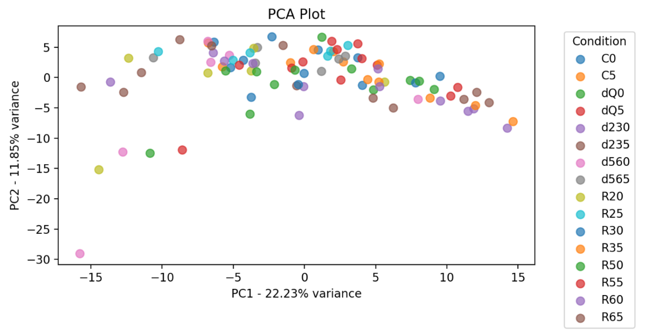
Figure 1: 2-Dimensional PCA Plot.

By combining dimensionality reduction with flexible visualization, these PCA plots provide an intuitive overview of sample relationships, helping users identify outliers, assess condition separation, and evaluate overall dataset structure.

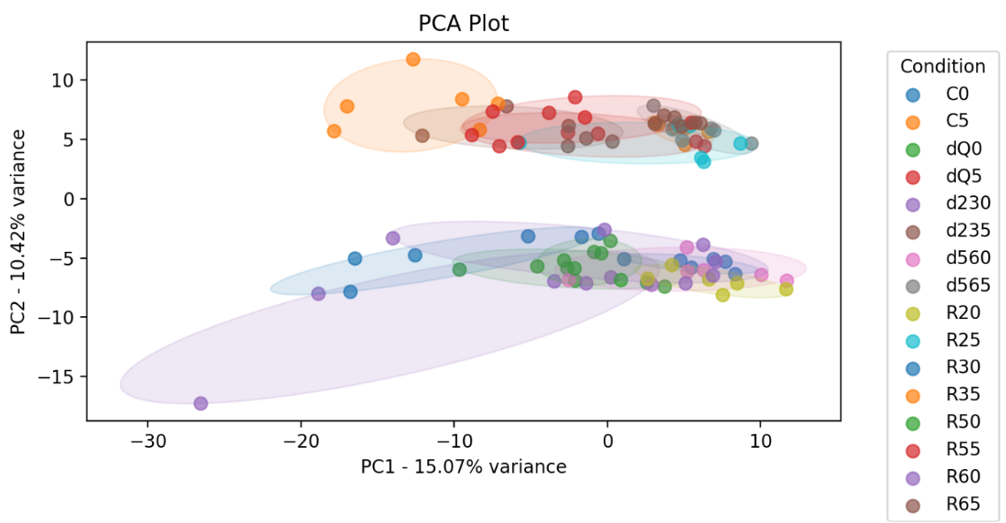
Figure 2: 2-Dimensional PCA Plot with overlayed ellipses emphasizing experimental conditions.

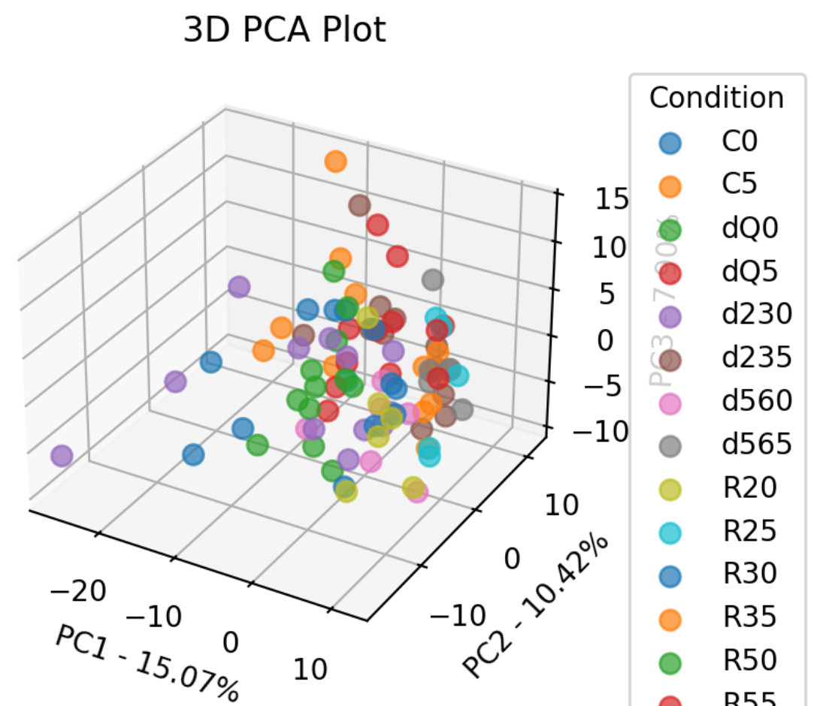
Figure 3: 3-Dimensional PCA-Plot

