Protein Boxplot Manual

1. User Interface (UI)

In the upper-right section of the user interface, you will find a set of controls for customizing the plot:

- Toggle Header: Enables or disables the display of the header in the plot.
- Toggle Legend: Enables or disables the display of the legend in the plot.
- Toggle Dots: Displays individual non-outlier intensity values as points overlaid on the boxes, helping to visualize the distribution within the interquartile range.
- Toggle Outliers: Enables or disables the display of outlier values outside the whiskers (1.5 × IQR). Outliers are shown as individual points.
- Levels: Allows selection of the data set to visualize. Available options include:
  - Protein – available after uploading protein-level data.
  - Phosphosite – available after uploading the phosphosite-level data.
  - Phosphoprotein – available after initializing a collapsing pipeline for the phosphosite-level data.
- Select Protein: Choose the specific protein, phosphosite, or phosphoprotein of interest to display its intensity distribution.
- Select Conditions: Choose which experimental conditions to include in the plot. Only conditions with at least three samples are plotted.
- Plot Width, Height, and DPI: Adjust the dimensions and resolution of the plot for download.
- Download Format: Choose the file format for downloading the plot, including PNG, JPG, SVG, or PDF.
- Download Button: Exports the plot according to the selected settings. Note that changes in size affect only the downloaded plot and do not modify the display in the interface.

2. Protein Boxplot

The protein boxplot functionality is implemented using dedicated functions to visualize the distribution of log₂-transformed intensity values for individual proteins, phosphosites, or phosphoproteins across experimental conditions:

- boxplot_int_single_prot – Generates per-protein boxplots, where each box represents the distribution of measured intensities for the selected protein within a given condition.

These plots allow users to examine how the intensity of a single protein varies across samples and conditions, providing a detailed view of both biological and technical variation.

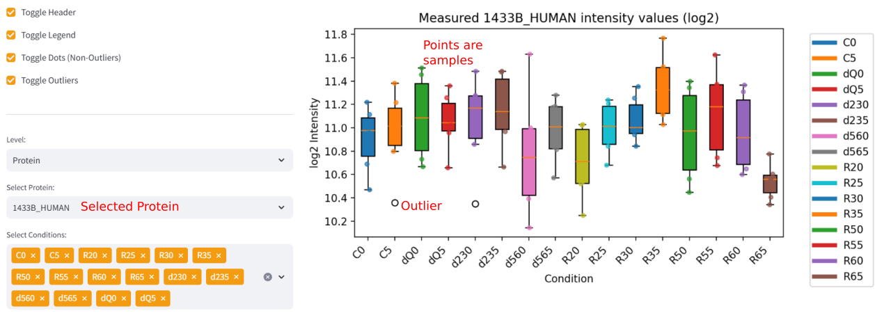
Figure 1: Protein Boxplot showing the intensities of the protein “1433B_HUMAN” measured in different conditions.

For each protein, the function extracts all intensity values corresponding to the selected conditions. Every box in the resulting plot represents one experimental condition, and all replicates for that condition contribute to the distribution. This perspective enables users to assess comparability between conditions, detect shifts in protein abundance, identify outlier samples, and evaluate the overall shape of the intensity distribution, including symmetry, spread, and potential skewness.

The boxplots follow the standard statistical definitions:

- Median: The central line within each box represents the 50th percentile of intensity values for the protein in that condition.
- Interquartile Range (IQR): The box spans the 25th to 75th percentiles (Q1 to Q3), covering the middle 50% of values:

$$\text{IQR}=Q3-Q1$$
- Whiskers: Extend to the most extreme values within 1.5 × IQR from the quartiles:

$$\text{Lower whisker}=Q1-1.5×\text{IQR}, \text{Upper whisker}=Q3+1.5×\text{IQR}$$
- Outliers: Values beyond the whiskers are plotted as individual markers. Outliers may indicate extreme biological variation or potential technical artifacts.

In well-behaved datasets, boxplots for a given protein show consistent shapes, similar median values across replicates, and reasonable symmetry after log₂ transformation. Deviations, asymmetries, or large numbers of outliers can highlight technical issues, differences in protein abundance, or biologically relevant variation, allowing users to make informed assessments of the data quality and variability at the single-protein level.

