Protein Lineplot Manual

1. User Interface (UI)

In the upper-right section of the user interface, you will find a set of controls for customizing the plot:

- Toggle IDs: Enables or disables the display of the sample IDs in the plot.
- Toggle Header: Enables or disables the display of the header in the plot.
- Toggle Legend: Enables or disables the display of the legend in the plot.
- Levels: Allows selection of the data set to visualize. Available options include:
  - Protein – available after uploading protein-level data.
  - Phosphosite – available after uploading the phosphosite-level data.
  - Phosphoprotein – available after initializing a collapsing pipeline for the phosphosite-level data.
- Select Protein: Choose the specific protein, phosphosite, or phosphoprotein of interest to display its intensity in different samples within a condition. One or more proteins can be shown in a single plot.
- Select Conditions: Choose which experimental conditions to include in the plot. Only conditions with at least three samples are plotted.
- Plot Width, Height, and DPI: Adjust the dimensions and resolution of the plot for download.
- Download Format: Choose the file format for downloading the plot, including PNG, JPG, SVG, or PDF.
- Download Button: Exports the plot according to the selected settings. Note that changes in size affect only the downloaded plot and do not modify the display in the interface.

2. Protein Lineplot

The protein line-plot comparison functionality is implemented using dedicated functions designed to visualize log₂-transformed intensity values of individual proteins, phosphosites, or phosphoproteins across ordered samples and experimental conditions:

- compare_prot_line – Generates line plots in which each input protein (or phosphosite/phosphoprotein) is drawn as an independent trajectory across samples. Each point on the line corresponds to the measured intensity of that protein in a specific sample, while the grouping and ordering of samples reflect the structure of the experimental design.

These plots enable users to track how the expression of a protein changes across samples, replicates, and conditions. By drawing intensities as connected points along the sample axis, the plot highlights trends, shifts, and sample-level differences that may be overlooked in aggregated statistical views.

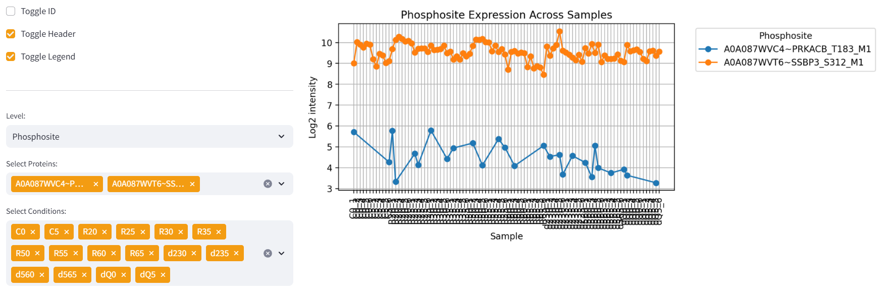

Figure 1: Lineplot showing the intensity values for the two phosphosites “PRKACB_T183” and “SSBP3_S312” withing the samples for selected conditions.

The samples are ordered according to the user-specified condition sequence, ensuring consistent visual alignment with the experimental workflow. Each protein is plotted as a separate line, with each marker representing one sample. Missing intensity values (NA) are simply omitted from the set of plotted points; no marker is shown for those samples, but the surrounding points remain connected. As a result, the line continues across any missing values without visible breaks, allowing users to follow overall expression trends even when certain measurements are unavailable.

This visualization allows users to evaluate temporal or conditional trends, detect replicate-level variation, and distinguish global vs. condition-specific shifts in expression. Because intensities are shown at sample resolution rather than aggregated per condition, the method offers a detailed view of biological heterogeneity and potential technical artifacts. Missing values appear implicitly as absent markers, helping users identify samples that were not quantified for a given protein, an indication that may reflect low abundance, detection limits, or technical dropout.

In well-behaved datasets, proteins exhibit smooth and consistent trajectories within conditions, with replicates clustering closely and transitions between conditions reflecting the expected biological responses. Abrupt changes, irregular oscillations, or highly variable replicate points may indicate technical issues such as sample preparation inconsistencies, batch effects, or measurement noise. Conversely, distinct condition-specific shifts or well-defined trends may correspond to biologically meaningful regulation at the protein or phosphosite level. When NA values cluster within particular conditions or sample groups, they may additionally point to systematic detectability issues or condition-specific protein loss that merits further investigation.

