Venn Diagram Manual

1. User Interface (UI)

In the upper-right section of the user interface, you will find a set of controls for customizing the plot:

- Toggle Header: Enables or disables the display of the plot title. When enabled, the title is shown above the Venn diagram.
- Levels: Allows selection of the data set to visualize. Available options include:
  - Protein – available after uploading protein-level data.
  - Phosphosite – available after uploading the phosphosite-level data.
  - Phosphoprotein – available after initializing a collapsing pipeline for the phosphosite-level data.
- Mode: Selects the method of comparison:
  - Single – compares two or three individual samples and visualizes their overlap in a Venn diagram.
  - Condition – compares two or three conditions by aggregating all replicates within each condition and visualizing shared and unique features.
- Sample/Condition 1: Selects the first sample or condition to include in the Venn diagram. In condition mode, all replicates are combined to determine the presence of features.
- Sample/Condition 2: Selects the second sample or condition to include in the Venn diagram. In condition mode, all replicates are combined to determine the presence of features.
- Sample/Condition 3 (optional): Allows selection of a third sample or condition for a three-way Venn diagram. If not selected, only a two-way diagram is generated.
- Alias for Sample/Condition: Allows the user to provide custom labels for each sample or condition, which will appear in the diagram instead of the original sample or condition names.
- Color Selection: Sets the fill colors for each sample or condition in the Venn diagram. Individual colors can be chosen for up to three groups.
- Plot Width, Height, and DPI: Adjust the dimensions and resolution of the plot for download.
- Download Format: Choose the file format for downloading the plot, including PNG, JPG, SVG, or PDF.
- Download Button: Exports the plot according to the selected settings. Note that changes in size affect only the downloaded plot and do not modify the display in the interface.

2. Venn Diagram

The Venn Diagram module provides a visual representation of overlapping and unique features across samples or conditions. This analysis enables users to quickly identify shared proteins, phosphosites, or phosphoproteins, as well as features that are specific to individual groups, supporting comparisons of dataset composition and coverage.
- overlap_plot_single – Generates two- or three-set Venn diagrams for individual samples. For each sample, non-missing and non-zero features are identified, and the diagram shows intersections and unique elements. Optional labels and colors can be applied to customize the display.
- overlap_plot_condition – Generates two- or three-set Venn diagrams at the condition level. All replicates within each condition are aggregated, and any feature detected in at least one replicate is considered present. The diagram then visualizes overlaps and unique features across the selected conditions.

For both functions, the following steps are applied:

- Extract features with non-missing and non-zero intensities for each sample or aggregated condition.
- Convert each set of detected features into a Python set.
- Pass the sets to a Venn diagram plotting function (venn2 for two groups, venn3 for three groups).
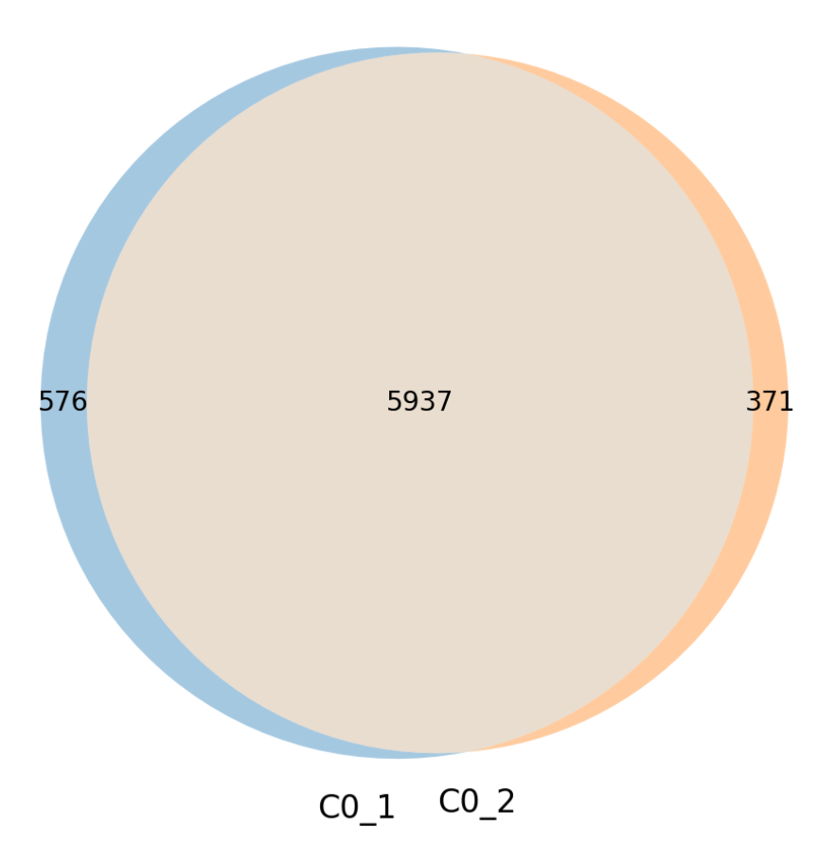
Figure 1: Venn diagram showing the protein overlap between two samples.

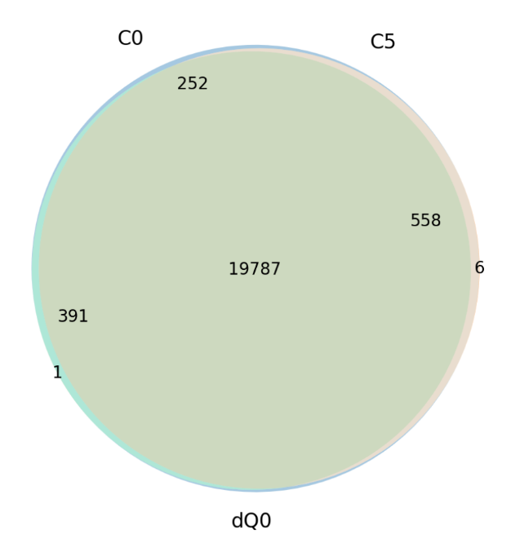

Figure 2: Venn diagram showing the phosphosite overlap between three conditions.
This visualization allows users to:

- Assess the overlap of detected features between samples or conditions.
- Identify sample- or condition-specific proteins, phosphosites, or phosphoproteins.
- Compare dataset completeness and feature distribution across groups.

The module supports up to three sets in both single-sample and condition-aggregated modes. By providing an intuitive overview of shared and unique elements, Venn diagrams help users evaluate biological reproducibility, experimental coverage, and condition-specific effects in a concise visual format.

