Volcano Plot Manual

1. User Interface (UI)

In the upper-right section of the user interface, you will find a set of controls for customizing the plot:

- P-value threshold: Defines the statistical cutoff for significance. Features with adjusted p-values below this threshold are considered significantly different between the two selected conditions.
- Log2 FC threshold: Specifies the minimum absolute log₂ fold change required for calling a feature up- or downregulated. Only features exceeding this magnitude and meeting the p-value criterion are labeled significant.
- Use uncorrected p-values: When enabled, significance is determined using raw p-values instead of FDR-adjusted values. This removes multiple-testing correction and applies the threshold directly to the unadjusted test statistic.
- Highlight Terms: Allows the user to supply protein or peptide identifiers that should be emphasized in the plot. Matching entries are rendered with increased marker size and a bright outline for visual distinction.
- Test Type: Selects the statistical testing framework used to compute differential abundance:
  - Unpaired – performs an independent-samples t-test, using pooled variance and appropriate degrees of freedom.
  - Single – computes within-sample differences and applies a paired t-test to the resulting vector of differences.
- Levels: Allows selection of the data set to visualize. Available options include:
  - Protein – available after uploading protein-level data.
  - Phosphosite – available after uploading the phosphosite-level data.
  - Phosphoprotein – available after initializing a collapsing pipeline for the phosphosite-level data.
- Add Volcano to Log: Stores the current volcano plot configuration (conditions, thresholds, test type, and corrections) into the session log for reporting.
- Remove Volcano from Log: Searches the log for an entry matching the current settings and removes it. If no matching entry exists, no changes are made.
- Condition 1: Specifies the first condition to be compared; all samples belonging to this group form the reference distribution.
- Condition 2: Specifies the second condition; feature intensities from this group are contrasted with Condition 1 to compute log₂ fold changes and t-statistics.

2. Volcano Plot

The volcano plot functionality is implemented using two complementary functions, each designed to quantify and visualize differential abundance between two conditions:

- volcano_data_f – Computes log₂ fold changes and p-values for all features, applying either unpaired or paired t-tests. Features are classified as upregulated, downregulated, or not significant based on user-defined thresholds for fold change and statistical significance.
- volcano_plot / volcano_plot_h – Generates an interactive volcano plot, where each point represents a feature positioned by its log₂ fold change (x-axis) and –log₁₀(p or adjusted p-value) (y-axis). The volcano_plot_h variant additionally highlights user-specified features for visual emphasis.

These functions allow users to rapidly identify strongly regulated proteins, phosphosites, or phosphoproteins, assess statistical significance, and visually compare effect sizes across the dataset. The combination of quantitative analysis and graphical representation supports comprehensive evaluation of differential abundance in proteomic and phosphoproteomic studies.

Difference Calculation
For the two selected conditions, the log₂-transformed intensity values of all features are extracted. For each feature, the mean intensity is calculated in both conditions:

$$\overset{ˉ}{x}=\text{mean of Condition 1}, \overset{ˉ}{y}=\text{mean of Condition 2}$$
The log₂ fold change (log₂FC) is then computed as:

$${\text{log}}_{2}FC=\overset{ˉ}{y}-\overset{ˉ}{x}$$
This metric represents the effect size, measuring the magnitude and direction of change for each feature between the two conditions. Positive values indicate upregulation in Condition 2 compared to Condition 1, while negative values indicate downregulation.

T-Testing
To determine whether the observed differences in feature intensities between two conditions are statistically significant, t-tests are applied. The t-test evaluates whether the mean difference between groups is larger than expected by chance, accounting for variability within each group. The test assumes that the data are approximately normally distributed and that the values are independent (except in the paired design). When these assumptions hold, the t-test provides a robust measure of statistical significance for each feature.

Unpaired t-test (independent samples):
This test is appropriate when the samples in each condition are independent and there is no inherent pairing between measurements. The procedure involves:

- Calculating the pooled variance, which combines the variability from both conditions:

$$s_{p}^{2}=\frac{(n_{1}-1)s_{1}^{2}+(n_{2}-1)s_{2}^{2}}{n_{1}+n_{2}-2}$$

- Computing the standard error of the mean difference, reflecting the expected variability of the difference between group means:

$$SE=\sqrt{s_{p}^{2}(\frac{1}{n_{1}}+\frac{1}{n_{2}})}$$

- Calculating the t-statistic, which compares the observed log₂ fold change to the expected variability under the null hypothesis:

$$t=\frac{{\text{log}}_{2}FC}{SE},df=n_{1}+n_{2}-2$$

This t-statistic is then used to derive a p-value, representing the probability that the observed difference could occur by chance.

Paired t-test (matched samples):
When each sample in Condition 1 has a corresponding matched sample in Condition 2, a paired t-test is used. This test accounts for within-sample correlations, often increasing statistical power by reducing variability due to sample-specific effects. The steps are:

- Compute the within-sample differences for each feature:

$$d_{i}=y_{i}-x_{i}$$

- Calculate the mean and standard deviation of these differences:

$$\overset{ˉ}{d}=\text{mean}(d_{i}),s_{d}=\text{std}(d_{i})$$

- Compute the t-statistic:

$$t=\frac{\overset{ˉ}{d}}{s_{d}/\sqrt{n}},df=n-1$$
By using the differences directly, the paired t-test removes variability due to individual sample effects, making it particularly suitable for repeated measures or matched designs.

Multiple Testing Correction:
When performing statistical tests on thousands of features simultaneously, as is typical in proteomics or phosphoproteomics, raw p-values are prone to false positives. To address this, a multiple testing correction is applied. The volcano plot pipeline uses the Benjamini–Hochberg (BH) procedure to control the false discovery rate (FDR).

The BH procedure operates as follows:

- Rank the p-values $p_{1},p_{2},…,p_{m}$in ascending order:

$$p_{(1)}≤p_{(2)}≤⋯≤p_{(m)}$$
- Compute the adjusted p-value for each feature using:

$${\text{adj_p}}_{(i)}=\frac{m}{i} p_{(i)}$$
where $m$ is the total number of tests and $i$is the rank of the p-value. Each adjusted p-value is also constrained to be no smaller than the previous rank’s value to maintain monotonicity:

$${\text{adj_p}}_{(i)}=min⁡({\text{adj_p}}_{(i)},{\text{adj_p}}_{(i+1)})$$
- Compare the adjusted p-values to the significance threshold $α$(default 0.05). Features with $\text{adj_p}<α$are considered statistically significant while controlling the expected proportion of false positives among discoveries.

This procedure ensures that, on average, the FDR — the proportion of false positives among all significant features — remains below the chosen threshold.

Thresholds, Feature Classification, and Volcano Plot Interpretation
To identify features that are both statistically significant and biologically meaningful, two complementary thresholds are applied:

- Significance threshold ($α$) – Typically an adjusted p-value of 0.05. Features with adjusted p-values below this threshold are considered statistically significant.
- Fold-change threshold ($τ$) – Typically an absolute log₂ fold change of 1.0. Features must exceed this magnitude to be deemed biologically relevant.

Using these thresholds, each feature is classified as follows:

- Upregulated: $\text{adj.p-value}<α$and ${\text{log}}_{2}FC>τ$
- Downregulated: $\text{adj.p-value}<α$and ${\text{log}}_{2}FC<-τ$
- Not significant: All other features

This dual-threshold approach ensures that features highlighted in the analysis exhibit both statistical confidence and biologically meaningful changes.
The resulting volcano plot provides a visually intuitive summary of these classifications:

- X-axis: log₂ fold change – representing the magnitude and direction of change. Positive values indicate upregulation in Condition 2 compared to Condition 1, while negative values indicate downregulation.
- Y-axis: –log₁₀(p-value or adjusted p-value) – representing statistical significance. Higher values indicate stronger evidence against the null hypothesis.

Reference lines indicate the thresholds:

- Horizontal line: –log₁₀($α$)
- Vertical lines: ±$τ$

Features are colored according to their classification: red for upregulated, blue for downregulated, and gray for not significant. In the volcano_plot_h variant, user-selected terms are highlighted with larger markers and distinct outlines, allowing easy tracking of specific proteins or phosphosites.

Interpretation:

- Features in the top-left and top-right quadrants are the most informative, combining strong effect sizes with high statistical significance.
- Features near the center or below the horizontal threshold are not significantly changed.
- The symmetry of the plot can reveal global shifts in abundance or systematic biases.

Overall, the volcano plot delivers a rigorous and intuitive visualization of differential abundance, enabling users to quickly identify key changes while accounting for experimental design, variability, and multiple testing correction.

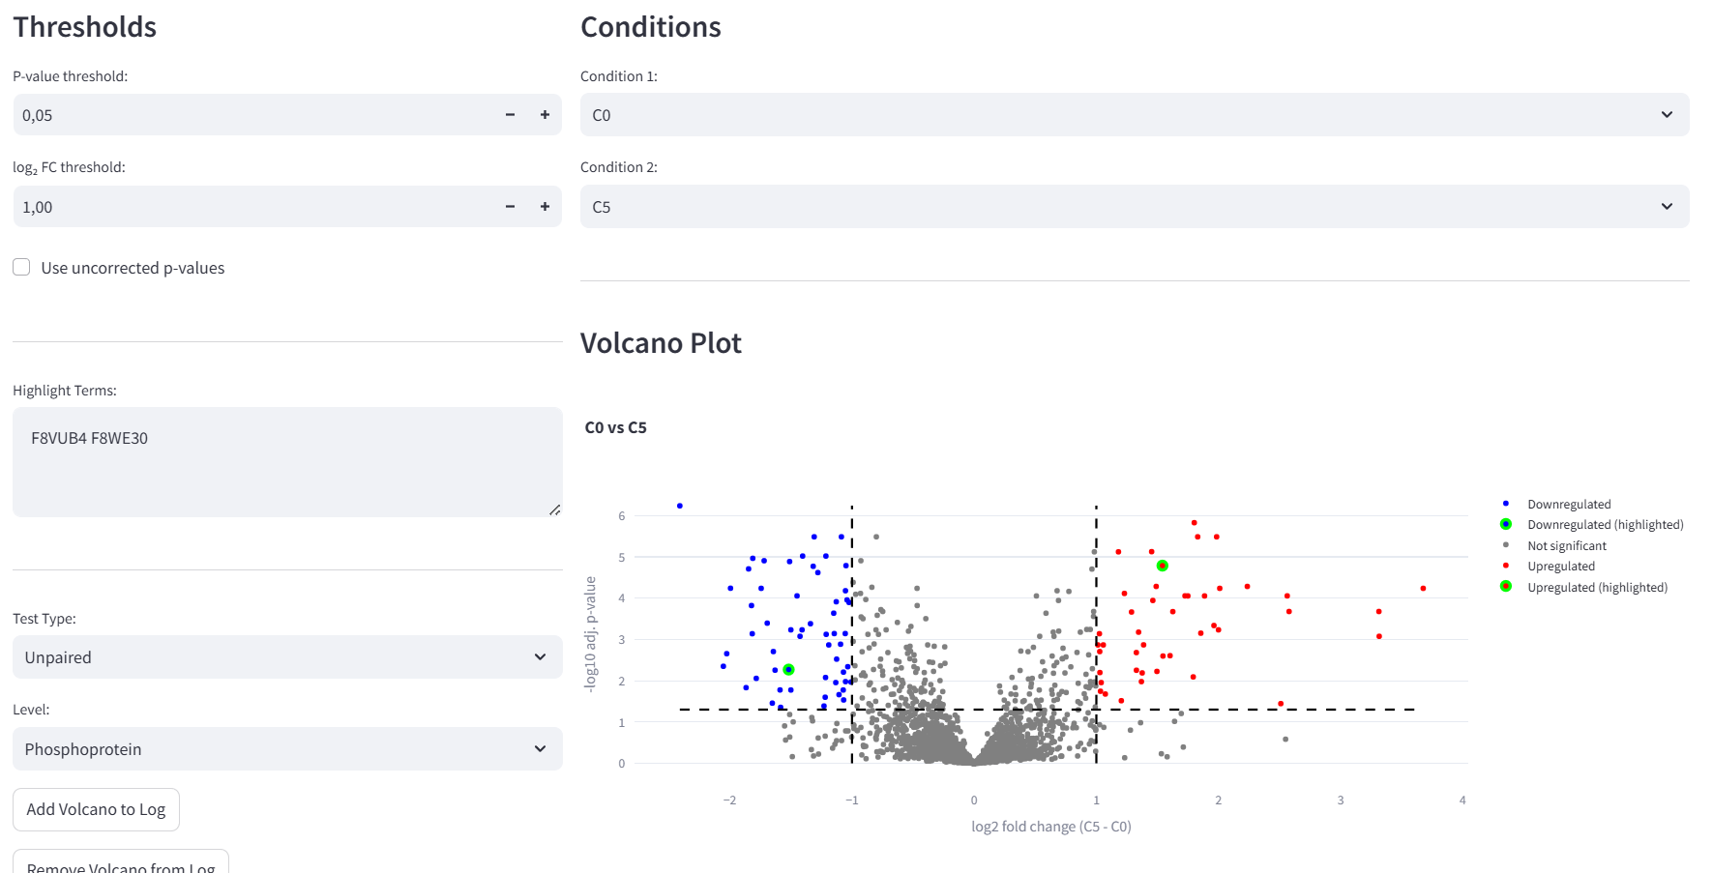
Figure 1: Volcano Plot for Conditions “C0” vs “C5”. The p-value threshold for the BH-adjusted p-values was chosen at 0.05 and the log2FC threshold at 1. The test method chosen was unpaired and phosphoprotein data is displayed. The two phosphoproteins “F8VUB4” and “F8WE30” are highlighted.
3. Volcano Table

The volcano data table is generated by the volcano_data_f function and provides a numerical summary of all features tested for differential abundance between two selected conditions. This table mirrors the visual volcano plot by reporting the same key metrics that define significance and effect size:

- Feature identifier: Protein name, phosphosite key, or phosphoprotein, depending on the selected data level.
- log₂ fold change (log2FC): The difference in mean log₂-transformed intensities between the two conditions.
- p-value (pval): The raw p-value derived from the appropriate t-test (paired or unpaired).
- Adjusted p-value (adj_pval): P-values corrected for multiple testing using the Benjamini–Hochberg procedure to control the false discovery rate.
- Significance: Classification of each feature as “Upregulated,” “Downregulated,” or “Not significant” based on the user-defined fold-change and p-value thresholds.
- –log₁₀(adjusted p-value) (neg_log10_adj_pval): Used for plotting the y-axis of the volcano plot.

For phosphoprotein-level data, additional columns such as site_num and PTM_Collapse_keys are included when available. This table allows users to inspect the exact values underlying the volcano plot, enabling detailed comparisons, filtering, or export for downstream analyses.

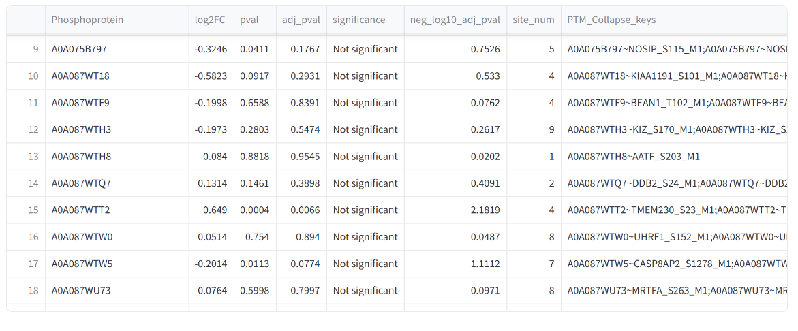
Figure 2: Summary Table.

