A.3) a)Generated Instances:
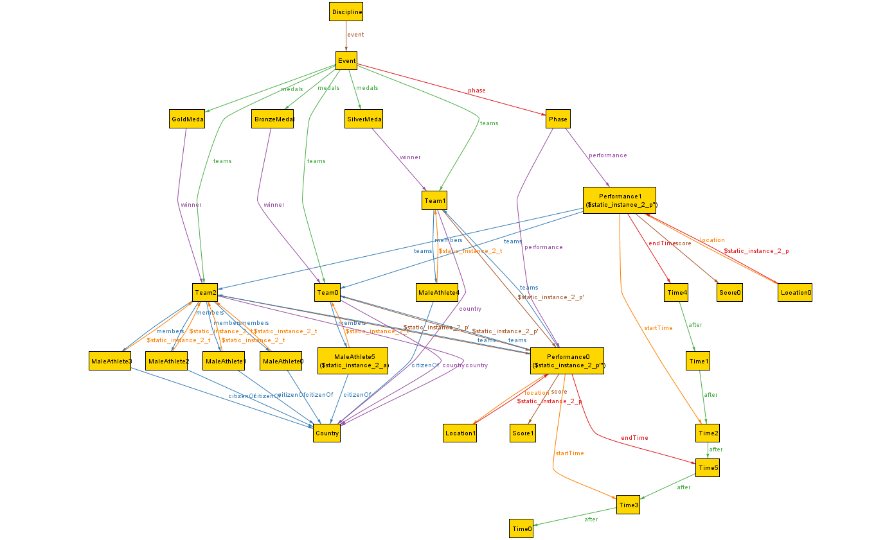

Static_Instance_2: Instance of the Olympics, where an athlete performs in two performances that follow each other immediately.

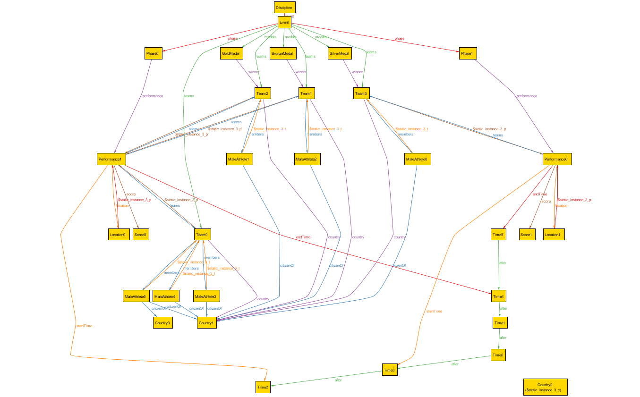

Static_Instance_3: Instance where there is a country without representation

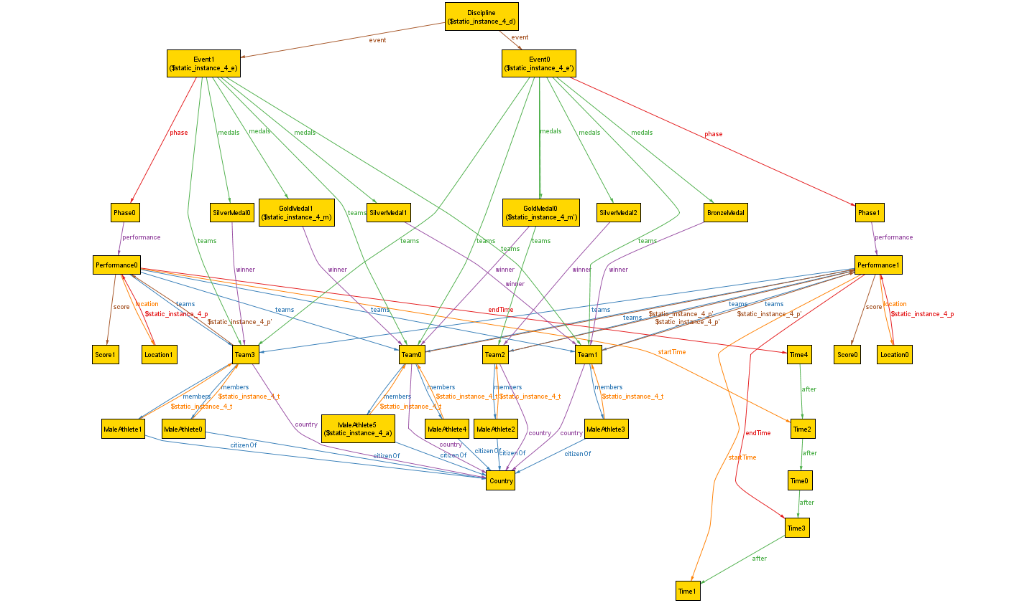
Static_Instance_4 : Instance where an athlete wins gold in two different events

A.3) b) Not Generatable

Static_Instance_1 cannot be generated, as no more than one performance can be at a specific location at a time.

A.3) c) Simplifications:

We ran all instances from the general part for 3 Countries, 2 Performances, 1 Discipline, 2 Events and 4 Teams. This does not affect the general model significantly, as with already little of these
sigs, we can verify that the relations hold as wished, while having more of them would lead to needing many more of the related sigs and therefore impairing the performance of alloy.

A.3) d) Not expressible in Alloy:

