Editing CSS Using Developers Tools

Jonas Nation

Rasmussen College

Author Note

CIS3801C Section 01 Fundamentals of Mobile Web Application Development – Instructor Christopher Mattie

Editing CSS Using Developers Tools

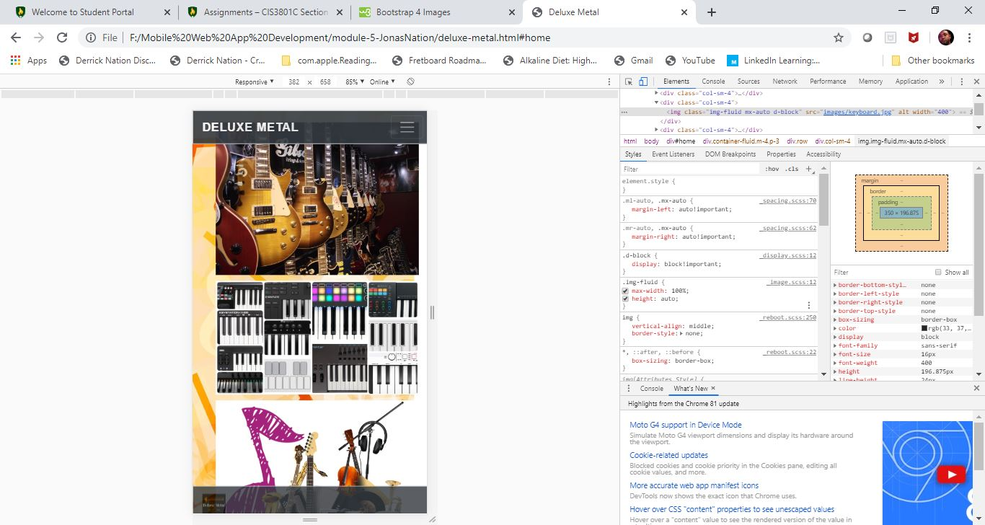

In the module 5 activity I showed that my homepage images was not aligned properly and when the screen became smaller they overlapped. I fixed it by using the google developer tool and I initially thought that if I adjust the margin and position it would fix my problem but that just made things worst. It fixed the overlap problem in the view up above but not in the landscape view. I found out that my columns was not correct, I was using col-md-4 and that wasn’t getting the job done but once I changed my columns to sm-3 (probably could have used md) and floated one images to the left and right then centered the middle image things began to look good in both wide and narrow view. After that I then made my images responsive by using img-fluid, now when then screen size change the images adjust to the size of the screen without overlapping. My images still overlapped a little once screen is changed to the narrow view, all I did to fix that was inside my CSS I styled all my columns in my home page to pad the bottom 10px, which gave my images space and no more overlap. The google dev tool helped me figure this out and I will keep the changes in my final webpage.

