Testing Screen Display Sizes

Jonas Nation

Rasmussen College

Author Note

CIS3801C Section 01 Fundamentals of Mobile Web Application Development – Instructor Christopher Mattie

Testing Screen Display Sizes

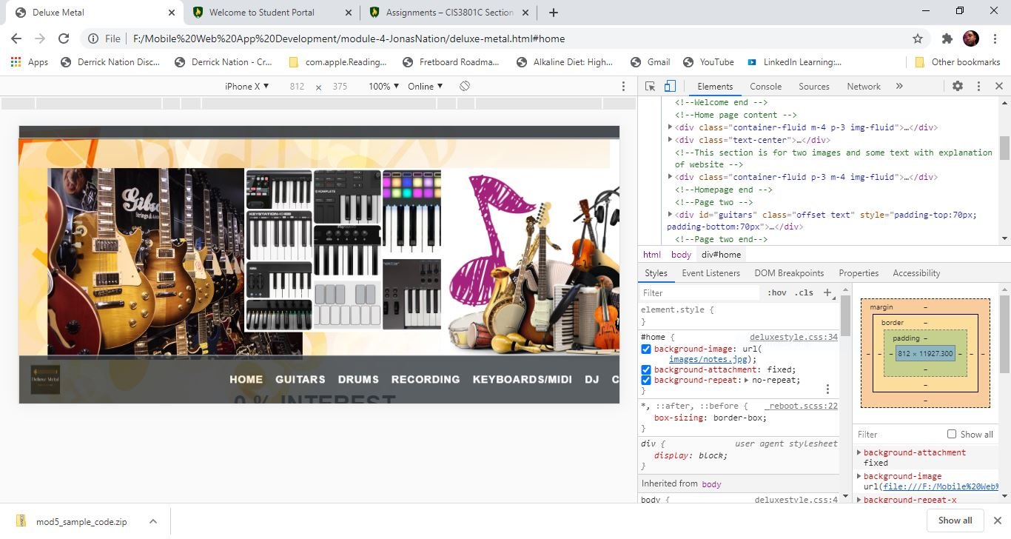

In this screen shot I used the iPhone X view in landscape and my home screen is the only problem I had with this site. As you can see my images are not aligned correctly and I would need to adjust the width and height of my images to get them to line up correctly which I believe will improve how the user accepts the site.

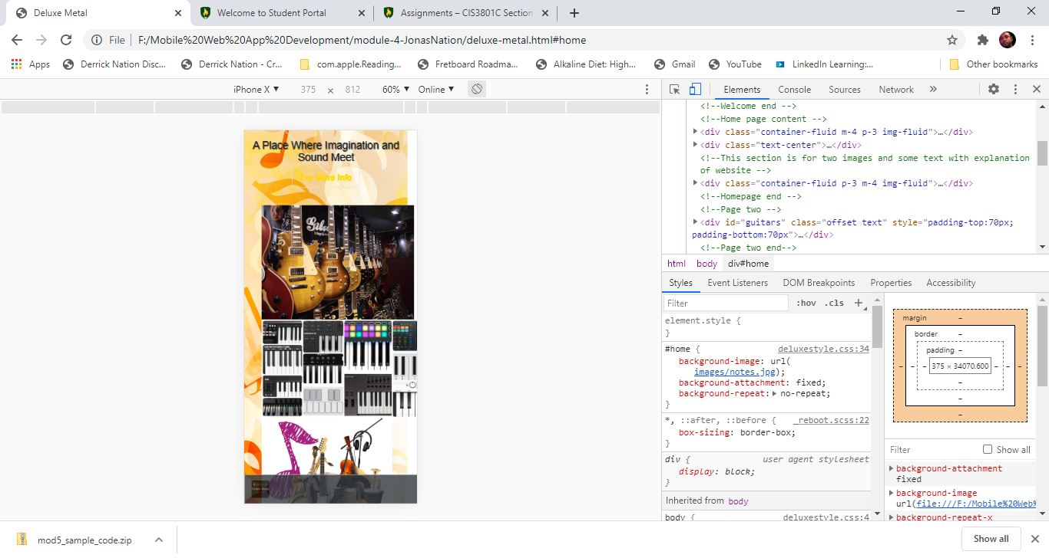

I am still using the iPhone X view and the images are still overlapping. I would need to just adjust the placement of my images for this screen view to give more space in between the images.

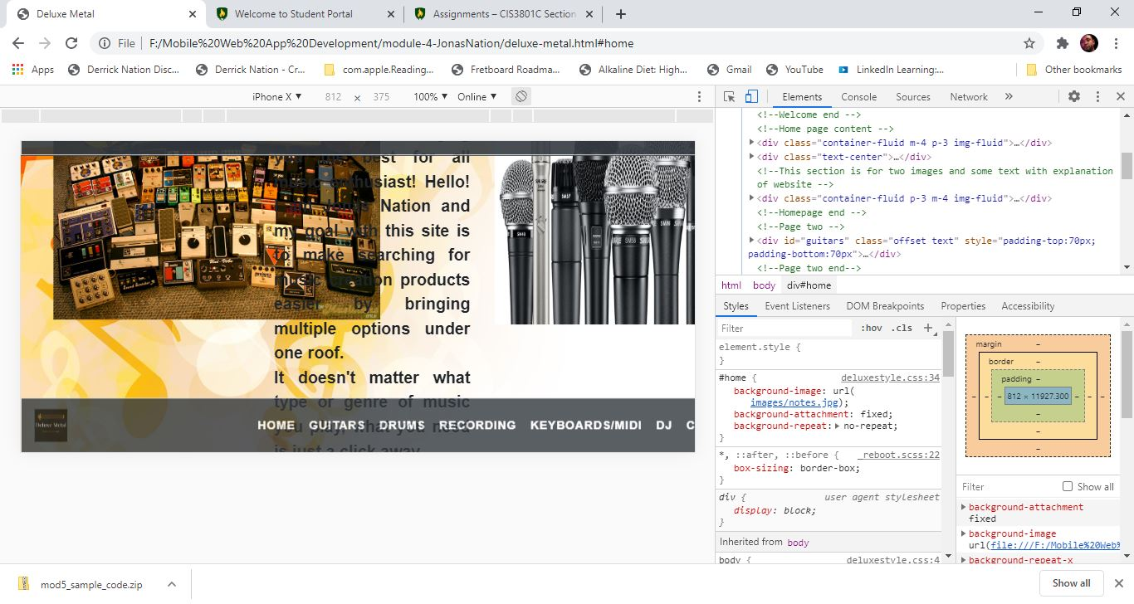

I am still using the iPhone X, I did try this with other screen sizes and I had the same result my home page is the only page that is having this problem with alignment. This will be fixed before I turn in my final project.