

**BEWEGING EN TRILLINGEN**

*Jonas Neeckx*

*Nicolas Heintz*

**Linkages: The Colibri**

PAPER

Titularis

Joris De Schutter

ACADEMIEJAAR 2076-2018

**1 Introduction**

In this paper we will discuss a kinematic and inverse dynamical analysis of a Colibri bird. The Colibri is represented by a nine-bar linkage system with eleven joints and a slider. A drawing of the system can be found in figure 1. The names on the figure are used through the entire paper. Joints A, D, G, H and K are connected to the ground. Bar two is the driver of the system and rotates around joint A with a constant speed. Point C is a slider and will always stay directly under joint A. The length of bars four and eight are variable to make the desired motion of the system possible. The initial values of the parameters can be found in figure 2.

This paper will start with the motion analysis and a discussion about any possible dead configurations. After this a kinematic analysis of the system is done to determine the positions, velocities and accelerations of the bars and joints. After checking these results, a dynamic analysis is used to calculate the internal and external forces of the system.

**2 Motion analysis and dead configurations**

**2.1 Motion analysis**

A motion analysis is used to determine the degree of freedom of the system.

n = 9 (the number of links) The angle between bars eight and nine and bars four and five are fixed so they both count as one bar. They are named separately to make the calculations easier to understand.

f1 = 11 joints that remove two degrees of freedom (A,B,C,D,E,F,G,H,I,J,K)

f2 = 1 joint that removes one degree of freedom(C)

Joint C is used twice in the calculation of the mobility, one as a joint with one degree of freedom and once as a slider with two degrees of freedom.

This gives us a mobility of one which means one variable can be chosen to determine the entire system. In this case phi2, the angle which drives bar two is chosen.

**2.2 Dead configurations**

The system has no dead configurations. Phi2 doesn’t have any limitations.

**3 Kinematic analysis**

**3.1 Loop equations**

There are ten unknown parameters of the system left. Angles three till eleven, the length of bar 4, the length of bar 8 and the distance between joints A and C.   
The entire system can be determined by ten independent equations or five loops in which each loop has an x and a y equation. The loop equations can be found in figure 3.

Phi5 and phi9 can be written in function of phi4 and phi8 as shown in loops four and five.

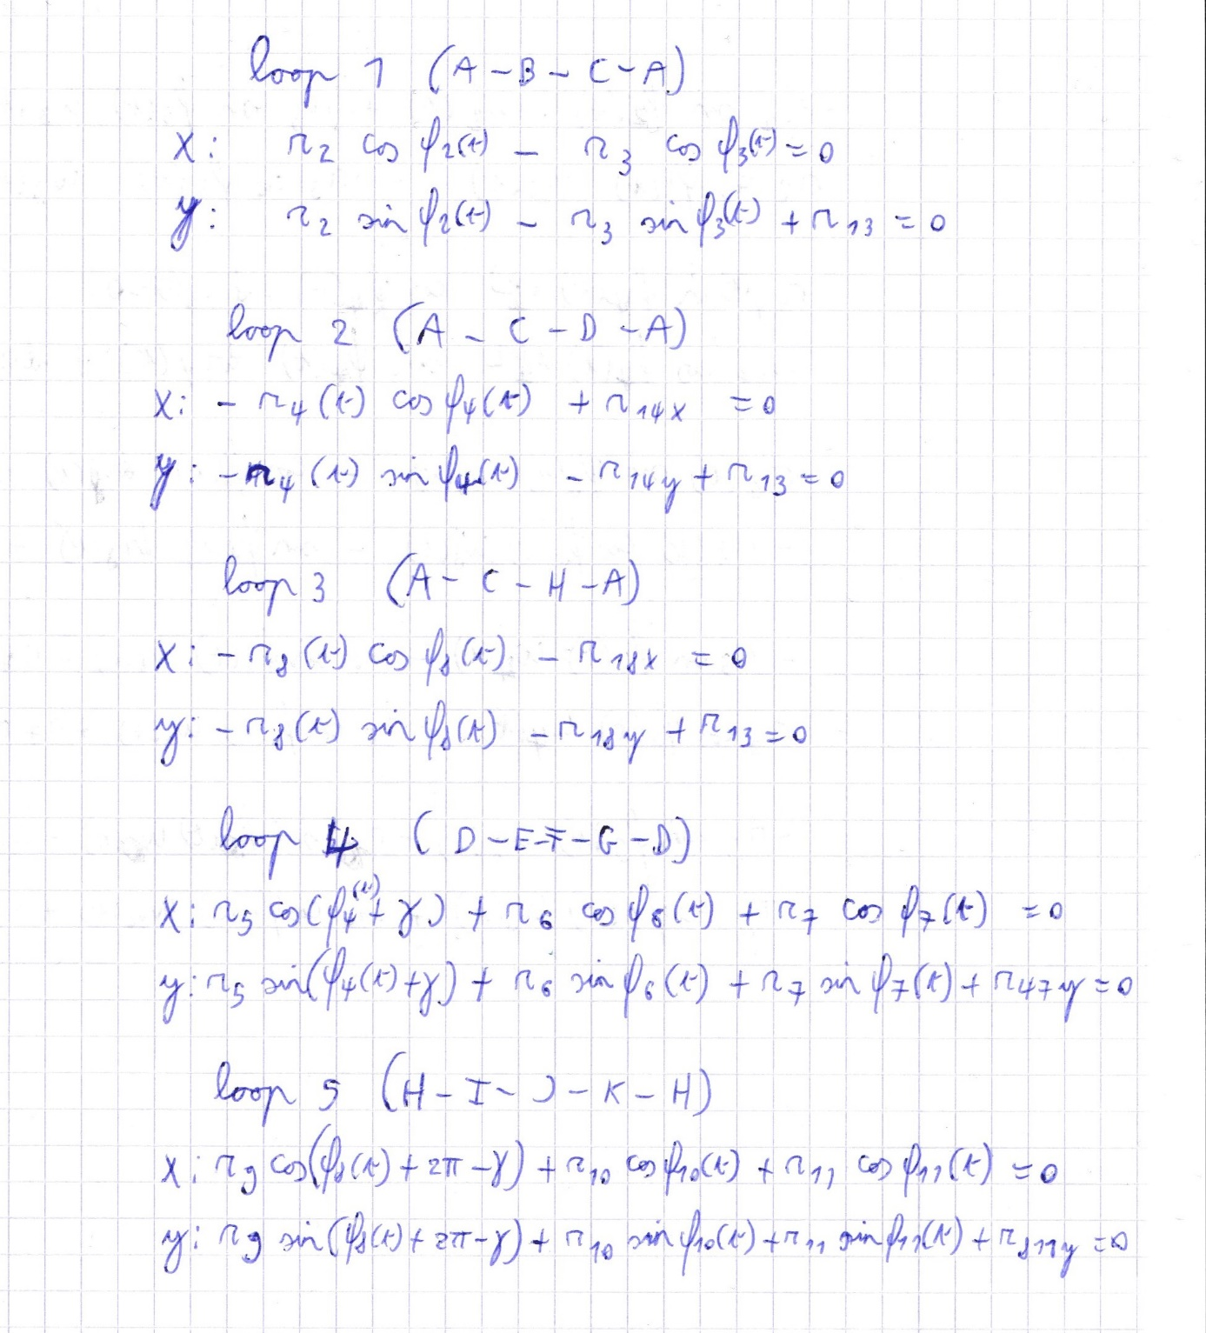

**3.2 Position analysis**

Matlab solves the system of ten equations and ten variables using fsolve. Fsolve calculates the angles in time based on the initial values given and phi2.

The results can be found in figures 4 and 5.

The symmetry of the system can be found in these figures, phi6 and phi10 both start at an angle of 90 degrees and will change in opposite direction. R4 and r8 are always the same length. This is already a good indicator that the position analysis is correct.

**3.3 Velocity analysis**

The velocity analysis can be done based on the closure equations by taking the time derivative of these equations. This yields a set of ten equations in ten unknowns. These unknowns can be calculated using matlab. The derived equations can be found in figure 6. The results can be found in figures 7 and 8. In these figures the symmetry can again be found.

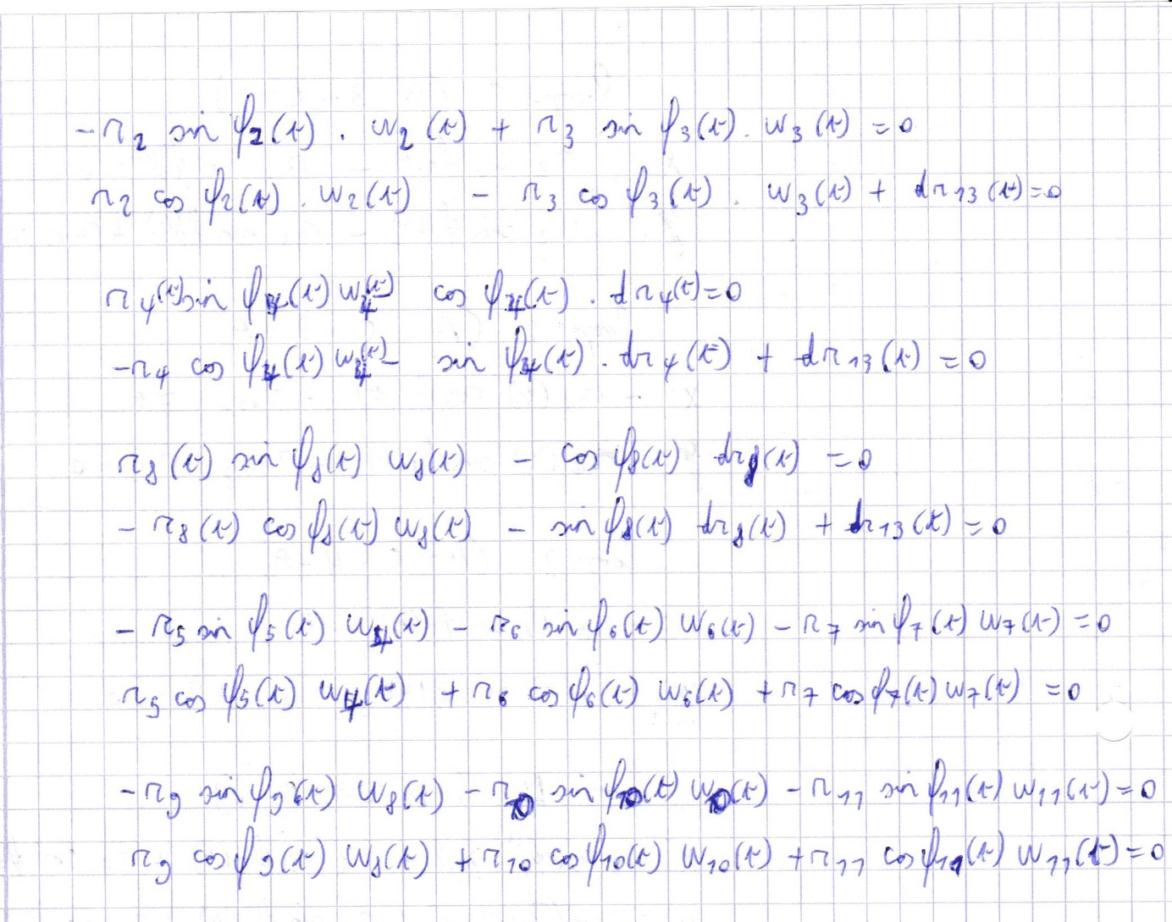

**3.3 Acceleration analysis**

The acceleration analysis is done by taking the derivative of the velocity analysis equations. This yields another ten equations in ten unknowns which can be calculated with matlab. The equations can be found in figure 9 and the results can be found in figures 10 and 11. And the same clear symmetry of the system can be seen.

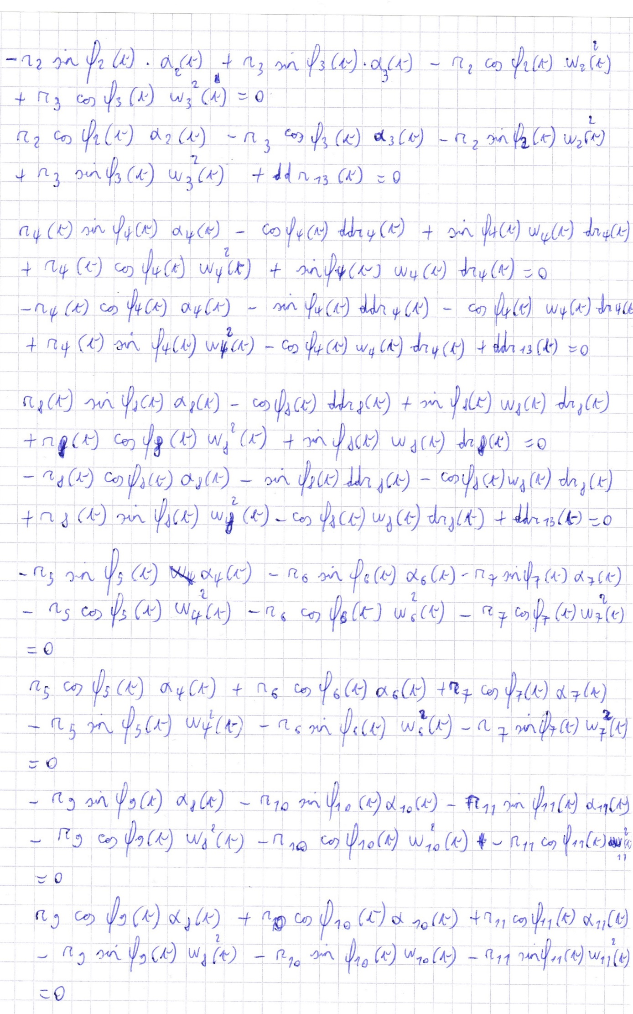

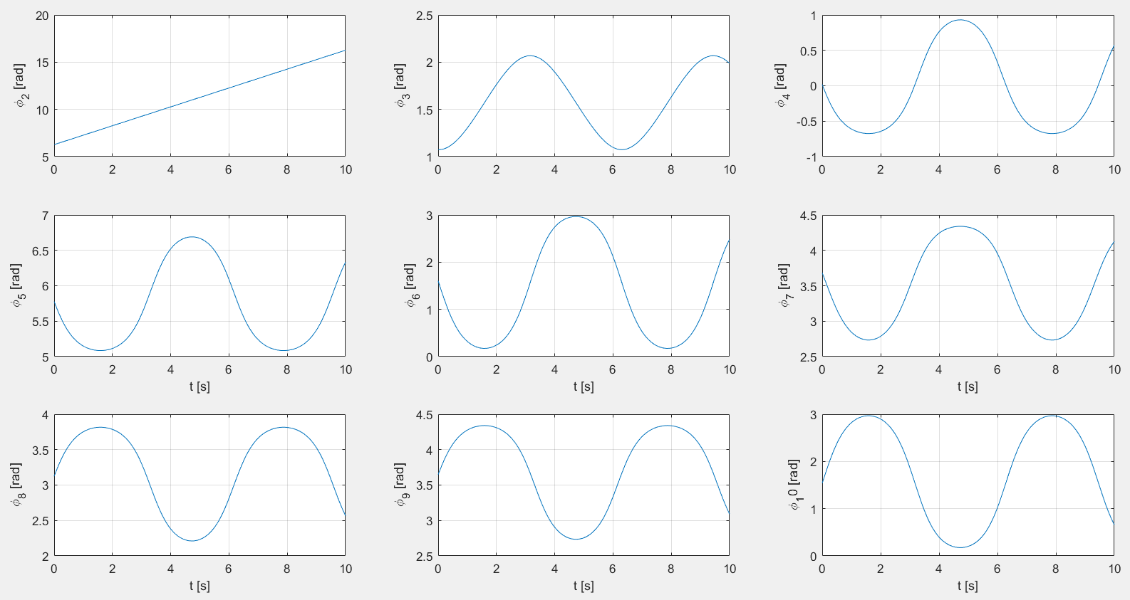

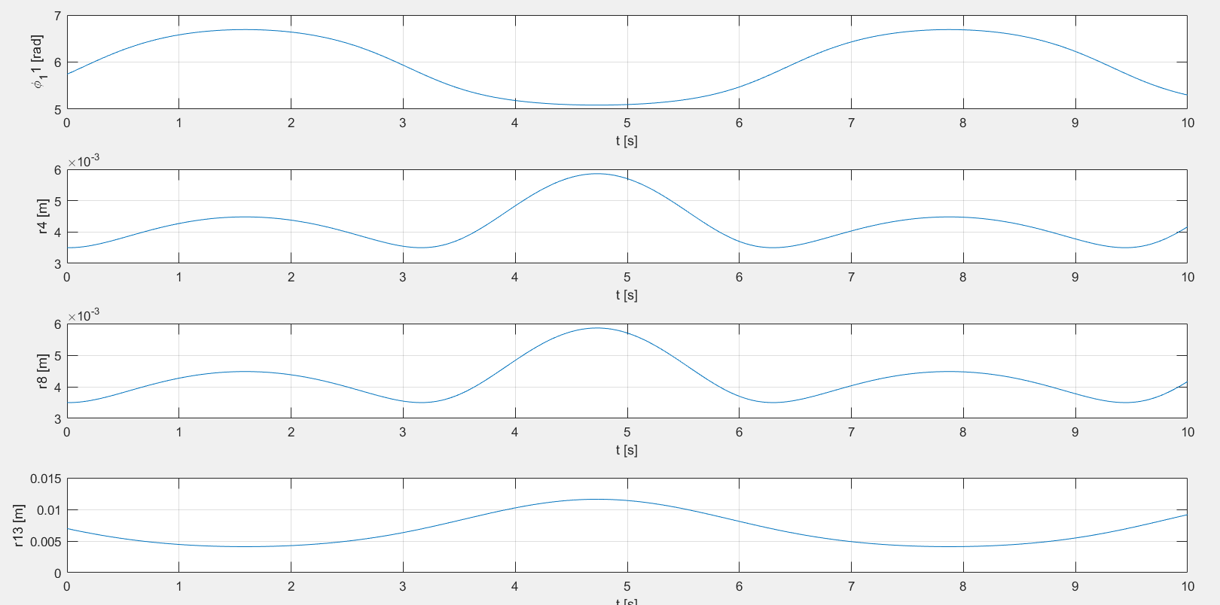

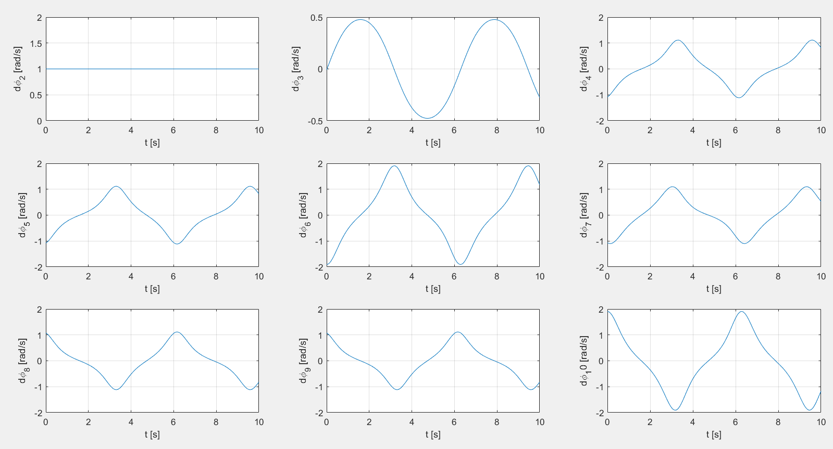

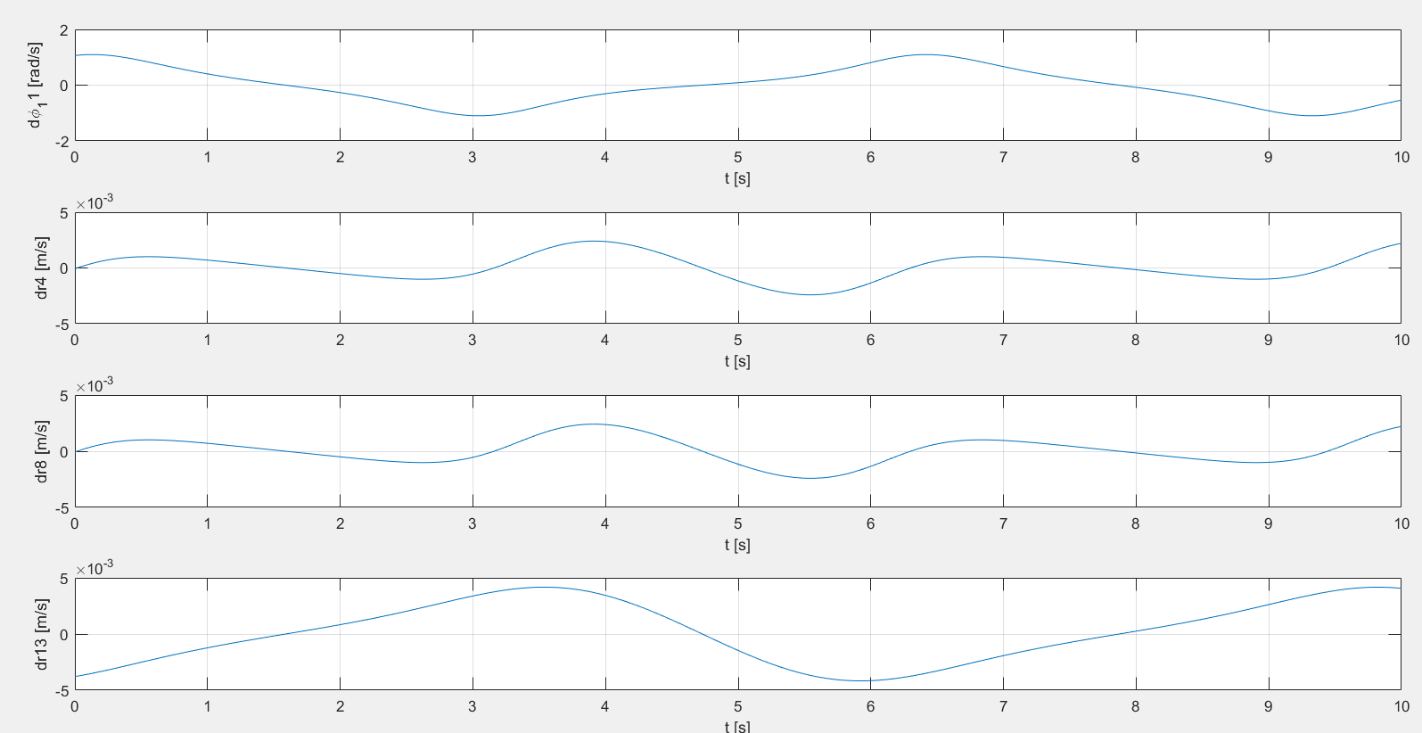

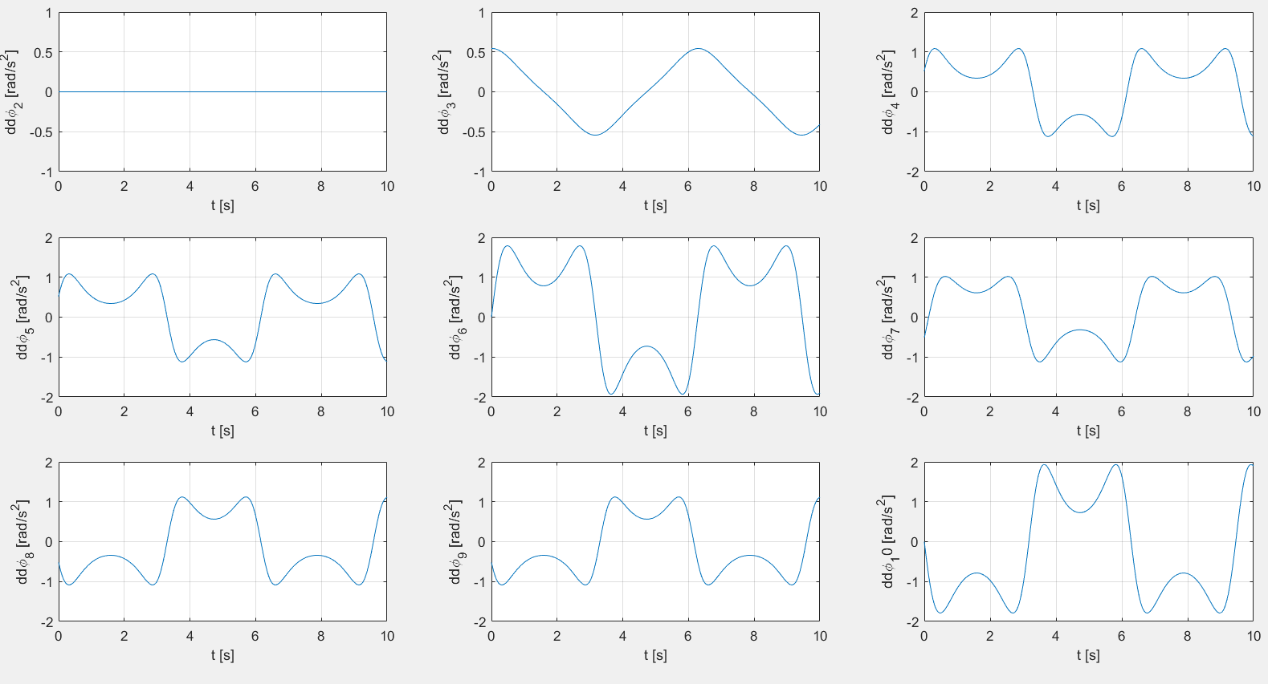

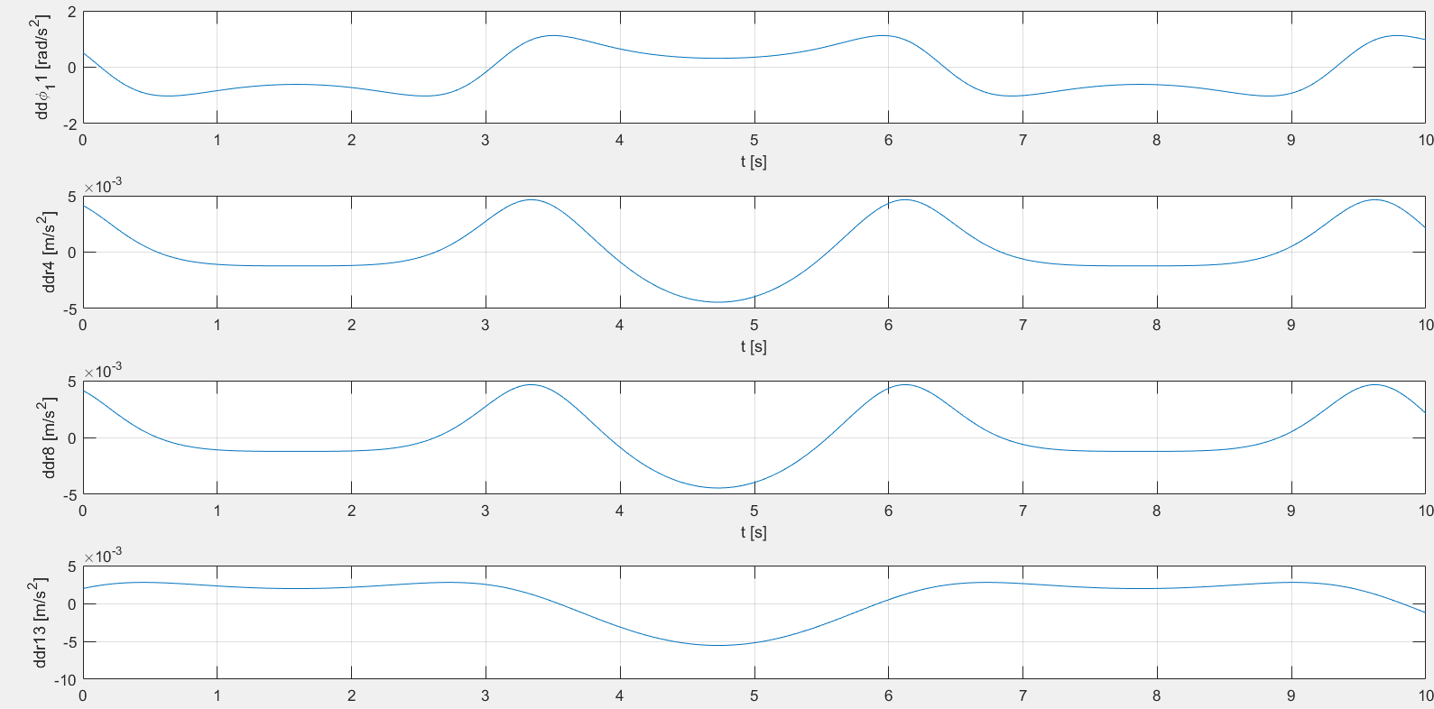

**3.4 Control**

All angles, velocities and accelerations have been analytically calculated, using the loop equations, in the sections above. These results must be checked by using other methods to calculate the positions, velocities and accelerations. First the position will be checked by a simple animation made in matlab to see if the system moves correctly, after this the position of a point will be calculated starting from two different points. Next the velocity and the acceleration will be checked using the numerical derivatives and by using two different points. Three points will be tested each time, point C and a point in each wing to make sure every subpart moves correctly.

**3.4.1 Position**

By running the added matlab files, it is clear that the system makes correct movements.

The position of F is calculated using D-E-F and using G-F. The position of I is calculated using K-J-I and using H-I. The position of C is calculated using A-B-C and using D-C. The errors can be found in figure 12.

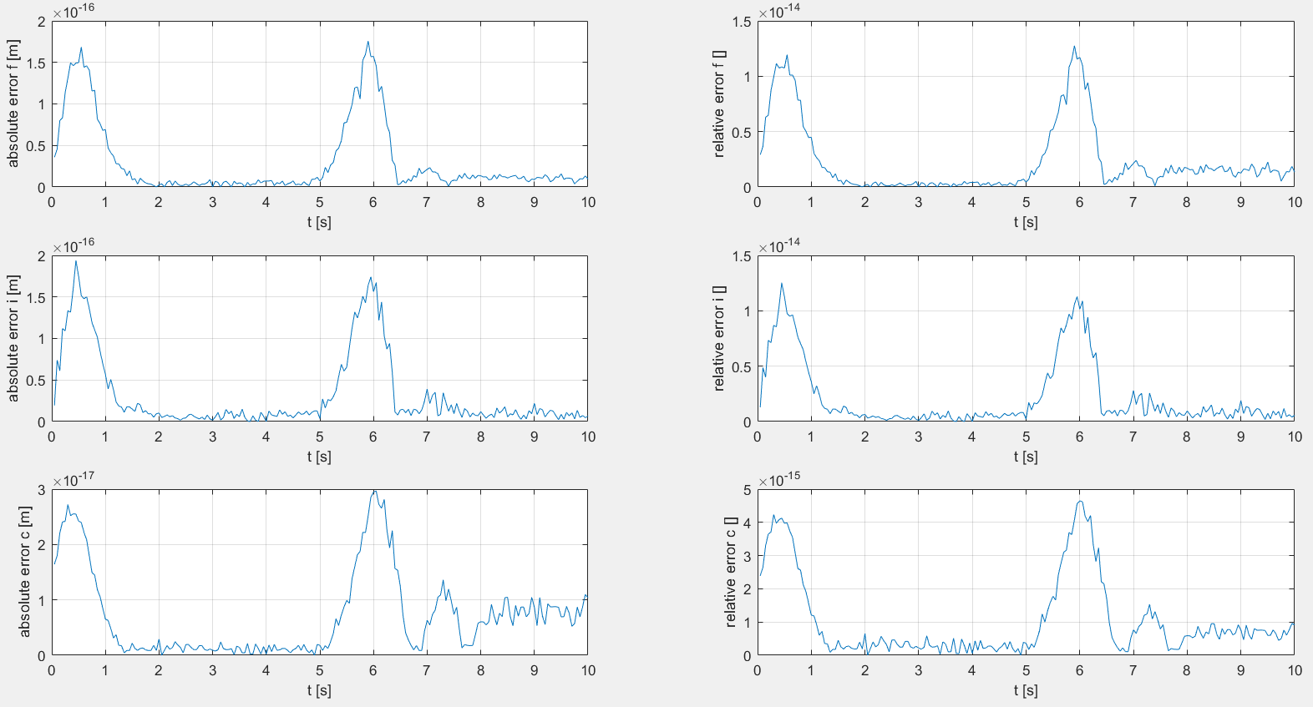

**3.4.2 Velocity**

Figure 13

**3.4.3 Acceleration**

Figure 14