

**BEWEGING EN TRILLINGEN**

*Jonas Neeckx*

*Nicolas Heintz*

**Design and dynamics of a cam-follower system**

NUMERICAL DATA NR 18

Titularis

Joris De Schutter

ACADEMIEJAAR 2017-2018

Index

1. Introduction 3

2. Motion analysis and dead configurations 5

2.1 Motion analysis 5

2.2 Dead configurations 5

3. Kinematic analysis 6

3.1 Loop equations 6

3.2 Position analysis 7

3.3 Velocity analysis 8

3.4 Acceleration analysis 9

3.5 Control 12

3.5.1 Position 12

3.5.2 Velocity 14

3.5.3 Acceleration 15

4. Dynamic analysis 17

4.1 Centre of gravity 17

4.2 Masses and moments of inertia 18

4.3 Acceleration and velocities 19

4.4 Force equations 20

4.5 Results 24

4.5.1 Internal forces 24

4.5.2 Torque on the motor 26

4.5.3 Force and torque after static balancing 26

4.5.4 Shaking forces 27

4.6 Control 28

4.7 Strength analysis 30

5. Conclusion 31

# Introduction

In this paper a cam-follower system is design and analysed on dynamic behaviour, both on a rigid-body and a deformable follower. The follower is a translating roller follower, the cam is radial. A spring attached on the follower realises a force-closure.

The following relative motions are necessary:

# From 45° to 120°: +15 mm

# From 120° to 180°: +15 mm

# From 200° to 280°: -30 mm

The motion does not have to start or end at the given angle, but the follower has to be at the given positions at that specific angle.

Meanwhile the mechanism needs to be able to provide the following forces:

* From 45° to 120°: a linear ascending pull force from 0N to 300N
* From 120° to 170°: a constant push force of 550N
* From 170° to 240°: constant push force of 300N

The cycle time is 2s. Most of the dimensions in this paper are threshold dimensions in order to just pass the requirements. For practical use, some safety margins might be advisable.

# Definition of the motion law

At first it is necessary to choose a certain motion law in order to obtain the highest level of continuity possible. With this in the mind, the following motion law has been chosen with 0mm at the base circle:

* From 0° to 60°: a dwell at 0mm
* From 60° to 120°: a lift from 0mm to 15mm with half-cycloid C1
* From 120° to 180°: a lift from 15mm to 30mm with half-cycloid C2
* From 180° to 200°: a dwell at 30mm
* From 200° to 280°: a descend from 30mm to 0mm with cycloid C6
* From 280° to 360°: a dwell at 0mm

The first lift only starts at 60° in order to create a complete cycloid from 60° to 180°. That way there is no sudden jump in end and start velocity at the transition between both half-cycloids.

The results of the motion law can be seen in figure 1.

As depicted, the cam is continuous until the third order, the acceleration. This is the maximal continuity that can be obtained with a cycloidal motion law. The maximal acceleration is $0.0295\frac{mm}{degree^{2}}$. With a cycle time of 2s, this results in a maximal linear acceleration of $0.0295\frac{mm}{degree^{2}}*{\left(180\frac{degree}{s}\right)}^{2}=955.8\frac{mm}{s^{2}}$

Figure 1:Motion law

# Geometry of the follower

It is also necessary to know the radius of the follower and base circle when designing a cam-follower system. They have an important influence on both the pressure angle and the appearance of undercutting. Apart from the radii, it is also possible to give the cam a certain excentricity, what enables the possibility to balance the pressure angle.

## Pressure angle

## Undercutting

## Excentricity

At last the maximal pressure angle can be lowered by applying excentricity on the cam. Excentricity merely shifts the pressure angle: if it lowers the pressure angle in the inward motion, it raises the pressure angle during the outward motion. The value of the optimal excentricity has been iteratively calculated by the computer with the aim to minimize the maximal absolute value of the pressure angle $|α|$. The pressure angle is related to the excentricity with the following formula:

$$α=\arctan\left(\frac{f^{'}\left(θ\right)-e}{\sqrt{R_{0}^{2}-e^{2}}+f\left(θ\right)}\right)$$

It is important to notice that at the optimal excentricity, the minimal and maximal pressure angle have the same absolute value. This shows that excentricity merely balances the pressure angle for inward and outward motion.

The optimal excentricity is -7.04mm. At this given excentricity, the pressure angle and radius of curvature can be seen in respectively figure x and x. The radius of curvature is still strictly positive and the pressure angle is perfectly balanced. It does become negative, but by reaching a perfectly flat surface with an infinity radius.



Figure 2: Pressure angle with excentricity

Figure 3: Radius of curvature with excentricity

The entire cam and follower geometry can be seen in figure x. As calculated, there is a certain point where the radius of curvature reaches close

# Rigid-body forces

## Spring

Now the geometry has been defined, it is possible to analyse the forces on the cam and follower. In this section, the follower and cam are designed as rigid bodies. Only the inertial forces, the force of the spring and external forces are taken into account.

At first a proportional spring must be designed that ensures a constant contact of the follower on the cam. This spring has both a stiffness $k [\frac{N}{mm}]$ and a prestress $F_{V0} [N]$. These have to be designed in order to keep the forces as low as possible, but also to make sure that the total force on the follower is always positive.

The Matlab function *spring.m* calculates these parameters by iterating over both the prestress and stiffness. With the used parameters, the normal force on the cam is calculated. If the minimal normal force $N_{min}>0$ and the maximal normal force is the smallest of all parameters for which $N_{min}>0$, that set of stiffness and prestress is chosen. In some cases, $N_{max}$ is identical for two sets of parameters. In that case, the set with the lowest average force is preferred.

The normal force is calculated as following:

$$N=\frac{{F_{load}+F_{inert}+F}_{v0}+k*S}{\cos\left(α\right)}$$

With S the lift [mm], $α$ the pressure angle [rad], $F_{inert}$ the inertial force [N] and $F_{load}$ the load applied on the mechanism [N].

The optimal stiffness is 2.84 N/mm, with a prestress of 257,4N. As figure x shows, the force is strictly positive. Some iterations also confirmed that this setting is optimal. It is also interesting that due to the low speed of the cam, the inertial forces are very low.



Figure 4: Normal forces on the cam

However, if a new setting requests to double the speed of the cam, the inertial forces are strongly affected. The motion law fixed the acceleration $α_{θ}$ as mm/degree². However, the inertial force is calculated according to Newton’s second law: $F=m*a=m*α_{θ}*ω^{2}*{10}^{-3} \sim ω^{2}$. If the rotational speed doubles, the inertial force multiplies by four. This effect can be seen on figure x. As the acceleration was just 0 at the critical point, the same spring can be used. However, a more optimal configuration is obtained with $k=5.24\frac{N}{mm}$ and $F_{v0}=221.4N$. This configuration is shown in figure x.

 

Figure 6: Normal forces at double speed with new spring

Figure 5: Normal forces at double speed with identical spring

## Power

When designing the motor used to power the cam, both the instantaneous and average power are very important parameters. As the follower strictly moves up and down, the easiest way to calculate the instantaneous power is

$$P= \vec{F}∙\vec{v}= N_{tot}*\cos\left(α\right)*V*ω*{10}^{-3}$$

With $N_{tot}$ [N] the total normal force exerted on the cam, $α$ [rad] the pressure angle, $V$ [mm/rad] the lift per radial, $ω$ [rad/s] the angular speed. The direction of $\vec{F},\vec{v}$ and $ω$ are drawn on figure x.

Due to the scalar product and a strictly vertical movement of the follower, only the vertical forces influence the power. The total force applied on the follower contains the inertial force, the spring force and the external force, all forces that are independent of the cam’s geometry as long as the spring, the followers mass and the motion law stay identical. Thus there is no expected difference between the instantaneous power of a cam with or without excentricity.

The result of the instantaneous power can be seen in figure x. As expected, the instantaneous power with and without excentricity is identical.



Figure 5: Power and control of the mechanism

The average power is only 0.1466W. This means that the mechanism needs more power than it consumes. However, the low value hints that the mechanism is almost self-sufficient. This allows the system to be driven by a very cheap motor. Off course loss due to friction has not been considered.

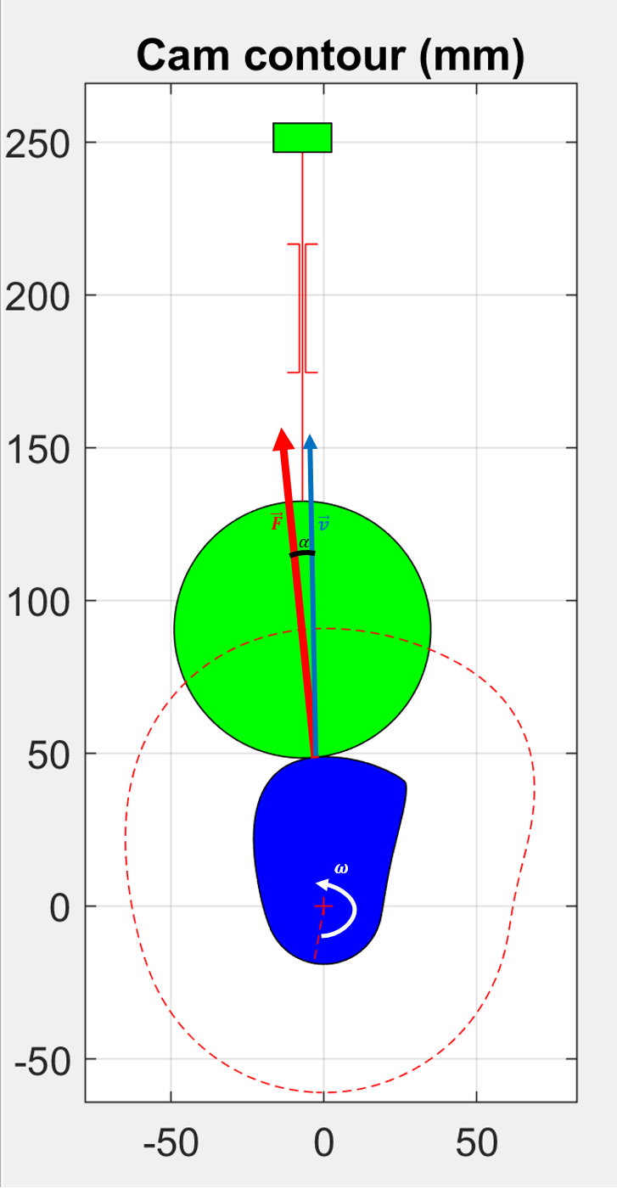

## Flywheel

As $P=T*ω$, the torque is easily calculated from the power. The average torque is 0.0467Nm and can be seen next to the instantaneous torque in figure x.



Figure 6: The instantaneous and average torque

Even though the low average torque permits a cheap motor, the high pikes in torque demand could lead to a large speed variation, which is unwanted. The motor is supposed to only deliver its nominal torque, which is more or less the average torque. When the motor cannot deliver the demanded torque, the mechanism slows down. In order to keep the relative deceleration and acceleration below 5% with respect to the nominal rotational speed, a flywheel is installed.

In the process of calculating the inertia, the first step is to find the place where the rotational speed is maximal and minimal. In this case the needed torque only rises above the average torque between 63.6° and 178.1°. Inside this domain, the cam decelerates, outside this domain it accelerates. The maximal speed is thus at 63.6°, the minimal speed at 178.1°. The loss in speed can be calculated as following:

$$A_{max}=\int_{θ_{m}}^{θ_{M}}{T\left(θ\right)-T_{av}dθ=\frac{1}{2}*I(ω_{M}^{2}-ω_{m}^{2})}$$

$$ω_{av} ≈\frac{ω_{M}+ ω_{m}}{2}$$

$$K=\frac{ω_{M}-ω_{m}}{ω_{av}}$$

$$I=\frac{A_{max}}{K*ω_{av}^{2}}$$

From the torque and the two angles, $A_{max}$ has been calculated as 13.7Nm. Naturally, $ω_{av}$ is $π$ rad/s. $ω_{M}$ and $ω_{m}$ can only vary with 5% with respect to $ω_{av}$. As the top speed and lowest speed are not necessary at the same relative distance from $ω_{av}$, $K = 0.06$ has been chosen as safety.

The chosen parameters result in $I=23.1 kgm^{2}$. If a cylindrical steel flywheel ( $ρ=8000\frac{kg}{m^{3}})$ were designed, a possible dimension would be a flywheel with a diameter of 0.6m and 0.227m long. This would be bigger than the entire mechanism itself.

This value can also be estimated from figure x: the total area above the average torque can be approximated by two triangles. The first is about $\frac{π}{3}$ radians long and 1 Nm high. The second one is also about $\frac{π}{3}$ radians long and 25 Nm high. The total area is thus 13.6 Nm, almost exactly equal to the $A_{max}$ that was previously calculated. This estimation gives an $I=23.0 kgm^{2}$. This close estimation suggests that the calculation is probably correct.

In figure x the evolution of the rotational speed can be seen in both absolute as relative values. The safety in the K-factor is indeed needed as the cam rotates most of the time at a higher speed, but drops in speed during 1/3th of his cycle.



Figure 7: Variation of the rotational speed

During the start-up, the cam also has to accelerate. Due to the high moment of inertia, this effect cannot be ignored. Start-up usually goes together with high peak currents through the motor. Even though the nominal torque of a motor is fixed, it can produce higher torques for a short period of time. The torque needed for start-up is determined by the angular acceleration:

$$T-T_{load}=I*α$$

Even though a motor can produce higher torques, it also has a limit, as its wires might burn when the applied current exceeds a certain point. If possible, it might be a lot cheaper to start slowly, so the motor doesn’t have to handle very high currents.

# Dynamics of a deformable follower