Final Project

Jonas Ratkevičius

Software Development Academy

Software Tester

Lecture Sandra Budrevičienė

2021 – 01 – 10

Contents

Documents Purpose 3

Testing Section 4

Testing checklist 5

Test cases 6

Founded issue/bugs 7

Bug Report – Search field is overlapping 7

Screenshot of bug 7

Bug Report – Contact us form 8

Screenshot of bug 8

Improvements 9

Test Design Techniques 10

Reflection 11

# Documents Purpose

The purpose of this document is the final project for the software tester course. Check which testing method can be used. Testing https://www.eso.lt/ page usability, UI, functionality.

# Testing Section

Home

https://www.eso.lt/

Input fee calculator for home

Change page language and check functionality

Header and Footer

UI design

Contact Us

Checking https://www.eso.lt/ page UI design bug, all working links in header and footer. If the English version of the page has all same functions as native Lithuanian. Try functional of input fee calculator for home.

# Testing checklist

Website testing checklist

* Interface testing
* Functionality testing
* Usability testing

UI ( Interface ) testing checklist

1. Testing different screen resolution
2. Design elements: fonts, icons, links, buttons.

Functionality testing checklist

1. There are no broken links in the header and footer
2. Check “Įvedimo skaičiuoklė” (Input fee calculator for home)

Usability testing

1. Access main menu from all page
2. There no grammar and spelling mistake
3. Buttons, field are comfortable for use
4. Image is placed properly with a proper size

# Test cases

|  |  |  |  |  |  |  |  |
| --- | --- | --- | --- | --- | --- | --- | --- |
| Test case | | | | | | | |
| Test case ID | Priority | Test scenario | Prie-Condition | Test Steps | Actual Result | Expected Result | Result Pass/Fail |
| 1 | High | Need to check "Įvedimo skaičiuoklė" how it calculate fee of service. Test until order. Do not make any order | Browser is launched Page | 1. Open https://www.eso.lt/ 2. Go to "Įvedimo skaičiuoklė" over "Elektros paslaugos" in main page. 3. Click on "Naujas Įvedimas" 4. Choose "Daugiabutis namas (butas) 5. Checkbox " iki 70m2. 6. Check "Dujine virykle" 7. Checkbox "7kW" click "Patvirtinti". 8. In field "Iveskite atstuma" Enter 0 then " Patvirntinti" 9. Click "Užsakyti" | Opened self-service page | Open self-service Login page | Pass |
| 2 | High | Enter random inputs to field | Browser is launched Page | 1. Go to tab "Verslui" 2.Click on "Įvedimo skaičiuoklė". 3. Choose " Galios didinimas" 4. In field "kW" enter different inputs | There no limit char number and can enter not only number | Limited char Number only | Fail |
| 3 | Low | Change language from LT to EN | Browser is launched Page | 1. Click on LT in navigation near Search field and change it to EN | Page is displayed in English | Page should be displayed in English | Pass |
| 4 | Normal | Try to upload *.exe file. | Browser is launched Page | 1. Go to "Susiekite internetu" in the footer. 2. Click on "Klausti" in "Bendro pobudzio klausimai" 3. Fill required field. 4. Upload *.exe file 5. Click on "Siųsti" | Mail could not be sent "*.exe" bad documents type. | Error message about bad documents type. | Pass |

# Founded issue/bugs

## Bug Report – Search field is overlapping

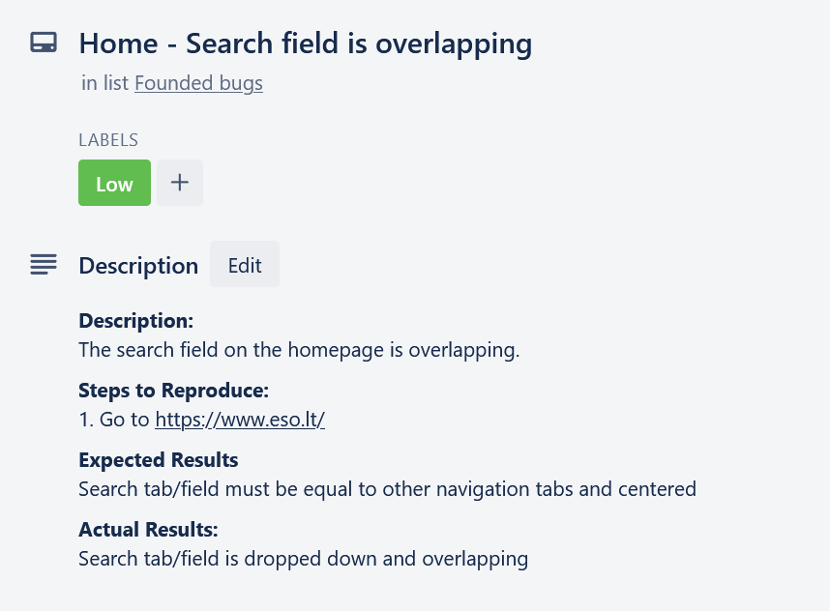

### Screenshot of bug

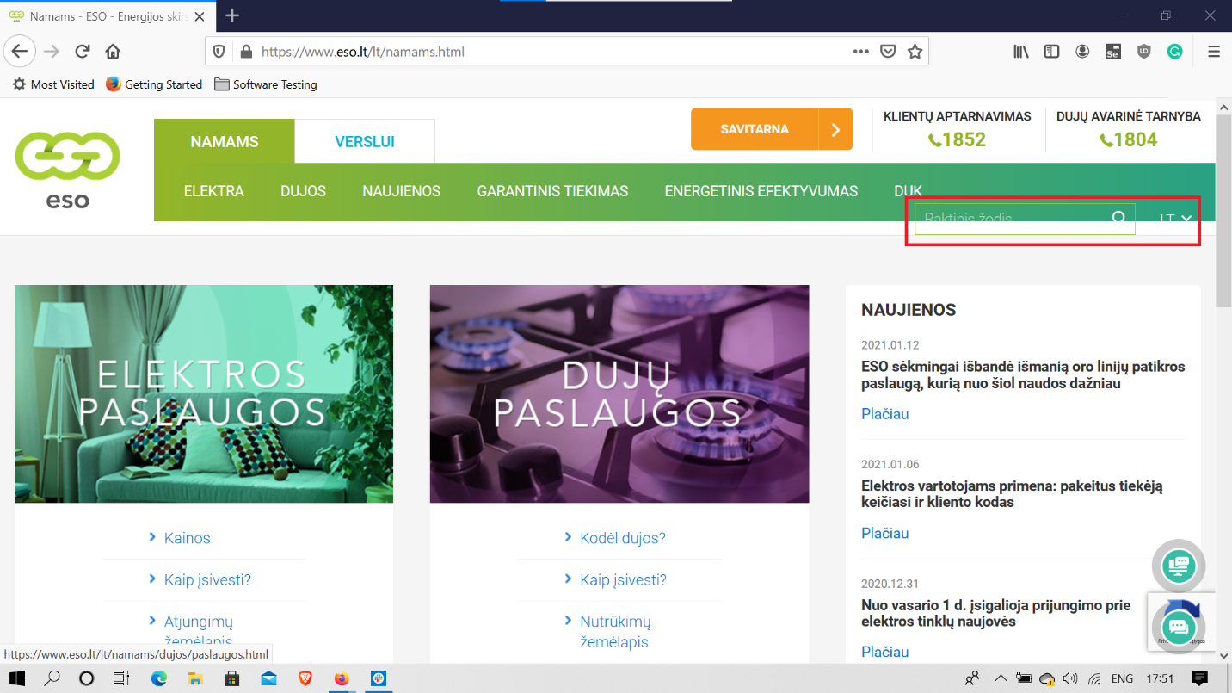

## Bug Report – Contact us form

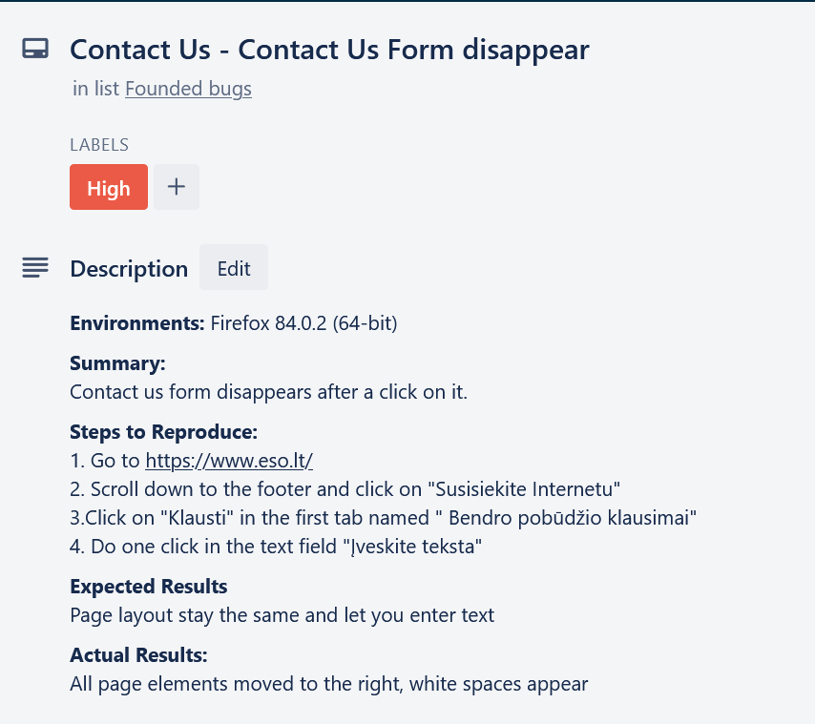

### Screenshot of bug

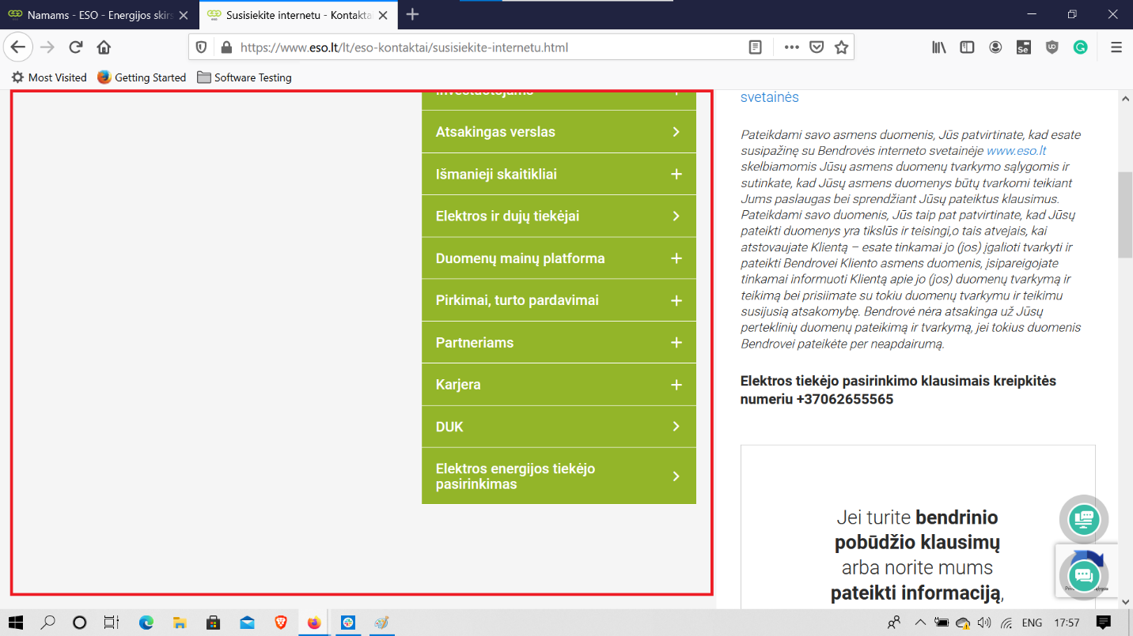

# Improvements

Improve website functionality in English, add calculate the fee of service, self-service in English page.

# Test Design Techniques

This test used test methods

* Equivalence Partitioning
* Boundary Value Analysis
* Monkey testing
* Smoke testing

# Reflection

In this work, I have been testing page localization with function available, UI, usability, and executing test cases.

Didn’t have any difficulties executing the test case, it pretty easy, and liked to do it.

The hardest way was to do first time diagram with test strategies and difficult selected webpage because couldn’t to do login don’t have access to it and try more function of a page.