115. Distinct Subsequences
給出兩個string s和t，s比t長，數s中有多少個subsequence等於t
思路：
遇到这种两个串的问题，很容易想到DP。但是这道题的递推关系不明显。可以先尝试做一个二维的表int[][] dp，用来记录匹配子序列的个数（以S="rabbbit",T = "rabbit"为例）：
r a b b b i t
1 1 1 1 1 1 1 1
r 0 1 1 1 1 1 1 1
a 0 0 1 1 1 1 1 1
b 0 0 0 1 2 3 3 3
b 0 0 0 0 1 3 3 3
i 0 0 0 0 0 0 3 3
t 0 0 0 0 0 0 0 3
从这个表可以看出，无论T的字符与S的字符是否匹配，dp[i][j] = dp[i][j - 1].就是说，假设S已经匹配了j - 1个字符，得到匹配个数为dp[i][j - 1].现在无论S[j]是不是和T[i]匹配，匹配的个数至少是dp[i][j - 1]。除此之外，当S[j]和T[i]相等时，我们可以让S[j]和T[i]匹配，然后让S[j - 1]和T[i - 1]去匹配。所以递推关系为：
dp[0][0] = 1; // T和S都是空串.
dp[0][1 ... S.length() - 1] = 1; // T是空串，S只有一种子序列匹配。
dp[1 ... T.length() - 1][0] = 0; // S是空串，T不是空串，S没有子序列匹配。
dp[i][j] = dp[i][j - 1] + (T[i - 1] == S[j - 1] ? dp[i - 1][j - 1] : 0).1 <= i <= T.length(), 1 <= j <= S.length()
public int numDistinct(String S, String T) {
2 int[][] dp = new int[S.length() + 1][T.length() + 1];
3 dp[0][0] = 1;//initial
4
5 for(int j = 1; j <= T.length(); j++)//S is empty
6 dp[0][j] = 0;
7
8 for (int i = 1; i <= S.length(); i++)//T is empty
9 dp[i][0] = 1;
10
11 for (int i = 1; i <= S.length(); i++) {
12 for (int j = 1; j <= T.length(); j++) {
13 dp[i][j] = dp[i - 1][j];
14 if (S.charAt(i - 1) == T.charAt(j - 1))
15 dp[i][j] += dp[i - 1][j - 1];
16 }
17 }
18
19 return dp[S.length()][T.length()];
20 }

375. Guess Number Higher or Lower II
思路：top-down解法
給定一個區間【a,b】嘗試區間中每一個數字都選下，找出最小的一個。用二維數組記錄，dp[i][j]表示在【i,j】內最小的支出。挑出一個數字x后，在[I,x-1]和[x+1,j]中看看那邊的支出大。在最大支出中挑出最小那個。
最後，結束迭代的條件是arr[a][b]不為0。可以減少很多迭代次數
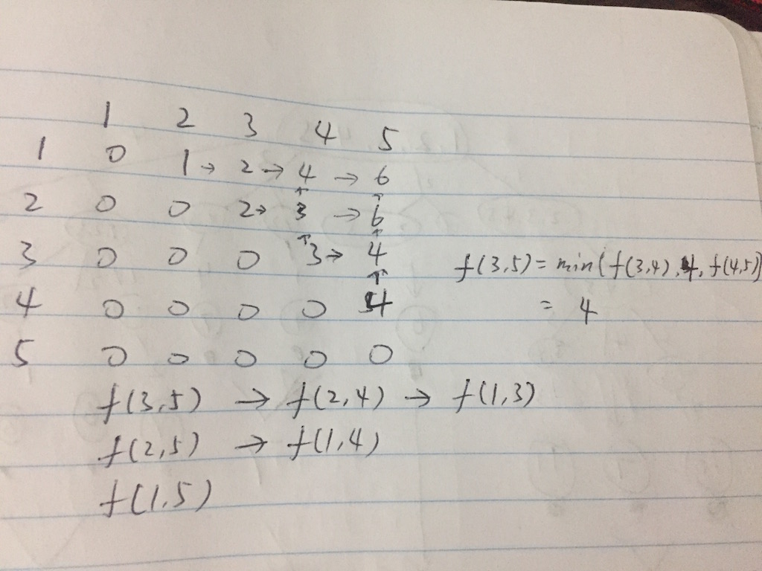
public class Solution {
public int getMoneyAmount(int n) {
int[][] table = new int[n+1][n+1];
return DP(table, 1, n);
}

int DP(int[][] t, int s, int e){
if(s >= e) return 0;
if(t[s][e] != 0) return t[s][e];
int res = Integer.MAX_VALUE;
for(int x=s; x<=e; x++){
int tmp = x + Math.max(DP(t, s, x-1), DP(t, x+1, e));
res = Math.min(res, tmp);
}
t[s][e] = res;
return res;
}
}

最長palindrome子序列
思路：一個矩陣按對角線從左上到右下方向掃描。L(x,y)

https://www.youtube.com/watch?v=yZWmS6CXbQc
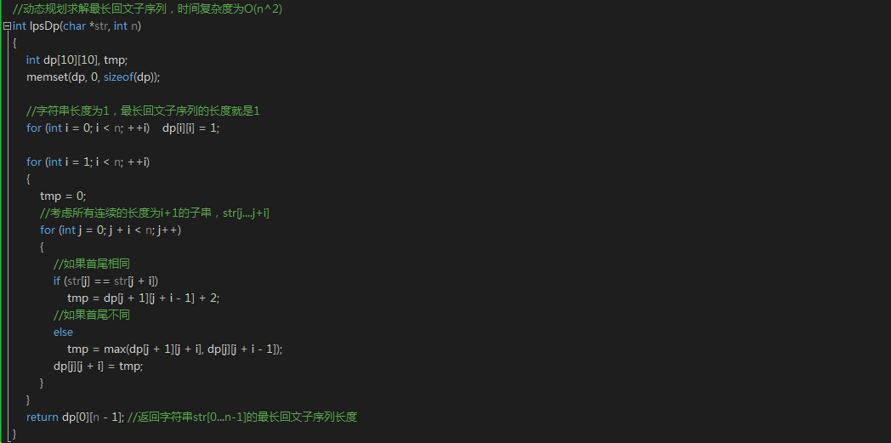

403. Frog Jump
A frog is crossing a river. The river is divided into x units and at each unit there may or may not exist a stone. The frog can jump on a stone, but it must not jump into the water.
Given a list of stones' positions (in units) in sorted ascending order, determine if the frog is able to cross the river by landing on the last stone. Initially, the frog is on the first stone and assume the first jump must be 1 unit.
If the frog's last jump was k units, then its next jump must be either k - 1, k, or k + 1 units. Note that the frog can only jump in the forward direction.

思路：每到了一個石頭上，下一步可以選擇跳K-1，K或K+1。分別拿出可以到達的石頭對應的hashset，往裡面插入下一次可以跳的步數。
Use map to represent a mapping from the stone (not index) to the steps that can be taken from this stone.
so this will be
[0,1,3,5,6,8,12,17]
{17=[], 0=[1], 1=[1, 2], 3=[1, 2, 3], 5=[1, 2, 3], 6=[1, 2, 3, 4], 8=[1, 2, 3, 4], 12=[3, 4, 5]}
Notice that no need to calculate the last stone.
On each step, we look if any other stone can be reached from it, if so, we update that stone's steps by adding step, step + 1, step - 1. If we can reach the final stone, we return true. No need to calculate to the last stone.
Here is the code:
public boolean canCross(int[] stones) {
if (stones.length == 0) {
return true;
}

HashMap<Integer, HashSet<Integer>> map = new HashMap<Integer, HashSet<Integer>>(stones.length);
map.put(0, new HashSet<Integer>());
map.get(0).add(1);
for (int i = 1; i < stones.length; i++) {
map.put(stones[i], new HashSet<Integer>() );
}

for (int i = 0; i < stones.length - 1; i++) {
int stone = stones[i];
for (int step : map.get(stone)) {
int reach = step + stone;
if (reach == stones[stones.length - 1]) {
return true;
}
HashSet<Integer> set = map.get(reach);
if (set != null) {
set.add(step);
if (step - 1 > 0) set.add(step - 1);
set.add(step + 1);
}
}
}

return false;
}

123. Best Time to Buy and Sell Stock III
最多買兩次，每次只能持一股票，求最大利潤
First assume that we have no money, so buy1 means that we have to borrow money from others, we want to borrow less so that we have to make our balance as max as we can(because this is negative).
sell1 means we decide to sell the stock, after selling it we have price[i] money and we have to give back the money we owed, so we have price[i] - |buy1| = prices[i ] + buy1, we want to make this max.
buy2 means we want to buy another stock, we already have sell1 money, so after buying stock2 we have buy2 = sell1 - price[i] money left, we want more money left, so we make it max
sell2 means we want to sell stock2, we can have price[i] money after selling it, and we have buy2 money left before, so sell2 = buy2 + prices[i], we make this max.
So sell2 is the most money we can have.
Hope it is helpful and welcome quesions!
public int maxProfit(int[] prices) {
int sell1 = 0, sell2 = 0, buy1 = Integer.MIN_VALUE, buy2 = Integer.MIN_VALUE;
for (int i = 0; i < prices.length; i++) {
buy1 = Math.max(buy1, -prices[i]);
sell1 = Math.max(sell1, buy1 + prices[i]);
buy2 = Math.max(buy2, sell1 - prices[i]);
sell2 = Math.max(sell2, buy2 + prices[i]);
}
return sell2;
}
解法2：
class Solution {
public:
int maxProfit(vector<int> &prices) {
int len = (int)prices.size();
if(len <= 1) {
return 0;
}

vector<int> profits;
profits.resize(len);

//首先我们正向遍历得到每天一次交易的最大收益
//并保存到profits里面
int minP = prices[0];
int sum = numeric_limits<int>::min();
for(int i = 1; i < len; i++) {
minP = min(minP, prices[i - 1]);
profits[i] = max(sum, prices[i] - minP);

sum = profits[i];
}

int maxP = prices[len - 1];
int sum2 = numeric_limits<int>::min();

//逆向遍历
for(int i = len - 2; i >= 0; i--) {
maxP = max(maxP, prices[i + 1]);
sum2 = max(sum2, maxP - prices[i]);

if(sum2 > 0) {
//这里我们直接将其加入profits里面，
//不需要额外保存
profits[i] = profits[i] + sum2;
sum = max(sum, profits[i]);
}
}

return sum > 0 ? sum : 0;
}
};

[LeetCode] Coin Change 硬币找零
我们维护一个一维动态数组dp，其中dp[i]表示钱数为i时的最小硬币数的找零，递推式为：
dp[i] = min(dp[i], dp[i - coins[j]] + 1);
其中coins[j]为第j个硬币，而i - coins[j]为钱数i减去其中一个硬币的值，剩余的钱数在dp数组中找到值，然后加1和当前dp数组中的值做比较，取较小的那个更新dp数组。

Partition Equal Subset Sum
數組求和，如果是奇數，不能拆分。target是求和/2
然後用01背包，縱坐標是nums，橫坐標是0到target。
如果算到最後一個坐標dp[nums[last]][target]=target說明可以，否則不行
public boolean canPartition(int[] nums) {
int sum=0;
for (int num:nums) sum+= num;
if(sum % 2 == 1) return false;
else{
sum /=2;
int n=nums.length;
// dp[i][j] 表示 如果我们取前i个数字，且背包容量为j的情况下，最多能放入多少东西
int dp[][]=new int[n][sum + 1];
// dp[0][0] 为初始状态，表示，没有任何没有东西没有体积，其余部分初始化
for(int i=nums[0];i<=sum;i++){
dp[0][i] = nums[0];
}
//遍历n个数字，即视为n个产品
for(int i=1;i<n;i++){
//加入了这种物品后更新状态
for(int j=nums[i];j<=sum;j++){
dp[i][j]=Math.max(dp[i-1][j], dp[i-1][j-nums[i]]+nums[i]);
}
}
//放满了才能表示正好1/2
if(dp[n-1][sum]==sum)
return true;
else
return false;
}

}

Longest increasing subsequence
思路：tails 數組中 tails[i]表示長度為i+1的遞增序列中最後一位數字。如果發現一個比當前數字比所有尾都大，len+1。否則在tails>當前數當中找出最小的一個，把tail 改為num

public class Solution {
/**
* @param nums: The integer array
* @return: The length of LIS (longest increasing subsequence)
*/
public int longestIncreasingSubsequence(int[] nums) {
// write your code here
if(nums.length <= 1) return nums.length;
int[] dp = new int[nums.length+1];
dp[0] = Integer.MIN_VALUE;

for(int i = 1; i < dp.length; i++){
dp[i] = Integer.MAX_VALUE;
}

for(int x : nums){
int index = search(dp, x);
dp[index] = x;
}

int i = 0;
for(i = dp.length - 1; i >= 1; i--){
if(dp[i] != Integer.MAX_VALUE)
break;
}
return i;

}

private int search(int[] dp, int x){
int left = 0;
int right = dp.length - 1;
while(left != right){
int mid = (left + right)/ 2;
if(dp[mid] < x){
left = mid + 1;
}
else{
right = mid;
}
}

return right;
}
}309. Best Time to Buy and Sell Stock with Cooldown
sell[0] = 0;
buy[0] = -prices[0];

for (int i = 1; i < prices.length; ++i) {
sell[i] = Math.max(sell[i - 1], buy[i - 1] + prices[i]);
buy[i] = Math.max(buy[i - 1], (i > 1 ? sell[i - 2] : 0) - prices[i]);
}
buy[i] = max(buy[i-1], sell[i-2]-prices[i]);
sell[i] = max(buy[i-1]+prices[i], sell[i-1]);

221. Maximal Square
dp[i][j] = min(dp[i-1][j-1], dp[i-1][j], dp[i][j-1]) + 1

198. House Robber
int[][] dp = new int[num.length + 1][2];
for (int i = 1; i <= num.length; i++) {
dp[i][0] = Math.max(dp[i - 1][0], dp[i - 1][1]); 不搶
dp[i][1] = num[i - 1] + dp[i - 1][0]; 搶
}
return Math.max(dp[num.length][0], dp[num.length][1]);

337. House Robber III
public class Solution {
public int rob(TreeNode root) {
int[] ans= helper(root);
return Math.max(ans[0],ans[1]);
}

public int[] helper(TreeNode root)
{
if(root==null)return new int[]{0,0};
int[] left=helper(root.left);
int[] right=helper(root.right);
int[] res=new int[2];
res[0]=Math.max(left[0],left[1])+Math.max(right[0],right[1]); 不搶當前點
res[1]=left[0]+right[0]+root.val; 搶當前點
return res;
}
}

377. Combination Sum IV（數組元素可以重複使用）
DP數組長度是target+1的長度，DP[n]指target是n時，combination數量

public int combinationSum4(int[] nums, int target) {
int[] comb = new int[target + 1];
comb[0] = 1;
for (int i = 1; i < comb.length; i++) {
for (int j = 0; j < nums.length; j++) {
if (i - nums[j] >= 0) {
comb[i] += comb[i - nums[j]];
}
}
}
return comb[target];
}

376. Wiggle Subsequence
首先skip掉前幾個相同的元素
如果nums[i] > nums[i-1], that means it wiggles up. the element before it must be a down position. so up[i] = down[i-1] + 1; down[i] keeps the same with before.
If nums[i] < nums[i-1], that means it wiggles down. the element before it must be a up position. so down[i] = up[i-1] + 1; up[i] keeps the same with before.
If nums[i] == nums[i-1], that means it will not change anything becasue it didn't wiggle at all. so both down[i] and up[i] keep the same.
public class Solution {
public int wiggleMaxLength(int[] nums) {

if( nums.length == 0 ) return 0;

int[] up = new int[nums.length];
int[] down = new int[nums.length];

up[0] = 1;
down[0] = 1;

for(int i = 1 ; i < nums.length; i++){
if( nums[i] > nums[i-1] ){
up[i] = down[i-1]+1;
down[i] = down[i-1];
}else if( nums[i] < nums[i-1]){
down[i] = up[i-1]+1;
up[i] = up[i-1];
}else{
down[i] = down[i-1];
up[i] = up[i-1];
}
}

return Math.max(down[nums.length-1],up[nums.length-1]);
}
}

343. Integer Break
一個整數分為n個數的和，使得分出的n個數字乘積最大
先拆出3，如果最後拆到2或者4就不要再拆

53. Maximum Subarray
public static int maxSubArray(int[] A) {
int maxSoFar=A[0], maxEndingHere=A[0];
for (int i=1;i<A.length;++i){
maxEndingHere= Math.max(maxEndingHere+A[i],A[i]);
maxSoFar=Math.max(maxSoFar, maxEndingHere);
}
return maxSoFar;
}

368. Largest Divisible Subset
從小到大排序
對於一個元素A，看看前面哪個可以整除的，如果B能整除的dp[A]=Max(dp[A],dp[B]+1)，并用另一個數組，在position[A]記錄下前面那個元素的位置，方便回頭的時候找回以前的元素加到subset

152. Maximum Product Subarray
掃描數組
暴力一點，min[i]=MIN( max[i-1]*num,min[i-1]*num, num);
max[i]=MAX[max[i-1]*num, min[i-1]*num,num]
public class Solution {
/**
* @param nums: an array of integers
* @return: an integer
*/
public int maxProduct(int[] nums) {
// write your code here

int res=nums[0];
int max=nums[0];
int min=nums[0];
for(int i=1;i<nums.length;i++){
int tempmax=max;
int tempmin=min;
max=Math.max(nums[i],Math.max(nums[i]*tempmax,nums[i]*tempmin));
min=Math.min(nums[i],Math.min(nums[i]*tempmax,nums[i]*tempmin));
res=Math.max(res,max);
}
return res;
}
}

494. Target Sum
給你一個數組，填入加或減號，使求和等於S。找出有多少種填法
Input: nums is [1, 1, 1, 1, 1], S is 3.
Output: 5
Explanation:

-1+1+1+1+1 = 3
+1-1+1+1+1 = 3
+1+1-1+1+1 = 3
+1+1+1-1+1 = 3
+1+1+1+1-1 = 3

There are 5 ways to assign symbols to make the sum of nums be target 3.
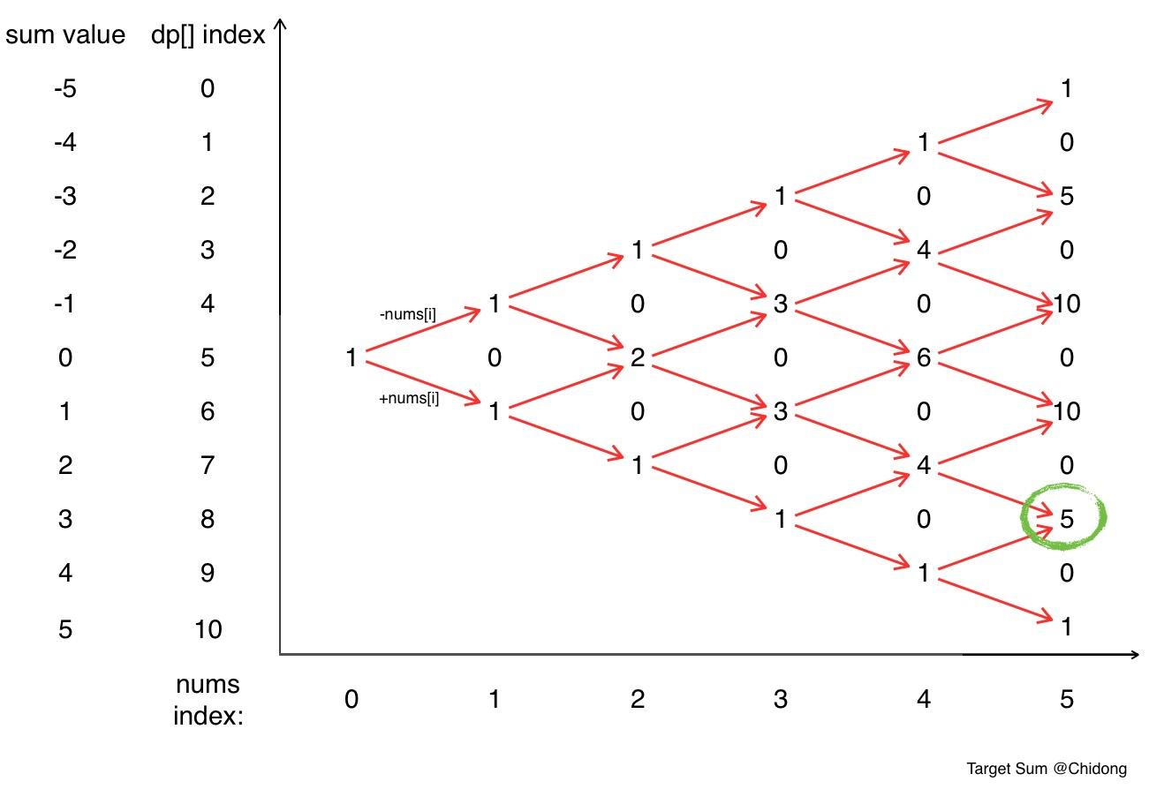
思路：算出sum，如果S>sum 或S< sum 肯定是0個填法。
弄一個dp數組，dp[ 2*sum+1 ]。現在開始至少有一種，所以在dp[0+sum]填入1；
每次循環新建一個數組next[ 2*sum+1] 對於之前那排dp數組。
next[ k+ nums[i]] += dp[k]; next[ k- nums[i]]-= dp[k];
然後dp=next；
最後答案就在 dp[sum+S]中

public class Solution {
public int findTargetSumWays(int[] nums, int s) {
int sum = 0;
for(int i: nums) sum+=i;
if(s>sum || s<-sum) return 0;
int[] dp = new int[2*sum+1];
dp[0+sum] = 1;
for(int i = 0; i<nums.length; i++){
int[] next = new int[2*sum+1];
for(int k = 0; k<2*sum+1; k++){
if(dp[k]!=0){
next[k + nums[i]] += dp[k];
next[k - nums[i]] += dp[k];
}
}
dp = next;
}
return dp[sum+s];
}
}

72. Edit Distance
給出兩個string，找出從string1 變為string2 最少的操作次數
操作包括如下：插入一個字符，刪除一個字符，替換一個字符

思路：
 | 空 | K | I | T | T | I | N | G
空 | 0 | 插入1 | 插入2 | 插入3 | 插入4 | 插入5 | 插入6 | 插入7
K | 刪除1 | 0 | 插入1 | 插入2 | 插入3 | 插入4 | 插入5 | 插入6
I | 刪除2 | 刪除1 | 0 | 插入1 | 插入2 | 插入3 | 插入4 | 插入5
T | 刪除3 | 刪除2 | 刪除1 | 0 | 插入1 | 插入2 | 插入3 | 插入4
T | 刪除4 | 刪除3 | 刪除2 | 刪除1 | 0 | 插入1 | 插入2 | 插入3
E | 刪除5 | 刪除4 | 刪除3 | 刪除2 | 刪除1 | 替換1 | 插入1 | 插入2
N | 刪除6 | 刪除5 | 刪除4 | 刪除3 | 刪除2 | 刪除1 | 保持1 | 插入2

如果當前字符不相等，每一格是左上，正上，和左邊三個中最小值加1。否則就是，三個中的最小值，不用加1

139. Word Break
要求給你一個string和dictionary，看string能不能有dictionary的詞組成
思路：注意有可能出現如下情況
[hello, love] str=hellove這種不行
所以必須用一個dp，dp[i]記錄string的第i位為止，是否有一個完整的單詞。
如上例子，雖然找到love，但是l對應的位置沒有找到單詞，所以這個不能算數
public class Solution {
public boolean wordBreak(String s, List<String> wordDict) {
boolean[] dp=new boolean[s.length()+1];
dp[0]=true;
for(int i=1;i<=s.length();i++){
for(int j=0;j<i;j++){
String sub=s.substring(j,i);
if(dp[j]&&wordDict.contains(sub)){
dp[i]=true;
break;
}
}
}

return dp[s.length()];
}
}

132. Palindrome Partitioning II
Given a string s, partition s such that every substring of the partition is a palindrome.
Return the minimum cuts needed for a palindrome partitioning of s.
For example, given s = "aab",
Return 1 since the palindrome partitioning ["aa","b"] could be produced using 1 cut.
思路： dp[i][j]記錄從i到j（包含）的字符串是否是parlindrome。按列掃描，當前i到j是parlindrome的判斷條件是 1. char I ==char j 並且 2. j-i<=1 或 dp[i+1][j-1]是true(除去頭尾兩個字母后字符串還是parlindrome)
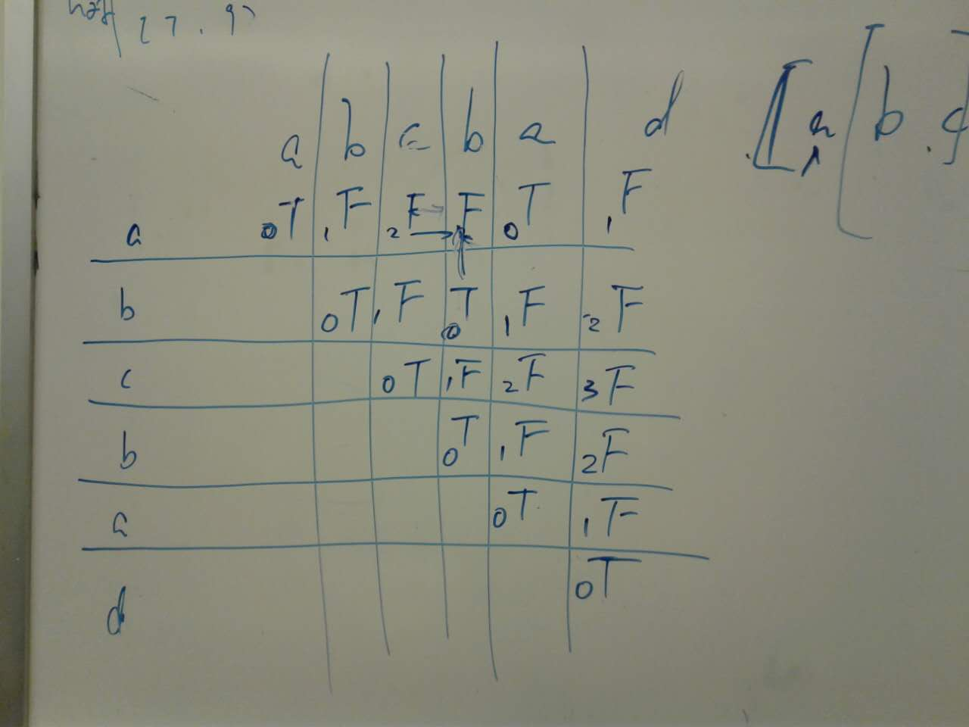
別管上圖的數字，數字是錯的。
// f[i] 表示前i个字母，最少可以被分割为多少个回文串
// 最后return f[n] - 1
然後一列列地看，例如第二個b那一列，第二行是true，說明bcb是回文串，所以abcb可以分為a 和bcb 兩個回文串。f[4]=min（f[4], f[1] + 1） 最後把f[6] -1 就是結果
// f[i] 表示前i个字母，最少可以被分割为多少个回文串
// 最后return f[n] - 1

public class Solution {
private boolean[][] getIsPalindrome(String s) {
boolean[][] isPalindrome = new boolean[s.length()][s.length()];

for (int i = 0; i < s.length(); i++) {
isPalindrome[i][i] = true;
}
for (int i = 0; i < s.length() - 1; i++) {
isPalindrome[i][i + 1] = (s.charAt(i) == s.charAt(i + 1));
}

for (int length = 2; length < s.length(); length++) {
for (int start = 0; start + length < s.length(); start++) {
isPalindrome[start][start + length]
= isPalindrome[start + 1][start + length - 1] && s.charAt(start) == s.charAt(start + length);
}
}

return isPalindrome;
}

public int minCut(String s) {
if (s == null || s.length() == 0) {
return 0;
}

// preparation
boolean[][] isPalindrome = getIsPalindrome(s);

// initialize
int[] f = new int[s.length() + 1];
f[0] = 0;

// main
for (int i = 1; i <= s.length(); i++) {
f[i] = Integer.MAX_VALUE; // or f[i] = i
for (int j = 0; j < i; j++) {
if (isPalindrome[j][i - 1]) {
f[i] = Math.min(f[i], f[j] + 1);
}
}
}

return f[s.length()] - 1;
}
}
523. Continuous Subarray Sum
Given a list of non-negative numbers and a target integer k, write a function to check if the array has a continuous subarray of size at least 2 that sums up to the multiple of k, that is, sums up to n*k where n is also an integer.
Example 1:
Input: [23, 2, 4, 6, 7], k=6
Output: True
Explanation: Because [2, 4] is a continuous subarray of size 2 and sums up to 6.
Example 2:
Input: [23, 2, 6, 4, 7], k=6
Output: True
Explanation: Because [23, 2, 6, 4, 7] is an continuous subarray of size 5 and sums up to 42.
思路：sum是記錄從開始到當前的sum
到了第i位，sum%k 的值如果在前面出現過，且出現位置與i相隔至少兩位，說明找到了
注意corner case k=0
class Solution {
public:
bool checkSubarraySum(vector<int>& nums, int k)
{
if (nums.size() < 2)
return false;
int runningSum = 0;
unordered_map<int, int> quickFind;
quickFind[0] = -1;
for(int i = 0; i < nums.size(); i++)
{
runningSum += nums[i];
if(k != 0)
runningSum %= k;
std::unordered_map<int, int>::iterator it;
it = quickFind.find(runningSum);
if(it == quickFind.end())
quickFind[runningSum] = i;
else if(i - it->second > 1)
return true;
}
return false;
}
};

Super Washing Machines 超级洗衣机
You have n super washing machines on a line. Initially, each washing machine has some dresses or is empty.
For each move, you could choose any m (1 ≤ m ≤ n) washing machines, and pass one dress of each washing machine to one of its adjacent washing machines at the same time .
Given an integer array representing the number of dresses in each washing machine from left to right on the line, you should find the minimum number of moves to make all the washing machines have the same number of dresses. If it is not possible to do it, return -1.
Example1
Input: [1,0,5]

Output: 3

Explanation:
1st move: 1 0 <-- 5 => 1 1 4
2nd move: 1 <-- 1 <-- 4 => 2 1 3
3rd move: 2 1 <-- 3 => 2 2 2
Example2
Input: [0,3,0]

Output: 2

Explanation:
1st move: 0 <-- 3 0 => 1 2 0
2nd move: 1 2 --> 0 => 1 1 1
Example3
Input: [0,2,0]

Output: -1

Explanation:
It's impossible to make all the three washing machines have the same number of dresses.
这道题的代码量其实不多，难点是在于解题思路，难的是对问题的等价转换等。博主也没有做出这道题，博主想到了要先验证衣服总数是否能整除洗衣机的数量，然后计算出每个洗衣机最终应该放的衣服数，返回跟初始状态衣服数之差的最大值，但这种解法是不对的，无法通过这个test case [0, 0, 11, 5]，最终每个洗衣机会留4件衣服，我想的那方法会返回7，然后正确答案是8。想想也是，如果这么是这么简单的思路，这题怎么会标记为Hard呢，还是图样图森破啊。这里直接参照大神Chidong的帖子来做，我们就用上面那个例子，有四个洗衣机，装的衣服数为[0, 0, 11, 5]，最终的状态会变为[4, 4, 4, 4]，那么我们将二者做差，得到[-4, -4, 7, 1]，这里负数表示当前洗衣机还需要的衣服数，正数表示当前洗衣机多余的衣服数。我们要做的是要将这个差值数组每一项都变为0，对于第一个洗衣机来说，需要四件衣服可以从第二个洗衣机获得，那么就可以把-4移给二号洗衣机，那么差值数组变为[0, -8, 7, 1]，此时二号洗衣机需要八件衣服，那么至少需要移动8次。然后二号洗衣机把这八件衣服从三号洗衣机处获得，那么差值数组变为[0, 0, -1, 1]，此时三号洗衣机还缺1件，就从四号洗衣机处获得，此时差值数组成功变为了[0, 0, 0, 0]，成功。那么移动的最大次数就是差值数组中出现的绝对值最大的数字，8次，参见代码如下：

class Solution {
public:
int findMinMoves(vector<int>& machines) {
int sum = accumulate(machines.begin(), machines.end(), 0);
if (sum % machines.size() != 0) return -1;
int res = 0, cnt = 0, avg = sum / machines.size();
for (int m : machines) {
cnt += m - avg;
res = max(res, max(abs(cnt), m - avg));
}
return res;
}
};

[LeetCode] Maximum Vacation Days 最大化休假日

LeetCode wants to give one of its best employees the option to travel among N cities to collect algorithm problems. But all work and no play makes Jack a dull boy, you could take vacations in some particular cities and weeks. Your job is to schedule the traveling to maximize the number of vacation days you could take, but there are certain rules and restrictions you need to follow.
Rules and restrictions:
- You can only travel among N cities, represented by indexes from 0 to N-1. Initially, you are in the city indexed 0 on Monday.
- The cities are connected by flights. The flights are represented as a N*N matrix (not necessary symmetrical), called flights representing the airline status from the city i to the city j. If there is no flight from the city i to the city j, flights[i][j] = 0; Otherwise, flights[i][j] = 1. Also, flights[i][i] = 0 for all i.
- You totally have K weeks (each week has 7 days) to travel. You can only take flights at most once per day and can only take flights on each week's Monday morning. Since flight time is so short, we don't consider the impact of flight time.
- For each city, you can only have restricted vacation days in different weeks, given an N*K matrix called days representing this relationship. For the value of days[i][j], it represents the maximum days you could take vacation in the city i in the week j.

You're given the flights matrix and days matrix, and you need to output the maximum vacation days you could take during K weeks.
Example 1:
Input:flights = [[0,1,1],[1,0,1],[1,1,0]], days = [[1,3,1],[6,0,3],[3,3,3]]
Output: 12
Explanation:
Ans = 6 + 3 + 3 = 12.
One of the best strategies is:
1st week : fly from city 0 to city 1 on Monday, and play 6 days and work 1 day.
(Although you start at city 0, we could also fly to and start at other cities since it is Monday.)
2nd week : fly from city 1 to city 2 on Monday, and play 3 days and work 4 days.
3rd week : stay at city 2, and play 3 days and work 4 days.

Example 2:
Input:flights = [[0,0,0],[0,0,0],[0,0,0]], days = [[1,1,1],[7,7,7],[7,7,7]]
Output: 3
Explanation:
Ans = 1 + 1 + 1 = 3.
Since there is no flights enable you to move to another city, you have to stay at city 0 for the whole 3 weeks.
For each week, you only have one day to play and six days to work.
So the maximum number of vacation days is 3.

Example 3:
Input:flights = [[0,1,1],[1,0,1],[1,1,0]], days = [[7,0,0],[0,7,0],[0,0,7]]
Output: 21
Explanation:
Ans = 7 + 7 + 7 = 21
One of the best strategies is:
1st week : stay at city 0, and play 7 days.
2nd week : fly from city 0 to city 1 on Monday, and play 7 days.
3rd week : fly from city 1 to city 2 on Monday, and play 7 days.

Note:
- N and K are positive integers, which are in the range of [1, 100].
- In the matrix flights, all the values are integers in the range of [0, 1].
- In the matrix days, all the values are integers in the range [0, 7].
- You could stay at a city beyond the number of vacation days, but you should work on the extra days, which won't be counted as vacation days.
- If you fly from the city A to the city B and take the vacation on that day, the deduction towards vacation days will count towards the vacation days of city B in that week.
- We don't consider the impact of flight hours towards the calculation of vacation days.

题目解释：
给出一个N*N的flights数组，如果flights[i][j] = 1 表示可以从城市i 飞去城市j
给出days数组，day[i][j]表示，如果第j周在城市i，可以有多少天假期。
不一定要游遍所有城市。问最多可以拿到多少天假期
思路：
Dp 从最后一周往前数。
例如有3城市，现在是第四周。Dp[4][i]表示第四周在城市i可以拿到的最多累计假期。
加入城市1和2都可以去到城市0
Dp[4][0] = Max(dp[5][1], dp[5][2], dp[5][0]) + days[i][4]
算出整个dp数组后，就可知道在出发点0城市时，最多的假期数
参见代码如下：

解法一：
class Solution {public:
int maxVacationDays(vector<vector<int>>& flights, vector<vector<int>>& days) {
int n = flights.size(), k = days[0].size(), res = 0;
vector<vector<int>> dp(n, vector<int>(k, 0));
for (int j = k - 1; j >= 0; --j) {
for (int i = 0; i < n; ++i) {
dp[i][j] = days[i][j];
for (int p = 0; p < n; ++p) {
if ((i == p || flights[i][p]) && j < k - 1) {
dp[i][j] = max(dp[i][j], dp[p][j + 1] + days[i][j]);
}
if (j == 0 && (i == 0 || flights[0][i])) res = max(res, dp[i][0]);
}
}
}
return res;
}
};

Count Different Palindromic Subsequences
Given a string S, find the number of different non-empty palindromic subsequences in S, and return that number modulo 10^9 + 7.
A subsequence of a string S is obtained by deleting 0 or more characters from S.
A sequence is palindromic if it is equal to the sequence reversed.
Two sequences A_1, A_2, ... and B_1, B_2, ... are different if there is some i for which A_i != B_i.
Example 1:
Input:
S = 'bccb'Output: 6Explanation:
The 6 different non-empty palindromic subsequences are 'b', 'c', 'bb', 'cc', 'bcb', 'bccb'.
Note that 'bcb' is counted only once, even though it occurs twice.

题意：给出一个字符串，计算里面有多少个subsequence是palindrome。但是subsequence必须是unique。例如bb 只有两个，虽然两个b和b在不同位置，但只能算一个

思路：
动态规划
Dp[start][end] 表示从start到end 的字符串（一定要包括start 和end）palindrome subsequence总数

假如不需要unique的话
如果 word[start] != word[end] dp[start][end] = dp[start][end - 1] + dp[start + 1][end] - dp[start+1][end-1]
如果 word[start] == word[end] dp[start][end] = dp[start][end - 1] + dp[start + 1][end] - dp[start + 1][end - 1] + dp[start + 1][end - 1] + 1 (左边加右边回文数 减去中间多算的 dp[start + 1][end - 1] + 1是包括start和end的回文数，+1代表只有start 和end两个字母)
但是这种解法不会去除duplicate

Unique解法
1. 当left > righ时，说明中间没有和S[i]相同的字母了，就是"aba"这种情况，那么就有dp[i][j] = dp[i + 1][j - 1] * 2 + 2，其中dp[i + 1][j - 1]是中间部分的回文子序列个数，为啥要乘2呢，因为中间的所有子序列可以单独存在，也可以再外面包裹上字母a，所以是成对出现的，要乘2。加2的原因是外层的"a"和"aa"也要统计上。
2. 当left = right时，说明中间只有一个和S[i]相同的字母，就是"aaa"这种情况，那么有dp[i][j] = dp[i + 1][j - 1] * 2 + 1，其中乘2的部分跟上面的原因相同，加1的原因是单个字母"a"的情况已经在中间部分算过了，外层就只能再加上个"aa"了。
3. 当left < right时，说明中间至少有两个和S[i]相同的字母，就是"aabaa"这种情况，那么有dp[i][j] = dp[i + 1][j - 1] * 2 - dp[left + 1][right - 1]，其中乘2的部分跟上面的原因相同，要减去left和right中间部分的子序列个数的原因是其被计算了两遍，要将多余的减掉。

class Solution {public:
int countPalindromicSubsequences(string S) {
int n = S.size(), M = 1e9 + 7;
vector<vector<int>> dp(n, vector<int>(n, 0));
for (int i = 0; i < n; ++i) dp[i][i] = 1;
for (int len = 1; len < n; ++len) {
for (int i = 0; i < n - len; ++i) {
int j = i + len;
if (S[i] == S[j]) {
int left = i + 1, right = j - 1;
while (left <= right && S[left] != S[i]) ++left;
while (left <= right && S[right] != S[i]) --right;
if (left > right) {
dp[i][j] = dp[i + 1][j - 1] * 2 + 2;
} else if (left == right) {
dp[i][j] = dp[i + 1][j - 1] * 2 + 1;
} else {
dp[i][j] = dp[i + 1][j - 1] * 2 - dp[left + 1][right - 1];
}
} else {
dp[i][j] = dp[i][j - 1] + dp[i + 1][j] - dp[i + 1][j - 1];
}
dp[i][j] = (dp[i][j] < 0) ? dp[i][j] + M : dp[i][j] % M;
}
}
return dp[0][n - 1];
}
};

