STAR-NOSE CAPACITIVE SENSOR
Technical Report: System Status, ML Roadmap & Signal Quality
May 2026
Jonathan Tirado

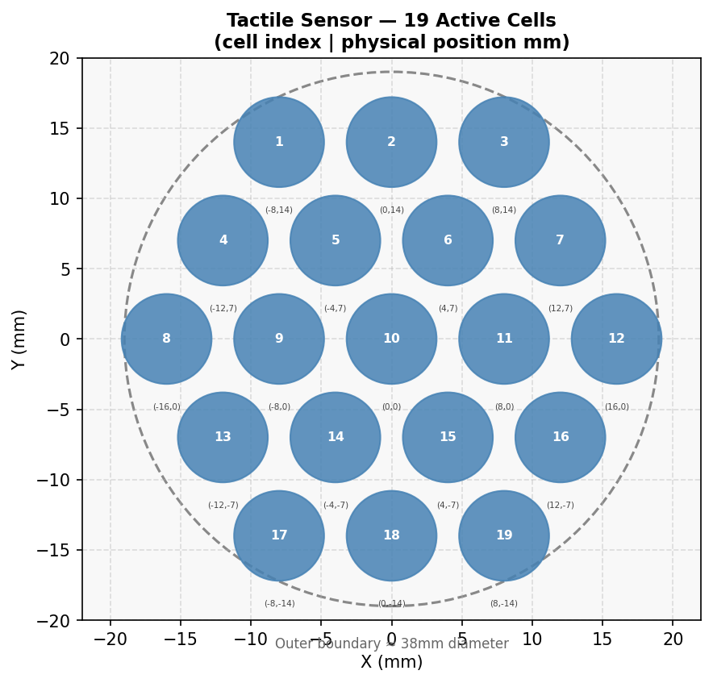
Figure 1. The 19-cell hexagonal capacitive array with physical coordinates (mm).

1. Current System Overview

1.1 Hardware
The sensor is a capacitive tactile array — the Star-Nose Sensor. Of the 252 raw cells in the skin, 19 are actively used, arranged in a hexagonal diamond grid spanning approximately 38 mm in diameter. Each cell outputs a capacitance value that is read over a serial connection (USB/UART) at 115,200 baud by a host computer.
The sensor is mounted on a UR5 6-DOF robot arm, which provides millimetre-accurate ground-truth labels during data collection: TCP position (x, y, z in mm) and force/torque readings (Fx, Fy, Fz, Tx, Ty, Tz). This combination eliminates the need for manual annotation.

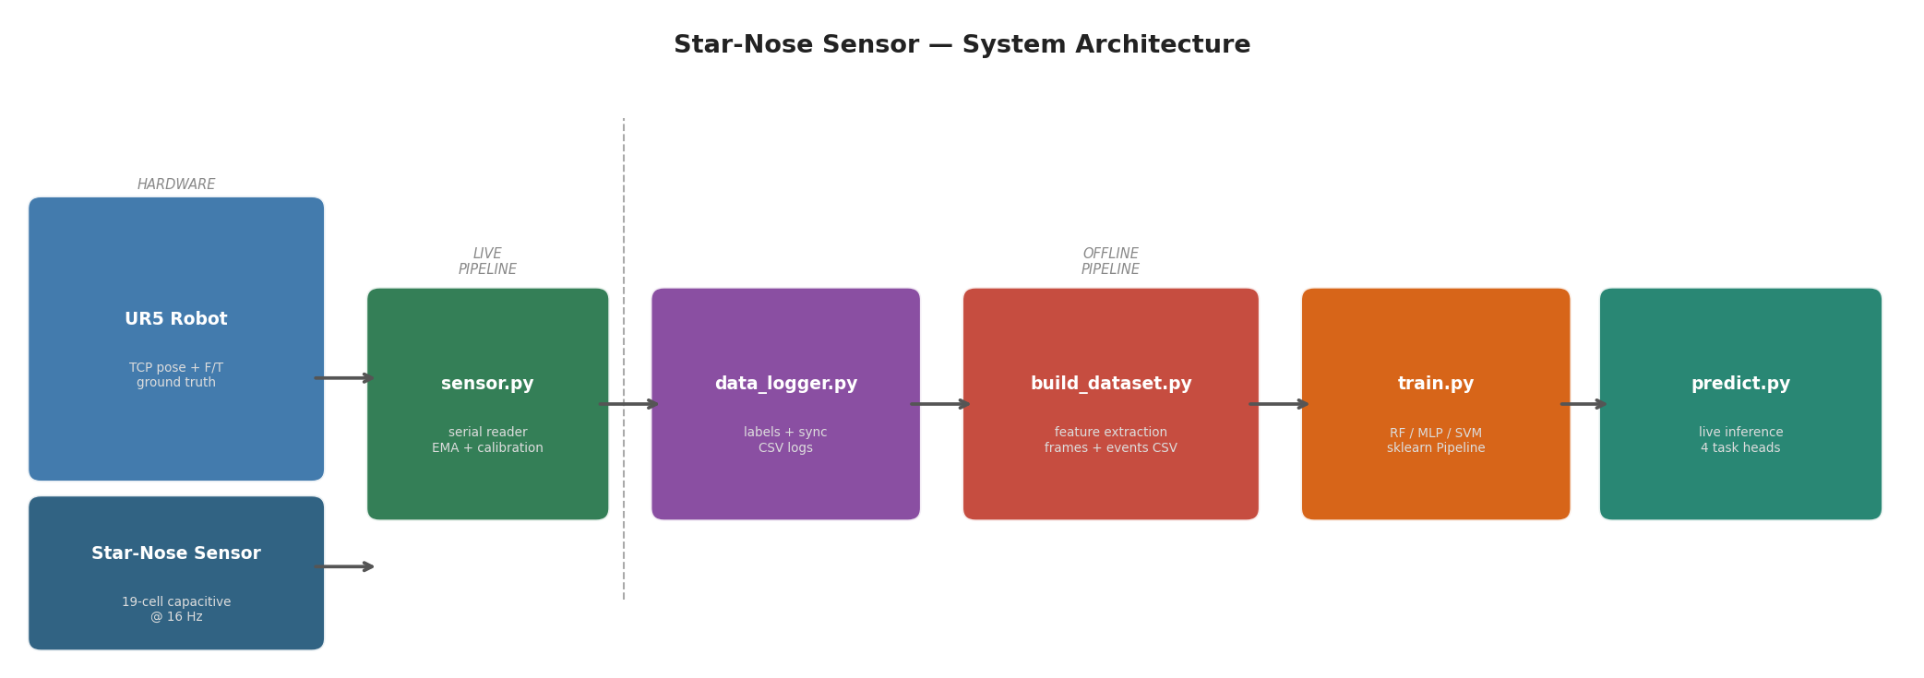
Figure 2. Full system architecture from hardware to live inference.

Parameter | Value / Description
Sensor cells | 19 active (from 252-cell Star-Nose skin)
Cell spacing | 8 mm (column), 7 mm (row)
Sensor diameter | ~38 mm (outer boundary)
Serial rate | 115,200 baud — USB UART to host PC
Frame rate | ~16 Hz (observed from session logs)
Robot arm | Universal Robots UR5 (6-DOF, ±0.1 mm TCP accuracy)
Force sensor | Integrated F/T at TCP (Fx, Fy, Fz, Tx, Ty, Tz)
Normalization | value = max(0, min((raw - baseline) / SENSITIVITY, 1))^GAMMA
Hyperparameters | SENSITIVITY = 30.0, GAMMA = 0.5

1.2 Software Stack
The software is organized into a live pipeline and an offline pipeline.
sensor.py — Serial reader running in a background thread. Handles auto-reconnection, calibration (single-frame baseline), normalization, and writes the current state to a shared JSON file at 30 Hz for inter-process access.
data_logger.py — Synchronizes UR5 TCP/F/T data with sensor readings, logs all channels to timestamped CSV files. Labels each frame with ur5_point, ur5_pressing, and ur5_done flags.
build_dataset.py — Post-processes CSV logs into ML-ready datasets: frames.csv (one row per frame during pressing) and events.csv (one row per complete press event, with peak and mean aggregations). Computes spatial features: centroid (x, y), spread, n_active, and diameter estimate.
train.py — Trains four independent sklearn pipelines (StandardScaler + model). Supports Random Forest, SVM, and MLP backends via --model flag. Saves .pkl files to saved_models/.
predict.py — Loads all saved models and runs live inference on the sensor stream, outputting contact class, (x, y) position, depth, and diameter simultaneously.

1.3 Current ML Tasks
Four regression/classification tasks are currently trained and deployed:
Task | Type | Target | Current Performance
Contact classifier | Classification | Which of 19 points (1–19) | High accuracy on trained points; no interpolation
Position regressor | Regression (2D) | (x, y) in mm | MAE reported per session; limited between-point generalization
Depth regressor | Regression (1D) | z indentation in mm | MAE ~0.3–0.5 mm on trained range; depends on depth coverage
Diameter estimator | Regression (1D) | Contact footprint (mm) | Derived from pressure spread; approximate

1.4 Dataset Status
As of May 2026, the labeled dataset contains approximately 28,000 frames across multiple sessions collected with the UR5. Sessions cover the canonical 19-point grid at varying depths. Several sessions use an empty dome (no object pressed), solid dome, and curved surface configurations.
Session group | Sessions | Labeled frames | Notes
dome_empty_tuesday (×6) | 6 | ~8,700 | Empty dome, 19-pt grid
dome_empty_burcu | 1 | ~1,400 | Different operator
test_curved (×2) | 2 | ~2,900 | Curved surface
solid_domes | 1 | ~1,400 | Solid dome object
ursim_19pts (latest) | 1 | ~1,795 | URSim — 19 pts, clean
Total (approx.) |  | ~28,000 frames

2. ML Learning Roadmap

The current pipeline handles static contact detection well. The next phase extends it to three new capabilities: rotation estimation, shape recognition, and displacement/trajectory tracking. This section describes the recommended approach for each.

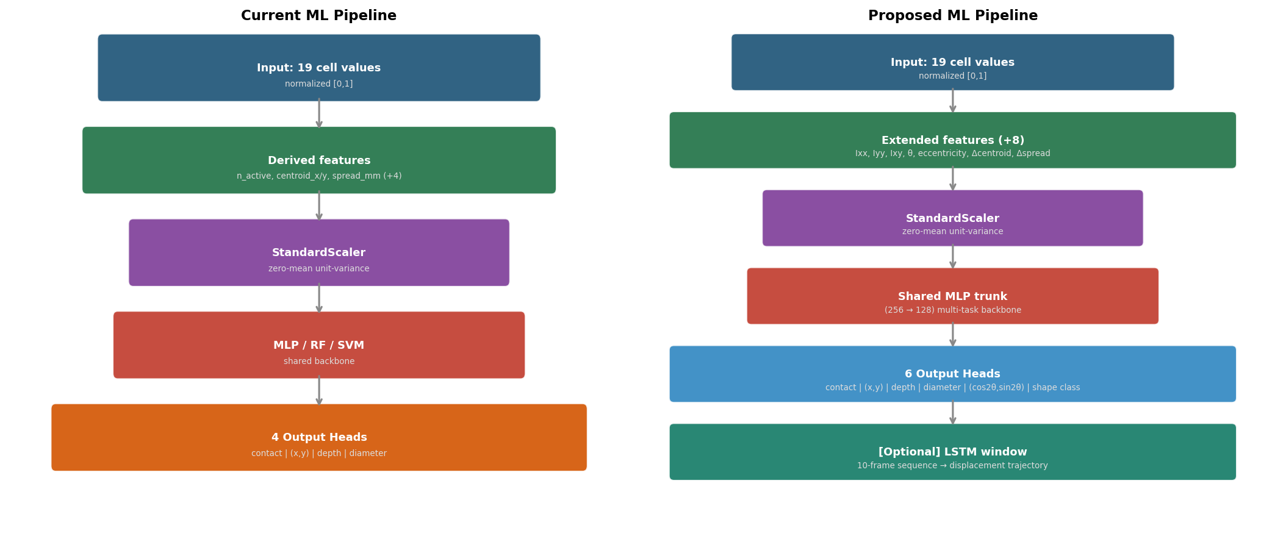
Figure 3. Current ML pipeline (left) vs. proposed multi-task pipeline with extended features (right).

2.1 Feature Engineering Extensions
The current feature vector (19 cell values + 4 spatial scalars = 23 features) is sufficient for static position and depth. For rotation and shape, second-order spatial moments must be added. These are computed from the weighted positions of active cells, where weights are the normalized cell values:
Feature | Formula | Physical meaning
Ixx | sum(v_i * (y_i - cy)^2) | Spread of activation along Y axis
Iyy | sum(v_i * (x_i - cx)^2) | Spread of activation along X axis
Ixy | sum(v_i * (x_i - cx)(y_i - cy)) | Cross-moment — captures tilt/rotation
theta | 0.5 * atan2(2*Ixy, Iyy - Ixx) | Principal axis angle of pressure ellipse
eccentricity | (L1 - L2) / (L1 + L2) | Ratio of eigenvalues — sphere=0, edge~1
delta_cx, delta_cy | centroid(t) - centroid(t-1) | Centroid velocity for displacement
delta_spread | spread(t) - spread(t-1) | Change in contact area
Adding these 7 features brings the total feature vector to 30 dimensions, which all existing model types (RF, SVM, MLP) can handle without architectural changes.

2.2 Rotation Estimation
Rotation estimation predicts the orientation angle of an elongated object (cylinder, edge, flat stamp) pressing on the sensor. The key challenge is that angles are periodic: 180° and 0° are equivalent for most symmetric probes.
Recommended approach: predict the 2D vector (cos(2theta), sin(2theta)) as a regression target instead of the raw angle. This is smooth, continuous, and handles wrap-around automatically. Recover the angle with atan2(sin_output, cos_output) / 2. A multi-output MLPRegressor with hidden layers (256, 128) is sufficient for this task with the moment features above.
Expected data requirement: 8 angles x 10 positions x 3 depths x 5 reps = 1,200 labeled events (one lab session with the UR5).

2.3 Shape Recognition
Shape recognition classifies what type of object is pressing on the sensor. With 4-7 distinct shape classes, this is a tractable classification problem given the moment features.
Shape | Key signature | Distinguishing features
Sphere | Circular footprint | eccentricity ~ 0, spread proportional to depth
Flat disk | Large uniform area | high n_active, low spread variance, eccentricity ~ 0
Cylinder (normal) | Elliptical ring | eccentricity > 0.5, theta stable with depth
Edge / rectangle | Line activation | eccentricity ~ 0.8-1.0, very low Iyy or Ixx
Ring / donut | Annular pattern | centroid activation low, peripheral high
A RandomForestClassifier with 300 trees on the 30-feature vector is the recommended starting point. If more than 7 classes are needed, a small MLP (128, 64) with softmax output will generalize better.

2.4 Displacement & Trajectory Tracking
Displacement tracking estimates how the contact moves across the sensor surface over time (sliding, dragging). Two levels of complexity are possible:
- Instantaneous velocity: add delta_cx and delta_cy to the feature vector and use the existing static regressors. This requires no architectural change and works at 16 Hz.
- Full trajectory reconstruction: use an LSTM over a sliding window of 10 frames (input shape: [batch, 10, 30]). The LSTM output predicts (x, y) at each timestep. This is the correct approach for continuous tracking but requires sequence-format training data from the UR5 slide trajectories.
For the LSTM, PyTorch Lightning is recommended as a lightweight extension to the existing Python codebase. A 2-layer LSTM with hidden size 64 and a linear output head is sufficient for the sensor resolution.

3. Data Collection Protocol

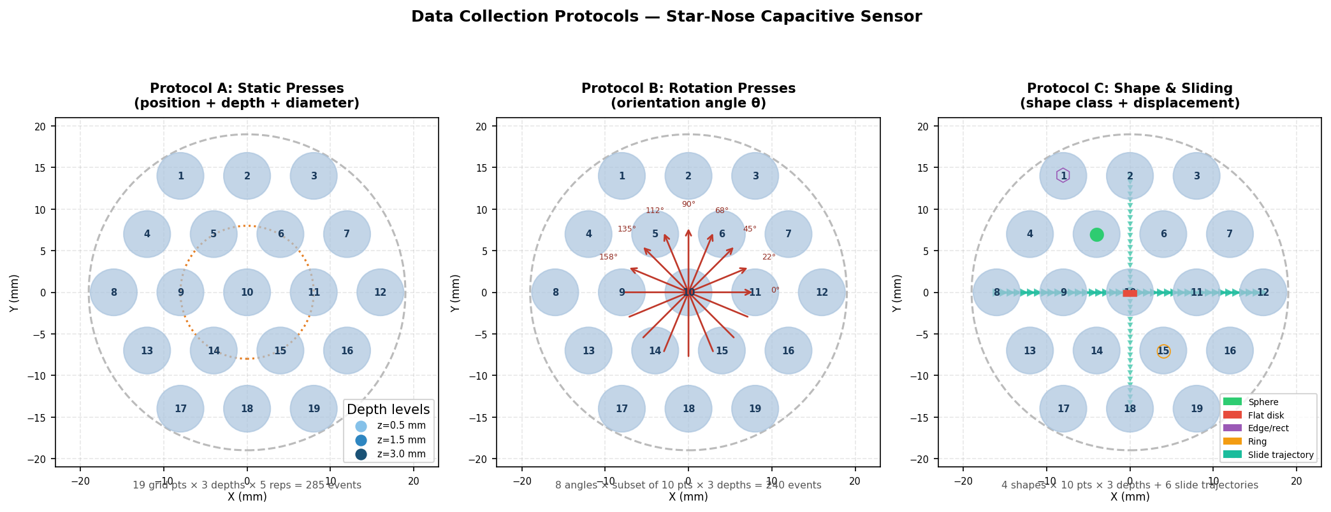
Figure 4. Three data collection protocols for the UR5-sensor system.

3.1 Protocol A — Static Presses (Position, Depth, Diameter)
This protocol is already partially implemented. The recommended extension is to increase depth coverage and add repeated presses for variance estimation.
Parameter | Specification
Grid points | 19 canonical + 6 intermediate (between adjacent pairs)
Depth levels | 0.5, 1.0, 1.5, 2.0, 3.0 mm (5 levels)
Repetitions | 5 presses per configuration, 1.5 s dwell time
Approach speed | 3 mm/s (slow enough for sensor settling)
Total events | 25 pts x 5 depths x 5 reps = 625 labeled events
Calib. check | Press point 10 (center) at 1.5 mm at start and end of session

3.2 Protocol B — Rotation Presses
Mount an asymmetric probe (cylinder or flat rectangular stamp, 8-12 mm long) on the UR5 TCP. Vary the TCP roll angle in 8 steps of 22.5° from 0° to 157.5°.
Parameter | Specification
Probe geometry | Cylinder (8 mm length, 3 mm diameter) or flat stamp (10 x 3 mm)
Angles | 0, 22.5, 45, 67.5, 90, 112.5, 135, 157.5 degrees (8 steps)
Grid points | Subset of 10 representative positions (center + ring)
Depth levels | 1.0 and 2.0 mm (2 levels)
Repetitions | 3 presses per configuration
Ground truth | TCP orientation (rx, ry, rz) logged — angle computed from rz
Total events | 8 angles x 10 pts x 2 depths x 3 reps = 480 labeled events

3.3 Protocol C — Shape & Sliding
Two sub-protocols: (a) discrete presses with different probe shapes, (b) continuous linear trajectories for displacement training.
- Shape presses: 4 probe geometries (sphere, flat disk, edge, ring), 10 positions each, 2 depths, 3 reps = 240 labeled events.
- Slide trajectories: 6 linear paths across the sensor (3 horizontal, 3 diagonal), constant depth 1.5 mm, speed 2 mm/s. Each path generates ~100 labeled frames.
- Label: shape_class (integer 0–3) and trajectory_id for sliding frames.

3.4 General Best Practices
- Always let the robot pause 0.5 s before logging the first pressing frame (settling time).
- Clean the sensor surface with isopropyl alcohol between shape changes.
- Add a calibration check press (center, 1.5 mm) at session start and end to detect drift.
- Log ambient temperature — capacitive sensors drift with temperature gradients.
- Mark sessions with the probe type in the filename (e.g., sphere_session_YYYYMMDD.csv).

4. Signal Quality Issues & Proposed Fixes

Analysis of the ursim_19pts_session_20260525 log reveals three distinct noise sources that degrade both live inference and training data quality. All three require fixes before extending the ML pipeline.

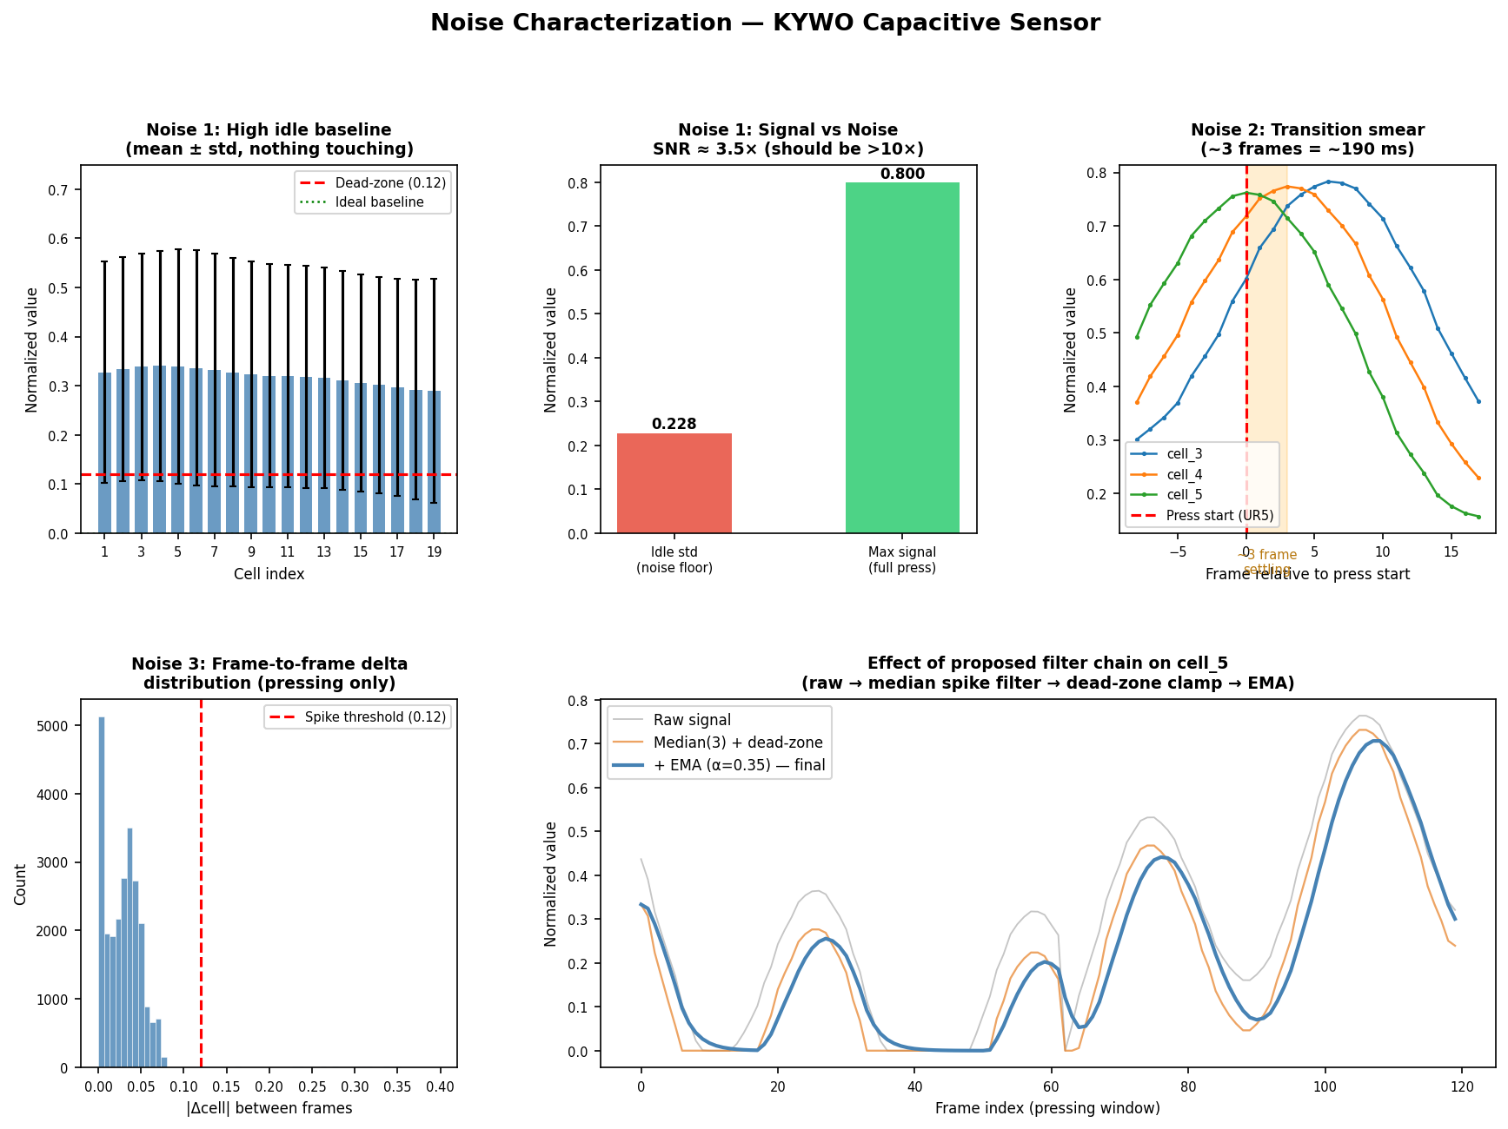
Figure 5. Noise characterization: idle baseline (top-left), SNR (top-center), transition smear (top-right), spike distribution (bottom-left), and filter effect (bottom-right).

4.1 Noise 1 — High Idle Baseline
Observed | Mean idle cell value ~0.32 across all 19 cells (should be ~0). SNR only 3.5x. All cells show idle std of ~0.22.
Root cause | Calibration is captured from a single frame immediately after connection. If the electronics have not settled, or if the UR5 arm is nearby generating EMI, the baseline is wrong. The GAMMA=0.5 exponent then amplifies small errors — a raw offset of 10 counts becomes (10/30)^0.5 = 0.58 instead of 0.33.
Fix | 1. Multi-frame calibration: accumulate N_CALIB=20 frames and use their mean as the baseline instead of a single frame. Estimated improvement: baseline noise reduced by 1/sqrt(20) ~ 78%.  2. Dead-zone clamp: after normalization, set values below DEAD_ZONE=0.12 to zero and rescale: v = max(0, v - DEAD_ZONE) / (1 - DEAD_ZONE). This eliminates idle chatter without affecting the signal region.  3. Periodic recalibration: expose a recalibrate() call triggered every N minutes or when no contact is detected for >10 s.

4.2 Noise 2 — Transition Smear
Observed | At every press start and end, cell values take ~3 frames (~190 ms at 16 Hz) to settle. These frames are currently included in the training dataset as valid pressing samples, teaching the model incorrect patterns.
Root cause | Two combined effects: (a) mechanical settling — the sensor membrane takes ~100 ms to reach equilibrium after first contact; (b) sensor RC time constant — capacitive sensors have an inherent low-pass response determined by the measurement circuit.
Fix | 1. Dataset: in build_dataset.py, add a MARGIN_FRAMES=3 parameter that skips the first and last 3 frames of each press event before emitting rows to frames.csv.  2. Live pipeline: in the UR5 collection routine, add a 0.5 s wait after the ur5_pressing flag goes high before starting to log sensor frames. This gives the sensor time to settle before any frames are recorded.

4.3 Noise 3 — Frame-to-Frame Spikes
Observed | 1.2% of pressing frames contain at least one cell with an impossible frame-to-frame jump (|delta| > 0.12 normalized units, >3x global std). These are physically impossible at 16 Hz given the sensor mechanics.
Root cause | Serial framing artifacts: partial UART lines received when the host reads mid-transmission, or USB interrupt collisions under load. The parser in sensor.py checks for len(parts) != SKIN_CELLS but does not validate value continuity.
Fix | 1. Live pipeline (sensor.py): after parsing a new frame, compute the max absolute delta from the previous frame. If any cell exceeds SPIKE_THRESHOLD=0.25 normalized units, discard the frame and retain the previous values.  2. Dataset (build_dataset.py): add a spike-rejection pass that drops rows where any cell delta exceeds the threshold before writing to frames.csv.  3. Smoothing (sensor.py): apply a per-cell EMA with alpha=0.35 after spike rejection. This attenuates residual high-frequency noise while keeping latency low (~2 frame lag = ~125 ms).

4.4 Summary of Proposed Signal Processing Chain
The complete filter chain applied to each incoming frame, in order:
Step | Operation | Implementation
1 | Multi-frame calibration | Average N_CALIB=20 frames for baseline; re-run every 10 min idle
2 | Standard normalization | (raw - baseline) / SENSITIVITY, clipped to [0, 1]
3 | Gamma compression | value^GAMMA (GAMMA=0.5) — keep for perceptual scaling
4 | Spike rejection | Discard frame if any |delta_cell| > SPIKE_THRESHOLD (0.25)
5 | Dead-zone clamp | v = max(0, v - DEAD_ZONE) / (1 - DEAD_ZONE), DEAD_ZONE=0.12
6 | Per-cell EMA | v_filtered = alpha * v_new + (1-alpha) * v_prev, alpha=0.35

5. Next Steps

# | Task | Details | Priority
1 | Fix signal pipeline (sensor.py) | Multi-frame calib, dead-zone, EMA, spike rejection — new branch recommended | HIGH
2 | Fix dataset builder (build_dataset.py) | Add MARGIN_FRAMES=3, spike rejection pass, moment features (Ixx, Iyy, Ixy, theta, eccentricity) | HIGH
3 | Collect rotation data (Protocol B) | One UR5 session, asymmetric probe, 8 angles x 10 pts x 2 depths | MEDIUM
4 | Collect shape data (Protocol C) | One UR5 session, 4 probe shapes + slide trajectories | MEDIUM
5 | Train rotation regressor | (cos2theta, sin2theta) targets, MLP(256,128), moment features | MEDIUM
6 | Train shape classifier | RF(300 trees), 30-feature vector including moments | MEDIUM
7 | Multi-task MLP (optional) | Shared (256,128) trunk, 6 output heads — better generalization | LOW
8 | LSTM for trajectory (optional) | PyTorch, 2-layer LSTM hidden=64, 10-frame window | LOW

End of Report

