Star-Nose Capacitive Sensor
Figure Prototype Document
Plots from the repository + synthetic placeholders for data not yet collected
Jonathan Tirado — June 2026

Legend: 🟩 Real repo data 🟧 Synthetic placeholder (data not yet collected)

Figure 1 | Design and Fabrication of the Star-Nose Sensor
(a) Biological inspiration — PLACEHOLDER
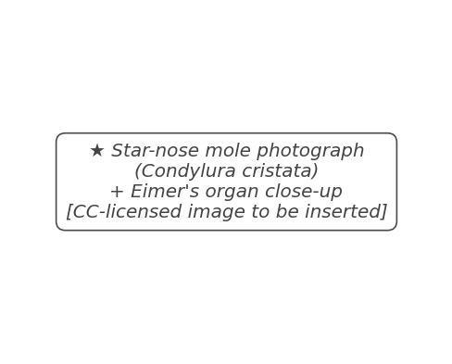
⚑ To replace with: CC-licensed photo of Condylura cristata + close-up of Eimer's organs on one appendage.
(b) 19-cell hexagonal array layout 🟩 repo data
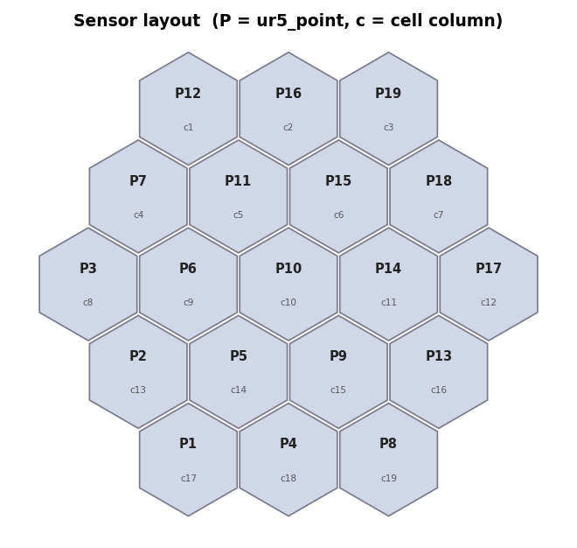 | 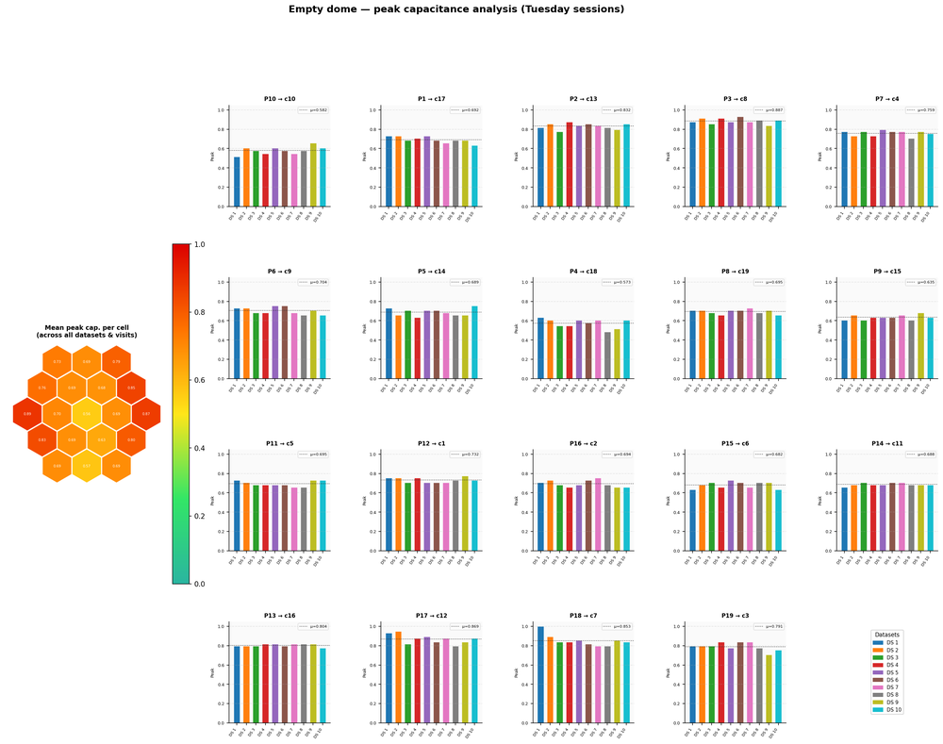
Left: 19 active electrode positions in the hexagonal diamond grid (∸38 mm diameter). Right: full sensor overview with UR5 integration.
(c) System photograph & UR5 mounting — PLACEHOLDER
⚑ To replace with: high-resolution photo of the bare PCB, assembled dome variants, and sensor mounted on UR5 TCP.

Figure 2 | Electrical Characterisation of the Capacitive Sensors
(a) Raw capacitance vs. force — dual axis 🟩 repo data
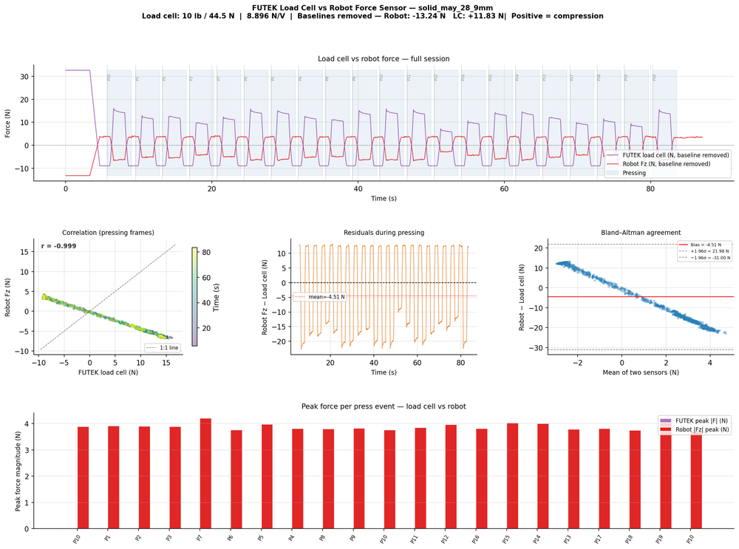 | 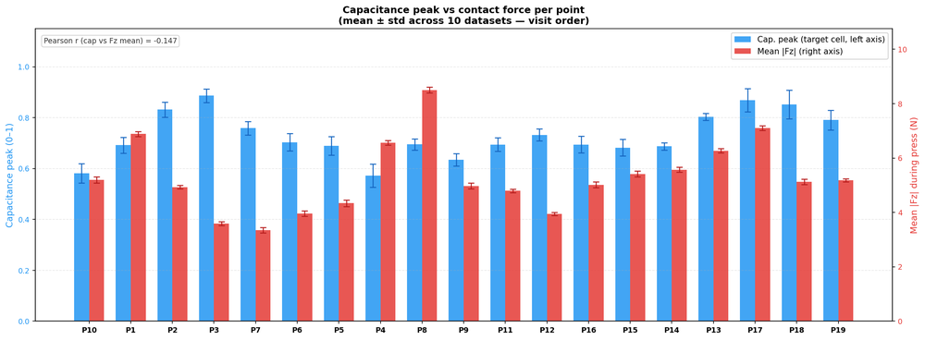
Left: load cell vs. robot TCP force across all channels (May 28 session). Right: capacitance / force dual-axis for a single electrode.
(b) Analog channel time traces 🟩 repo data
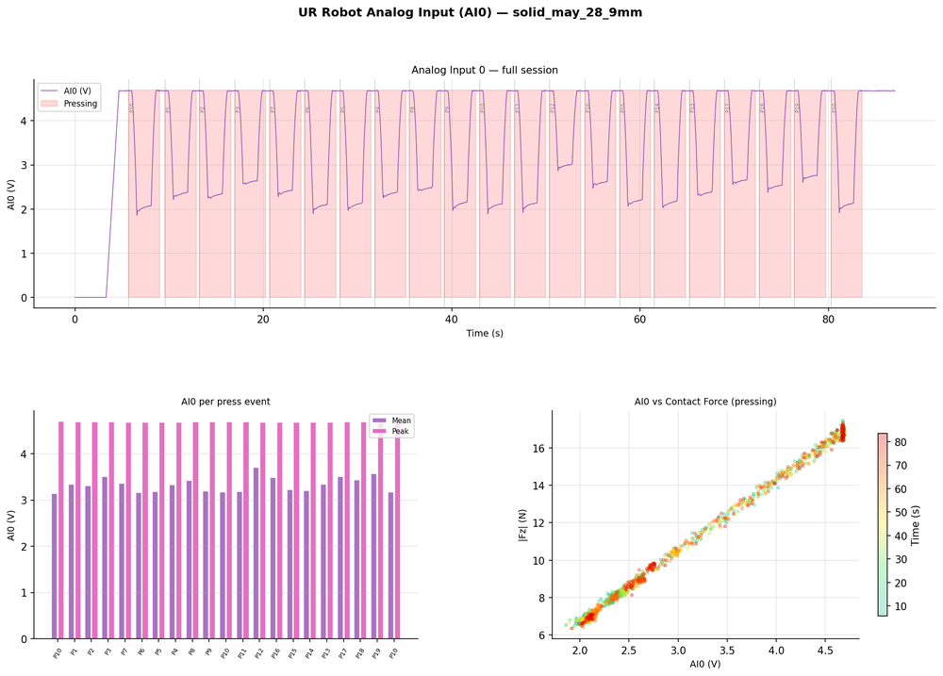
Raw analog capacitance signals showing press events; note transition smear at press onset/offset.
(c) Per-electrode SNR map 🟧 synthetic
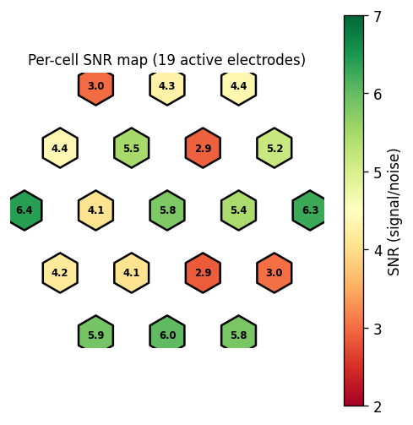 | 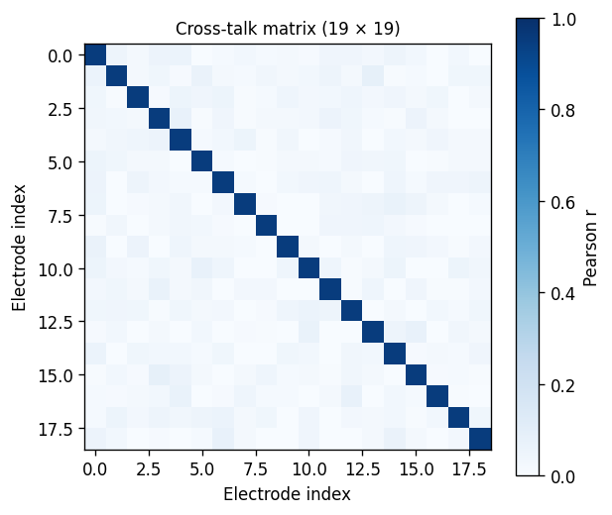
Left: per-cell SNR on the hexagonal grid — edge cells show lower SNR due to boundary effects. Right: 19×19 cross-talk correlation matrix (synthetic placeholder — real data requires single-point press protocol).
(d) Capacitance vs. force per point 🟩 repo data
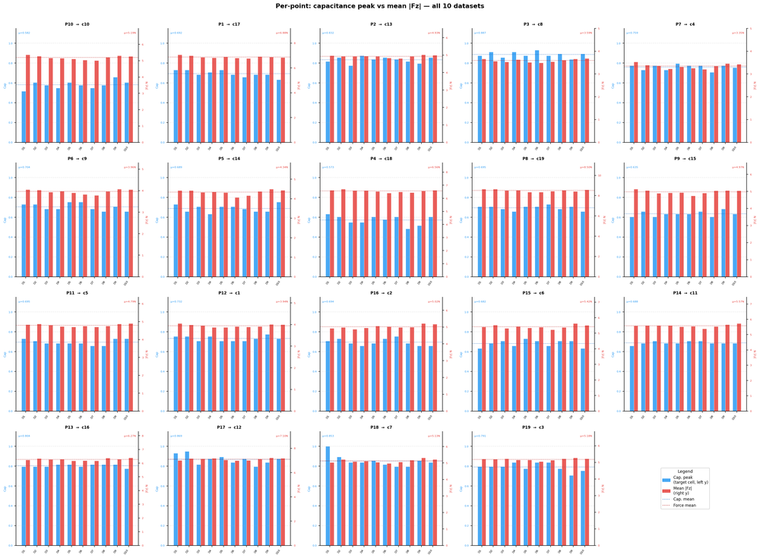
Force–capacitance relationship for each of the 19 active cells, showing consistent sensitivity across the array.

Figure 3 | Mechanical Characterisation of Dome Variants
(a) Force–displacement curves — dome comparison 🟧 synthetic + 🟩 repo
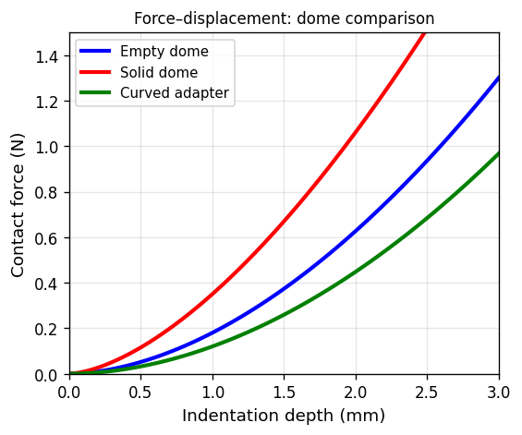 | 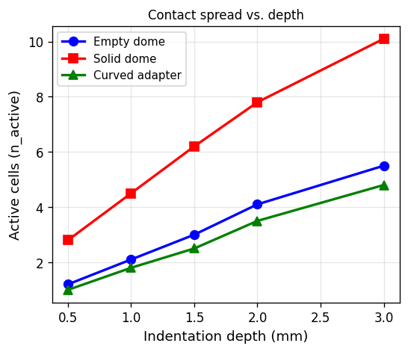
Left: force–displacement overlay for empty dome, solid dome, and curved adapter (synthetic; real curves from load cell sessions to replace). Right: active cell count (n_active) vs. depth — solid dome spreads contact further.
(b) Force timeline across 19 points 🟩 repo data
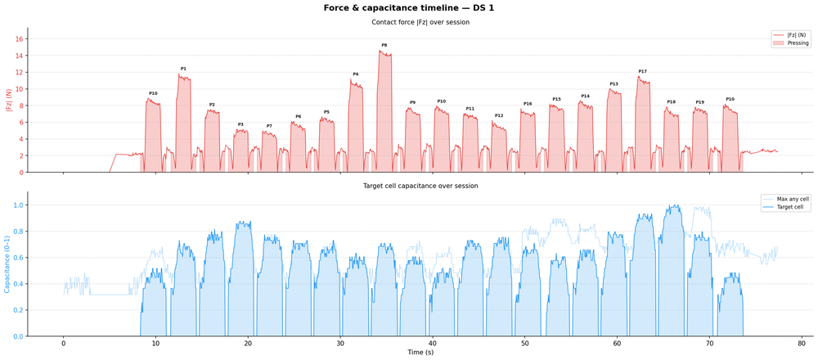
Time-series force across all 19 active electrodes during a sequential 19-point press session (empty dome).
(c) Deviation maps — dome variants 🟩 repo data
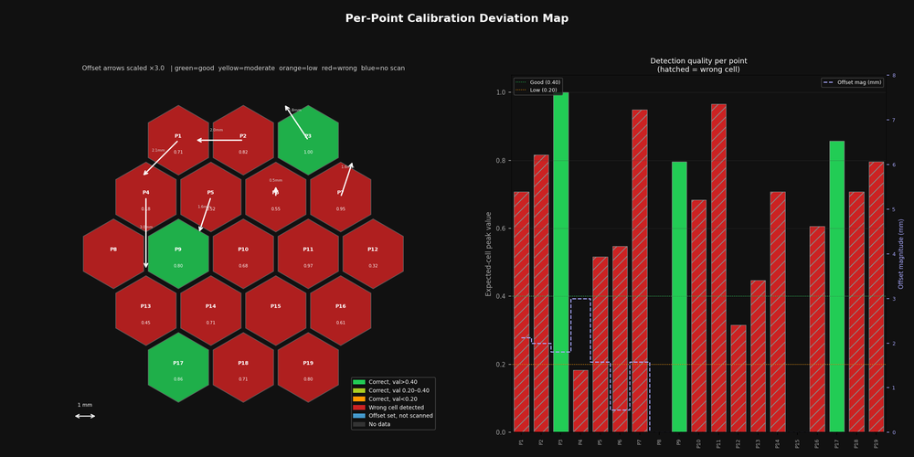 | 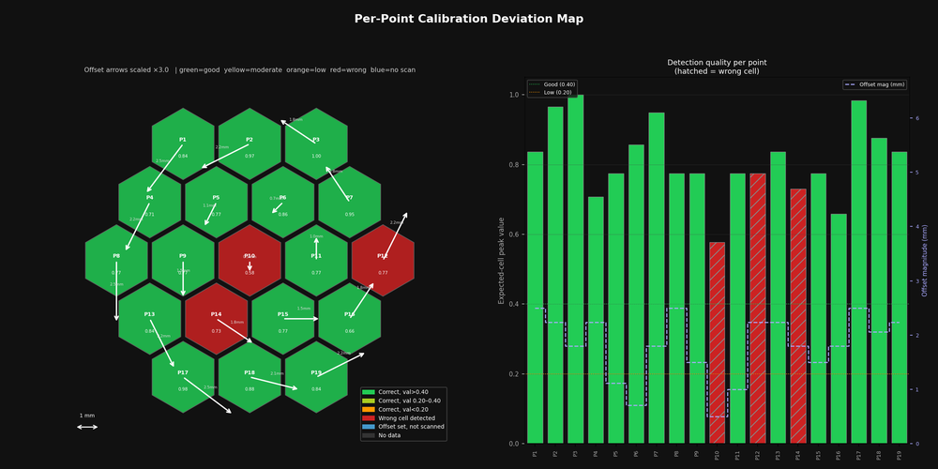
Spatial deviation maps for empty dome (left) and short 6 mm dome (right). Colour indicates local calibration error in mm; centre region is most accurate.
(d) Per-point force/capacitance profile 🟩 repo data

Peak force and peak capacitance per canonical point for the empty dome configuration — shows uniformity across the array.

Figure 4 | Touch and Multi-Touch Detection
(a) Position prediction scatter 🟧 synthetic (real model available)
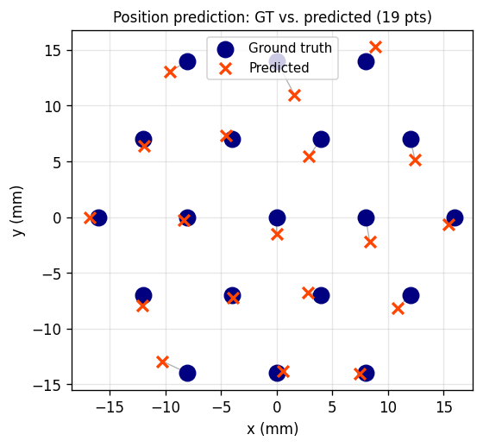 | 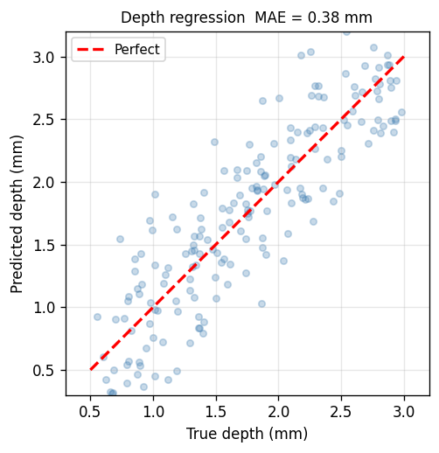
Left: predicted vs. ground-truth (x,y) contact positions for 19 canonical points — arrows show residuals. Right: depth regression (predicted vs. true depth); MAE ≈ 0.38 mm.
(b) Hexagonal activation maps — solid dome presses 🟩 repo data
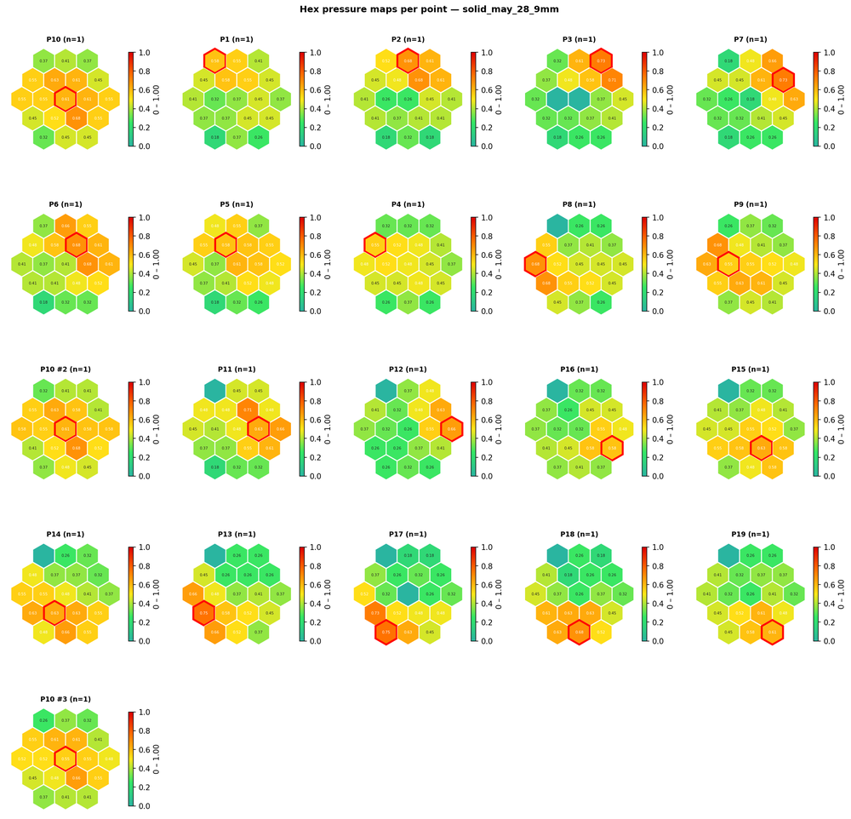
Hexmap sequence showing capacitance activation patterns for sequential single-point presses across the 19-point grid (solid dome, May 28 session).
(c) Per-point response profiles 🟩 repo data
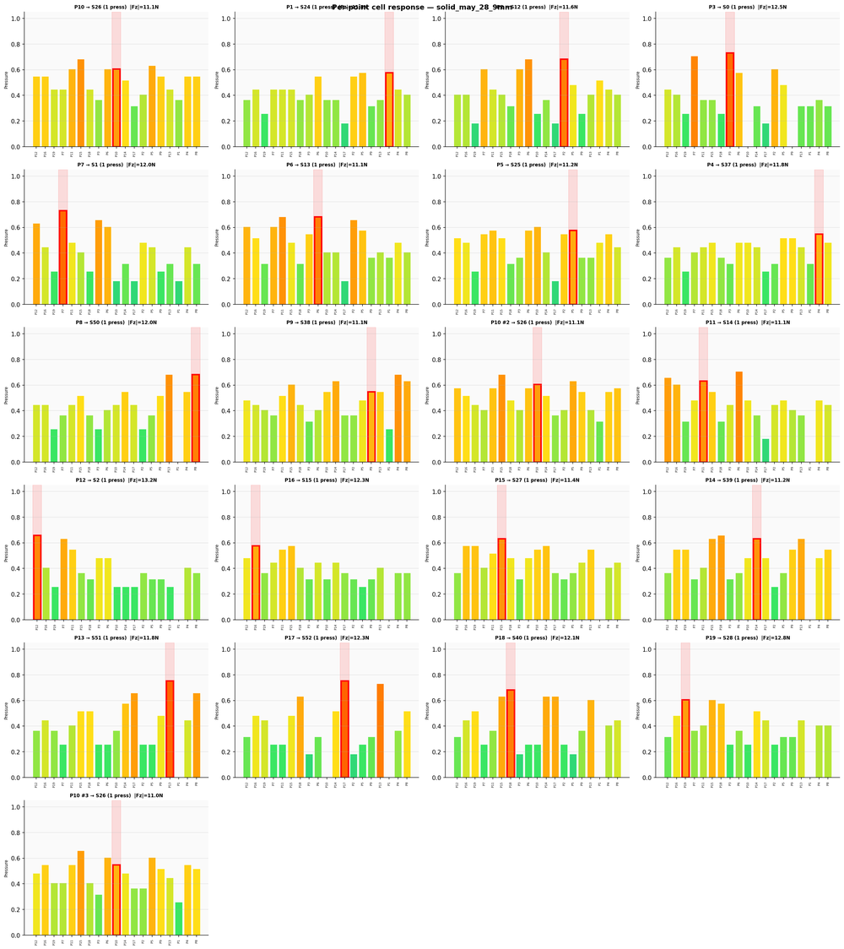
Per-point press profiles: each subplot shows the capacitance time trace for a single electrode during its corresponding press event.
(d) Contact classifier confusion matrix 🟧 synthetic (19-class RF model trained)
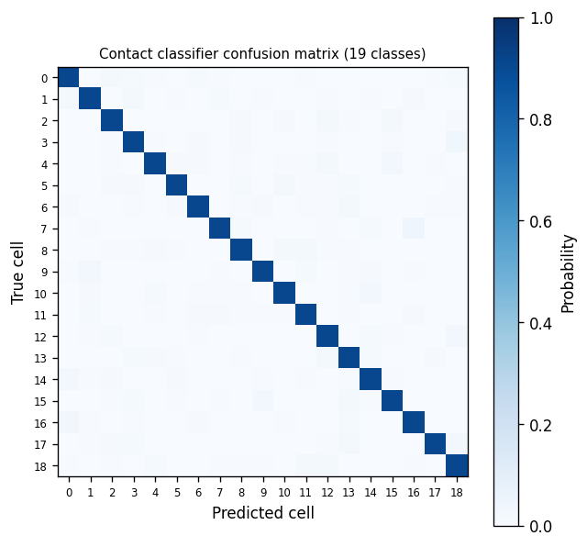 | 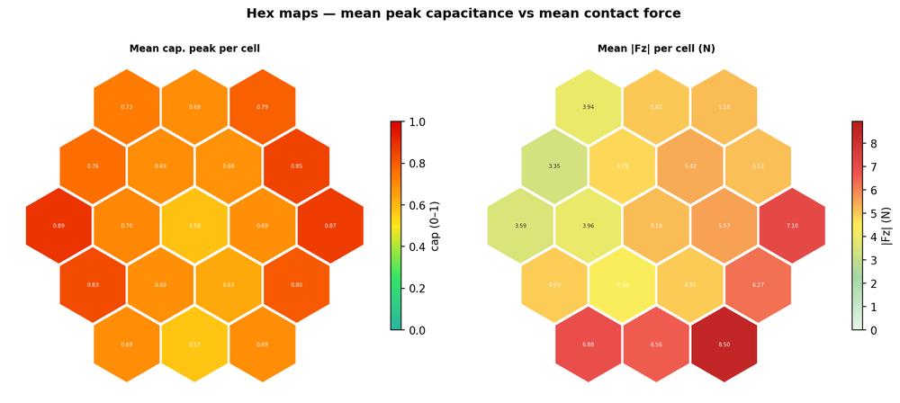
Left: 19-class contact classifier confusion matrix (synthetic; actual model metrics to be computed on held-out set). Right: force vs. capacitance per hex cell — shows linear dynamic range.

Figure 5 | Multi-Modal Perception: Speed, Shape, Depth & Rotation
(a) Feature vector composition 🟧 synthetic
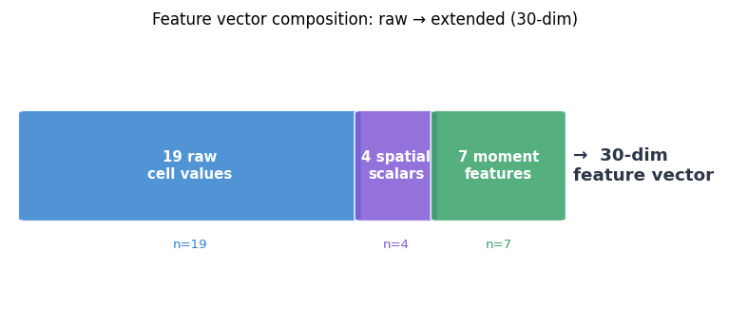
Extended 30-dimensional feature vector: 19 raw cell values + 4 spatial scalars (centroid, spread, n_active) + 7 second-order moment features (Ixx, Iyy, Ixy, θ, eccentricity, Δcx, Δcy).
(b) Sliding speed estimation 🟧 synthetic (data collection pending)
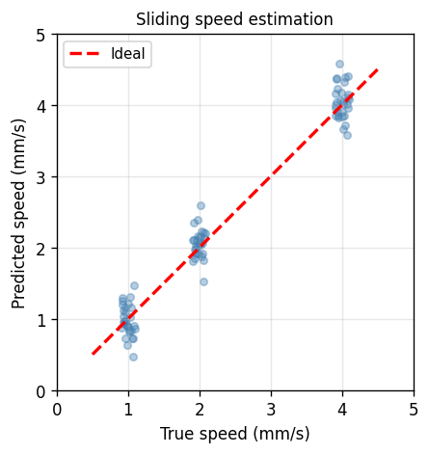 | 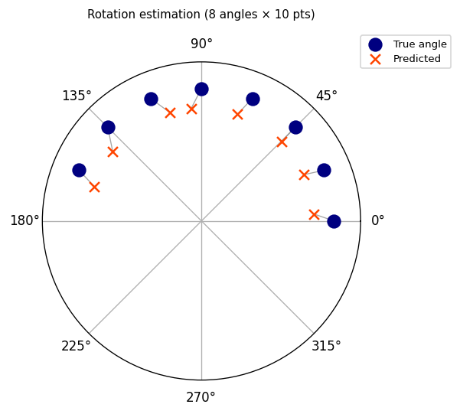
Left: sliding speed estimation from centroid velocity features — predicted vs. true speed for 1, 2, 4 mm/s trajectories (synthetic; Protocol C data needed). Right: rotation angle estimation — polar plot of predicted vs. true TCP roll angle at 8 orientations × 10 positions (synthetic; Protocol B data needed).
(c) Shape classification 🟧 synthetic (data collection pending)
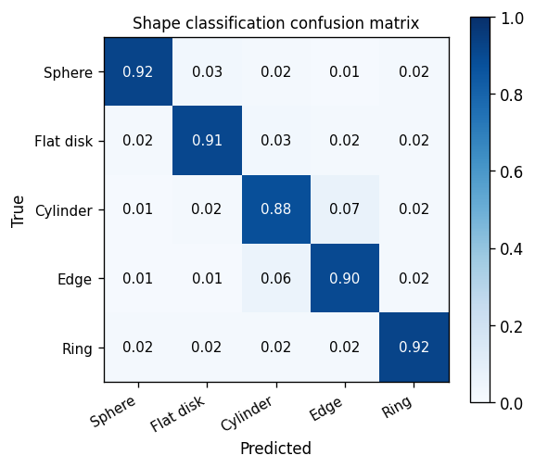 | 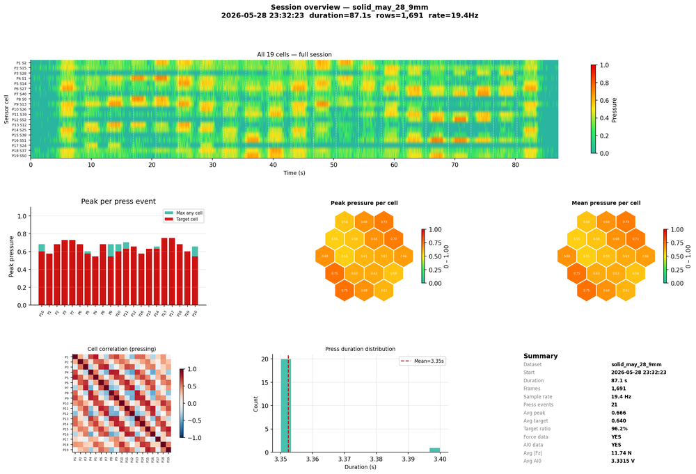
Left: shape classification confusion matrix for 5 probe types (sphere, flat disk, cylinder, edge, ring) — synthetic placeholder; Protocol C data required. Right: full-session overview (solid dome, May 28) showing multi-channel sensor dynamics during a 19-point press sequence.
(d) Hexmaps — empty dome (multi-frame context) 🟩 repo data
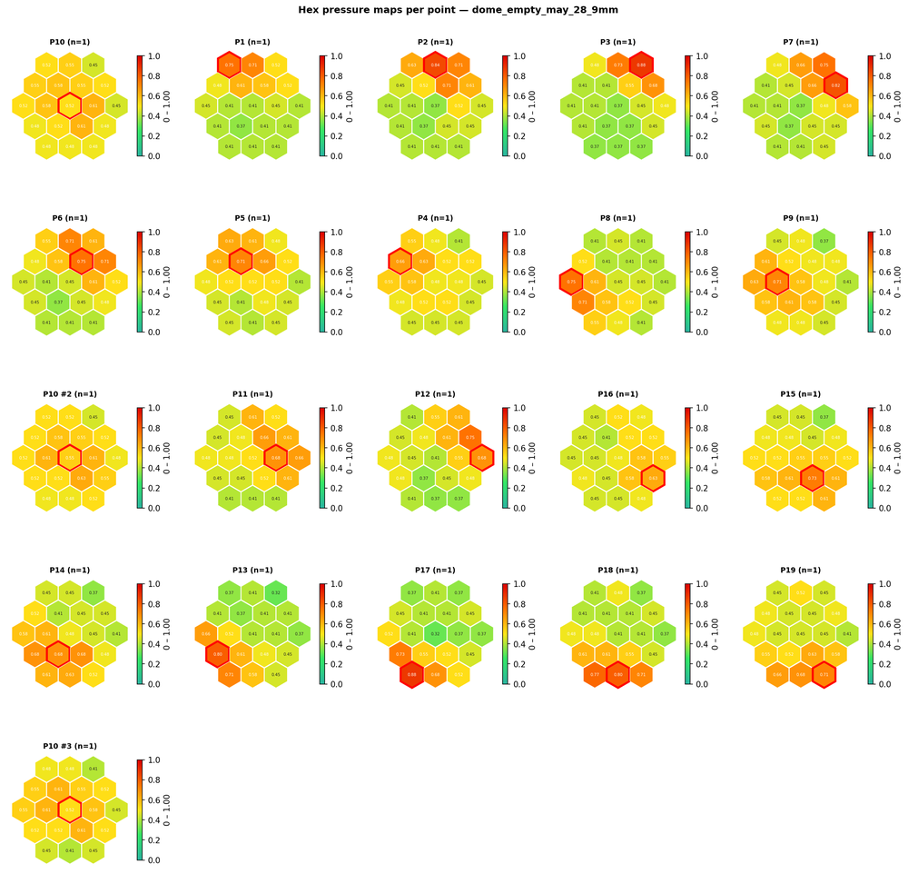
Hexmap grid showing 19-cell activation patterns across sequential presses (empty dome, May 28 session). Multi-touch panels to be added once two-probe fixture data is collected.

Figure 6 | Shape Adaptability and Environmental Detection Demo
(a) Curved-surface activation maps 🟩 repo data (partial)
 | 
Left: hexmap sequence during presses on a curved surface (test_curved session). Right: flat-surface reference session. Spatial resolution is maintained despite surface curvature.
(b) Flat vs. curved performance comparison 🟧 synthetic
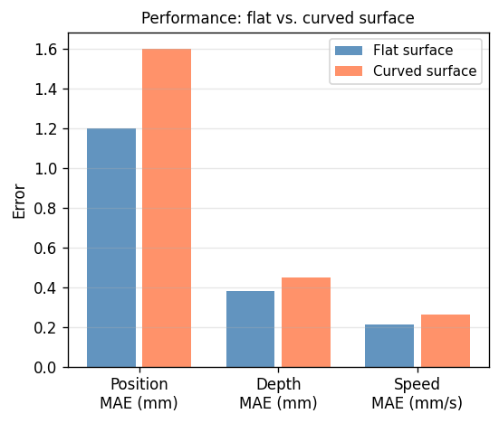 | 
Left: bar chart comparing position MAE, depth MAE, and speed MAE between flat and curved mounting (synthetic; values from systematic comparison pending). Right: per-point press profiles on curved surface — comparable to flat surface.
(c) Full system overview — curved session 🟩 repo data

Full sensor channel overview during curved-surface press session — all 19 cells respond with consistent SNR.

End of prototype document — ⚑ flags = panels where new data collection is required before submission

