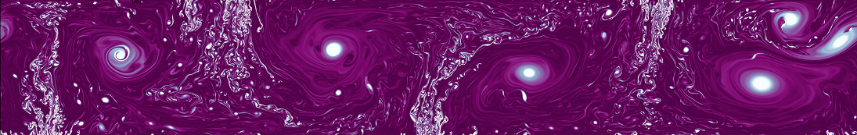**Jonas Powell**

**ASTR231**

**Final Paper**

Since the dawn of stellar-modeling time, we have leaned heavily on our understanding of convection to model energy transport in stars. However, that understanding - and the resulting models - have been hamstrung by the traditional theory of convection's reliance on the mixing length parameter (MLP), a tunable scaling parameter relating the mean length traveled by a convective element to the natural distance scale of the star. This value has traditionally been set to the observed value in the Sun, but there exists no theoretical justification for this generalization and, consequently, our entire understanding of convection - a crucial element in stellar astrophysics - has an enormous asterisk next to it.

Convection is one of the three main methods of energy transport in a star (in addition to radiation and conduction), but is also present in many more familiar scenarios, like in boiling water. In convection, fluid in a higher temperature region gathers into "convective units" and pushes outward, moving down an energy gradient and into cooler regions of the environment (outward in a star, or upward, away from the stovetop, in a pot of boiling water). As these high-energy convective-units escape, their place is filled with the lower-energy fluid that they are displacing, which creates effective mixing of the whole fluid, distributing the energy more uniformly through the environment.

In 1951, Bermann et al. proposed a method that been the standard reference for discussions of stellar convection ever since. In it, they present the mixing length theory (MLT), in which convective elements travel a "mean-free-path" *l*, proportional to the natural distance scale *h* by a factor of the mixing length parameter *Λ* such that *l = Λh.* The value of *Λ* is found for the Sun by comparing its observed and theoretical values, and then using the MLP to make up the difference. Without anything better to go off, it has been assumed that this value is more or less universal and can be applied to models of other stars as well.

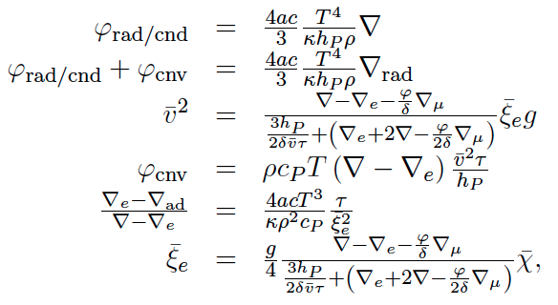In their 2014 paper, Pasetto et al. presented a new method of modeling the motion of these convective elements without the use of the mixing length parameter. In the paper, they shifted their calculations' reference frame from that of the environment (i.e. the star or the stove-top) to a non-inertial reference frame co-moving with the convective element. They then integrated the Navier-Stokes equation of fluid dynamics to find expressions for the radiative and conductive flux, total flux, mean square velocity, convective flux, relative energy gradients, and the mean size of the convective elements (respectively, top to bottom in the above equations, Fig. 1). In 2018, the authors followed up their original paper by showing that their new model matched the traditional MLT predictions for the solar structure extremely well.[1] Because this 2018 paper is the focus of the present article, it is not crucially important that we dive into the mathematical work that went into establishing these final equations of motion in the 2014 paper, although the interested reader is strongly encouraged at least skim those derivations to acquire a flavor of their origins.

Figure : Equations of motion in stellar convection (Pasetto et al., 2014)

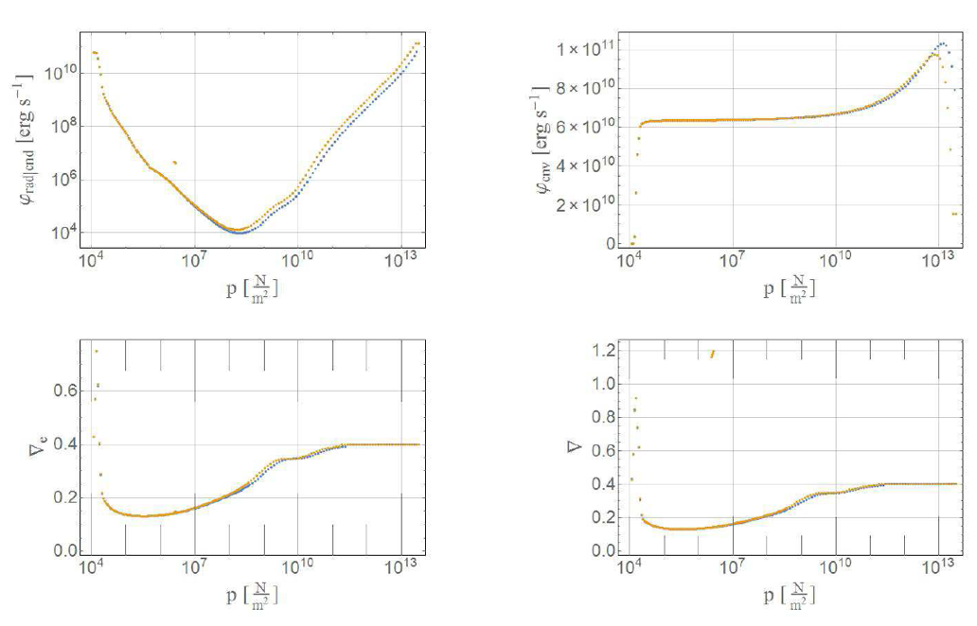

In the present paper, the authors systematically integrated both the scale-free convection (SFC) and the mixing-length theory (MLT) for solar models. For the MLT, they used a mixing-length parameter value of 1.65, a value that is known to be accurate for solar models. The authors found that all the results from the MLT are successfully recovered by the SFC without use of the arbitrary mixing length parameter, an enormous success (Fig. 2).

Figure : The authors found that their new models for stellar convection (blue) recovered the same features as the mixing length theory (yellow)

With these more comprehensive, physically justified models in hand, the astronomical community - should it choose to adopt them - will finally be able to overcome a fundamental uncertainty in its grasp of stellar structures and the dynamics therein.

1. Recall that the main weakness of the mixing-length parameter is the question of whether or not using its value that we have for the Sun on other stars is appropriate, but that since we do have a well-calibrated Solar value, the MLT should do a very good job on the Sun.