How to analyze fMRI

Jonathan Sahar

connect to the MRI center file

Other locations in file manager

smb://mrilabfs.tau.ac.il/mriXXlab$

username/password - same as in TAU

Order the data on my computer:

BIDS folder structure
The standard way to order and share imaging data https://bids.neuroimaging.io/
Batel has a script for that :)

types of sacns

Mprage - anatomical

cmrr - functional

each scan name contains the number of volumes, and a name we can choose

there’s an _sbref scan for each scan: used for motion correction, we don’t use it usually

each dicom is 3D at a given Tr

use the 2nd mprage dir - has been filtered

analyzing with FSL
Can open individual tools from command line - for GUI, call tool with capital letter (otherwise is calls the function directly)

BET
Extract the brain only need to do only once - for the anatomical data, FEAT later uses it give it the anatomical DICOM

FEAT - first level

Data:
Preprocessing & GLM analysis first level: single run second level: multiple runs group analysis fulle analyis = inc. running a GLM highpass filter = 100HZ

pre-stats
Keep defaults, and add slice time correction = interleaved

registration
Select anatomicalbrain image (from BET) for the standard space use full search & 12 DOF

Stats
Need to create an EVs (events) files for every kind of event that happend in the scan: 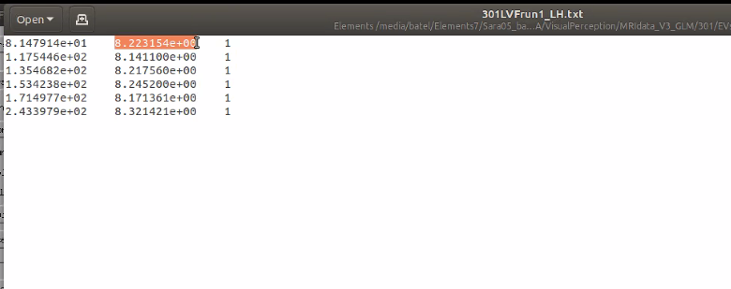 onset duration weight
The GLM: “Full model setup” create a page for each EV HRF: double gamma

post-stats = multi comparisons correction
Don’t need for first-

save! before hitting go
Creates a “batch” file : .fsf

go
Creates a FEAT report html that updates in real time shows the quailty of registration, motion correction, the details of the statistical model etc.
Can run from command line as “feat path/to/design.fsf”

load
load an existing .fsf file can create an empty .fsf with names of vars in “”, and then populate file with a script

output:
Work with filteredFuncdata feed into FSLeye
cope files: the different contrasts we computed: we can use them later for the higher order analysis.
in stat directory:
- peNUM: the beta value for each eventNUM in EVs: also NIFTI files, the beta for each voxel
- tfiles - the t-values for each voxel
Feat doen’t apply the transformation to MNI - the coomputations for doing so are in reg dir. Also in reg - hireshead - the anatomical head

FEAT - higher level
Analyze multiple runs from the same esubject input the cope files from previous analysis of all runs averages the different run + transforms to MNI space

FSLeyes
Presentation of images

dcm2nii - external app
Convert DICOM to NIFTI

more info on FSL - videos from jeanette mamford https://www.youtube.com/channel/UCZ7gF0zm35FwrFpDND6DWeA

Code -
mainvisualPerceptionAnalysis.m in Batel’s code base

