GCM
Datasheet
-
Version 5.x

This document has been made with LibreOffice.

Copyright (C) 2020 Guillaume Guillet
Licensed under CERN-OHL-W v2 or later

This source describes Open Hardware and is licensed under the CERN-OHL-W v2 or later.

You may redistribute and modify this documentation and make products using it under the terms of the CERN-OHL-W v2 (https:/cern.ch/cern-ohl). This documentation is distributed WITHOUT ANY EXPRESS OR IMPLIED WARRANTY, INCLUDING OF MERCHANTABILITY, SATISFACTORY QUALITY AND FITNESS FOR A PARTICULAR PURPOSE.

Please see the CERN-OHL-W v2 for applicable conditions.

Table of contents
Description 3
Features 3
Details 4
Clock generation 4
Source switching 7
Reset 8
Fabrication 10
Getting the PCB 10
Getting the materials 10
Soldering 10
Changes 11

Description
The GCM or G_CardMother is a custom, from scratch, with no micro-controller, only made with logic circuits, 8bits motherboard.
This project is one part of a larger project which is the complete development of a home-made 8bits computer.
One of the goals is to create a new community around 8bits computers with a set of electrical/mechanical standards and projects in order to be able to create a simple and practical environment for all interested persons, whether they are hobbyists or not.

Features
- Follow the MOM1_SPS1*¹ standard.
- A controllable frequency of 50Mhz divisible by multiples of two up to a division of 65536.
- The same separate controllable frequency divisible by multiples of two for peripherals.
- 4 peripherals slot (that follow standard PP1*¹).
- 2 MM1*¹ memory slot with address extension.
- Readable code source switching from the 2 memory slot.
- Redirection of the writing buses.
- Accessible debug pins.

*¹ You can find the standard here:
https://github.com/JonathSpirit/GComputer_standard

Details

Clock generation
The frequency of the processor is generated via a 50Mhz crystal oscillator.

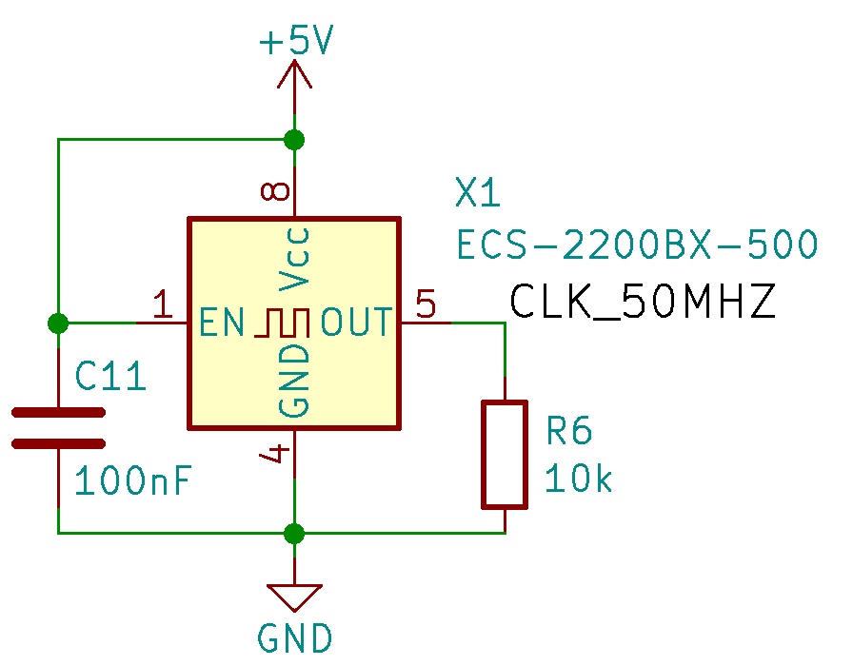

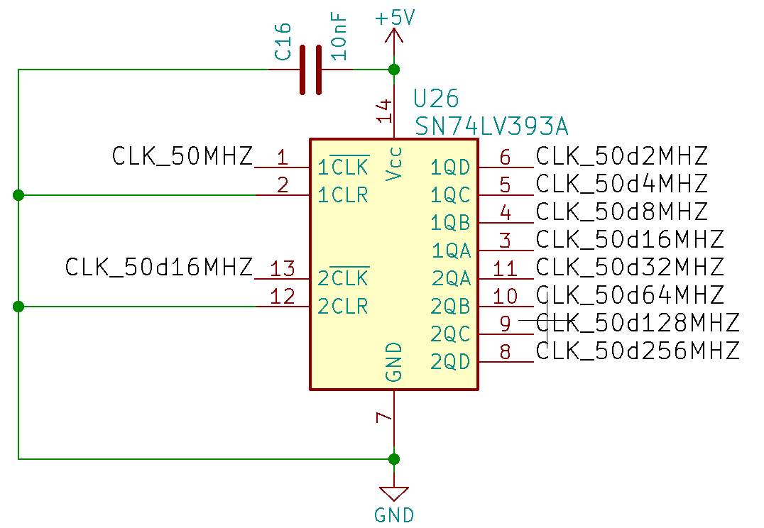
The 50Mhz frequency is then divided by 4 4bits counter for achieving a division of 65536.
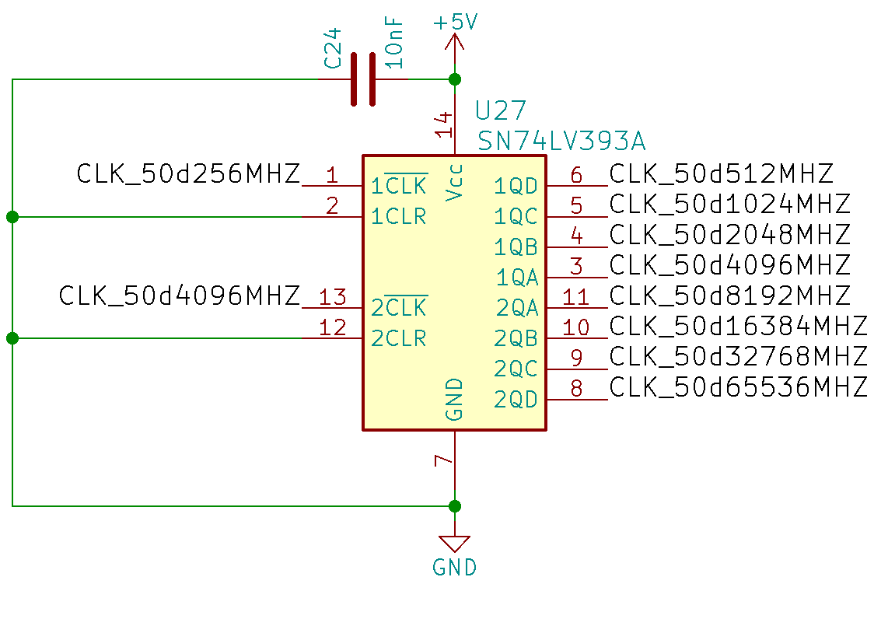

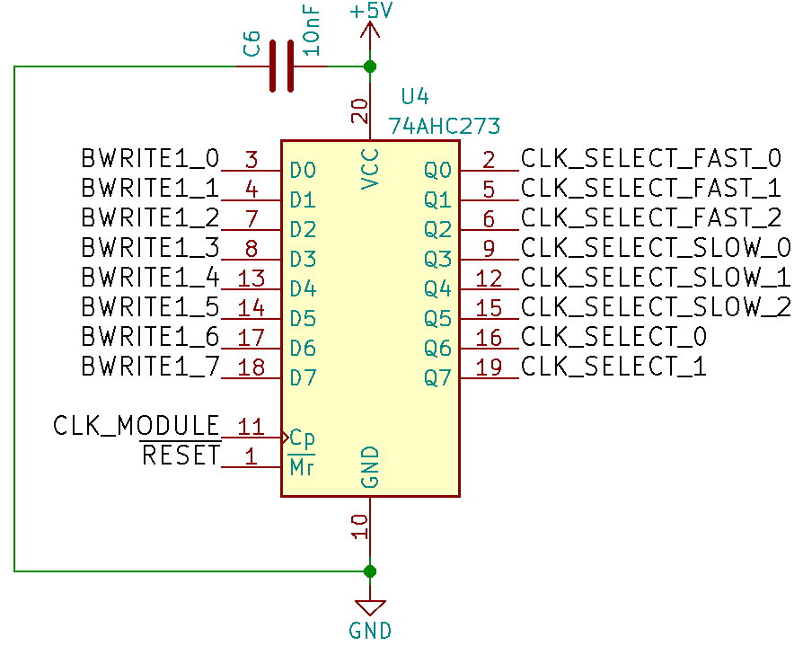
You can control what division you want by applying a byte on the D-latch register ‘U4’ and by selecting the module/peripheral 7.

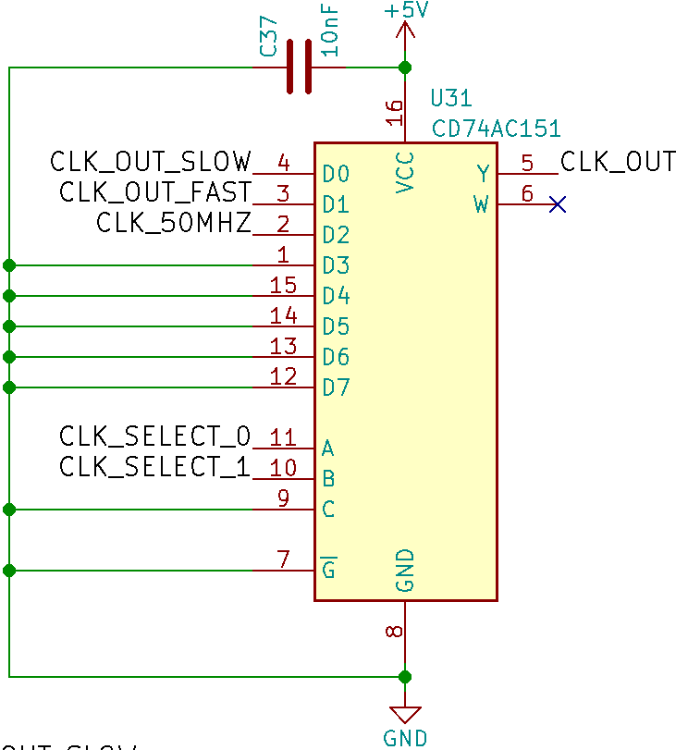
The default frequency is 50Mhz /65536 every power reset.
After the selection (latch) of a new frequency, the system send a light reset signal.

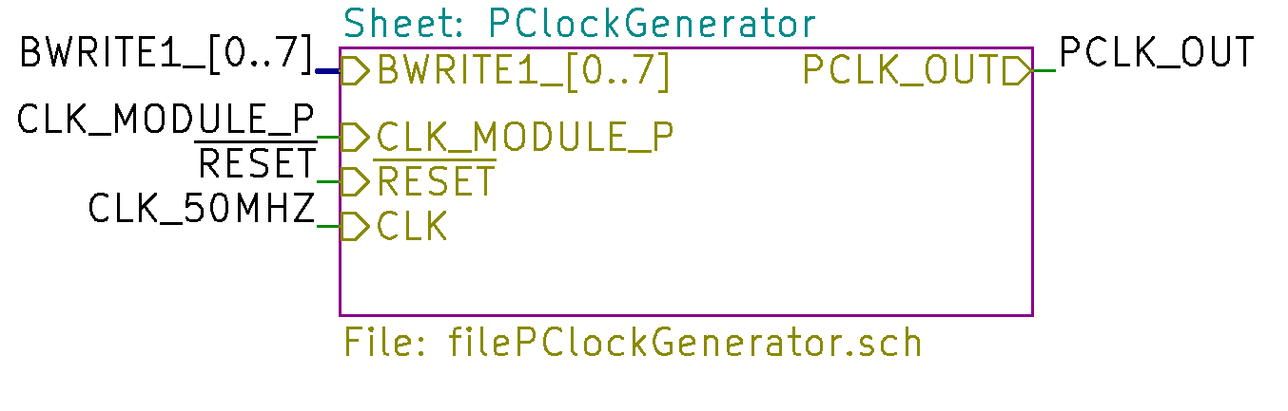
You can control separately the peripheral clock division by selecting the module/peripheral 8.

Processor/Peripheral frequency and configuration
Division | Frequency [f] = kHz | Configuration binary | Configuration hex
1 | 50’000 | 10xx’xxxx | 0x80
2 | 25’000 | 01xx’x111 | 0x47
4 | 12’500 | 01xx’x110 | 0x46
8 | 6250 | 01xx’x101 | 0x45
16 | 3125 | 01xx’x100 | 0x44
32 | 1562.5 | 01xx’x011 | 0x43
64 | 781.25 | 01xx’x010 | 0x42
128 | ~390.625 | 01xx’x001 | 0x41
256 | ~195.313 | 01xx’x000 | 0x40
512 | ~97.656 | 0011’1xxx | 0x38
1024 | ~48.828 | 0011’0xxx | 0x30
2048 | ~24.414 | 0010’1xxx | 0x28
4096 | ~12.207 | 0010’0xxx | 0x20
8192 | ~6.104 | 0001’1xxx | 0x18
16384 | ~3.052 | 0001’0xxx | 0x10
32768 | ~1.526 | 0000’1xxx | 0x08
65536 | ~0.763 | 0000’0xxx | 0x00
- | 0 | 11xx’xxxx | 0xC0

Source switching
You can choose to execute a code in memory slot 1 or from memory slot 2.

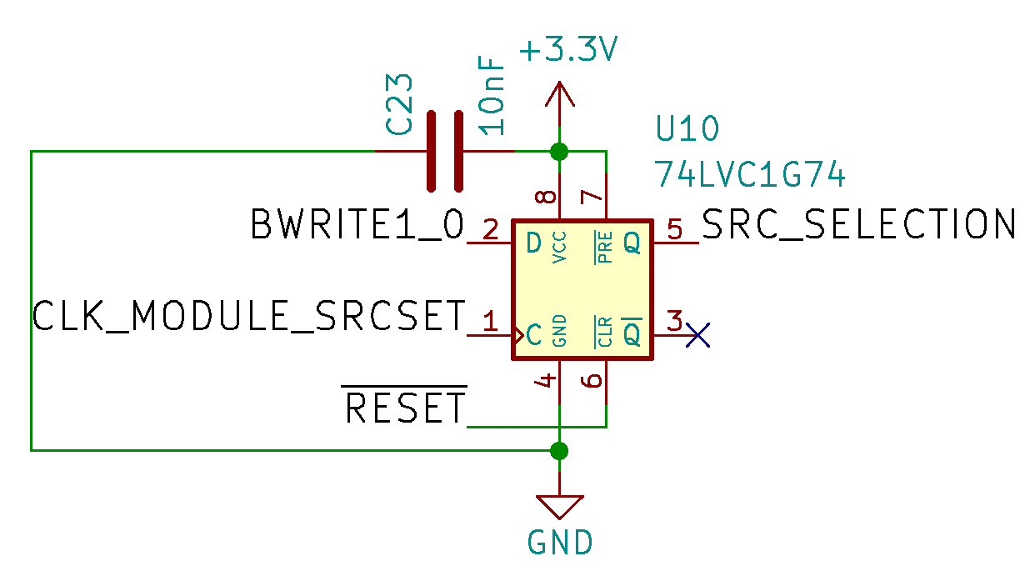
To do that you have to select peripheral/module 6 and apply a value of ‘0’ (memory 1) or ‘1’ (memory 2).
After applying the value the system send a light reset signal.

When a memory is in used for code execution you cannot control it. You can, however, control the unused memory by selecting the peripheral/module 5.

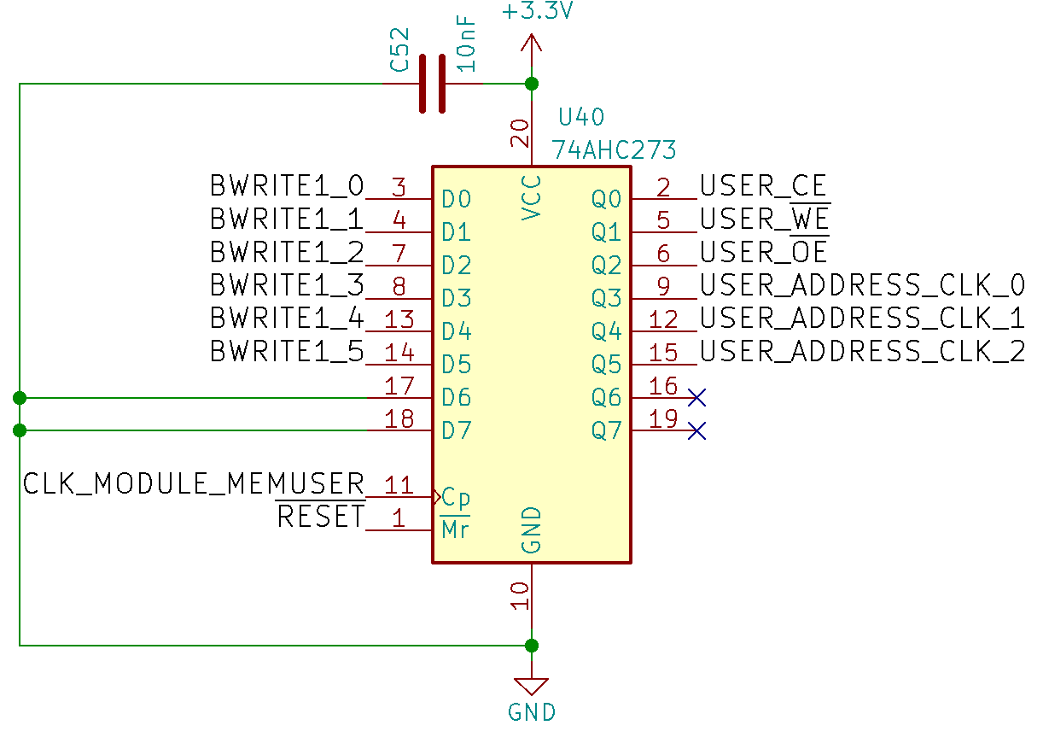
You will be able to control all of the memory control pins and the 24bits address bus.
The “chip enable” pin is inverted.

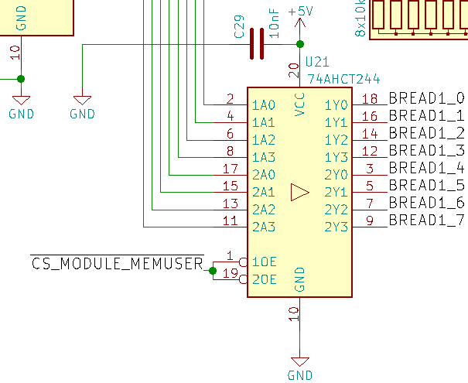
To read the unused memory, select the peripheral/module 5 and set the “output enable” and the “chip enable” pin to ‘0’.
The value will be on the “BREAD1” bus.

Reset
There are 2 different types of reset :
The power reset who is executed only after powering up the motherboard.
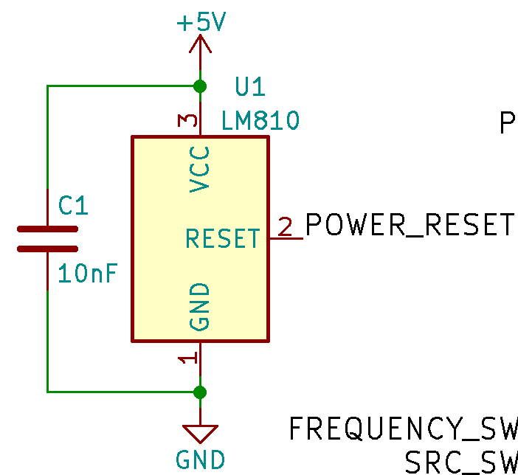
The LM810 chip sent a ~240ms pulse.

Device | Is reset? | Reset value
Processor clock | yes | 0x00 (50Mhz /65536)
Peripheral clock | yes | 0x00 (50Mhz /65536)
Processor | yes | -
Peripherals | yes | -
Address counter | yes | 0x000000
Memory controller | yes | 0x00
Source selection | yes | 0 (Memory slot 1)

And the light reset who is executed after a source or clock change.
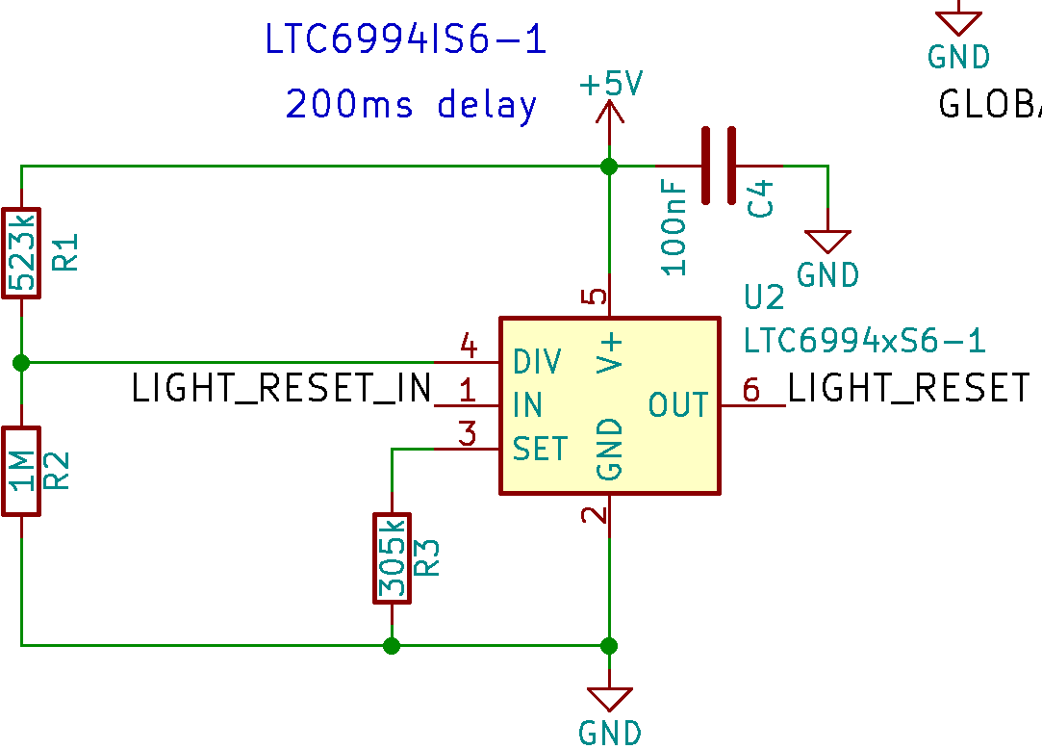
The LTC6994-1 chip sent a ~200ms pulse.

Device | Is reset? | Reset value
Processor clock | no | 0x00 (50Mhz /65536)
Peripheral clock | no | 0x00 (50Mhz /65536)
Processor | yes | -
Peripherals | yes | -
Address counter | yes | 0x000000
Memory controller | no | 0x00
Source selection | no | 0 (Memory slot 1)

Fabrication

Getting the PCB
Fabrication files can be found in the folder: “documents/GCM_gerbert”.

For JLCPCB or other manufacturers, you can zip the fabrication folder and send it to them directly.

Getting the materials
A bill of materials can be found here: “documents/GCM_materials”. Note that if you want to change the supplier, you have to make sure that the component is fully compatible mostly for the package.

Soldering
If you solder the board manually, a microscope can be useful for small component like the CPLD.
Follow the bill of materials and the PCB placement file to solder the board.
I suggest you start with the CPLD and finish with the connectors.

Changes
Revision 0:
initial release

